EVENTFORCE MANAGEMENT SYSTEM
SALESFORCE IMPLEMENTATION DOCUMENTATION

Project: EventForce Management System
Platform: Salesforce
Document Type: Project Implementation & Documentation
Prepared By: M.Kalsiselvi
M.Asika
K.Kanishka Shri
R.Harini
V.Kavya
Institution: Anjalai Ammal Mahalingam Engineering College
Submission Date: 03/10/2026

1. Project Overview
EventForce Management System is a Salesforce-based CRM solution designed for Event Planner Solutions. The system brings event planning activities into a centralized platform covering client bookings, venue reservations, vendor coordination, feedback collection, approvals, reminders, reporting, and security.
The reference implementation defines custom Salesforce objects for Event, Client, Vendor, Venue, Feedback, and Event Vendor, together with relationships, automation, Apex logic, user access controls, reports, and dashboards. The objective is to reduce manual work and provide real-time visibility into event operations.
The reference identifies targeted business value of reducing manual processes by 60%, improving booking efficiency by 40%, improving client satisfaction through timely communication, and supporting data-driven business growth through reporting and analytics. These figures are project targets described in the reference, not measured production results.

Business Areas Covered
- Client booking and event management
- Venue reservation and availability management
- Vendor coordination and event-vendor assignment
- Client feedback collection
- Cancellation approval workflow
- Automated client reminders
- Reports and dashboards for operational visibility
- Role-based security and controlled record sharing

2. Objectives
- Create a centralized CRM platform for event management operations.
- Digitize and automate client bookings, venue reservations, vendor coordination, and feedback collection.
- Provide real-time visibility into events and operational activities.
- Use Salesforce automation to handle reminders, approvals, and status updates.
- Maintain accurate data through validation rules, formulas, and relationship constraints.
- Protect business information using profiles, roles, permission sets, sharing rules, and Organization-Wide Defaults.
- Provide management insights through reports and dashboards.

3. Solution Architecture and Data Model
The solution uses Salesforce custom objects as the primary data layer. Event is related to Client and Venue through lookup relationships. Feedback is related to Event and Client. A junction object, Event Vendor, implements the many-to-many relationship between Event and Vendor using two master-detail relationships.
Object | Purpose | Important Fields / Relationships
Event__c | Core event record | Event Name, Event Date, Event Type, Event Status, Event Budget; lookup to Client and Venue
Client__c | Stores client details | Client Name, Email, Phone, Address, Country, City
Vendor__c | Stores service providers | Vendor Name, Email, Phone, Service Type, Status
Venue__c | Stores venue details | Venue Name, Address, Location, Capacity, Availability Status
Feedback__c | Stores event feedback | Feedback ID, Rating, Comments; lookup to Event and Client
EventVendor__c | Junction object | Links Event and Vendor through two master-detail relationships

Relationship model: Event → Client (Lookup); Event → Venue (Lookup); Feedback → Event (Lookup); Feedback → Client (Lookup); EventVendor → Event (Master-Detail); EventVendor → Vendor (Master-Detail).

4. Phase 1 – Requirement Analysis & Planning
Phase 1 establishes the functional scope, stakeholders, data model, automation requirements, security needs, and implementation roadmap.

Functional Scope
- Custom objects: Event, Client, Vendor, Venue, Feedback, and Event Vendor.
- Lookup, master-detail, and many-to-many relationship modeling.
- Flows for reminders, feedback notifications, and approval updates.
- Validation rules and formula fields for data accuracy and event budget calculation.
- Approval process for event cancellation requests.
- Profiles, roles, and permission sets for user-level access.
- Reports and dashboards for event summaries, vendor performance, and upcoming events.
- Apex classes and triggers for venue availability and double-booking prevention.

Stakeholders
Stakeholder | Primary Responsibility
Clients | Request event services, provide feedback, and view event updates.
Event Coordinators | Manage event scheduling, client communication, and approval workflows.
Vendors | Handle assigned event services such as catering, décor, and logistics.
Venue Managers | Manage venue availability and reservations.
Event Administrators | Oversee system operations, security, and data monitoring.

5. Phase 2 – Backend Development & Configurations
Phase 2 builds the functional engine of the CRM using declarative Salesforce tools, Apex, and security configurations. Record-triggered flows, validation rules, formula fields, approval processes, Apex classes, and triggers work together to automate business operations.

Core Backend Components
- Custom objects and fields for event-management data.
- Formula field for Event Budget based on Event Type.
- Validation rule Email_Valid_Address on Client to check email format.
- Approval process Event_Cancellation_Process for cancellation requests.
- Record-triggered flow Client Reminder - 3 Days Before for confirmed events.
- VenueStatusHelper Apex class and EventTrigger13 to update venue availability.
- PreventDoubleBooking trigger to stop two events from using the same venue on the same date.
- BatchCompleteEvents and ScheduleCompleteEvents for scheduled completion of past events.

Event Budget Formula
The reference defines the Event Budget as a currency formula based on Event Type: Wedding 50,000; Corporate 30,000; Birthday 10,000; Anniversary 20,000; Festival 60,000; Concert 40,000; Other 15,000; otherwise 0.

Validation
The Client Email_Valid_Address validation rule uses a regular-expression condition. If the email does not match the defined pattern, the record cannot be saved and the user receives the message “Please Enter Valid Email Address.”

6. Phase 3 – UI/UX Development & Customization
Phase 3 focuses on a simple, user-friendly Lightning interface. The Event Planner application groups Events, Clients, Vendors, Venues, Feedback, Reports, and Dashboards into a single workspace.

Lightning App
- App name in the reference: Event Planner.
- Navigation includes Event, Client, Vendor, Venue, Feedback, Reports, and Dashboards.
- The app is configured for the System Administrator profile in the reference implementation.
- The interface supports centralized access to event-management modules.

Reports and Dashboard
- Upcoming Events by Month report: groups events by calendar month and summarizes event counts and total budget.
- EventForce Operations Dashboard: uses the Upcoming Events by Month report as a dashboard widget.
- The dashboard provides a visual overview of upcoming events for operational monitoring.

7. Phase 4 – Data Migration, Testing & Security
Phase 4 prepares the solution for deployment by importing validated records, creating users, applying role-based access, and testing data, automation, and permissions.

Data Migration
- Records for Events, Clients, Vendors, Venues, and Feedback are imported using the Data Import Wizard.
- Pre-validation checks are performed to reduce duplicate and inconsistent data.
- The reference recommends creating sufficient sample records before report testing.

Security Model
- Profiles define object, field, user, tab, app, Apex, and other permissions.
- Roles support the reporting hierarchy and record-access structure.
- Permission Set: Feedback Manager provides additional Feedback object permissions and is assigned to an Event Coordinator user.
- OWD for Event is configured as Private in the reference.
- Sharing rule Event_Sharing_For_Vendors shares Event records from the Event Coordinator role to the Vendor Manager role with Read Only access.
- User profiles include Event Admin, Event Coordinator, Vendor Manager, and Client Profile.
Profile | Reference Access
Event Admin | Full access based on System Administrator as the base profile.
Event Coordinator | Event C/R/E/D; Client Read/Edit; Vendor Read; Venue Read; Feedback Create/Read.
Vendor Manager | Vendor C/R/E/D; Event, Venue, Client, Feedback Read Only.
Client Profile | Event Read Only for own events; Feedback Create/Read; Vendor/Venue No Access.

Testing
- Validate imported data for completeness and consistency.
- Test validation rules by entering invalid values and confirming that the save is blocked.
- Test the cancellation approval path for both approval and rejection outcomes.
- Test the three-day reminder flow for confirmed events with valid client email addresses.
- Test venue status updates when events are confirmed or canceled.
- Test the double-booking trigger using the same venue and event date.
- Verify role, profile, permission-set, OWD, and sharing-rule behavior.

8. Phase 5 – Deployment, Maintenance & Documentation

Deployment Strategy
The reference implementation was built and tested inside a Salesforce Developer Edition Org. A live production deployment was not performed because the Developer Edition environment is standalone and is not connected to a production instance.
For a real deployment, the reference describes using sandbox environments, change sets, or Salesforce DevOps approaches such as GitHub CI/CD pipelines or Salesforce DX. The academic implementation therefore focuses on preparing metadata and configurations so that objects, fields, flows, Apex, security settings, reports, and dashboards are structured for future migration.

Maintenance, Monitoring & Troubleshooting
- Keep event, client, vendor, venue, and feedback data accurate and up to date.
- Regularly monitor flows, Apex jobs, and approval processes for failures.
- Resolve user-access errors and permission conflicts.
- Debug Apex triggers and Flow logic when automation does not behave as expected.
- Adjust validation rules and sharing settings when business requirements change.
- Maintain clear configuration records so future administrators can understand the system.

Documentation Summary
- Business overview and objectives
- Phase-wise implementation details
- Data model and relationship structure
- Automation components: Flows, Approval Process, Validation Rules, and Apex
- Security model: Profiles, Roles, Permission Sets, OWD, and Sharing Rules
- Testing activities and results
- Screenshots of Salesforce configuration and reporting features
The documentation acts as a reference for future developers and administrators and supports training, maintenance, scalability, and knowledge transfer.

9. Required Screenshots
The reference PDF contains implementation screenshots. The figures below are included as clearly marked reference figures to help organize the submission. Before final submission, replace them with screenshots captured from your own EventForce Salesforce org so that the documentation represents your actual implementation.
Figure – Data Architecture / Objects
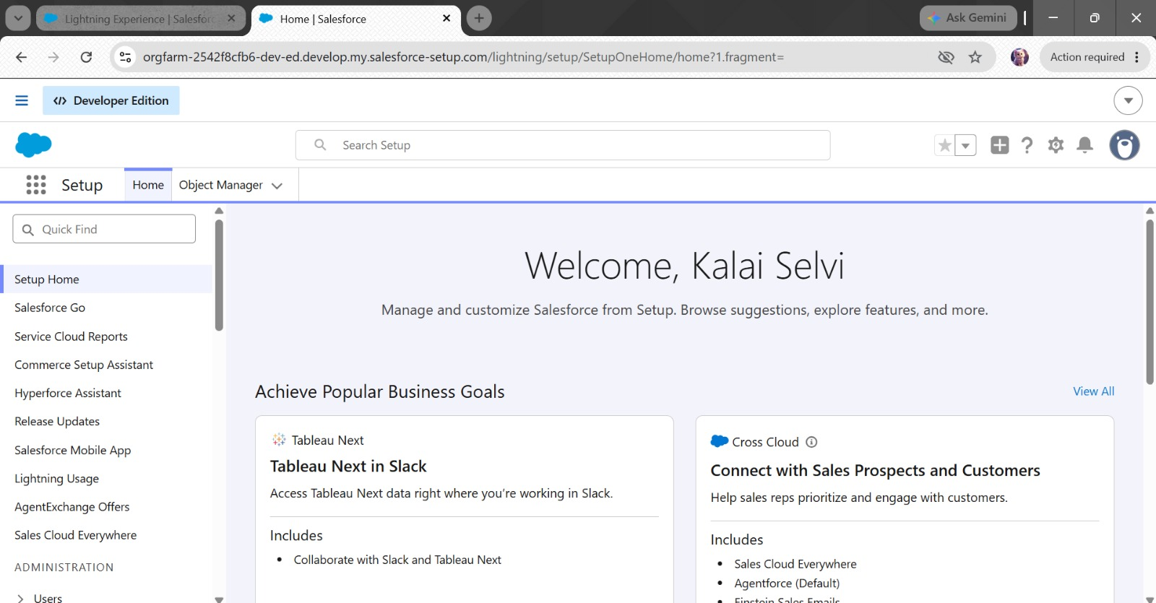
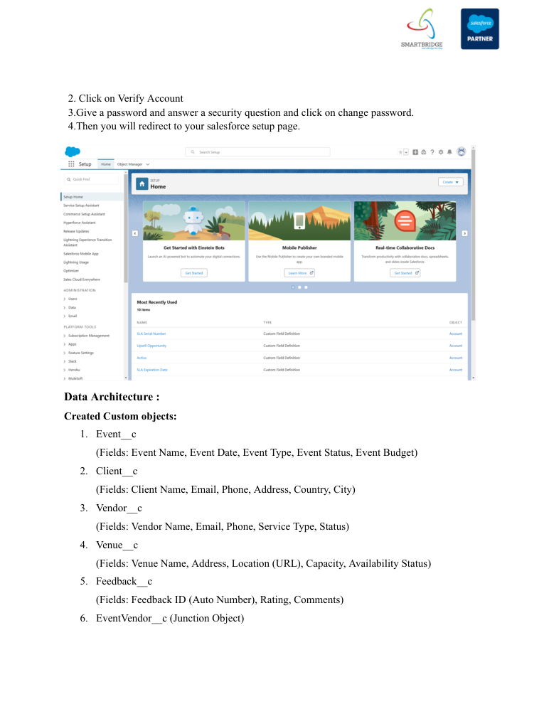
Reference screenshot from the supplied implementation guide — replace with your own project screenshot before submission.
Figure – Validation Rule
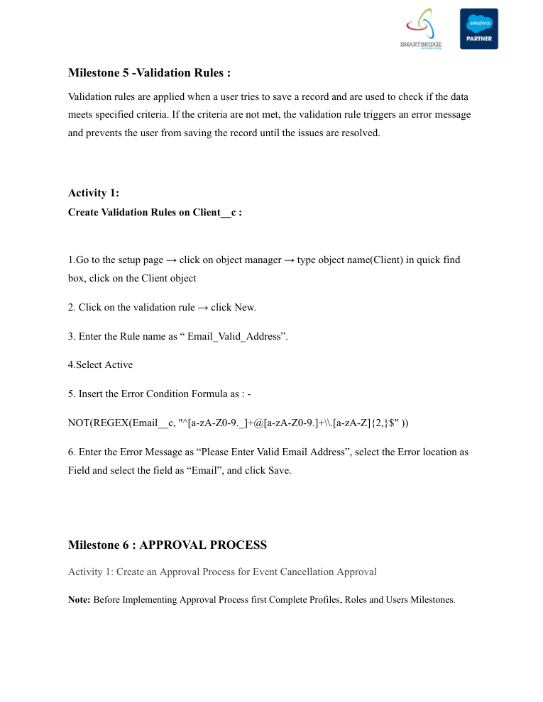
Reference screenshot from the supplied implementation guide — replace with your own project screenshot before submission.
Figure – Approval Process
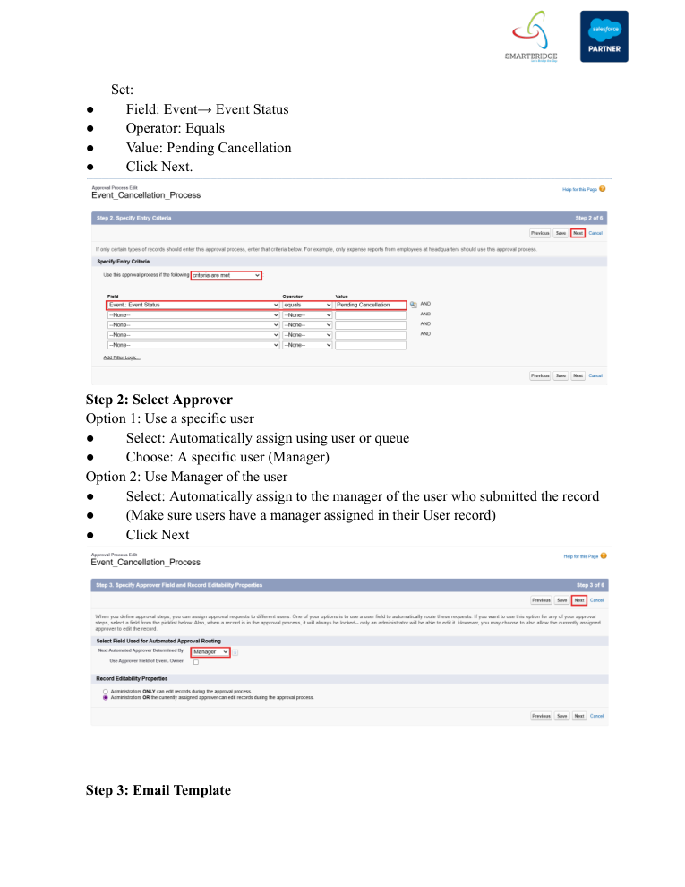
Reference screenshot from the supplied implementation guide — replace with your own project screenshot before submission.
Figure – Reminder Flow
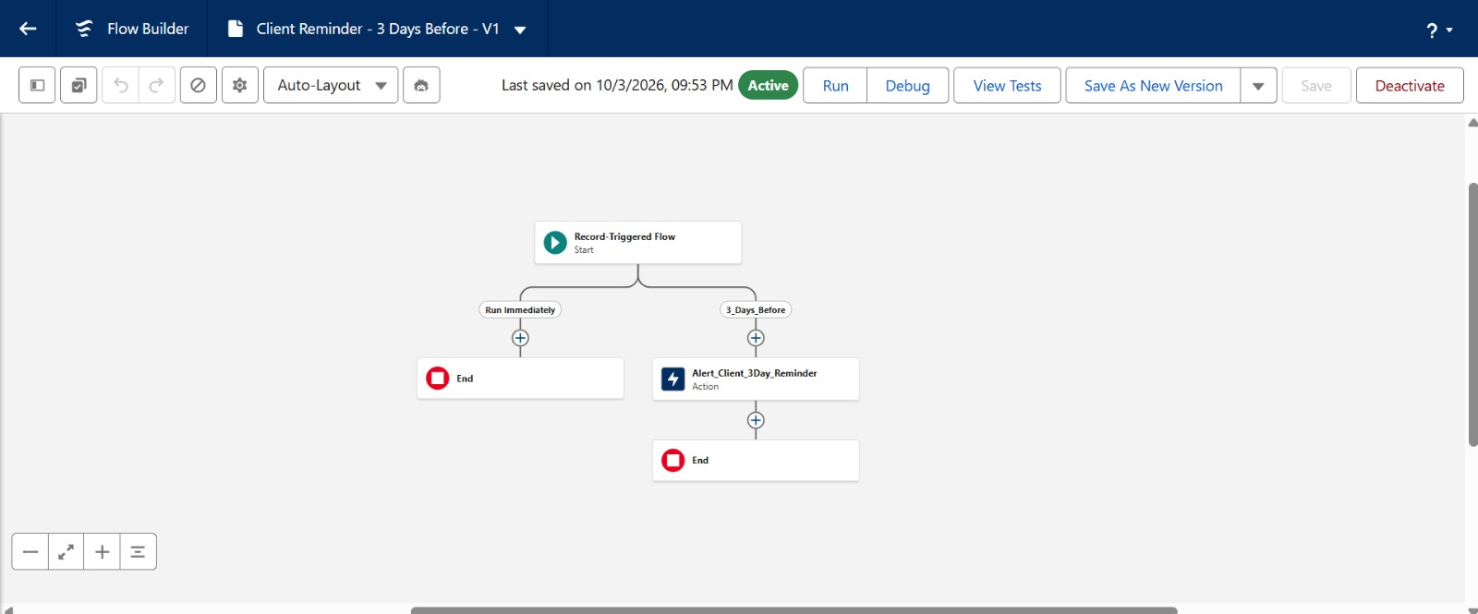
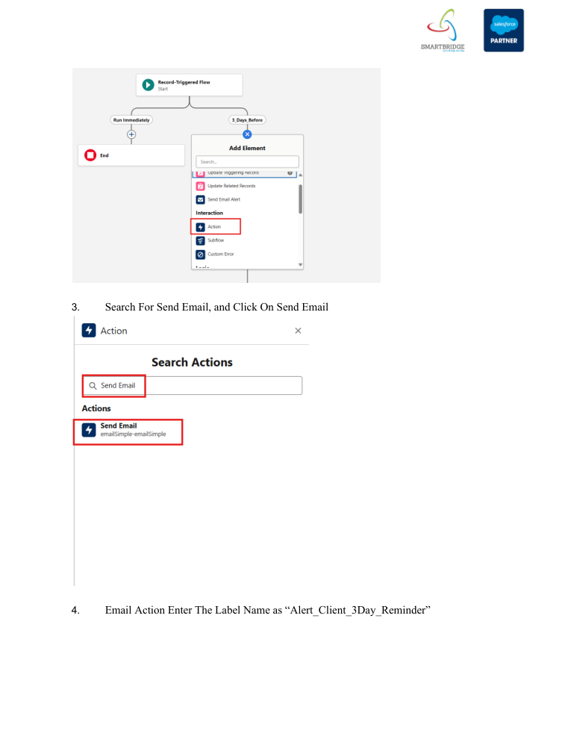
Reference screenshot from the supplied implementation guide — replace with your own project screenshot before submission.
Figure – Reports
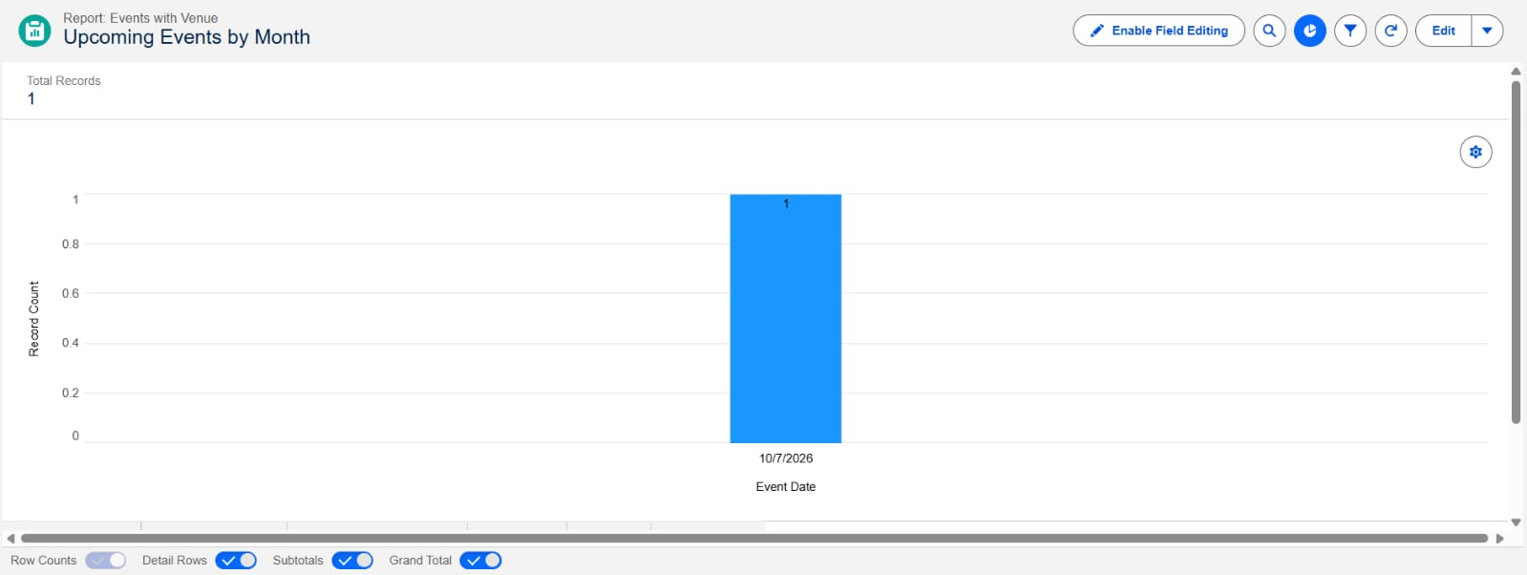
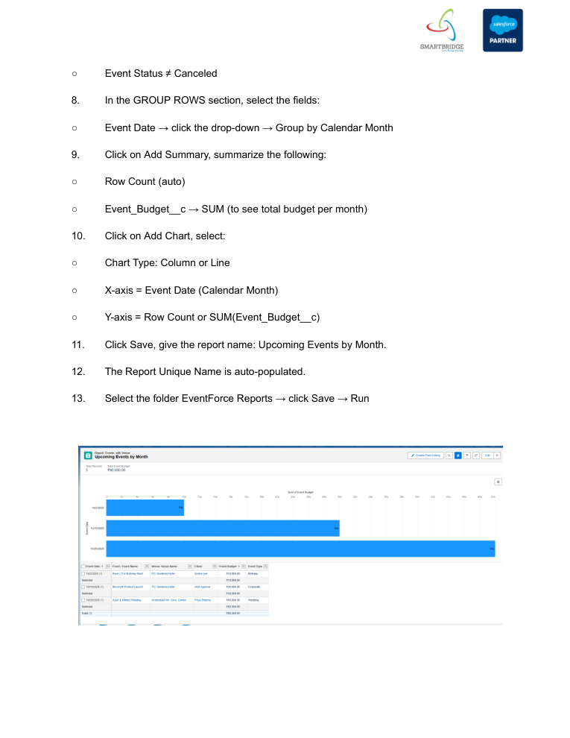
Reference screenshot from the supplied implementation guide — replace with your own project screenshot before submission.
Figure – Dashboard
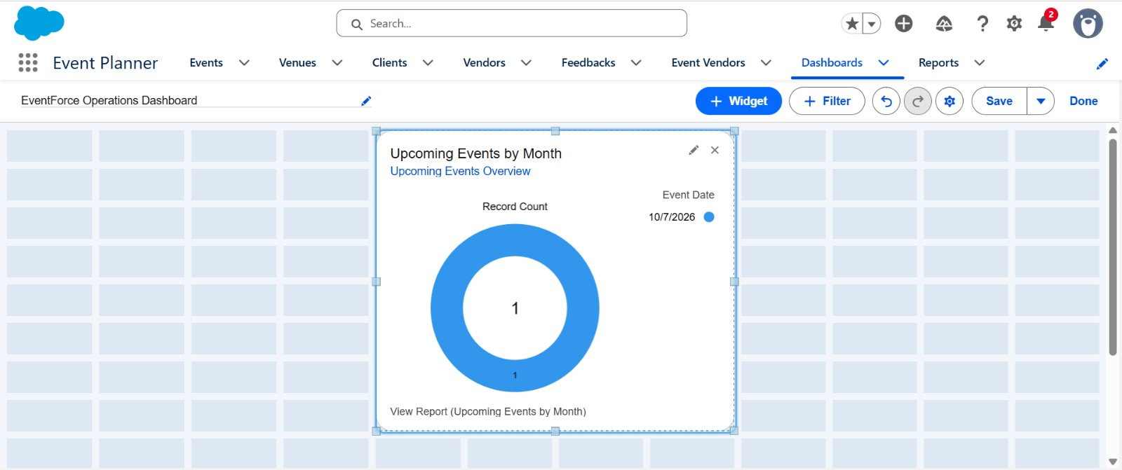
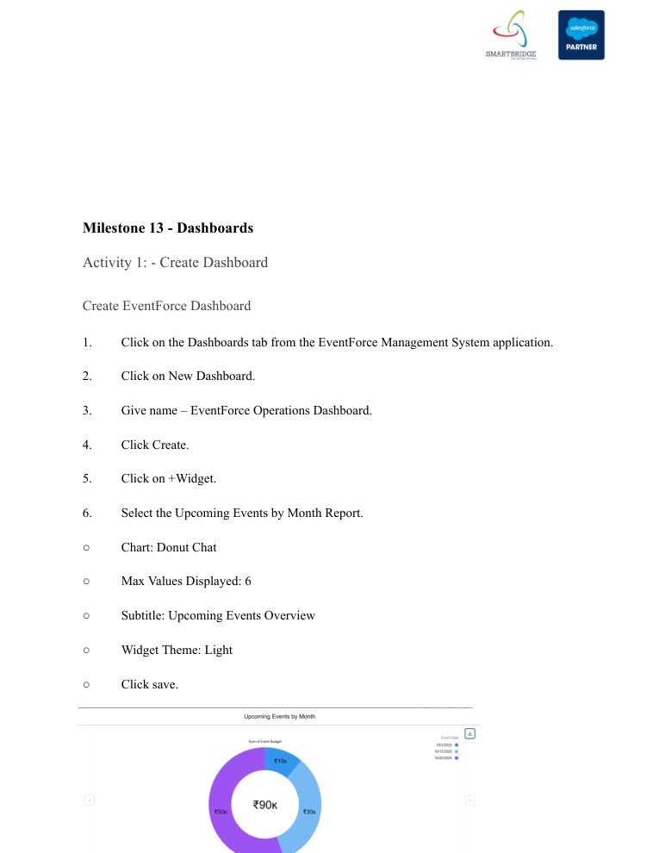
Reference screenshot from the supplied implementation guide — replace with your own project screenshot before submission.
Figure – Security / Profiles
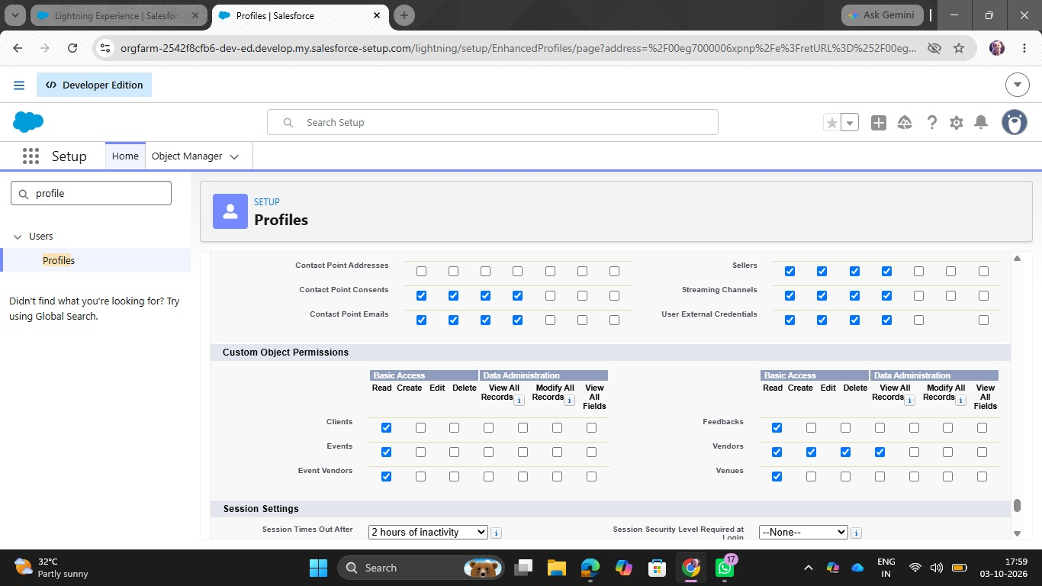
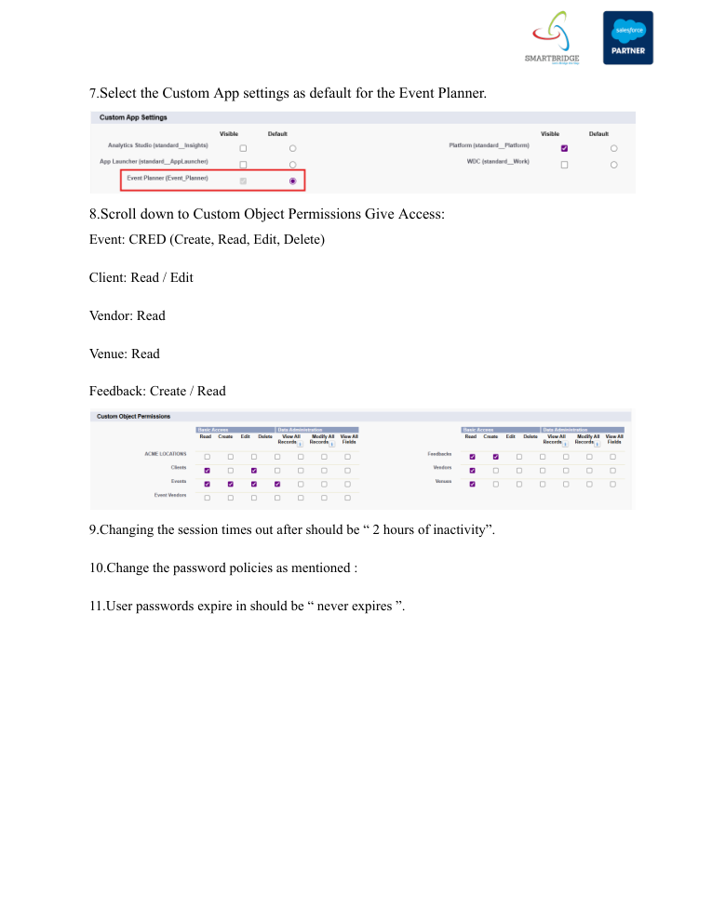
Reference screenshot from the supplied implementation guide — replace with your own project screenshot before submission.
Figure – Sharing Settings
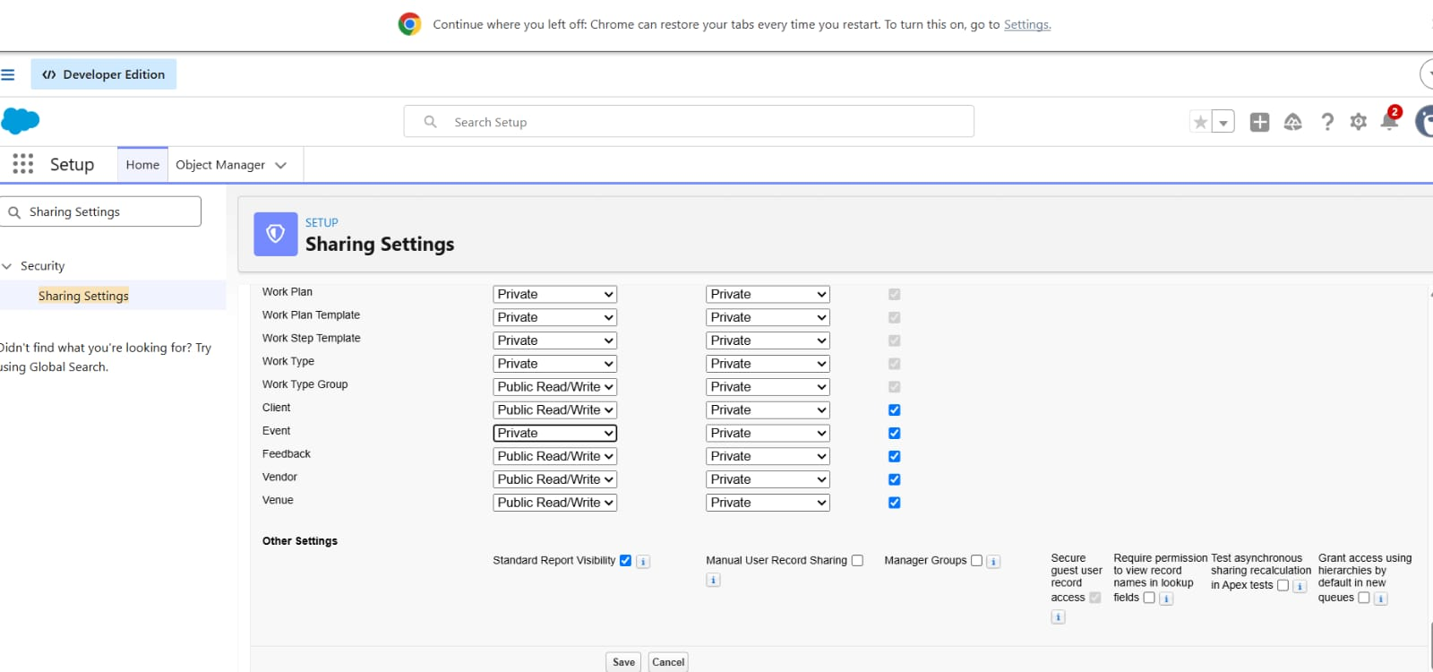
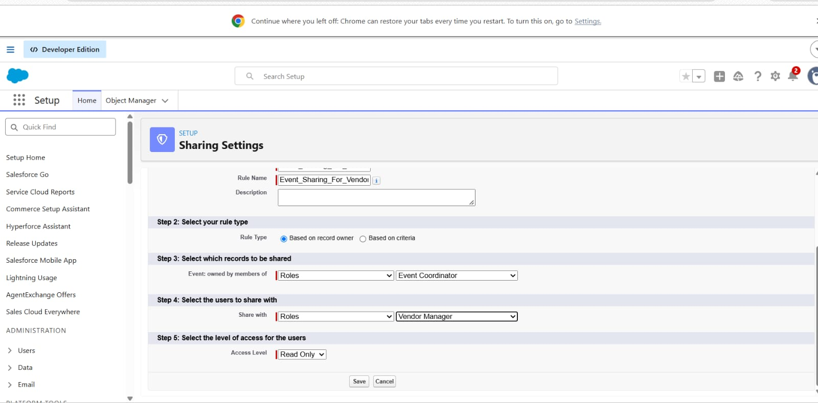
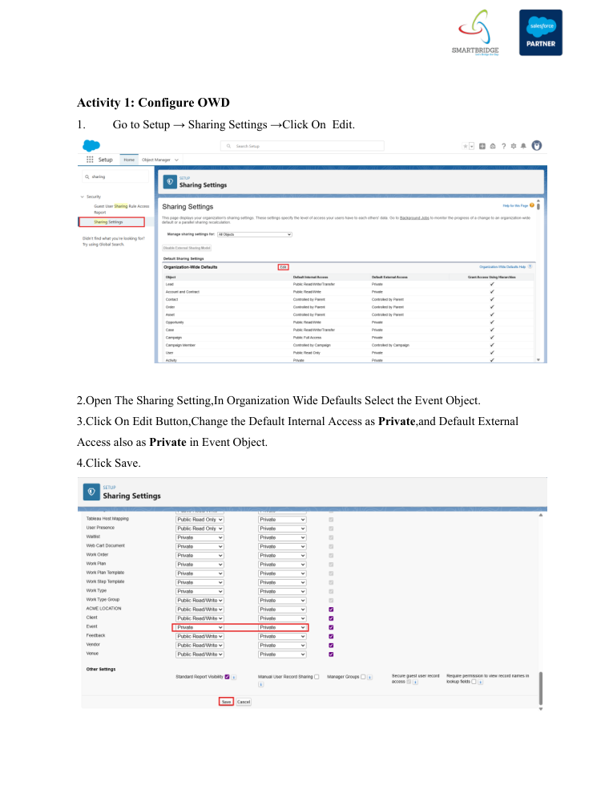
Reference screenshot from the supplied implementation guide — replace with your own project screenshot before submission.

Screenshot Checklist
- Custom objects / Object Manager – Event, Client, Vendor, Venue, Feedback, Event Vendor
- Fields and relationships – especially Event, Client, Venue, and Event Vendor
- Validation rule – Email_Valid_Address
- Approval process – Event_Cancellation_Process
- Flow – Client Reminder - 3 Days Before
- Apex / trigger – venue status or double-booking logic
- Report – Upcoming Events by Month
- Dashboard – EventForce Operations Dashboard
- Profiles / Roles / Permission Set
- OWD and Event_Sharing_For_Vendors sharing rule

10. Conclusion
The EventForce Management System demonstrates how Salesforce can be configured as a centralized CRM for event-planning operations. The project combines custom objects and relationships with automation, approval management, Apex business logic, reporting, dashboards, and role-based security.
The implementation provides practical learning across the Salesforce project lifecycle: requirement analysis, data modeling, backend configuration, UI customization, automation, security, testing, deployment planning, and documentation. The reference implementation was completed in a Developer Org for academic purposes, while the deployment and maintenance section connects the work to real-world CRM practices.
The main outcome is a structured and documented EventForce solution that can be maintained, extended, and used as a foundation for future Salesforce enhancements.

11. Source Reference
Primary source used for this documentation: “EVENTFORCE- SALESFORCE IMPLEMENTATION” PDF supplied with the project. All project-specific names, objects, relationships, automation names, security configurations, deployment notes, and business targets in this document are derived from that reference.

