Microsoft Fabric + Power BI –
Financial Statements Analysis Dashboard (2009–2023)

- INTRODUCTION
As an aspiring Data Analyst, I developed this end-to-end project using Microsoft Fabric and Power BI to demonstrate my ability to work with real-world financial data, build a Medallion Architecture (Bronze → Silver → Gold), write structured SQL queries, create analytical KPIs, and deliver business insights through interactive dashboards.

This project analyzes the financial performance of 12 major companies across multiple sectors, enabling insights into growth trends, profitability, efficiency, and investment potential.

- PROJECT OVERVIEW
Dataset Name: Financial_Statements.csv
Time Period: 2009 – 2023
Total Records: 161 rows
Companies Covered: AAPL, MSFT, GOOG, PYPL, NVDA, INTC, AMZN, MCD, AIG, BCS, PCG, SHLDQ
Objective: Build a structured financial analytics system to evaluate company performance using SQL-based transformations and Power BI dashboards.

- TECH STACK
Microsoft Fabric: Lakehouse, SQL Analytics Endpoint, Notebook
Power BI Desktop: Direct Lake / Live Connection
SQL: Bronze, Silver, Gold Layers

- DATASET OVERVIEW

CATEGORY | COLUMN NAME
Time | Year
Company Information | Company, Category
Financial Metrics | Revenue, Gross_Profit, Net_Income, EPS (Earning_Per_Share), EBITDA, Market_Cap_B_USD, Shareholder_Equity
Ratios | Current_Ratio, Debt_Ratio, ROE, ROA, ROI, Net_Profit_Margin
Calculated Metrics (Silver/Gold) | Gross_Margin_Pct, Net_Profit_Margin_Pct, ROE_Pct, Revenue_Growth_YoY_Pct
Others | Number_of_Employees, Current_Ratio, Debt_Ratio

- SQL ANALYSIS
Medallion Architecture (Bronze→ Silver→ Gold)
- BRONZE LAYER (Raw Data Processing)
Column structure validation
Data quality checks (nulls, duplicates, inconsistencies)
Dataset overview (row count, time range, company list)

SQL QUERIES:
1.Bronze Overview
SELECT
COUNT(*) AS total_rows,
COUNT(DISTINCT Company) AS num_companies,
COUNT(DISTINCT Category) AS num_categories,
MIN(Year) AS min_year,
MAX(Year) AS max_year
FROM bronze_financial_statements;

2.Bronze Column List Check
SELECT COLUMN_NAME
FROM INFORMATION_SCHEMA.COLUMNS
WHERE TABLE_NAME = 'bronze_financial_statements'
ORDER BY ORDINAL_POSITION;

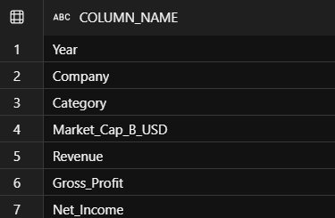
3.Bronze Quality Check
SELECT
SUM(CASE WHEN Revenue IS NULL THEN 1 ELSE 0 END) AS missing_revenue,
SUM(CASE WHEN Net_Income IS NULL THEN 1 ELSE 0 END) AS missing_net_income,
SUM(CASE WHEN Share_Holder_Equity IS NULL THEN 1 ELSE 0 END) AS missing_equity,
COUNT(*) - COUNT(DISTINCT CONCAT(Year, Company)) AS duplicate_rows
FROM bronze_financial_statements;

- SILVER LAYER (Cleaned Data)
Data cleaning and standardization (column formatting, TRIM, fixing data types)
Handling missing values and removing inconsistencies
Creation of financial metrics (Gross Margin %, Net Profit Margin %, ROE %)
Transformation of raw Bronze data into structured analytical format

SQL QUERIES:
1.Silver Financial Statement
CREATE OR ALTER VIEW silver_financial_statements AS
SELECT
Year,
TRIM(Company) AS Company,
TRIM(Category) AS Category,
Market_Cap_B_USD,
Revenue,
Gross_Profit,
Net_Income,
Earning_Per_Share AS EPS,
EBITDA,
Share_Holder_Equity AS Shareholder_Equity,
Cash_Flow_from_Operating,
Cash_Flow_from_Investing,
Cash_Flow_from_Financial_Activities,
Current_Ratio,
Debt_Ratio,
ROE,
ROA,
ROI,
Net_Profit_Margin,
Free_Cash_Flow_per_Share AS FCF_per_Share,
Return_on_Tangible_Equity,
Number_of_Employees,
US_Inflation_Rate,

-- Percentage columns (format these as Percentage in Power BI)
ROUND(CASE WHEN Revenue > 0 THEN (Gross_Profit / Revenue) * 100 ELSE NULL END, 2) AS Gross_Margin_Pct,
ROUND(CASE WHEN Revenue > 0 THEN (Net_Income / Revenue) * 100 ELSE NULL END, 2) AS Net_Profit_Margin_Pct,
ROUND(CASE WHEN Share_Holder_Equity > 0 THEN (Net_Income / Share_Holder_Equity) * 100 ELSE NULL END, 2) AS ROE_Pct

FROM bronze_financial_statements;

2.Silver Verification
-- Query 2: Silver Verification - See the Table
-- Revenue & Net Income shown as full numbers
-- Pct columns should be formatted as Percentage in Power BI
SELECT TOP 5
Year,
Company,
Category,
Revenue, -- Full number (e.g. 394328)
Net_Income, -- Full number (e.g. 99803)
EPS,
Gross_Margin_Pct, -- Format as Percentage (%) in Power BI
Net_Profit_Margin_Pct, -- Format as Percentage (%) in Power BI
ROE_Pct -- Format as Percentage (%) in Power BI
FROM silver_financial_statements
ORDER BY Year DESC, Revenue DESC;

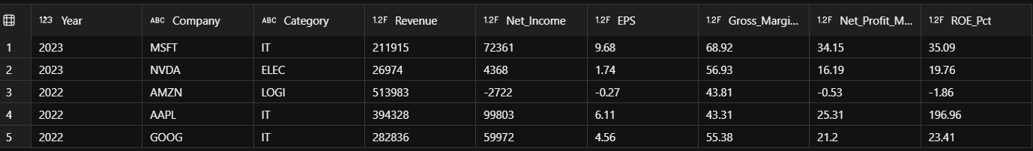

- GOLD LAYER (Business-Ready Data)
Creation of Company Yearly KPI Table
Year-over-year (YoY) revenue growth using window functions (LAG)
Final analytical dataset preparation
Gold layer validation queries

SQL QUERIES:
1. Gold Company Yearly KPI

CREATE OR ALTER VIEW gold_company_yearly_kpis AS
SELECT
Year,
Company,
Category,
Revenue,
Net_Income,
EPS,
Market_Cap_B_USD,
ROE,
ROA,
Current_Ratio, -- Added back
Gross_Margin_Pct,
Net_Profit_Margin_Pct,
ROE_Pct,

-- YoY Growth
LAG(Revenue) OVER (PARTITION BY Company ORDER BY Year) AS Prev_Year_Revenue,
ROUND(
CASE WHEN LAG(Revenue) OVER (PARTITION BY Company ORDER BY Year) > 0
THEN ((Revenue - LAG(Revenue) OVER (PARTITION BY Company ORDER BY Year))
/ LAG(Revenue) OVER (PARTITION BY Company ORDER BY Year)) * 100
ELSE NULL END, 2) AS Revenue_Growth_YoY_Pct,

ROUND(
CASE WHEN LAG(Net_Income) OVER (PARTITION BY Company ORDER BY Year) <> 0
THEN ((Net_Income - LAG(Net_Income) OVER (PARTITION BY Company ORDER BY Year))
/ NULLIF(LAG(Net_Income) OVER (PARTITION BY Company ORDER BY Year), 0)) * 100
ELSE NULL END, 2) AS Net_Income_Growth_YoY_Pct

FROM silver_financial_statements;

2.Gold Verification

SELECT TOP 5
Year,
Company,
Category,
Revenue, -- Full number
Net_Income, -- Full number
Revenue_Growth_YoY_Pct, -- Format as % in Power BI
Net_Income_Growth_YoY_Pct, -- Format as % in Power BI
Gross_Margin_Pct, -- Format as % in Power BI
Net_Profit_Margin_Pct, -- Format as % in Power BI
ROE_Pct -- Format as % in Power BI
FROM gold_company_yearly_kpis
ORDER BY Year DESC, Revenue DESC;

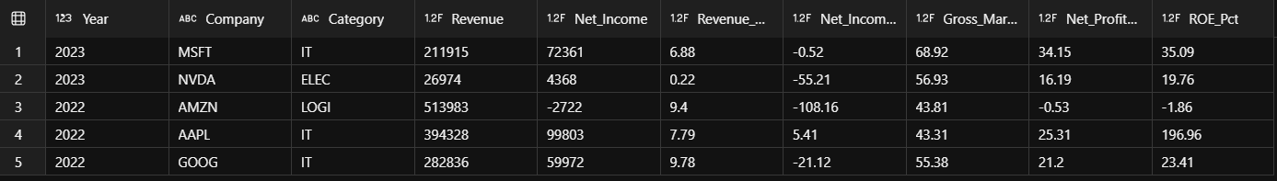

- DASHBOARD SUPPORTING SQL QUERIES

A. GROWTH & PROFITABLILITY
This section focuses on financial growth trends and profitability analysis across companies and categories.

1. Revenue Trend by Year
SELECT
Year,
Company,
Category,
Revenue, -- Full number (format as $394M in Power BI)
Net_Income, -- Full number (format as $100M in Power BI)
Revenue_Growth_YoY_Pct -- Format as Percentage (%) in Power BI
FROM gold_company_yearly_kpis
ORDER BY Year DESC, Revenue DESC;

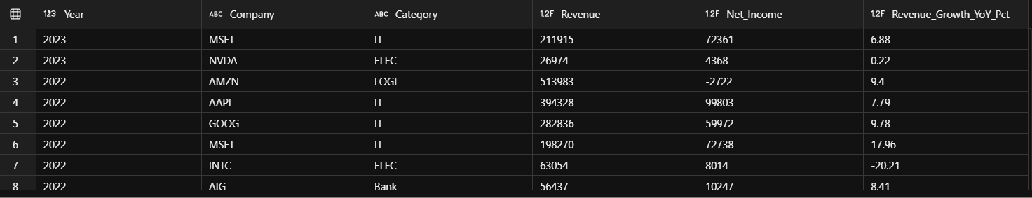

2. Top Companies by Revenue
SELECT TOP 5
Company,
ROUND(AVG(Revenue), 0) AS Avg_Revenue,
ROUND(AVG(Market_Cap_B_USD), 2) AS Avg_Market_Cap_B_USD,
ROUND(AVG(Net_Profit_Margin_Pct), 2) AS Avg_Net_Profit_Margin_Pct
FROM gold_company_yearly_kpis
GROUP BY Company
ORDER BY Avg_Revenue DESC;

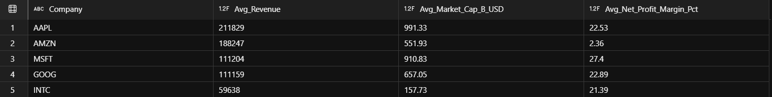

3. Average Profit Margin by Companies
SELECT
Category,
ROUND(AVG(Gross_Margin_Pct), 2) AS Avg_Gross_Margin_Pct,
ROUND(AVG(Net_Profit_Margin_Pct), 2) AS Avg_Net_Profit_Margin_Pct
FROM silver_financial_statements
GROUP BY Category
ORDER BY Avg_Net_Profit_Margin_Pct DESC;

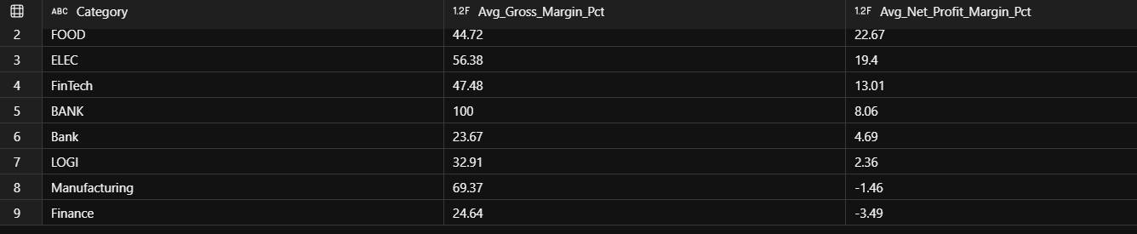

4. Average Net Income by Year
SELECT
Year,
Company,
Net_Income,
Net_Income_Growth_YoY_Pct
FROM gold_company_yearly_kpis
ORDER BY Year DESC, Net_Income DESC;

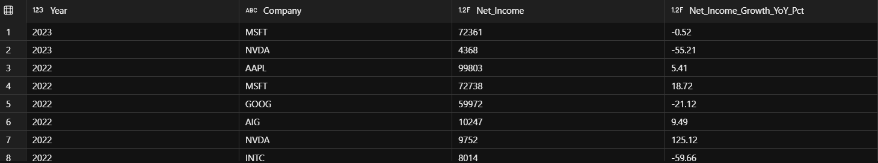

B. PERFORMANCE & RISK
This section focuses on company performance comparison and financial risk evaluation using key financial metrics.

1.Average ROE% By Year
SELECT
Year,
Company,
Category,
ROUND(ROE_Pct, 2) AS ROE_Pct, -- Format as Percentage (%) in Power BI
Revenue_Growth_YoY_Pct, -- Format as Percentage (%) in Power BI
Net_Income_Growth_YoY_Pct -- Format as Percentage (%) in Power BI
FROM gold_company_yearly_kpis
ORDER BY Year DESC, ROE_Pct DESC;

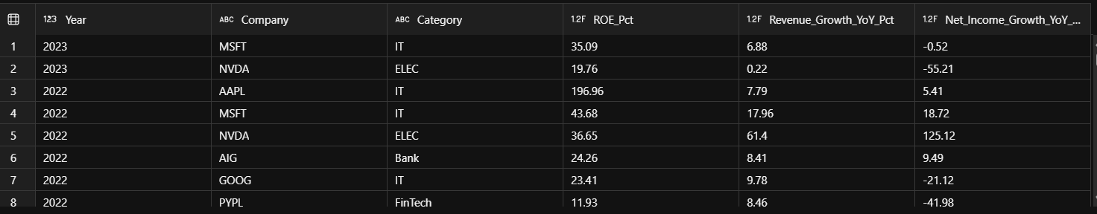

2.Market Capitalization vs Profit Margin
SELECT
Year,
Company,
Category,
Market_Cap_B_USD, -- Full number (format as $B in Power BI)
ROUND(Net_Profit_Margin_Pct, 2) AS Net_Profit_Margin_Pct, -- Format as % in Power BI
ROUND(ROE_Pct, 2) AS ROE_Pct, -- Format as % in Power BI
Revenue -- For bubble size if needed
FROM gold_company_yearly_kpis
ORDER BY Market_Cap_B_USD DESC;

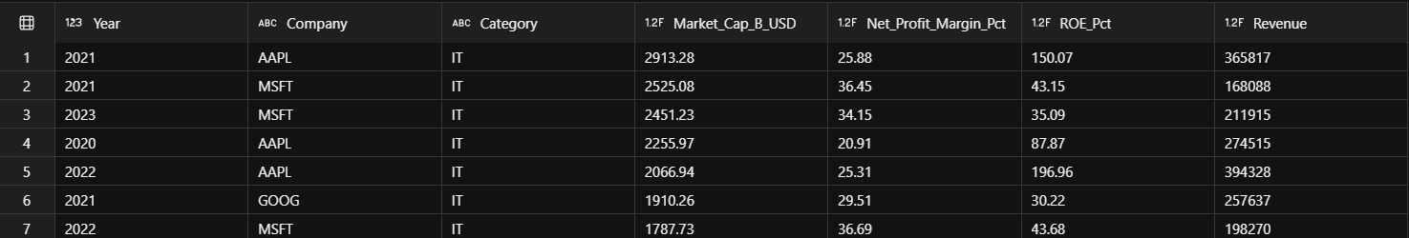

3. Sector Strength Comparison
SELECT
Category,
ROUND(AVG(Current_Ratio), 2) AS Avg_Current_Ratio,
ROUND(AVG(Debt_Ratio), 2) AS Avg_Debt_Ratio,
ROUND(AVG(Net_Profit_Margin_Pct), 2) AS Avg_Net_Profit_Margin_Pct,
COUNT(DISTINCT Company) AS Num_Companies
FROM gold_company_yearly_kpis_table
GROUP BY Category
ORDER BY Avg_Current_Ratio DESC;

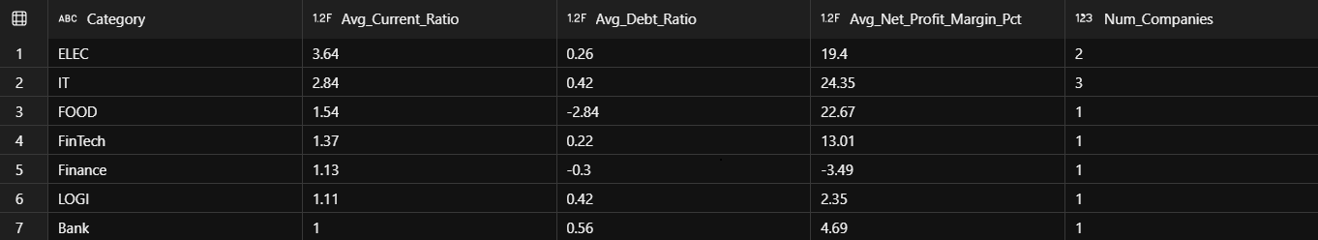

4. Average Net Income by Year
SELECT
Year,
Company,
Net_Income,
Net_Income_Growth_YoY_Pct
FROM gold_company_yearly_kpis
ORDER BY Year DESC, Net_Income DESC;

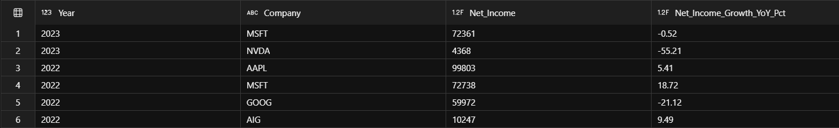

- Final Outcome
This project successfully demonstrates a complete end-to-end financial analytics pipeline, combining:
Data Engineering (Microsoft Fabric)
SQL-based transformations (Bronze → Silver → Gold)
Business KPI modeling
Interactive Power BI dashboards
Financial performance analysis of global companies

