

**Sports Management System**

**Software Requirement Specification (SRS) Document**

**Sprint 1 Implementation**

**Project Timeline: 20.10.2022 to 28.10.2022**

**INDEX**

1. Introduction

1.1 Purpose ----------------------------------- 4

1.2 Intended audience ----------------------------------- 4

1.3 Intended use ----------------------------------- 4

1.4 Scope ----------------------------------- 4

2. Overall description ----------------------------------- 4

2.1 Assumptions and dependency ------------------------------------ 5

3. System feature and requirements ------------------------------------ 5

3.1 Functionality ------------------------------------ 5

3.1.1 Add_Sports_Database ----------------------------------- 5

3.1.2 Maintain_Sports_Database ----------------------------------- 5

3.1.3 Add_Sports_Teacher_Database ------------------------------------ 5

3.1.4 Maintain_Sports_Teacher_Database ------------------------------------ 5

3.1.5 List_Winners ------------------------------------ 5

3.1.6 View_Results ----------------------------------- 5

3.1.7 Sports_Pending_List ----------------------------------- 5

3.1.8 First_Placed ----------------------------------- 5

3.1.9 Max_Registered_Sports ------------------------------------ 6

3.1.10 Event_Completed_Sports_Teacher ----------------------------------- 6

3.1.11 Admin_Access ----------------------------------- 6

3.2 System requirement ------------------------------------- 6

3.2.1 Tools to be used -------------------------------------- 6

3.3 System feature ------------------------------------- 6

4. DataFlow Diagram

4.1 DFD level 0 ---------------------------------------- 7

4.2 DFD level 1 ----------------------------------------- 8

### **1.** **Introduction: -**

The introduction of the software requirement specification provides an overview of the entire software. The entire SRS with overview description purpose, scope, tools used and basic description. The aim of this document is to gather, analyze and give an in-depth insight into the complete sports management system by defining the problem statement in detail. The detailed requirements of the Sports Management System is provided in this document.

**1.1** **Purpose**: **-**The purpose of this document is to show the requirements for the Sports Management System, in which the project is to simplify the process of handling each sports event by providing a web interface for admin and sports-teacher.

**1.2** **Intended Audience: -**This document is intended to be read by, Admin and user of the system.

**1.3** **Intended Use: -**

* Development Team
* Maintenance Team
* Admin

Since this a general-Purpose Software any one can access it.

**1.4** **Scope: -**This project aims to create the Sports Management System, which takes the event and player information from admin such as Sport-ID, Sport-Name, No of students registered, month in which it is held and sports-teacher assigned adds it to the sports-database and the sports-teacher can conduct that event and update the results and returns the Winning data of the players as to display the top three winners and list of sports conducted and their results and ports pending for the year.

**2. Overall Description: -**

It is a sports management system used to keep the track of the scheduled events and winner list for each sports. This consists the admin portion of the sports event consists of many modules, including adding the sport (indoor or outdoor), adding students who are interested in a specific sports activity, adding teachers who will lead the specific sports activity, which is assigned by the admin itself, and finally, viewing the outcomes of the sports event held in college. All the event allocated sports activities are being managed by the teacher. The teacher completes a variety of tasks, including recording the attendance of the students who have registered for a specific sporting event, noting the winner of each round on the list of students, and creating results based on the student's who won in many rounds.

**2.1 Assumptions and Dependency: -**

* System should have Ubuntu Linux installed.
* · System should have either 4GB or more RAM.
* The service is used preferably on a desktop or laptop.

**3.System Features and Requirements: -**

**3.1 Functionality: -**

**3.1.1 SMS_01-> Add_Sports_Database :** This function adds the sports database in detail. It asks for the sports-ID whereas it should be unique for each sports, then sports-name, type of sports whether it is indoor or outdoor, no of students registered for that particular sports, month in which the event is held and sports-Teacher assigned for that particular event.

**3.1.2 SMS_02-> Maintain_Sports_Database** : This function is used to edit/update any kind of changes into the existing records in the sports database itself.

**3.1.3 SMS_03-> Add_Sports_Teacher_Database :** This function is used to create a database for sports teacher by adding sports teacher ID, name of the sports that is handled by them and name of the students enrolled for the particular sports.

**3.1.4 SMS_04-> Maintain_Sports_Teacher_Database :** This function is used to edit/update any kind of changes into the existing records in the sports teacher database by the admin .

**3.1.5 SMS_06-> List_Winners :** This function adds the name of the students who got 1st, 2nd & 3rd place for the sports conducted by the sports teacher.

**3.1.6 SMS_07-> View_Results :** This function is used to view the generated reports of the players after the event. It displays the winners list, the participants list and their performance.

**3.1.7 SMS_08-> Sports_Pending_List :** It shows the pending list of the sports event and their sports teachers of that year.

**3.1.8 SMS_09-> First_Placed :** This function displays the report that shows the details of first-placed students across various sports event conducted by the sports teacher.

**3.1.9 SMS_10-> Popular_Sports :** Since we need know the interest of the sports-students who are willing to play a particular sports which is liked to play by the majority of the players. This function shows the details of the sports for which the maximum sports students had been registered.

**3.1.10 SMS_11-> Event_Completed_Sports_Teacher :** It shows the list of all sports teacher who have successfully completed all the sports that they are associated with, should be displayed.

**3.1.11 SMS_13-> Admin_Access :** This function authenticate the admin’s password, whether the password is matching or not .If it is matching the admin is allowed to edit the details .

**3.2 System Requirements: -**

### **3.2.1. Tools to be used:**

* C File Handling
* C Language
* Data Structures using C

### **3.3 System Features: -**

### Supportability:The system is easy to use.

* Design Constraints: The system is built using only C language.
* Usability:The Sports Management System can be used to replace the to simplify the process of handling each sports event by providing a web interface for admin and sports.
* Reliability & Availability**:** The system is available 24/7 that is whenever the admin would like to use the system, they can use it up to its functionalities.

### Performance: The system will work on the admin’s terminal**.**

**4. DataFlow Diagram:**

**4.1 DFD Level 0 –**

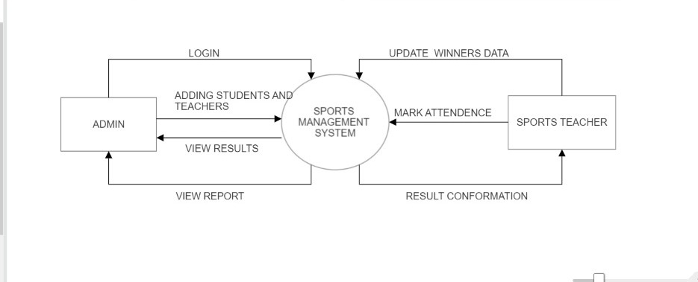

**4.1 DFD Level 1 –**

