ORBIT — OFFLINE MULTIMODAL RAG ASSISTANT
COMPLETE USER & INSTALLATION GUIDE
100% Air-Gapped Intelligence · Installation · Post-Launch Walkthrough · Feature Guide

1. Executive Overview & Mission
Orbit is an advanced, local-first Retrieval-Augmented Generation (RAG) platform designed to deliver enterprise-grade document intelligence without sending a single byte of data to external cloud servers. Powered by local vector search, sparse Rank-BM25 recency reranking, and Ollama local LLMs (llama3.2:3b), Orbit ensures complete privacy, zero API costs, and air-gapped security.

2. Download & Installation Step-by-Step Guide
• Download Setup Package: https://github.com/kalakonda-akshay/RAG/releases/latest/download/OfflineRAGAssistant_Setup.zip
• Web Portal: https://offlinerag-psi.vercel.app
• Environment Setup: python launcher/first_run_setup.py
• Pull Local LLM Models: ollama pull llama3.2:3b && ollama pull nomic-embed-text
• Launch Application: python launcher/run_app.py (http://localhost:8501)

3. Opening the App — Layout & Interface Walkthrough
When you open Orbit at http://localhost:8501, you are presented with a 3-column interactive layout:
1. Left Knowledge Rail: Brand header, workspace switcher (documents, research, finance, engineering), indexed file cards, upload dropzone, AI persona switcher, export PPTX button.
2. Center Q&A Thread: Scope banner, 12 feature navigation tabs, message stream with [1], [2] citations, interactive source pills, raw text chunk inspector, prompt bar.
3. Right Grounding Rail: Grounding confidence meter (0.91 high), cited document relevance cards, <mark> text highlights, page and chunk markers.

4. Visual Screenshot Tour

Figure 1: Grounded Q&A Thread & Interactive Citations
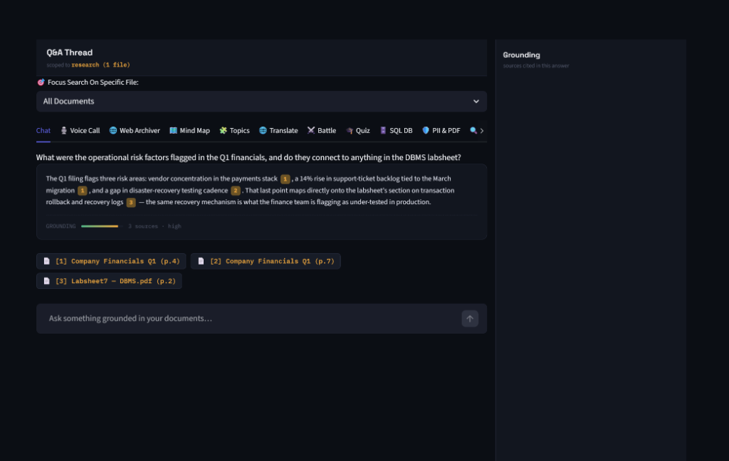

Figure 2: Real-Time Voice Call Mode
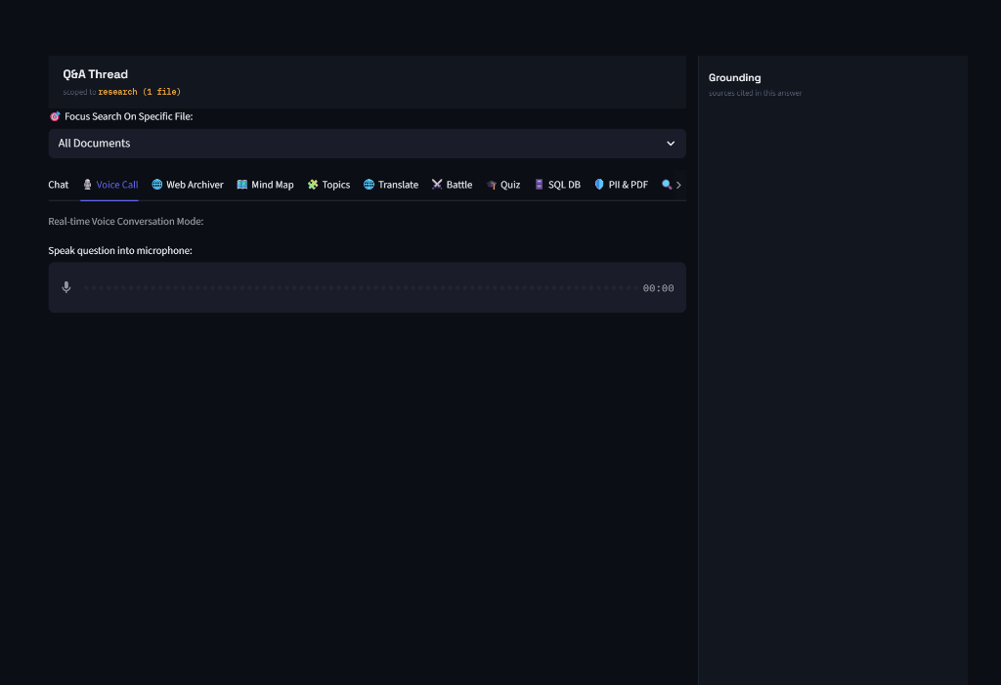

Figure 3: Auto-Generated Document Quiz Workspace
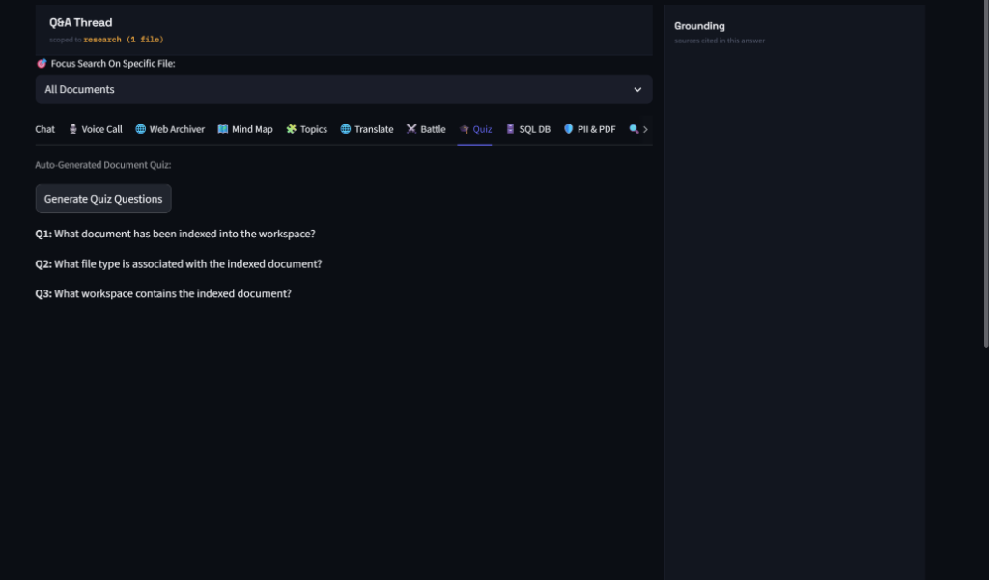

5. Complete Feature & Workspace Reference (12 Tabs)
💬 Grounded Q&A Chat: Dense vector search + Rank-BM25 hybrid retrieval + Self-RAG verification.
🎙️ Voice Call Mode: Hands-free voice interface using microphone input and local Whisper speech transcription.
🌐 Web Archiver: Parses and indexes offline web pages, documentation HTML, and articles.
🗺️ Mind Map Generator: Generates interactive visual Mermaid.js mind maps from uploaded document concepts.
🧩 Topic Cluster Discovery: Performs K-Means semantic clustering to discover hidden themes across files.
🌐 Multilingual Translator: Translates document passages into 10+ target languages completely offline.
⚔️ Model Battle Mode: Compares responses side-by-side across multiple local LLMs.
🎓 Auto Document Quiz: Generates practice test questions with answer keys from document text.
🗄️ Natural Language SQL Engine: Queries SQLite (.db/.sqlite) tables using auto-generated SQL code.
🛡️ PII Redactor & PDF Exporter: Detects and redacts SSNs, credit cards, emails, and phone numbers, exporting sanitized PDFs.
🔍 Document Comparator: Compares two documents side-by-side highlighting overlaps, diffs, and contradictions.
📊 Report & PPTX Exporter: Generates 1-click PowerPoint presentations (.pptx) and executive brief summaries.

