ORBIT — OFFLINE MULTIMODAL RAG ASSISTANT
COMPLETE USER & INSTALLATION GUIDE
100% Air-Gapped Intelligence · Installation · Feature Guide · Screenshot Tour

1. Executive Overview & Mission
Orbit is an advanced, local-first Retrieval-Augmented Generation (RAG) platform designed to deliver enterprise-grade document intelligence without sending a single byte of data to external cloud servers. Powered by local vector search, sparse Rank-BM25 recency reranking, and Ollama local LLMs (llama3.2:3b), Orbit ensures complete privacy, zero API costs, and air-gapped security.
Platform Name | Orbit (Offline Multimodal RAG Assistant)
Live Website URL | https://offlinerag-psi.vercel.app
Setup Download Package | https://github.com/kalakonda-akshay/RAG/releases/latest/download/OfflineRAGAssistant_Setup.zip
Supported File Formats | 29 Extensions (PDF, Word, Excel, PowerPoint, Audio, Video, Images, SQL)

2. Download & Installation Step-by-Step Guide
Step 1: Download the Application Package
Visit the live production web portal at https://offlinerag-psi.vercel.app or download the 1.9 GB standalone setup zip directly from GitHub Releases:
Download URL: https://github.com/kalakonda-akshay/RAG/releases/latest/download/OfflineRAGAssistant_Setup.zip
Saved File: OfflineRAGAssistant_Setup.zip (1.9 GB)
Step 2: Extract & First-Run Environment Setup
1. Extract OfflineRAGAssistant_Setup.zip to your desired folder (e.g. C:\OrbitAssistant).
2. Open Windows Command Prompt or PowerShell inside the extracted folder.
3. Run the automatic setup wizard:
python launcher/first_run_setup.py
This script verifies your Python environment, installs core dependencies, and configures Ollama.
Step 3: Download Local AI Models (Ollama)
Ensure Ollama is running in the background, then pull the local generation & embedding models:
ollama pull llama3.2:3b
ollama pull nomic-embed-text
Step 4: Launch the Orbit User Interface
Run the launcher script to open the 3-column interactive workspace in your web browser:
python launcher/run_app.py
Access URL: http://localhost:8501

3. Visual Interface & Screenshot Tour
Below are live screenshots of Orbit running in real-world scenarios:

Figure 1: Grounded Q&A Thread & Interactive Citations
Shows the central Q&A chat stream with numbered citation chips [1], [2], interactive source buttons, and raw text chunk inspector:
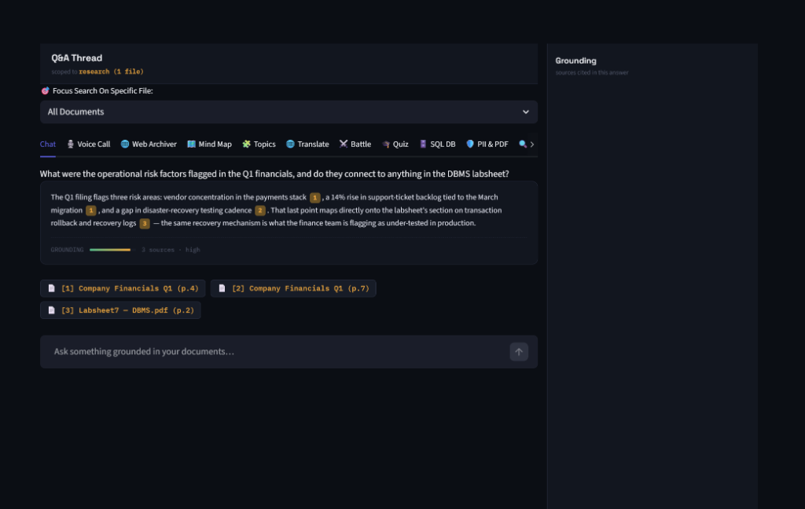

Figure 2: Real-Time Voice Call Mode
Shows real-time microphone audio recording and local Whisper speech-to-text transcription:
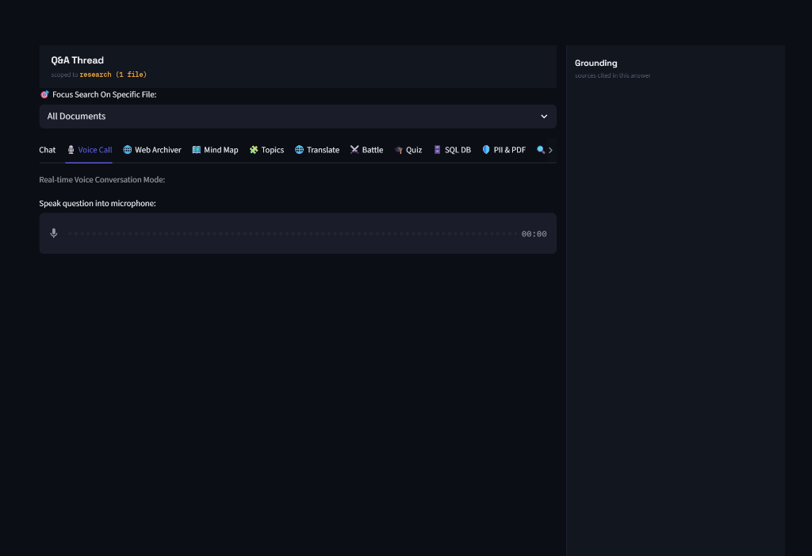

Figure 3: Auto-Generated Document Quiz Workspace
Shows dynamic multiple-choice test questions auto-generated from indexed document contents:
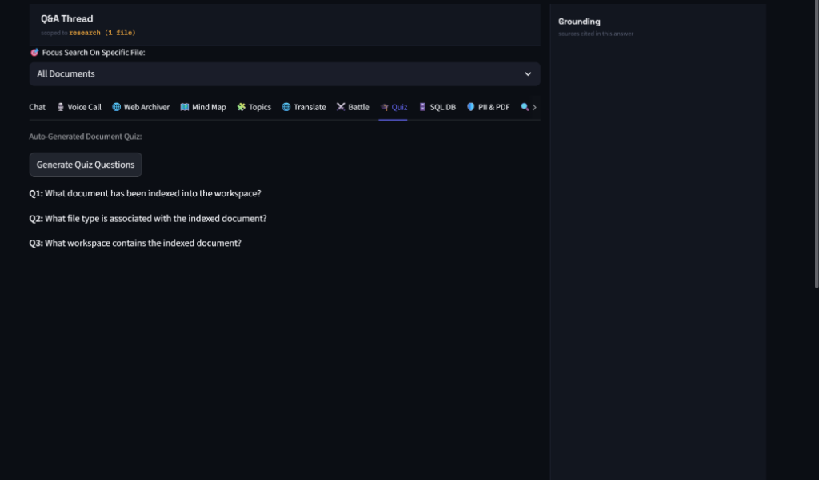

4. Complete Feature & Workspace Reference (12 Tabs)
💬 Grounded Q&A Chat: Dense vector search + Rank-BM25 hybrid retrieval + Self-RAG hallucination verification.
🎙️ Voice Call Mode: Hands-free voice interface using microphone input and local Whisper speech transcription.
🌐 Web Archiver: Parses and indexes offline web pages, documentation HTML, and articles.
🗺️ Mind Map Generator: Generates interactive visual Mermaid.js mind maps from uploaded document concepts.
🧩 Topic Cluster Discovery: Performs K-Means semantic clustering to discover hidden themes across files.
🌐 Multilingual Translator: Translates document passages into 10+ target languages completely offline.
⚔️ Model Battle Mode: Compares responses side-by-side across multiple local LLMs.
🎓 Auto Document Quiz: Generates practice test questions with answer keys from document text.
🗄️ Natural Language SQL Engine: Queries SQLite (.db/.sqlite) tables using auto-generated SQL code.
🛡️ PII Redactor & PDF Exporter: Detects and redacts SSNs, credit cards, emails, and phone numbers, exporting sanitized PDFs.
🔍 Document Comparator: Compares two documents side-by-side highlighting overlaps, diffs, and contradictions.
📊 Report & PPTX Exporter: Generates 1-click PowerPoint presentations (.pptx) and executive brief summaries.

5. Supported File Formats (29 Extensions)
• Documents & Presentations (5): .pdf, .docx, .pptx, .ppt, .md
• Spreadsheets & Tables (3): .xlsx, .xls, .csv
• Image & OCR (7): .png, .jpg, .jpeg, .webp, .bmp, .tiff, .gif
• Audio Recordings (3): .wav, .mp3, .m4a
• Video Files (4): .mp4, .mkv, .mov, .avi
• Code & Text Markup (7): .txt, .py, .js, .json, .html, .xml, .sql
• Relational DBs (2): .sqlite, .db

