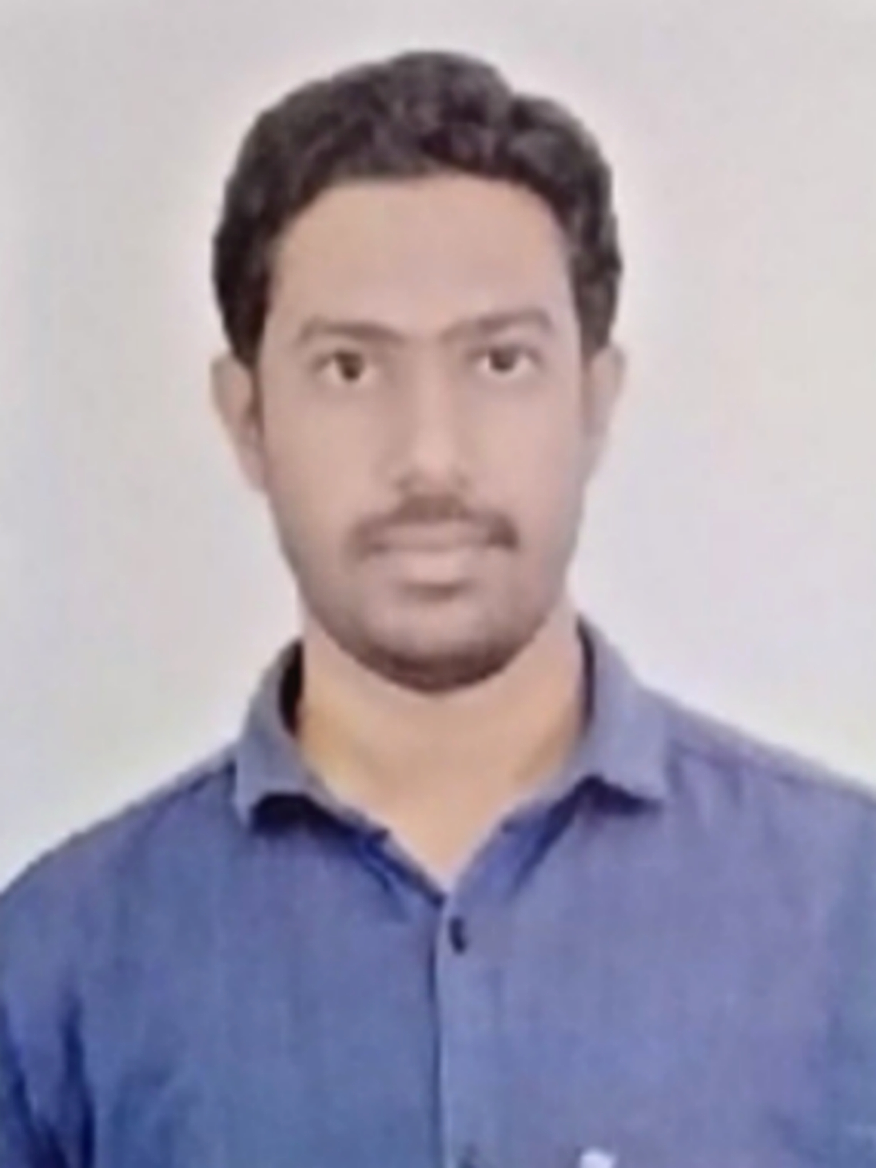

kalam kadumuru | 7799368357 | k.kalamkaif@gmail.com

# About me

fresher, searching for a challenging role

# Work Experience

**fresher** *0-0* fresher

# Skills

* c,cpp, java, python
* django