Date period







SUMMARY

Being a Third-year Computer Science student with a strong grasp of web

. Proficient in React, I

development, specializing in JavaScript, CSS, HTML, and C

create visually captivating websites with animations. AWS Certified, I possess cloud

computing expertise. Adept at troubleshooting code errors, I'm committed to

becoming a software developer. Fluent in Marathi, Hindi, and English, I seek an

internship to apply my skills and knowledge in a dynamic development environment.

EDUCATION

Bachelor Of Technology (B.Tech) ,Computer

Science & Engineering,

PES College Of Engineering Aurangabad, (Dr. Babasaheb

Ambedkar Technological Univercity)

STRENGTHS

Teamwork

How did you acquire it? What

did it result in?

Problem Solving

How did you acquire it? What

did it result in?

Patience

How did you acquire it? What

did it result in?

SKILLS

HTML

CSS

JavaScript

C

Programming

C Programming

Java Basic)

LANGUAGES

English

Intermediate

Hindi

Advanced

Marathi

Native

E



q

e

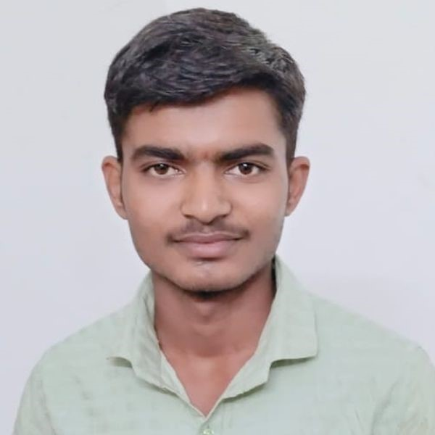

KRUSHNA SONYABAPU

KALAMKAR

Web Developer Intern and App Developer Intern

9022577607

kalamkarkrushna48@gmail.com

krushna kalamkar

Aurangabad