Lab Report 3
Index-23000422
Part A — K-Means on the Iris Dataset
Question 1. Loading and inspecting the data
- Load the built-in datasets library and display the first six rows of the iris dataset.
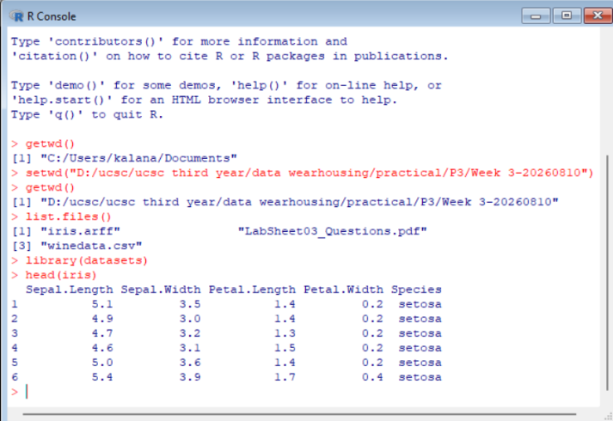

- List the column (variable) names of iris. Which column is the class label, and how many classes does it have?
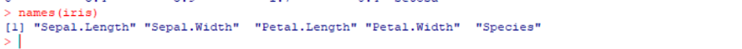
Column names

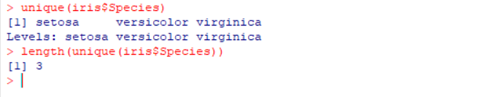
class label Colum is species
how many classes does it have

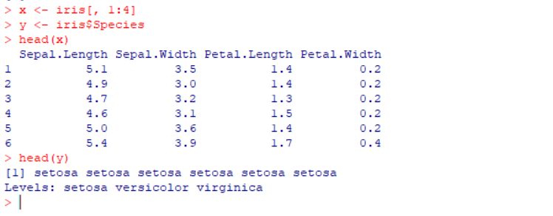
(c) Create two new variables: x containing only the four numeric feature columns, and y containing the Species column

Question 2. Running your first k-means model
- Fit a k-means model to x using 3 clusters. Store the result in a variable called kc.
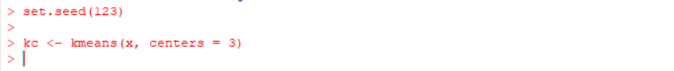

The set.seed(123) makes your result reproducible. If you run the same code again, you should get the same result.
- Print kc and identify:
- the size of each cluster
Cluster 1 = 50
Cluster 2 = 62
Cluster 3 = 38
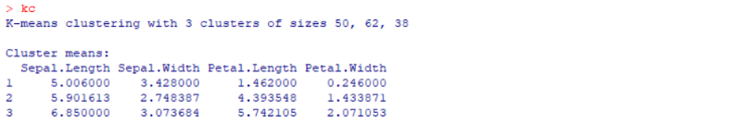
(ii)the cluster means

So this is the centroids for each cluster colums
For example, if Cluster 1's centroid is:
5.006 3.428 1.462 0.246
that means the average flower in Cluster 1 has approximately:
- Sepal Length = 5.006
- Sepal Width = 3.428
- Petal Length = 1.462
- Petal Width = 0.246
The cluster centres show clear differences in the measurements, particularly in petal length and petal width. Cluster 1 has relatively small petal measurements, while Cluster 3 has the largest petal length and petal width. This indicates that the petal characteristics contribute strongly to the separation of the iris observations into clusters.

(iii) the between_SS / total_SS percentage.
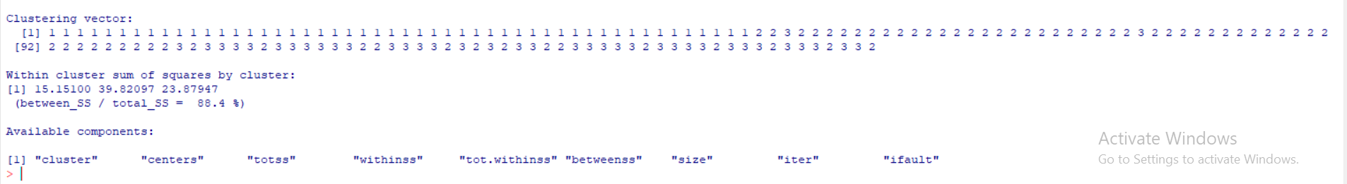
For each cluster, K-Means has a center (centroid), These numbers measure how spread out each cluster is
Between_SS / Total_SS = 88.4%

88.4% of the variation in the Iris observations is explained by the differences between the three clusters.
The remaining 11.6% is variation within the clusters.
Therefore, your clustering provides a relatively strong separation of the observations.
- Produce a confusion-style table comparing y (true species) with kc$cluster. Which species is perfectly separated from the others, and which two species are most often confused?
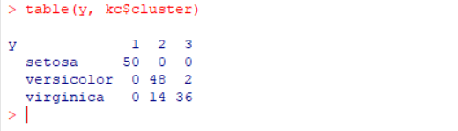

Question 3. Visualising the clusters
- Produce a scatter plot of Sepal.Length against Sepal.Width, colouring points by their assigned cluster (kc$cluster).
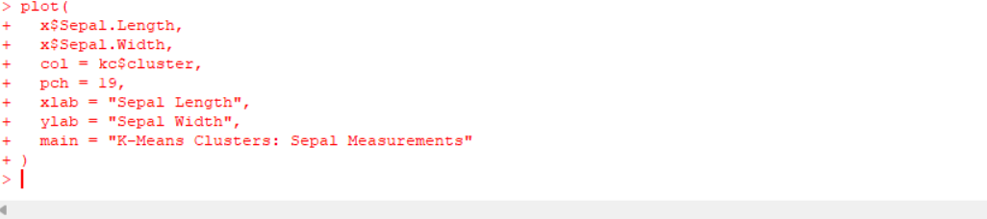

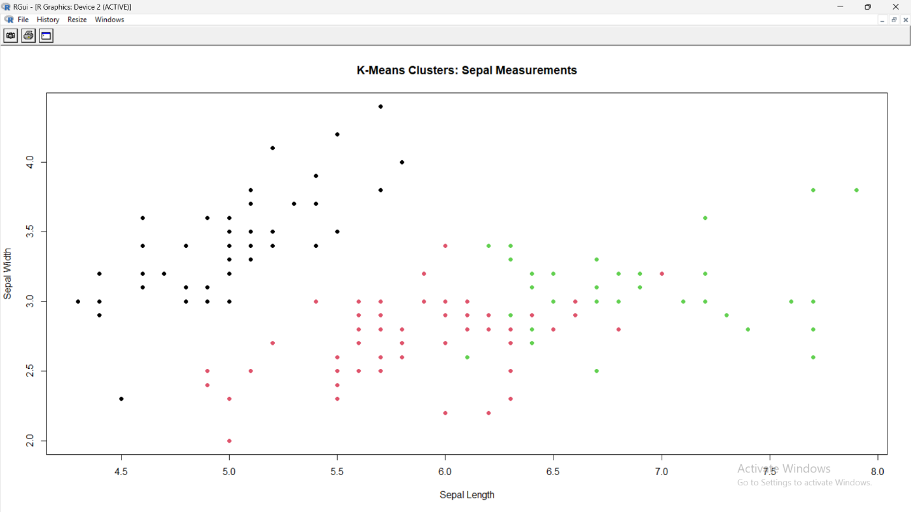

(b) Overlay the cluster centres on the same plot using points() with a distinct plotting symbol.
So stars represent the 3 centroid values coordinates
As example:
Cluster 1 have sepal.length:5.006 and sepal.width: 3.428, so these are the centroids, so that two value are one coordinates, that display by star
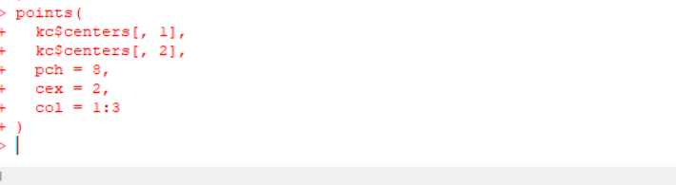

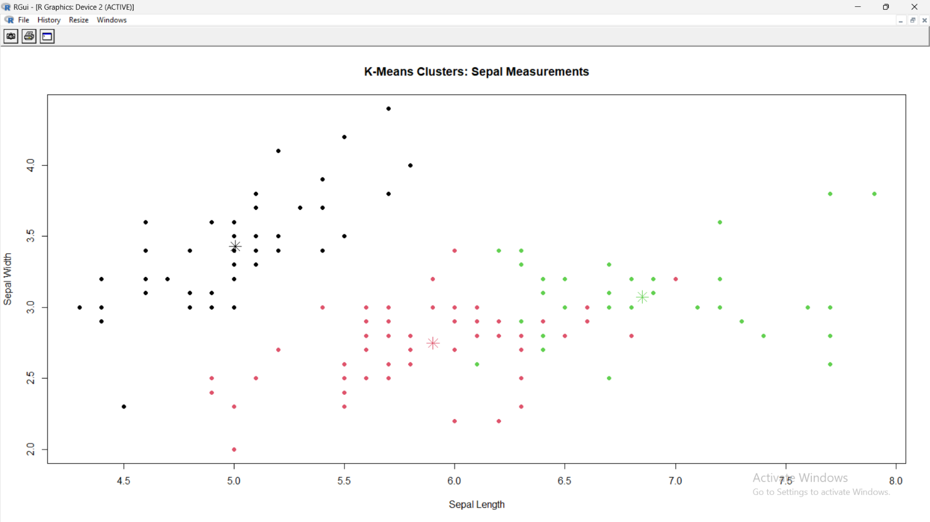
- Repeat the plot using Petal.Length and Petal.Width instead. Which pair of variables gives visually cleaner clusters? Explain briefly why this makes biological sense.

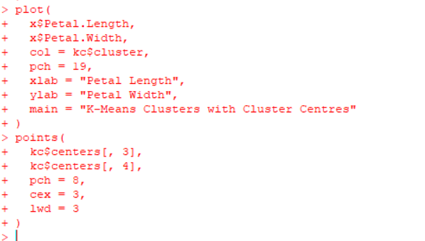

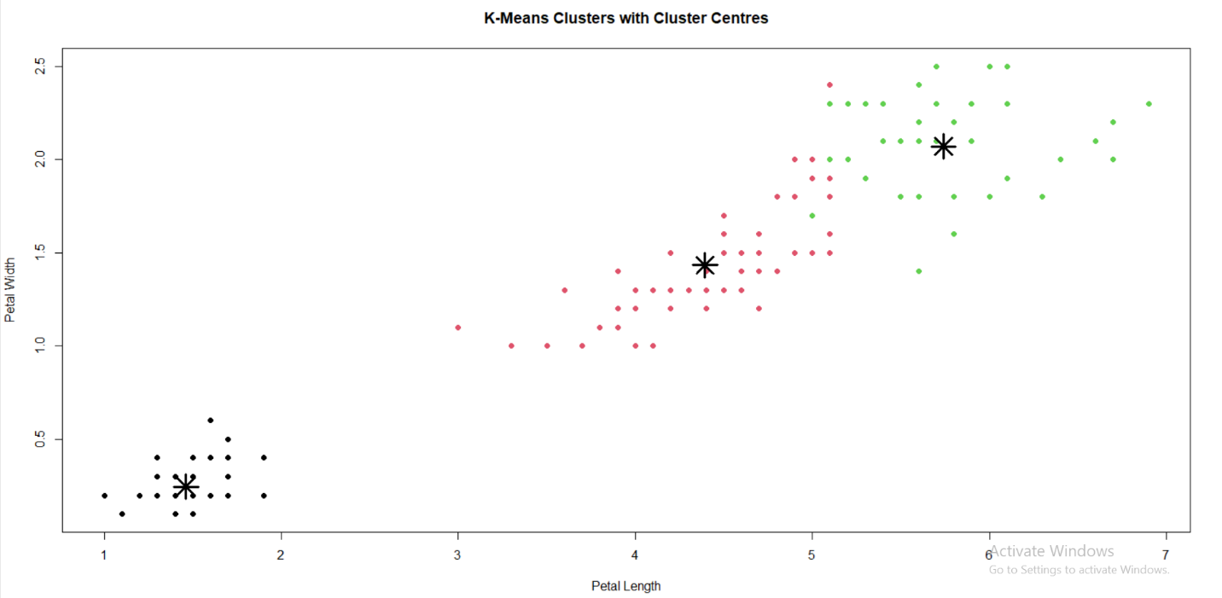

Petal.Length and Petal.Width give much cleaner cluster separation .
The Petal.Length and Petal.Width pair gives visually cleaner clusters than Sepal.Length and Sepal.Width. This makes biological sense because petal size differs more substantially among the three Iris species, making petal length and width more useful features for distinguishing the species.
Question 4. Reproducibility and initial centroids
- Explain, in your own words, why running kmeans() twice on the same data can give two different results.

Running kmeans() twice on the same data can produce different results because the algorithm starts with randomly selected initial cluster centres. Different starting centres can lead to different assignments of observations to clusters and therefore different final cluster centres and within cluster sum of squares. Setting a random seed using set.seed() makes the results reproducible.
- Set a random seed of your choice with set.seed(), then re-run k-means on iris[,3:4] with 3 clusters and nstart = 20. What does the nstart argument do, and why is it good practice to use it?
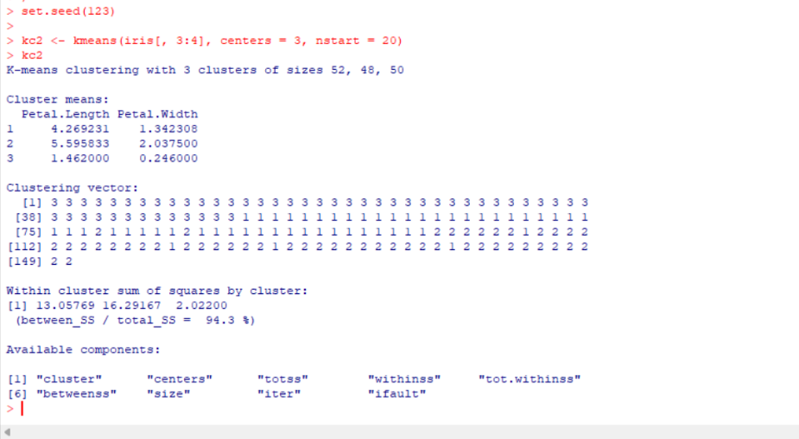

What does nstart = 20 mean?
Instead of running K-means from one random starting position, R runs it 20 times with different initial cluster centres.
It then chooses the solution with the lowest total within-cluster sum of squares.

- Compare the resulting clustering to the true Species labels using table(). How many observations are misclassified?
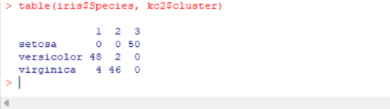

Step 1 — Identify the main cluster for each species
Because K-means cluster numbers are arbitrary, we match each species with the cluster containing most of its observations
Setosa: 0 + 0 + 50
→ Cluster 3
So: 0 misclassified

Versicolor: 48 + 2 + 0
→ Cluster 1 is the main cluster.
So: 2 misclassified

Virginica: 4 + 46 + 0
→ Cluster 2 is the main cluster.
So: 4 misclassified
Total misclassified :6
correctly classified: 144
(144/150)*100=96%
giving an effective clustering accuracy of 96%.
generally, fewer misclassified observations is better when you are comparing a clustering result against known class labels

Question 5. Choosing the number of clusters
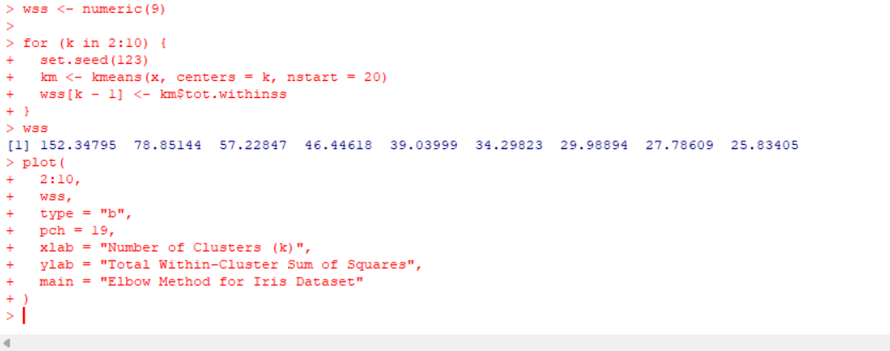
- Using the elbow method, compute the total within-cluster sum of squares (tot.withinss) for k = 2 to k = 10 on the iris feature data, and plot k against the within-cluster sum of squares.

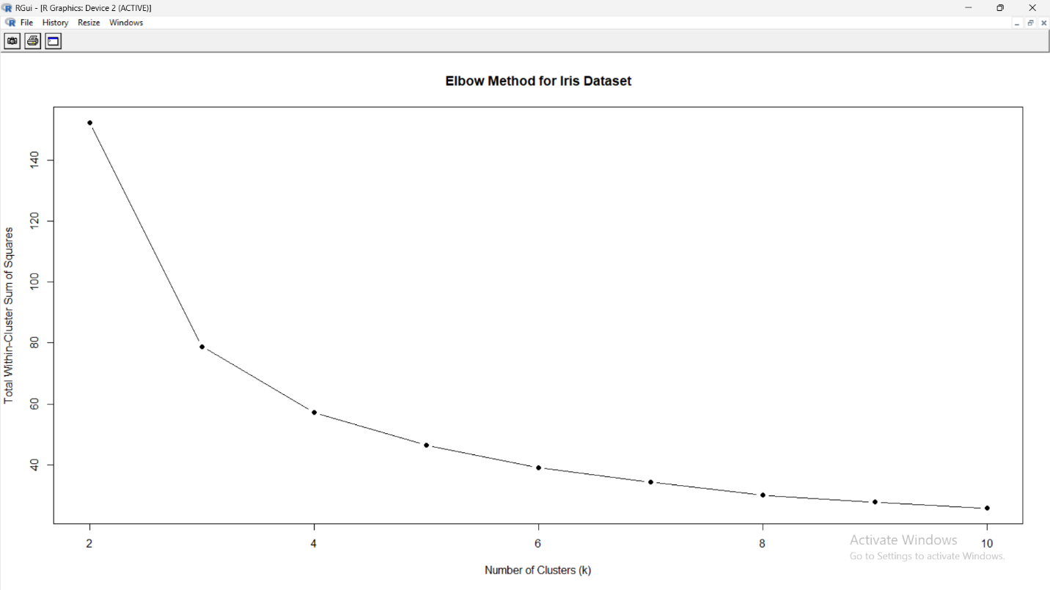

- From your plot, identify the k value at the 'elbow' (bend) of the curve. Does this agree with the known number of iris species?
Notice that the WSS always decreases as k increases. That's expected.
If you increase the number of clusters, each cluster generally contains fewer observations, so the observations can be closer to their respective centroids.
The important thing is not simply choosing the lowest WSS. If we did that, we'd always choose k = 10 (or an even larger number). Instead, we look for the elbow — where adding more clusters gives progressively smaller improvements ( it happened in cluster 3)
- Load the NbClust package and run NbClust() on the iris feature data (with the Species column removed) for min.nc = 2, max.nc = 10, method = "kmeans", index = "all". According to the majority rule, what is the best number of clusters?
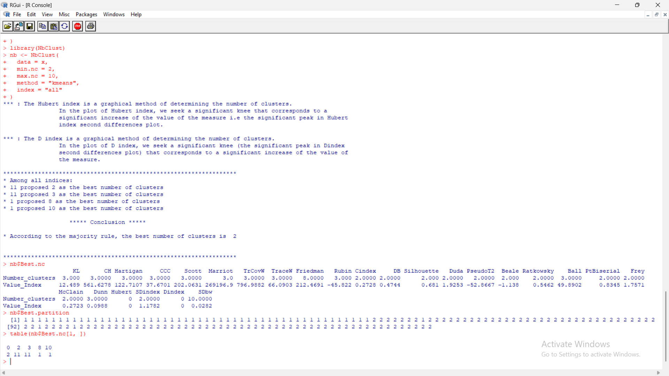

the best number of clusters is 2

(d) Briefly explain, in 2–3 sentences, why a single index (like the elbow plot) might disagree with the majority-vote result from NbClust, and why it can be useful to consult multiple indices.
A single method such as the elbow plot may recommend a different number of clusters because it evaluates cluster quality using one specific criterion, while NbClust combines the results of many different clustering indices. Consulting multiple indices is useful because different measures assess different aspects of cluster quality, providing a more reliable basis for choosing the number of clusters.
this is demonstrated by your results:
Elbow method → k = 3
NbClust majority rule → k = 2
(both of these methods are unsupervised clustering, because They do not use the true Species labels)

Part B — K-Means on the Wine Dataset
Question 6. Loading and exploring winedata.csv
- Read winedata.csv into a data frame called wine using read.csv()
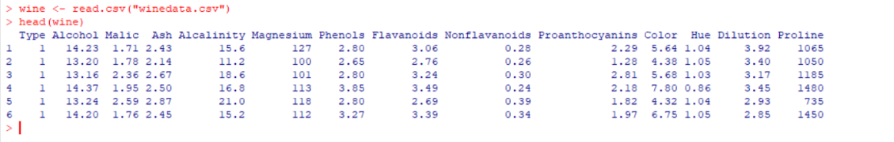

- Use str() to inspect the structure of wine. How many observations and how many variables are there? Which variable represents the wine's true class (cultivar)?
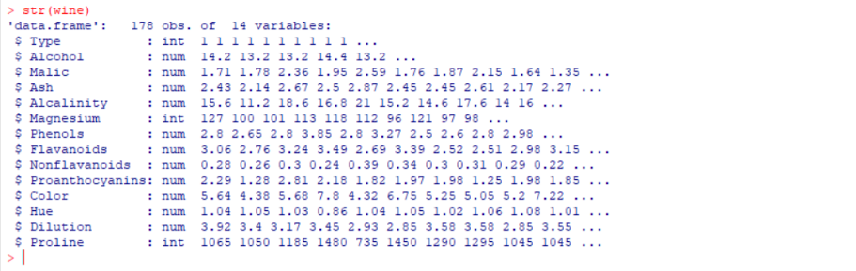

178 observations → 178 wine samples
14 variables → 14 columns
13 chemical variables
1 true class variable(cultivar): Type

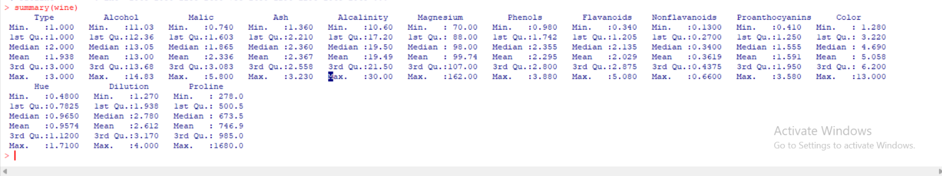
- Using summary() or otherwise, comment on whether the 13 chemical variables are all measured on similar scales.

The scales are very different.
For example:
Alcohol → 11.03 to 14.83
Magnesium → 70 to 162
Proline → 278 to 1680
while some variables are only around 0–5.
Why does this matter for K-means?
K-means uses distance to determine which observations belong to the same cluster.
Because Proline has values as high as 1680, it can have a much greater influence on the distance than something like Hue, which ranges only from 0.48 to 1.71.
Therefore, we need to scale the variables before clustering.

Question 7. Scaling the data
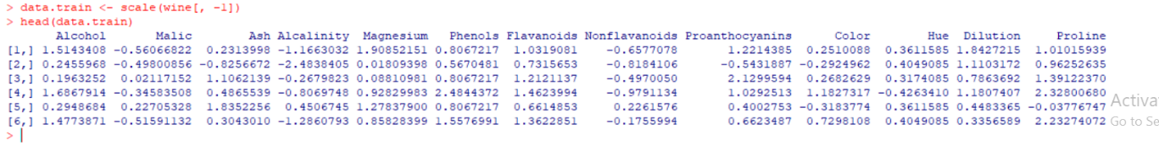
(a) Create a scaled version of the chemical variables (excluding the Type column) called data.train, using the scale() function.

(b) Explain why scaling is necessary before applying k-means to this dataset, referring to how k means computes distances.
K means uses distance to decide which observations are closer to each other.
For example, it calculates distances using the chemical measurements: Alcohol, malic
A simplified Euclidean distance is:
d=[(x₁​−y₁​)²+(x₂​−y₂​)²+⋯+(x₁₃​−y₁₃​)^{2​}]^{1/2}
Example:
Wine A = (1, 2, 3)
Centroid = (2, 4, 5)
d²=(1−2)²+(2−4)²+(3−5)²
d=3
So the squared distance = 9
The actual Euclidean distance(d) would be: 9^{1/2}=3
Example:
So the problem is :
Alcohol → 11.03 – 14.83
Malic → 0.74 – 5.80
Magnesium → 70 – 162
Proline → 278 – 1680
Because Proline has much larger numerical values, it can contribute much more to the distance calculation than variables such as Alcohol or Hue
Example:
Suppose two wines differ by:
Alcohol: 1
Proline: 300
In the squared-distance calculation:
1²=1
but:
300²=90,000
So the Proline difference can have a dramatically larger effect on the distance.
That's the main reason we scale the data.
- Confirm that each scaled variable now has a mean of (approximately) 0 using summary(data.train) or colMeans()
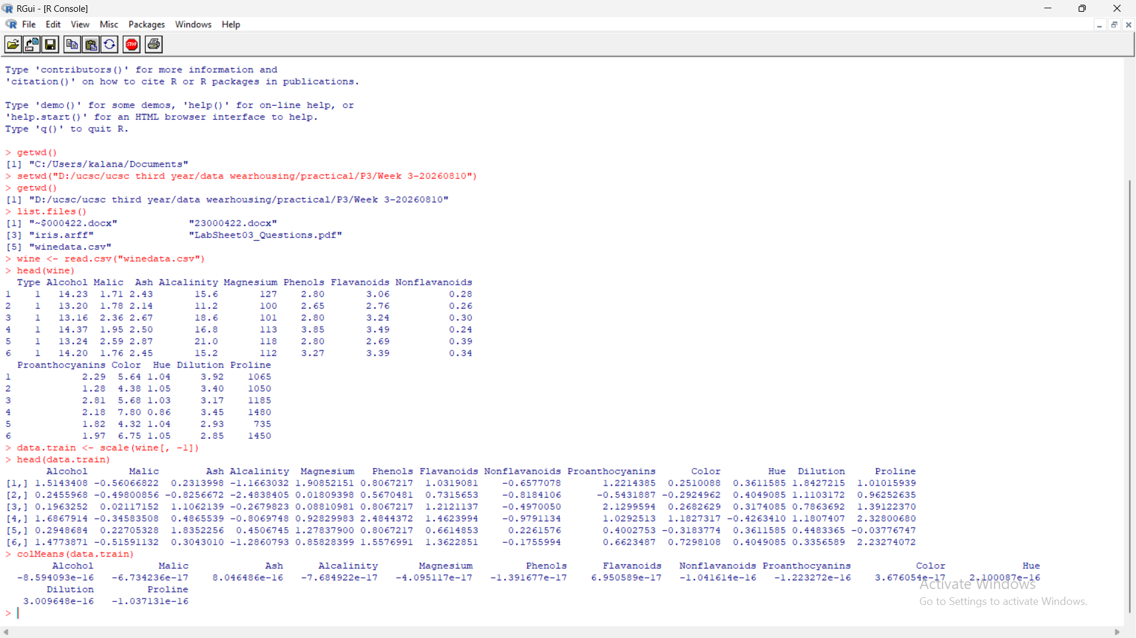

The column means of the scaled variables are all approximately 0. The very small values, such as −8.59×10−16 and 3.01×10−16, are effectively zero and result from floating-point numerical precision. Therefore, the scale() function has successfully standardized the 13 chemical variables

Question 8. Choosing k and fitting the model
- Run NbClust on data.train (min.nc = 2, max.nc = 15, method = "kmeans") and produce a bar chart of the number of criteria proposing each value of k

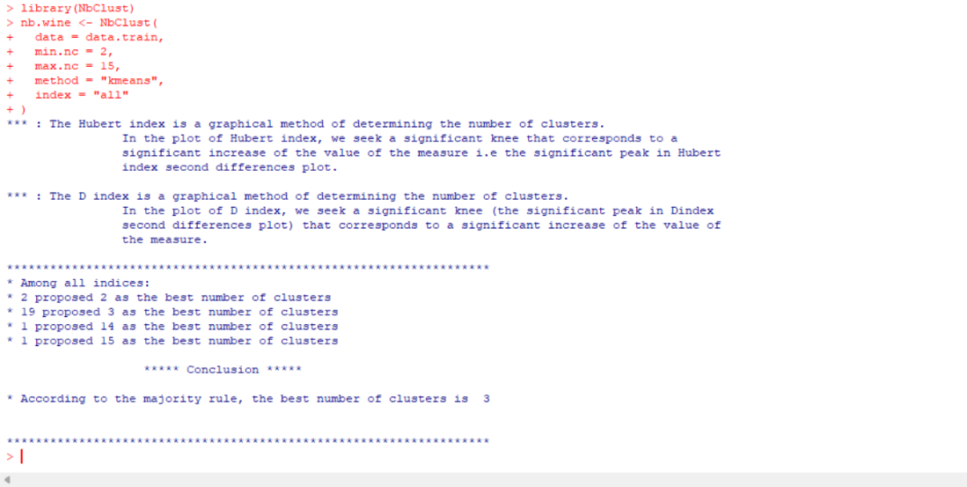

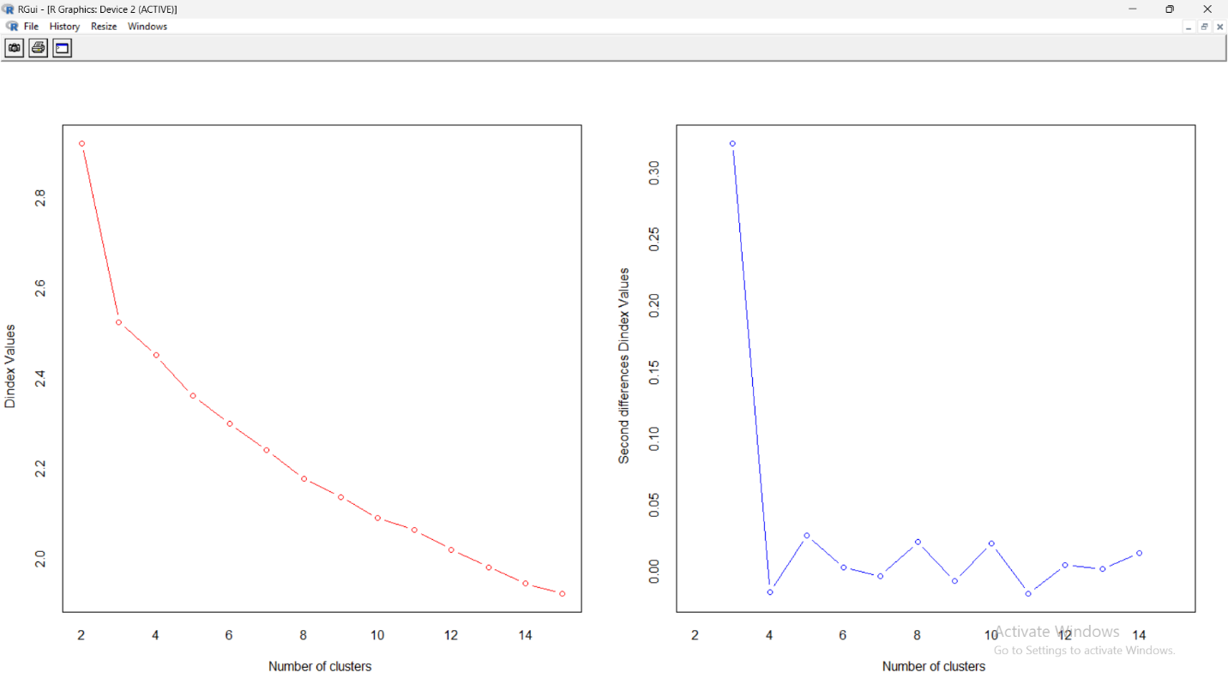
NbClust was applied to the scaled wine dataset using k-means clustering for values of k from 2 to 15. Two criteria proposed k = 2, nineteen criteria proposed k = 3, one criterion proposed k = 14, and one criterion proposed k = 15. Therefore, according to the majority rule, k = 3 was selected as the best number of clusters.
- Separately, write a for loop that computes the within-cluster sum of squares for k = 1 to 15 and plot the resulting scree plot. Does the elbow agree with NbClust's recommendation?

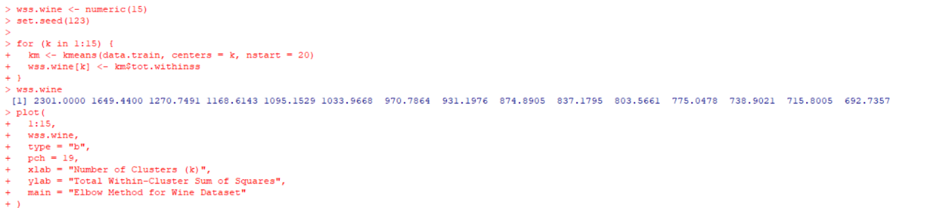

The scree plot shows that the total within-cluster sum of squares decreases as the number of clusters increases. The largest reductions occur between k = 1 and k = 3, after which the decrease becomes considerably smaller. Therefore, the elbow appears at approximately k = 3. This agrees with the NbClust majority-rule recommendation, which also selected k = 3.

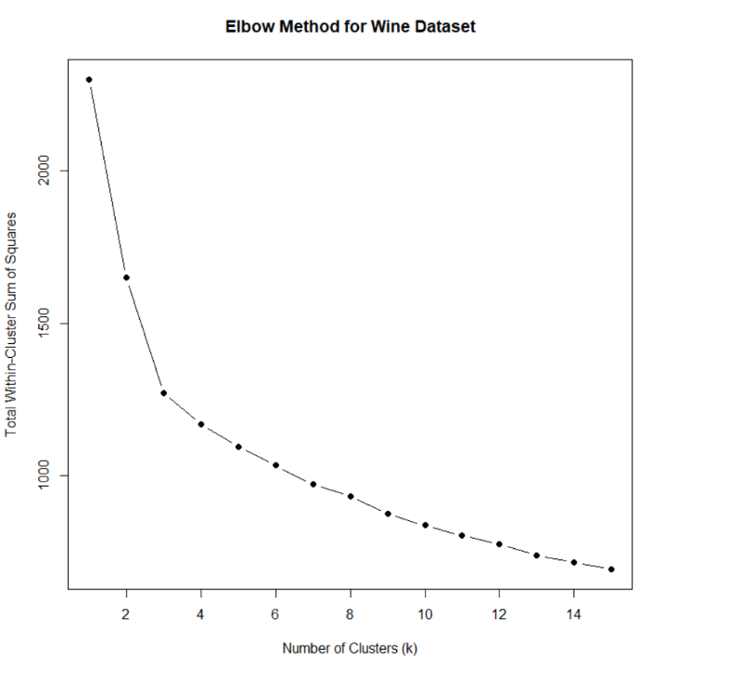

- Set a seed and fit a final k-means model, fit.km, to data.train using the number of clusters you decided on in parts (a)-(b).
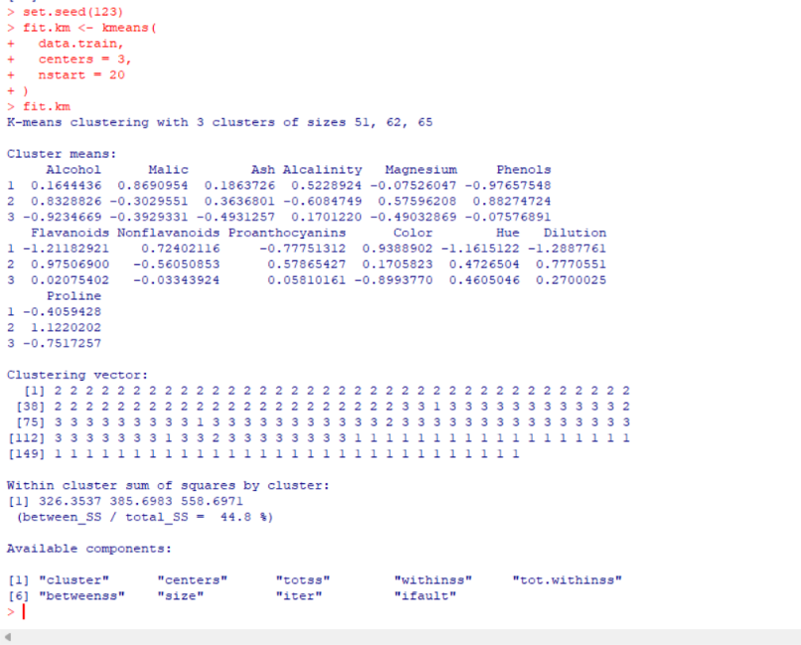

Based on both the NbClust majority rule and the elbow method, k = 3 was selected. A final K-means model was fitted to the scaled wine dataset using three clusters, a random seed of 123, and nstart = 20. The resulting clusters contained 51, 62, and 65 observations, respectively. The model achieved a between-cluster sum of squares to total sum of squares ratio of 44.8%.

Question 9. Interpreting and evaluating the clusters
- Print fit.km$centers. Choose one cluster and describe, in a sentence or two, what kind of wine it represents (e.g. relatively high/low in particular chemicals).

Cluster 2 represents wines with relatively high Alcohol, Magnesium, Phenols, Flavanoids, Proanthocyanins, and Proline levels compared with the overall dataset average. It also has relatively low Malic Acid, Alcalinity, and Nonflavanoids levels.
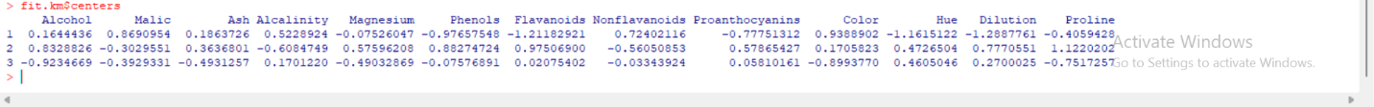
- Build a confusion matrix comparing wine$Type to fit.km$cluster using table(). How many wines are misclassified overall?
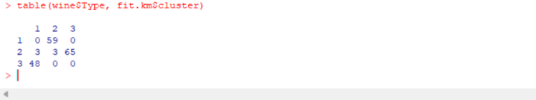
The confusion matrix shows that 59 Type 1 wines were assigned to Cluster 2, 65 Type 2 wines were assigned to Cluster 3, and 48 Type 3 wines were assigned to Cluster 1. Since cluster labels are arbitrary, the clusters were matched to the dominant wine types. Thus, 172 out of 178 wines were correctly clustered, resulting in 6 misclassified wines overall.
- Load the flexclust package and compute the Adjusted Rand Index (ARI) for your confusion matrix using randIndex(). What does an ARI close to 1 indicate, and what would an ARI of 0 mean?

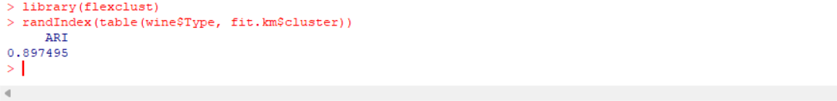

The Adjusted Rand Index (ARI) for the K-means clustering is 0.897495. Since this value is close to 1, it indicates a strong agreement between the clusters produced by K-means and the known wine classes. An ARI of 0 would indicate that the agreement between the clustering and the true class labels is approximately equivalent to what would be expected by random chance.
Question 10 Visualisation
(a) Using the fpc package, produce a discriminant projection plot of the wine clusters with plotcluster().
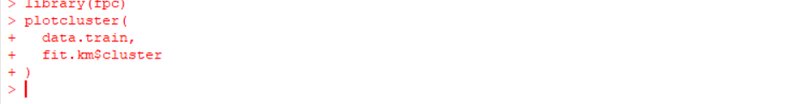
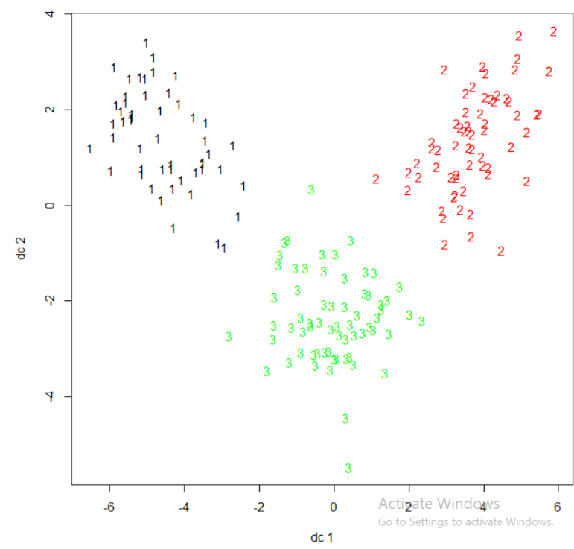

b) In 2–3 sentences, comment on how well-separated the three clusters appear to be in this projection.
The discriminant projection shows that the three wine clusters are generally well separated, with most observations forming distinct groups. However, there is some overlap between the clusters, particularly for a small number of observations, which is consistent with the six misclassified wines and the ARI value of 0.8975.

Part C —Short Answer / Theory
Question 11. Conceptual questions
- List, in order, the four main steps of the k-means algorithm.
The four main steps of the K-means algorithm are:
- Initialize k cluster centroids.
- Assign each observation to the nearest centroid based on distance.
- Update each centroid by calculating the mean of the observations assigned to that cluster.
- Repeat the assignment and update steps until the clusters converge or the stopping condition is reached.
- K-means is described as a 'partitioning' method. Name one clustering method that is NOT a partitioning method, and briefly state one key difference between it and k-means.
Hierarchical clustering is a clustering method that is not a partitioning method. Unlike K-means, which directly divides the data into a predefined number of clusters by assigning observations to the nearest centroid, hierarchical clustering builds a hierarchy of nested clusters by repeatedly merging or splitting clusters. The resulting hierarchy can be visualised using a dendrogram.
- Give one advantage and one limitation of k-means clustering compared to hierarchical clustering.
Advantage: K-means is generally faster and more computationally efficient than hierarchical clustering, especially when working with large datasets.
Limitation: K-means requires the number of clusters (k) to be specified in advance, whereas hierarchical clustering can produce a dendrogram that allows different numbers of clusters to be explored without initially specifying k.
- Why is k-means considered an unsupervised learning technique, even though the datasets you used in this lab (iris and wine) actually have known class labels?
K-means is considered an unsupervised learning technique because it creates clusters using only the input features and does not use the known class labels during the clustering process. Although the Iris and Wine datasets contain true labels such as Species and Type, these labels were only used after clustering to evaluate how well the resulting clusters matched the known classes. Therefore, K-means itself remains unsupervised.

