**Assignment #1 – EE 568 – Digital Image Processing – Winter 2021**

**Name: Kalana Sahabandu**

**Question 1**

1. Original Image (600 x 600)

1. Enlarged image (1500 x 1500)

**Question 2**

1. Please refer to the code attached with the submission (Q2.py file)
2. Type of the loaded image data: uint8

Maximum data value: 255

Minimum data value: 0

1. We can show the image using python cv2.imshow() function without any errors during the runtime. However, the image it shows is not similar to the Lena image (shows a corrupted version of the image as follows)



Image output after converting image data to double

1. In order to show an image that has been converted to double we need to normalize all the values between 0 – 1 range. Since the maximum value we found is 255, we could divide each element in the image data (which is a matrix) by 255. This way we can normalize the image data between 0 – 1 range.

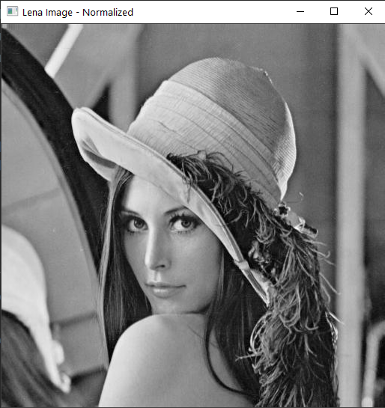

Lena image after normalizing

**Question 3**

1. Please refer to the code attached with the submission (Q3.py file)
2. Please refer to the Z0.tif image submitted with this assignment
3. Please refer to the Z1.tif image submitted with this assignment
4. Yes, even though Z0.tif image is correctly rotated 120 degrees clockwise, Z1.tif is not correctly rotated 120 degrees clockwise (it rotated less than 120 degrees clockwise)



Z1.tif

Z0.tif