**Assignment #2 – EE 568 – Digital Image Processing – Winter 2021**

**Name: Kalana Sahabandu**

**Question 1**

Part a

1. 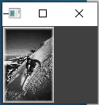
2. 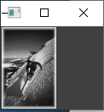

Part b

1. 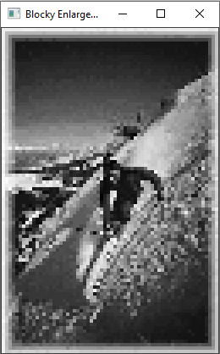
2. 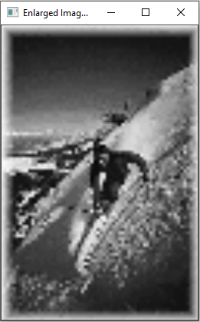
3. When we compare the image, we got from pixel repeating to image that we got by performing Bilinear Interpolation, it is clear that Pixel repeating does not do a very good job at enlarging an image since the enlarged picture looks more pixelated (blocky) and unreadable (hard to see what this picture captures). On the other hand, the resulting image we got by performing Bilinear Interpolations looks more smooth and fairly readable (We can actually see what this picture captures to an extent) compared to the resulting image we got from pixel repeating.

**Note: Please refer “Q1_code” directory for the python code associated with Question 1, Part a and Part b**

**Question 2**

* 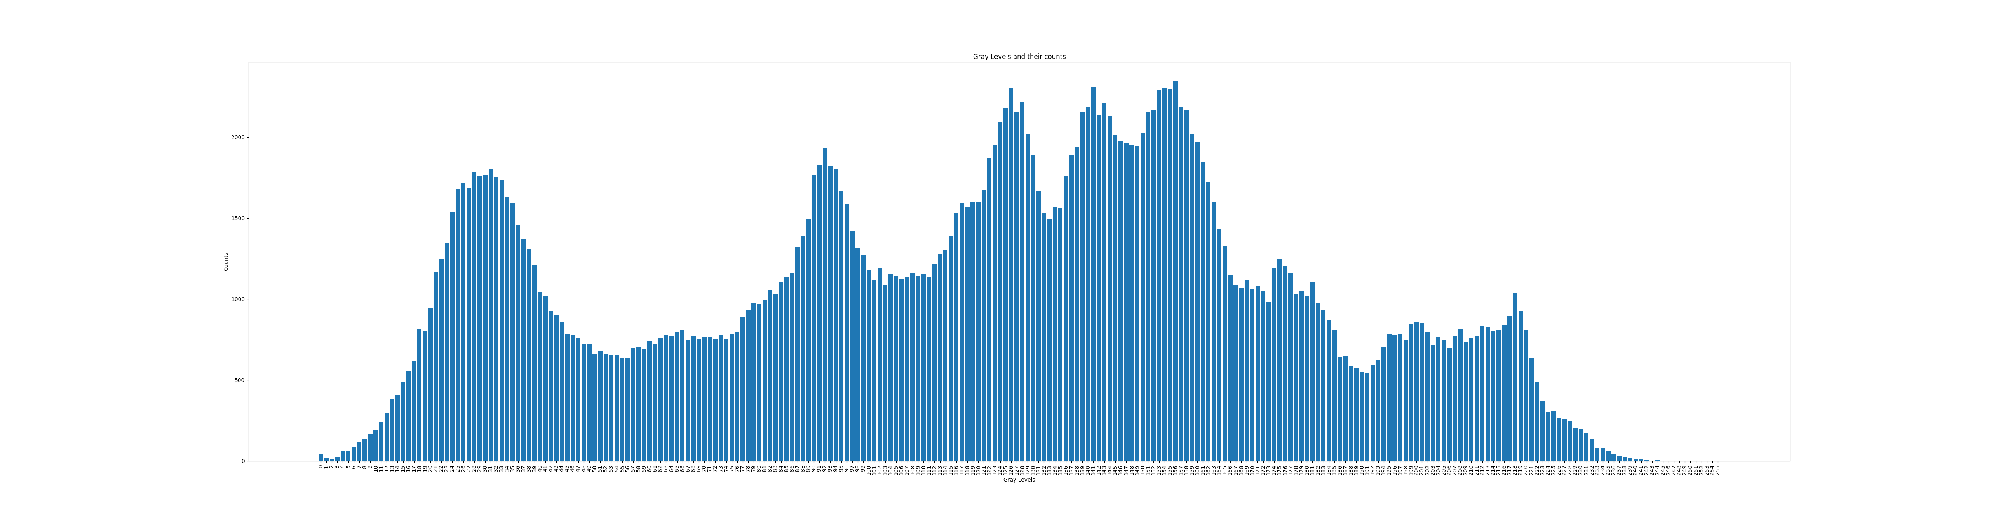Gray levels and their counts

* 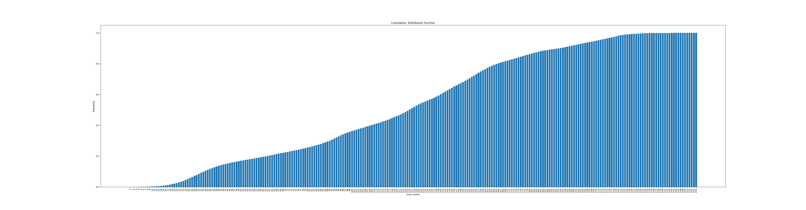Cumulative Distribution Function (CDF)

* Probability Density Function (PDF)

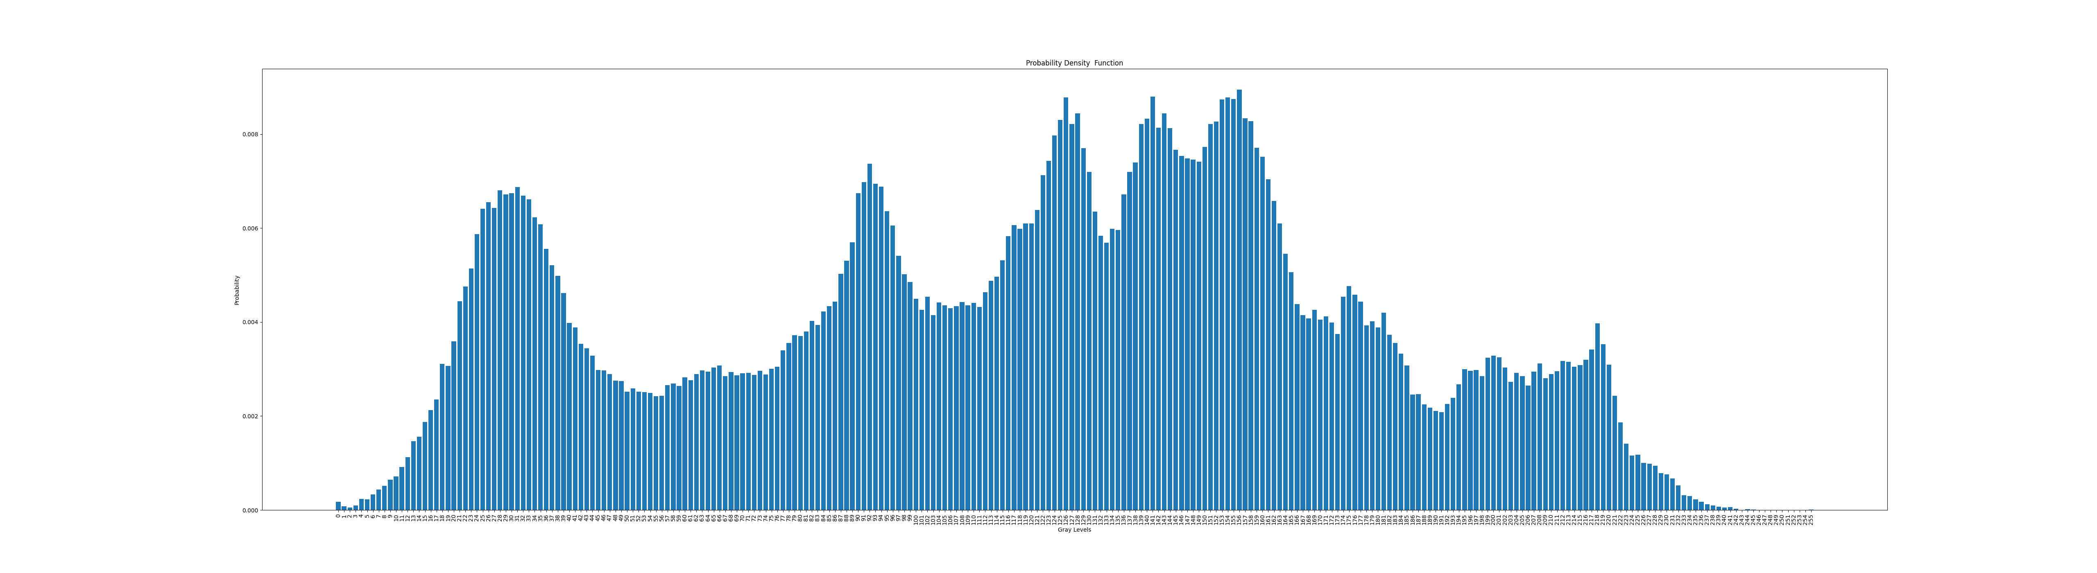

**Note: Please refer “Q2_code” directory for the python code associated with Question 2. Above plots are attached with the submission as well**