**Assignment #4 – EE 568 – Digital Image Processing – Winter 2021**

**Name: Kalana Sahabandu**

**Question 1**

1. Original Image

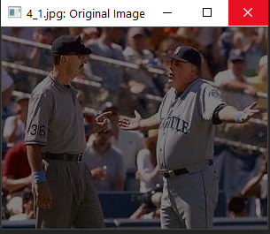

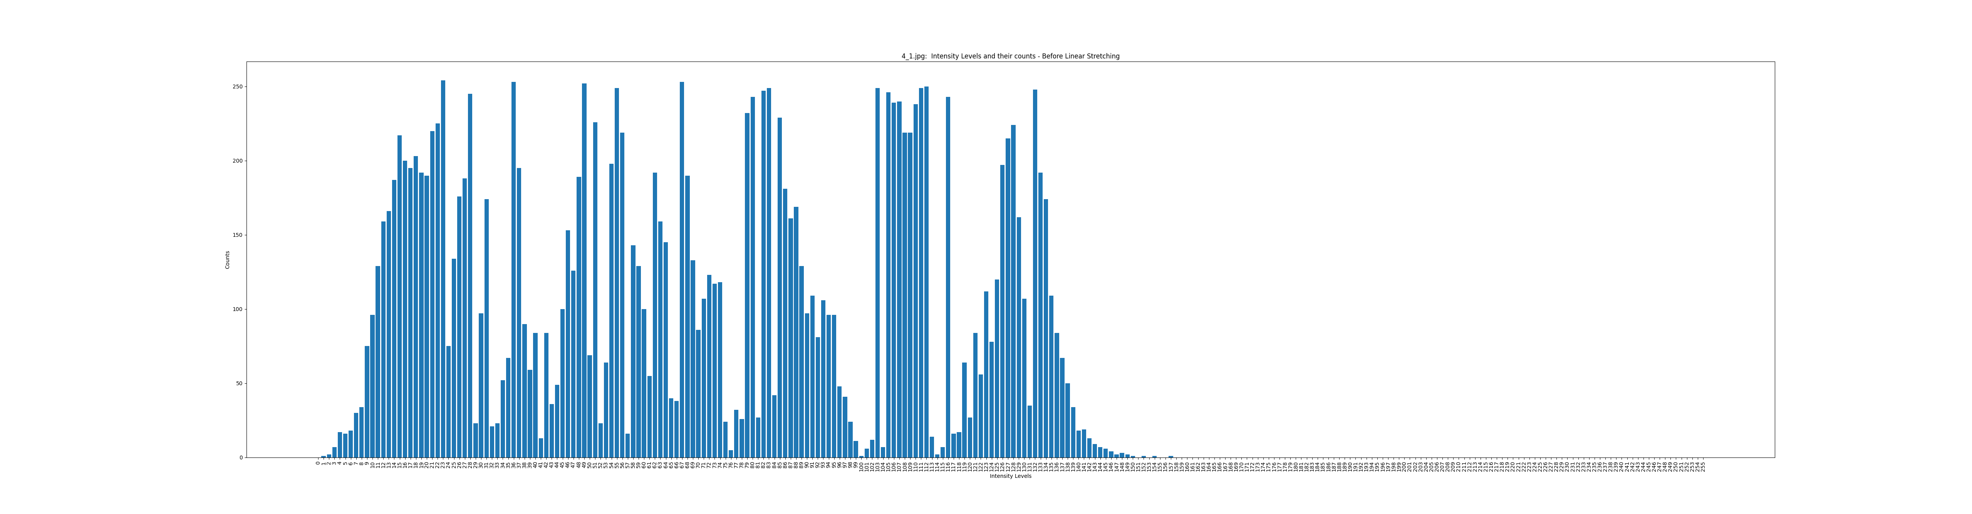

Intensity distribution of the original Image

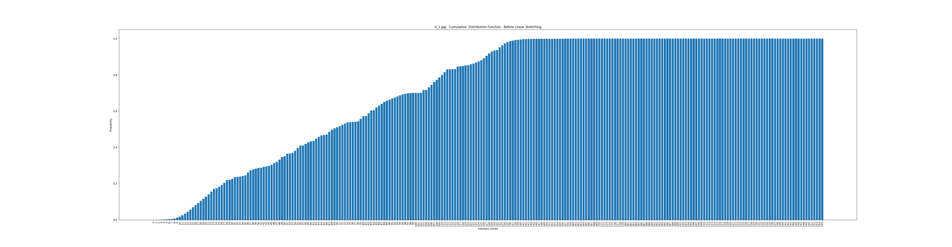

CDF of the original Image

1. Linear Stretching

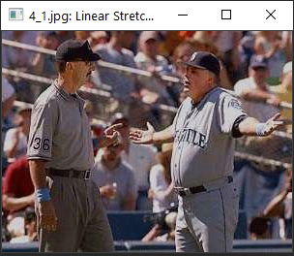

* When we compare the linear stretched image to the original image, it is clearly little brighter than the original image. Also, when compare the intensity distribution of the original image to the intensity distribution of the Linear Stretched image. It is clear that in the original image the intensity distribution is between 1 -157 while the intensity of the Linear Stretched image is between 0 -255 which helps to increase the overall brightness of the resulting image. Also, when we compare CDF graph of original image to the CDF graph of the Linear Stretched we can see probability of the linear stretched image is are very nicely (linearly) increasing while the probability values of the original image rapidly increased and toping off at 139 and stay there until 255.

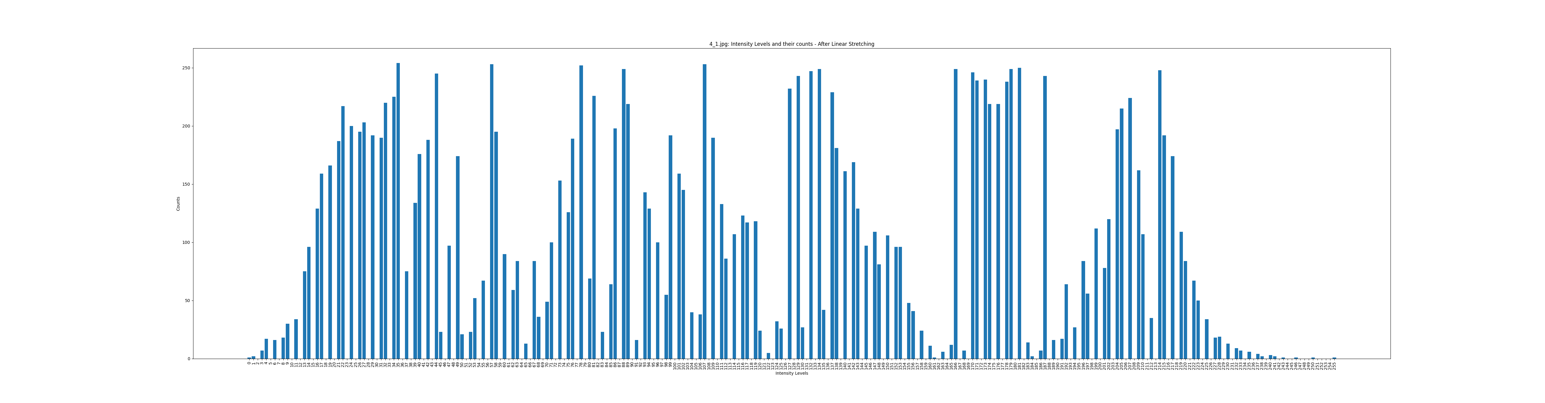

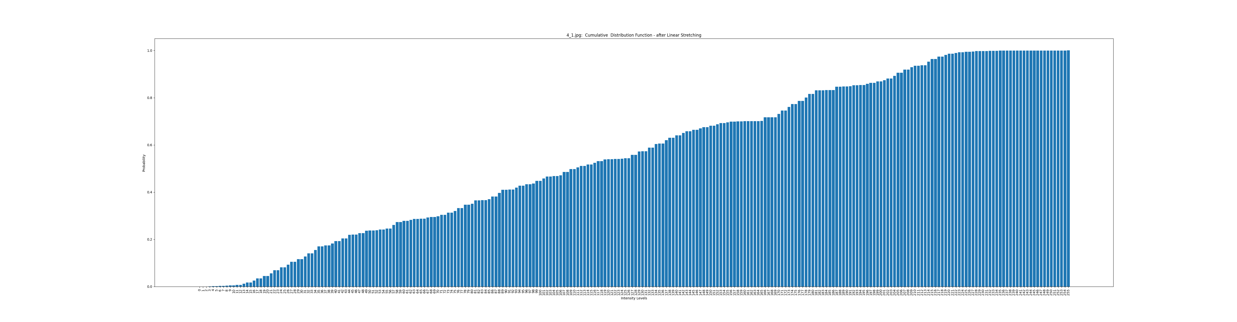Intensity distribution of the Linear Stretched Image

CDF of the Linear Stretched Image

1. Histogram Equalization

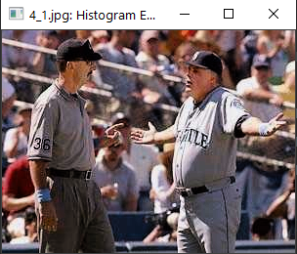

* 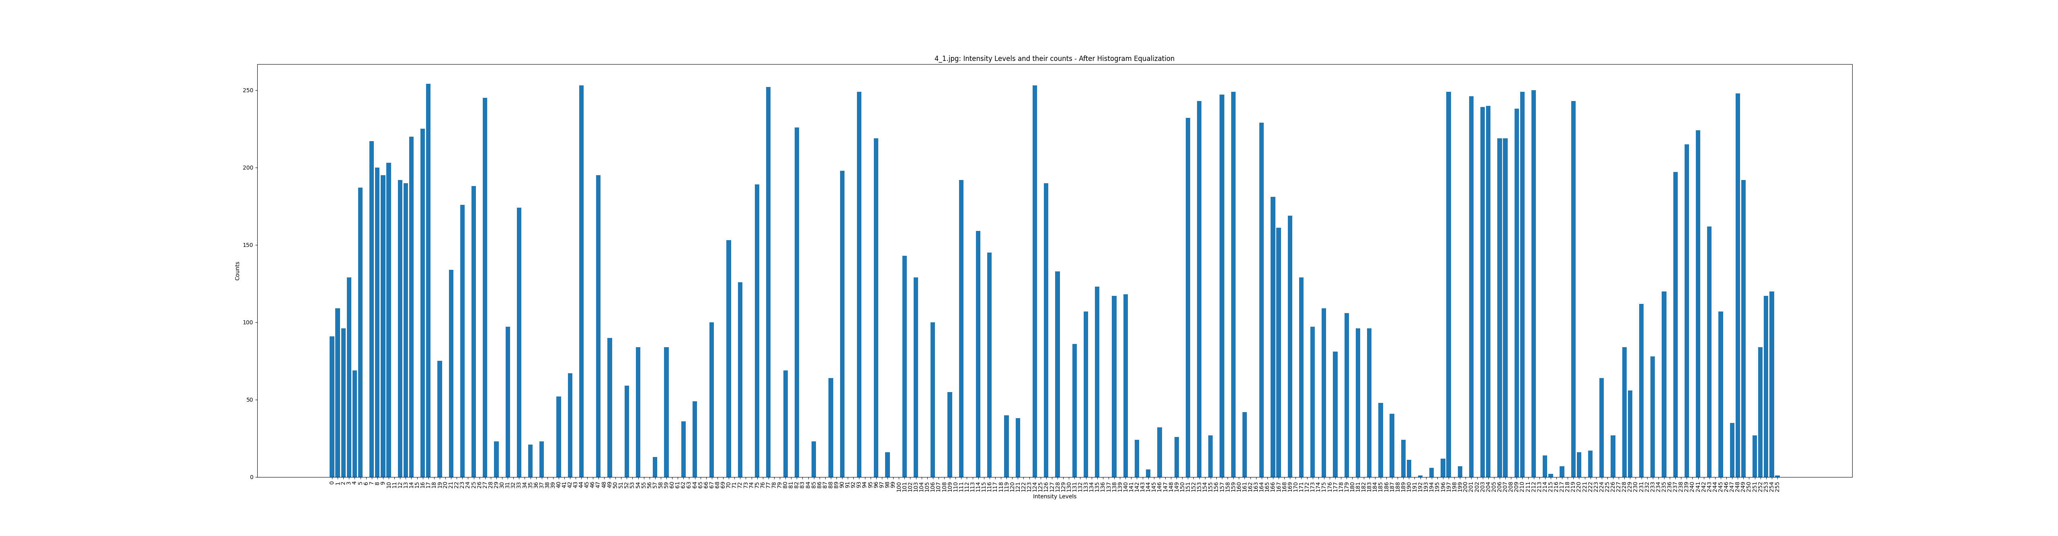 When we compare resulting image of the histogram equalization, it is clear that this method produces much brighter images compared to linear stretching method. Also, just like in Linear stretching Intensity of the pixels are very nicely distributed between 0 -255 range just like in linear stretching method. However, on the CDF plot Histogram equalization shows a better linear increase of the probability values compared to the CDF plot of the Linear stretching method.

Intensity distribution of the Histogram equalized Image

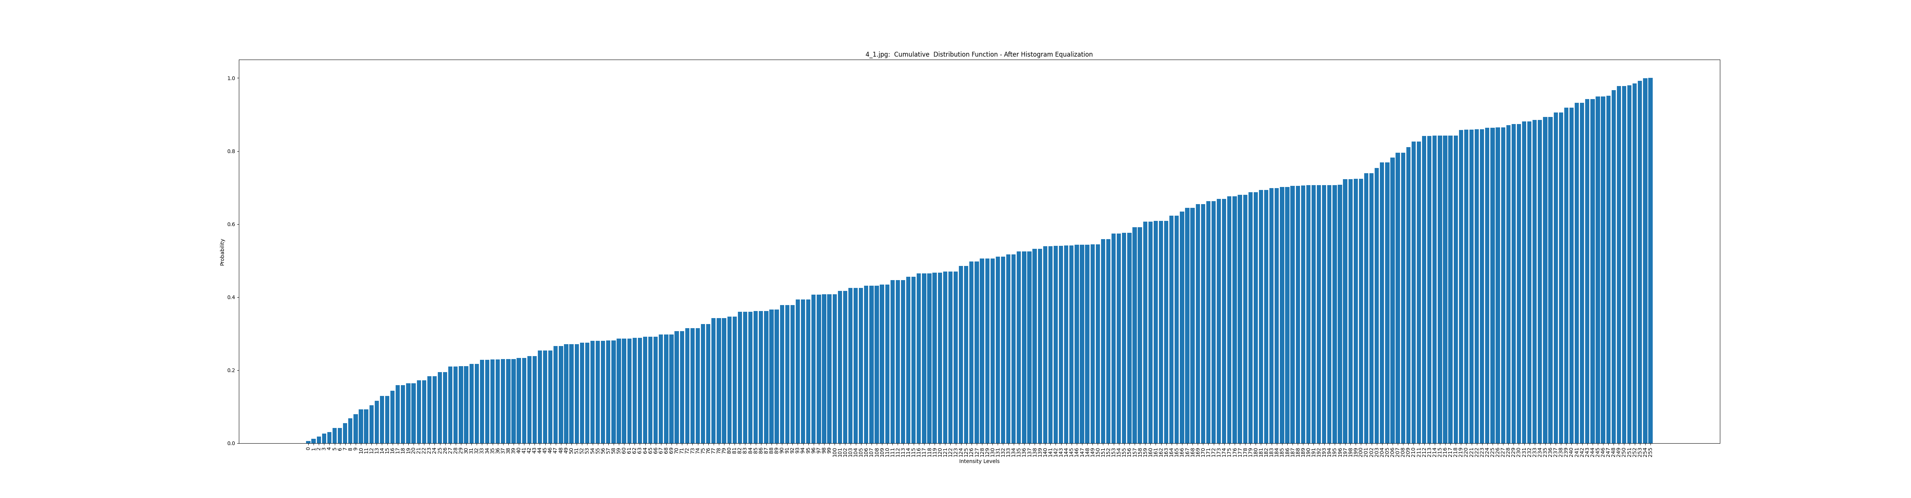

CDF of the Histogram equalized Image

1. 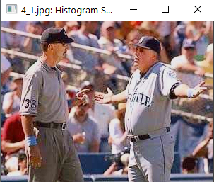Histogram Specification

* Out of above 2 methods, Histogram specification produces the brightest and most vibrant image, since the user can specify the intensity distribution using a target image, meaning the user can use a much better version of the original image (i.e. target image) to optimize/map the intensity values of the original image to better values. In this case, I have produced a better version of the original image using Photoshop’s brightness correction feature and feed that image to the algorithm such that algorithm can count pixel intensities of the better version of the image (i.e. target image) to map the original image’s pixel intensities.

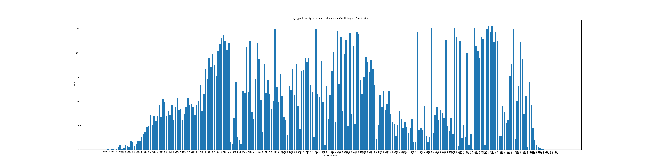

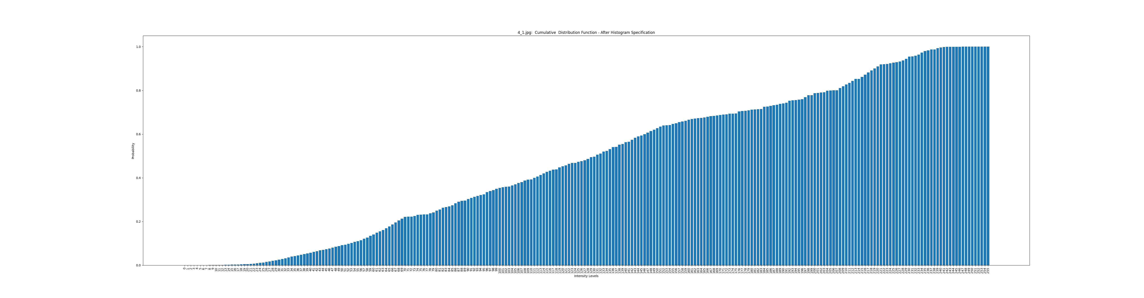Intensity distribution of the Histogram specified Image

CDF of the Histogram specified Image

1. 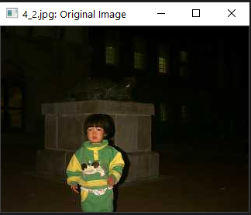Original Image

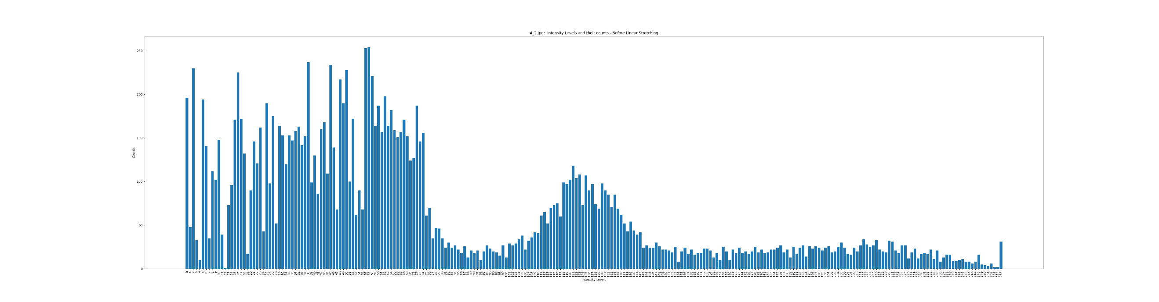

Intensity distribution of the original Image

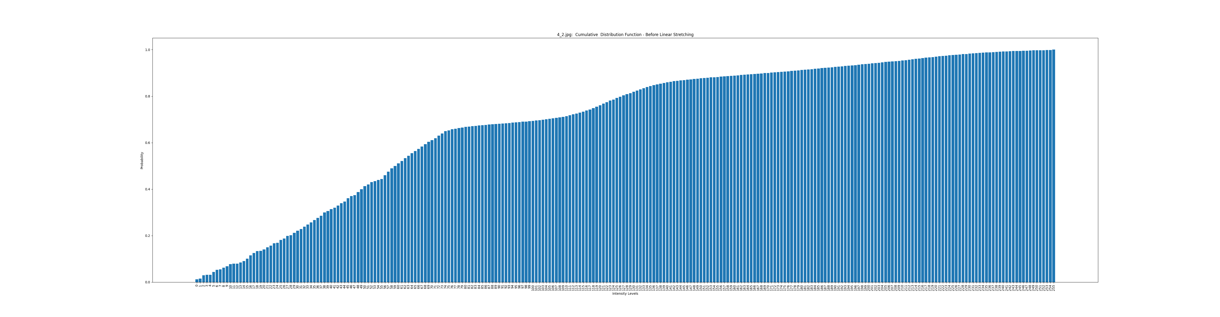

CDF of the Original Image

1. 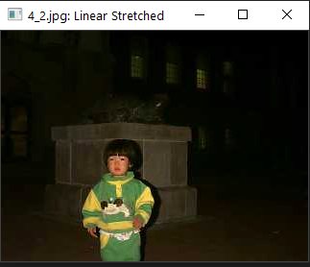Linear Stretching

* This is a special case of Linear Stretching, as we compare the original image, Intensity distribution and CDF plot to the resulting linear stretched image, its intensity distribution and CDF plot they are exactly the same. Reason behind this is the original image is already between 0-255 range and that’s exactly what linear stretching does, i.e. if the original image’s intensity distribution is between a smaller range, it will map intensity levels into 0 -255. However, in this case original image’s intensity levels are already distributed between 0-255. Therefore, linear stretching method does not work for this image.

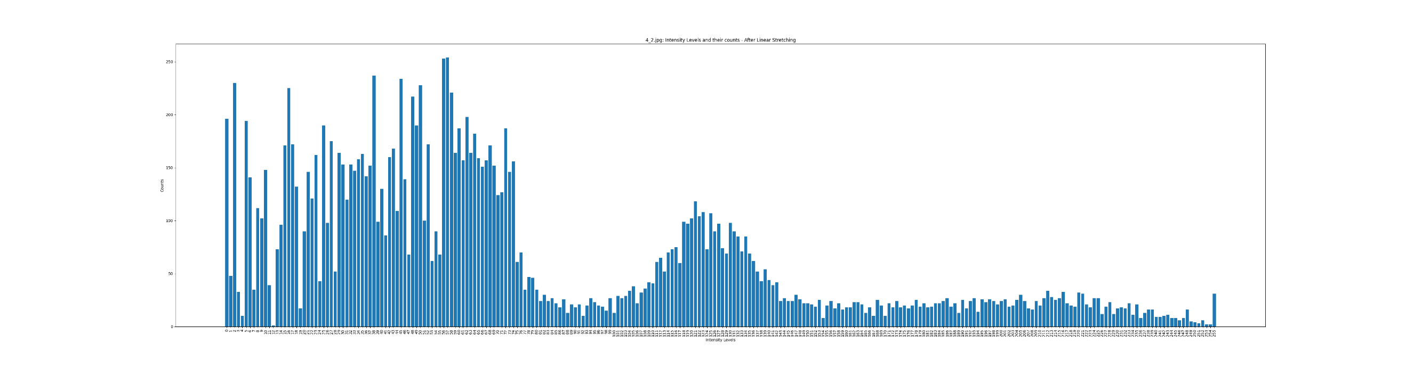

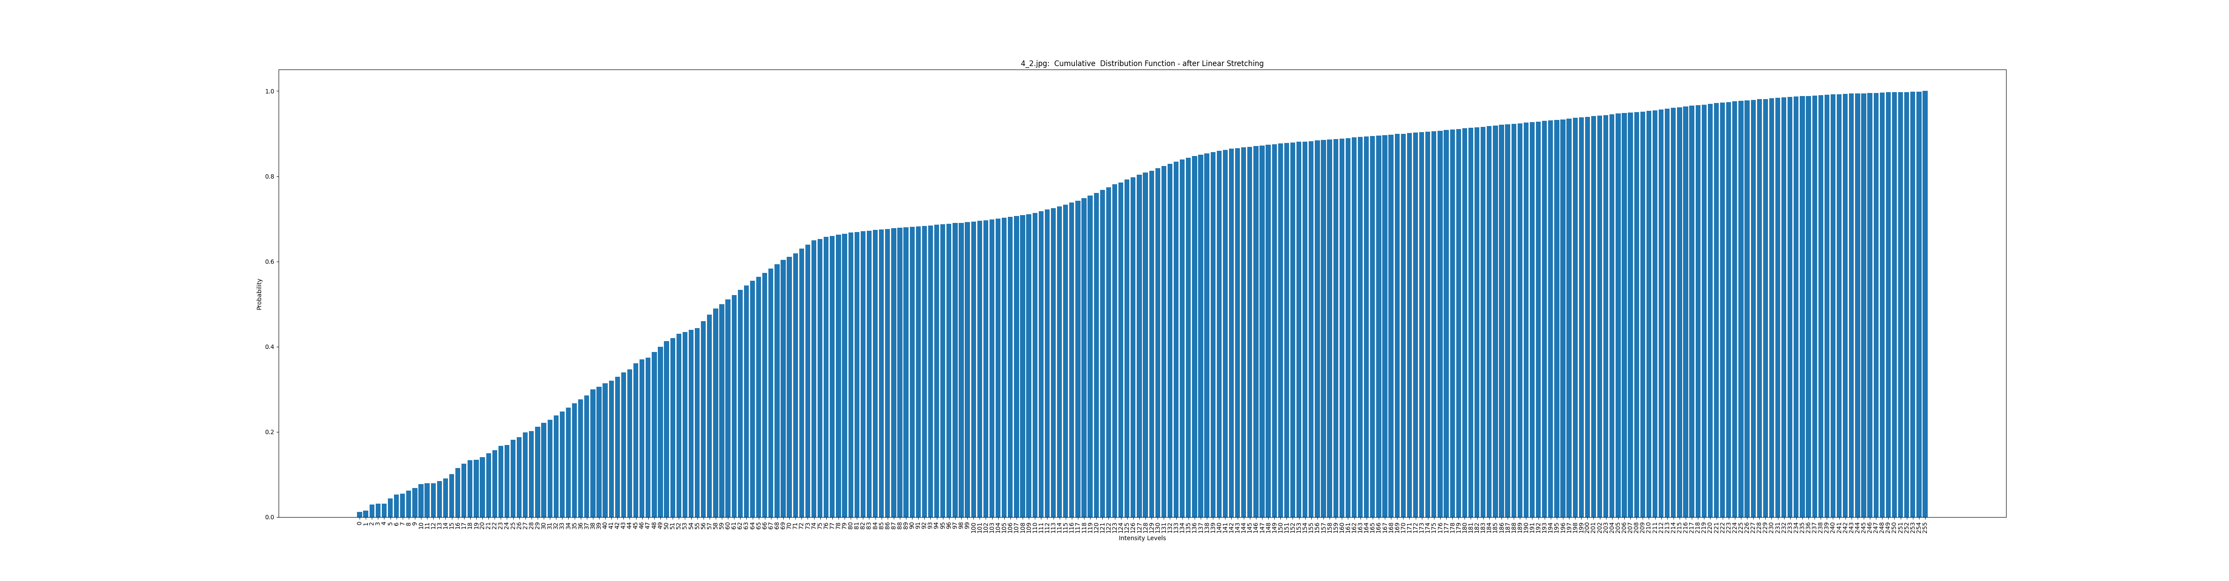Intensity distribution of the Linear Stretched Image

CDF of the Linear Stretched Image

1. Histogram Equalization

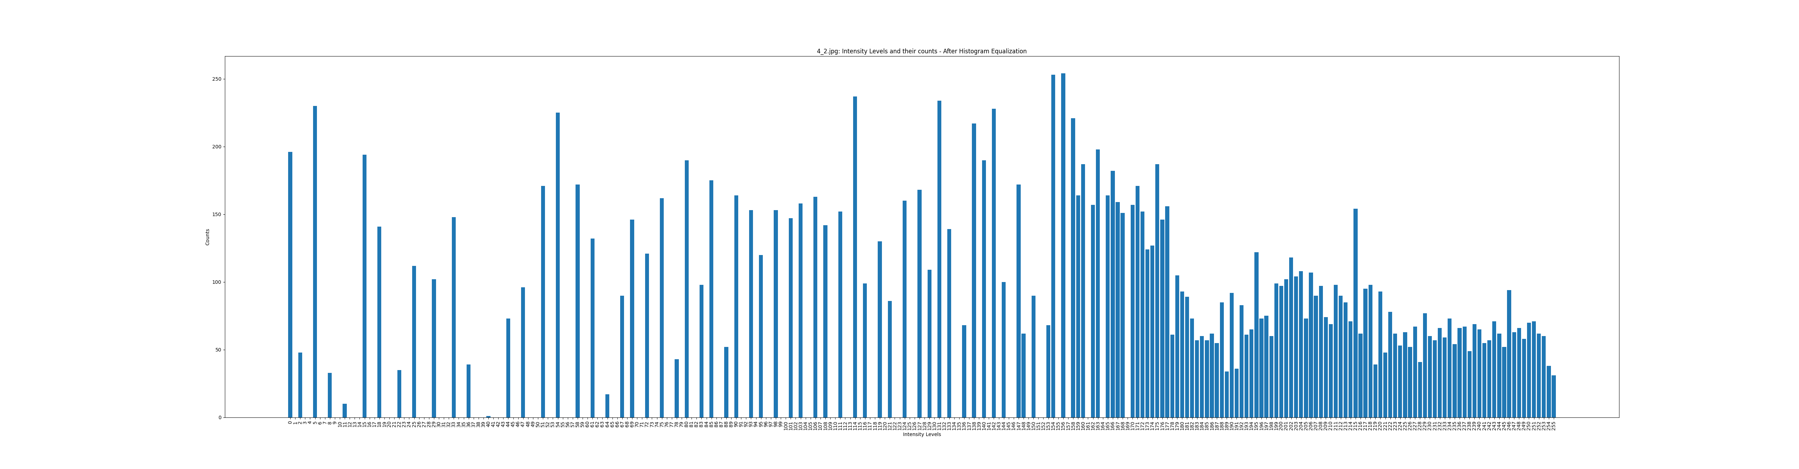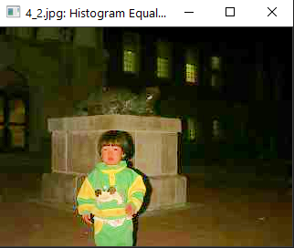

* When we compare resulting image from the histogram equalization to linear stretching and original image, this is the brightest image. Also, intensity distribution is distributed between 0-255 just like in Linear stretching and the probability distribution in Histogram equalization is much linearly distributed in histogram equalization compared to the probability distribution of the linear stretching. However, the resulting image from histogram equalization is little over brightened and blocky (pixelated) compared to resulting image from linear stretching.

Intensity distribution of the Histogram equalized Image

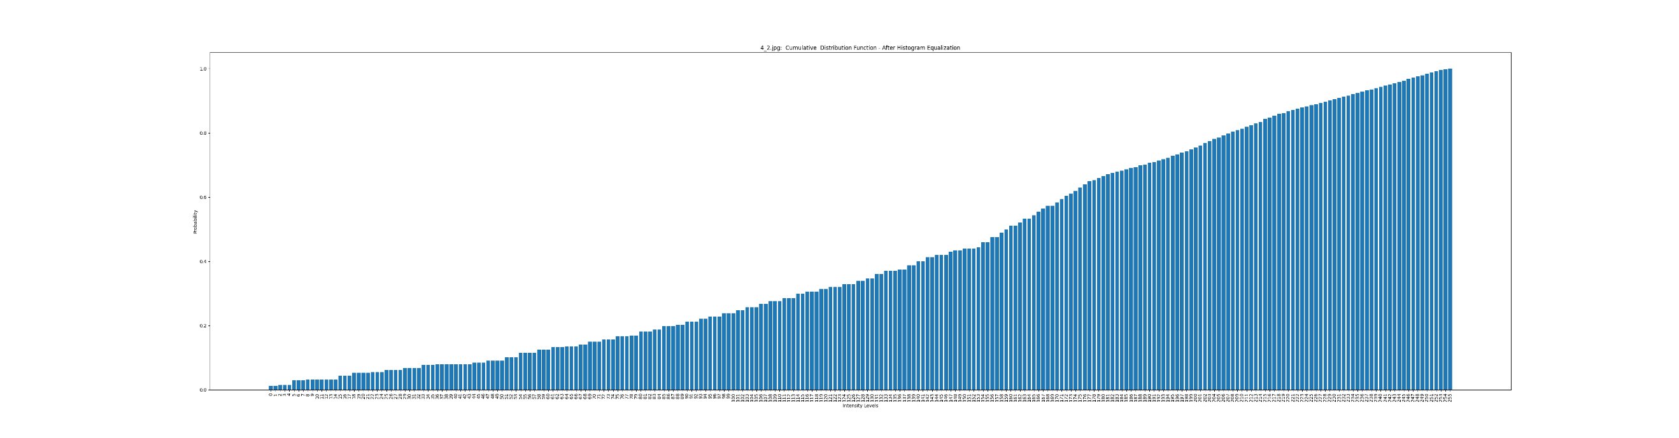

CDF of the Histogram equalized Image

1. Histogram Specification

* 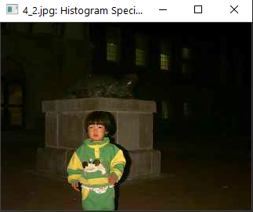Out of above 2 methods, Histogram specification produces much better image, since the user can specify the intensity distribution using a target image, meaning the user can use a much better version of the original image (i.e. target image) to optimize/map the intensity values of the original image to better values. In this case, I have produced a better version of the original image using Photoshop’s brightness correction feature and feed that image to the algorithm such that algorithm can count pixel intensities of the better version of the image (i.e. target image) to map the original image’s pixel intensities. Also, when we compare this image to the original image, we can see the structure behind the kid clear to some extent and this image is not overly brightened nor blocky (pixelated) compared to the resulting image from Histogram equalization.

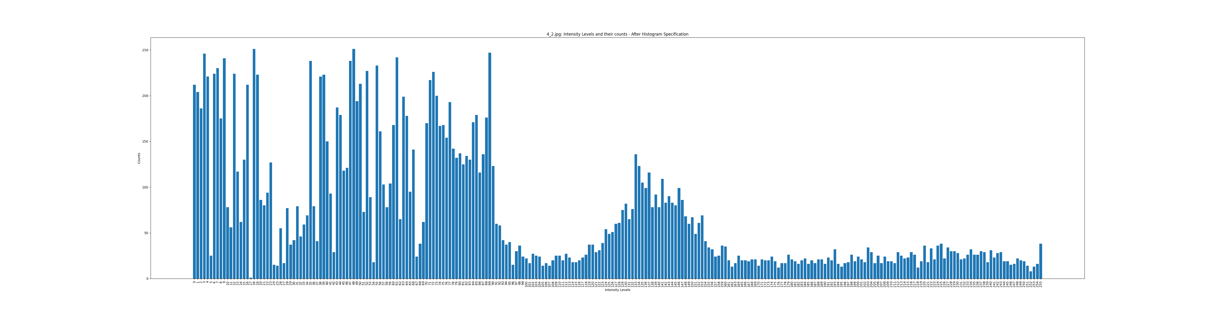

Intensity distribution of the Histogram specified Image

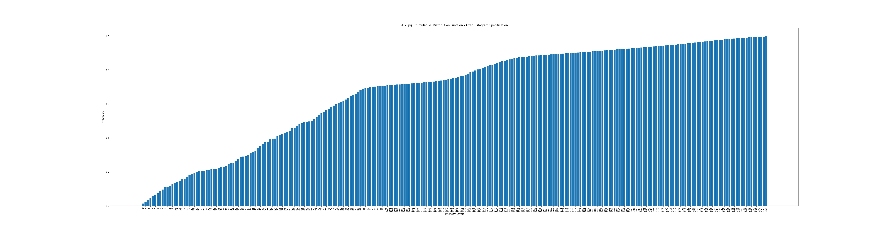

CDF of the Histogram specification Image

**Out of above three methods, I believe histogram specification produces better results since user can specify and play around with the intensity values using a target image or a specified histogram until the resulting image matches their desired brightness.**

**Question 2**

For this question I have used median filter and averaging filter.

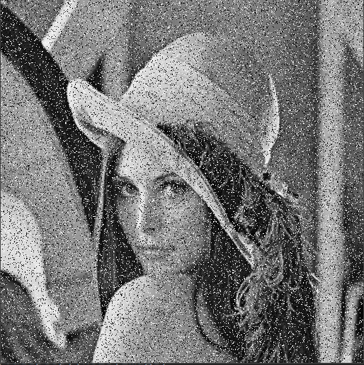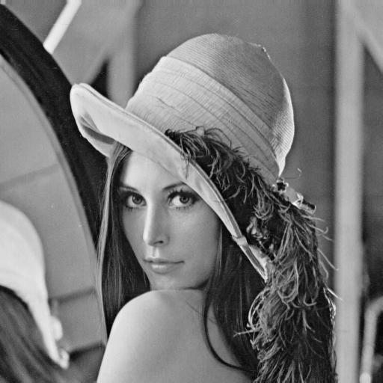

Noisy Image

Original Image

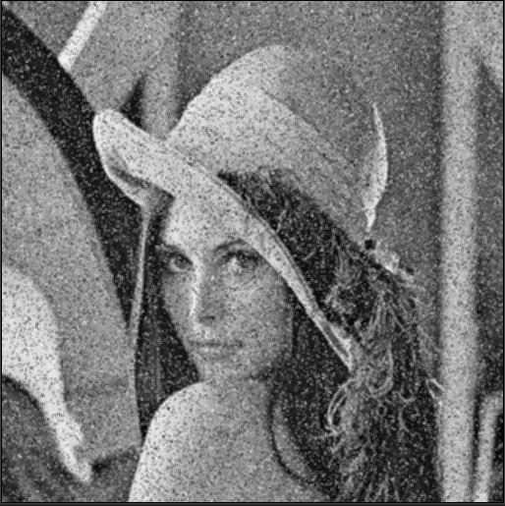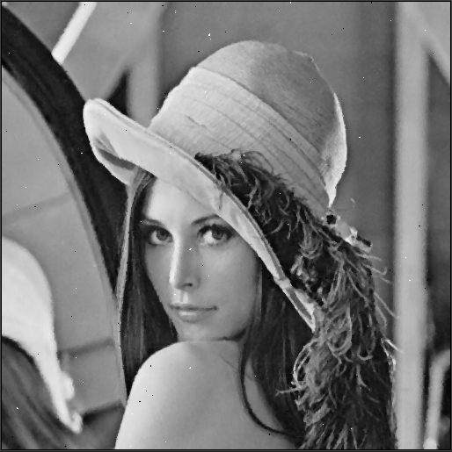

With averaging filter

With median filter

* When we compare resulting image from median filter to averaging filter, we can clearly see that median filter does a much better job at reducing noise (but there is very minute amount of noise left) compared to averaging filter where it consists of much noise. Also, the resulting image produced by the averaging filter blurry compared to median filter resulting image.