**Assignment #5 – EE 568 – Digital Image Processing – Winter 2021**

**Name: Kalana Sahabandu**

**Question 1**

I have used following filter to obtain the resulting image

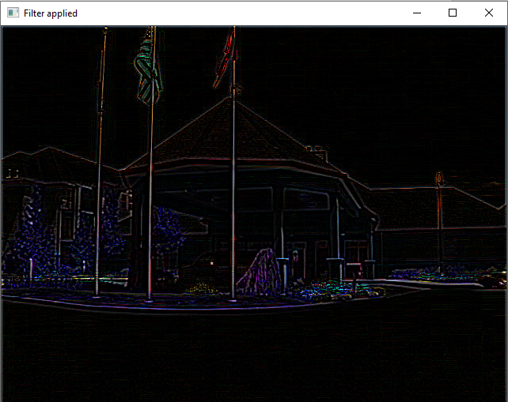

**After applying 3x3 high boost filter on 5_1.bmp image**

**Question 2**

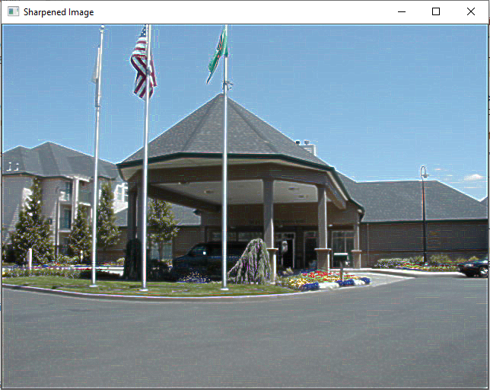

**After sharpening 5_1.bmp**