Coding Style, Project Structure, Minimum PC Requirements

1. Variables, Classes, Functions:
   1. **Public Variable**s: Use proper naming convention and a word that describes what the variable is used for.
   2. **Private Variables**: Add the letter ‘p’ an underscore(‘p_’) before every word to identify them as private (i.e. p_privateVar).
   3. **Global Variables**: Add ‘g_’ before the start of each word to identify the variable as a global one (i.e. g_GlobalVar).
   4. **Constant Variables**: Make the letters in all caps (i.e. CONST_VAR).
   5. **Classes**: Cap the first letter of every word (i.e. MyBaseClass).
   6. **Functions**: Make sure the function name describes its nature (i.e. CountTime, function that counts time).

1. Project Structure:

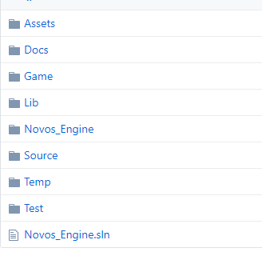

1. Minimum PC Requirements:
   1. **CPU**: Inter Core i5-8400
   2. **RAM**: 8GB
   3. **Graphics Card**: Nvidia GTX 970 / 1050(Recommended) GPU
   4. **Storage**: 256GB SSD, 1TB HDD

Component Architecture Description:

Our actor component will contain the following components:

1. Physics component which will include a Rigidbody, square collider, edge collider and capsule collider.
2. Pickup component that will be incharge of, weapons, health, mana and power-ups.
3. Script component which will contain input, movement, player and enemy.
4. Audio component that will take the audio source and an audio listener.
5. AI component that will be in charge of, pathfinding, follow and action.
6. Render component will contain mesh renderer, text renderer and sprite renderer.
7. Animation component that will take care of the animator and animation.

UML engine class structure

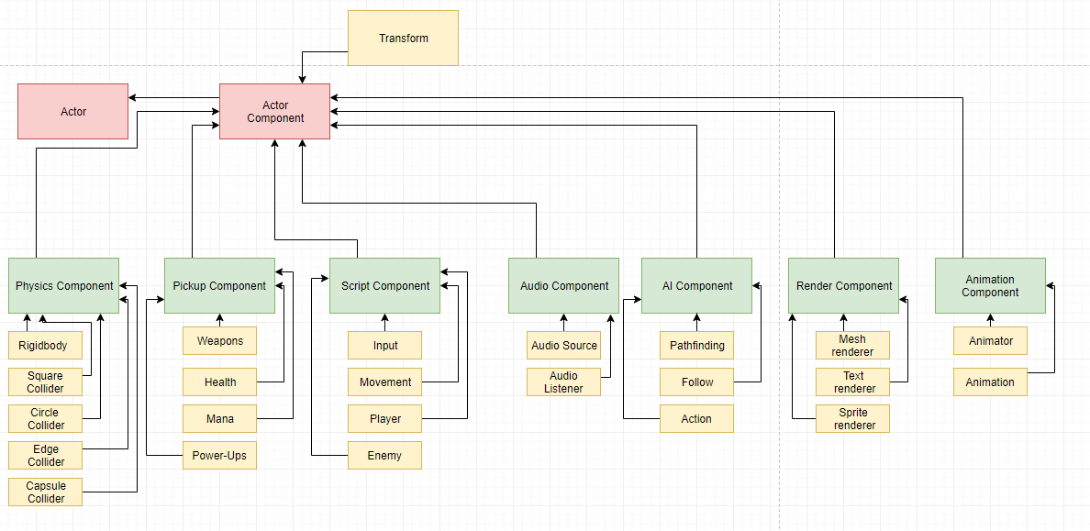

Description of your main loop:

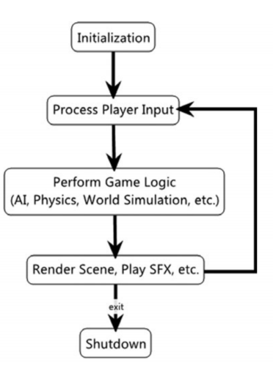

Skeleton files

