Project Statement

My plan is to make a space invaders style of game. I just want this to be a fun project where I can gain some experience to see if C# is a language that I want to continue to develop. I’ve always liked to play Galaga as a kid, and I miss playing it now since I really don’t ever have time for games anymore. A lot of my peers grew up also playing this game and I think they would enjoy a blast from the past. I would like this to be a multi-level game and have multiple modes of user input to play the game.

Project Plan

|  |  |
| --- | --- |
| 7/12-7/14 | Set up a UML diagram |
| 7/15 | Create private github repository |
| 7/16 | Revise UI mockup |
| 7/17-7/18 | Start working on invader class |
| 7/19-7/20 | Work on alien class |
| 7/21 | Revise requirements list |
| 7/22 | Create bullet class |
| 7/23 | Create bomb class |
| 7/24-7/26 | Set up UI |
| 7/27 | Test basic functionality |
| 7/28 | Add lives calculator-indicator |
| 7/29 | Add score indicator |
| 7/30 | Add score memory for high score return |
| 7/31 | Test functionality |
| 8/1 | Polish Code |
| 8/6 | Full Review and submit |

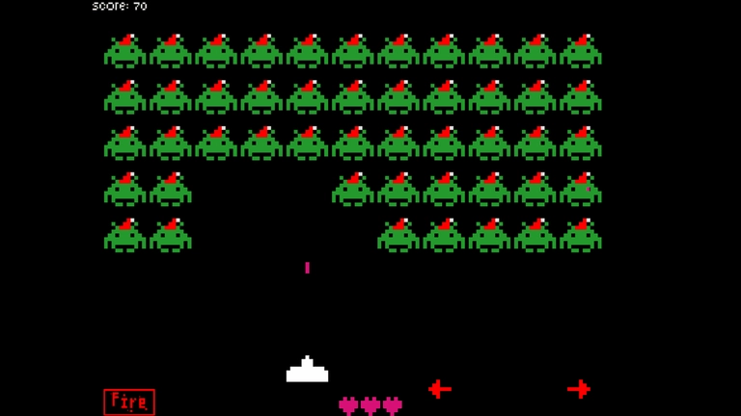UI Mockup

I plan for my game to look similar to this aesthetic.

Project Requirements

1. Moving player
2. Shooting a bullet
3. firing a bomb
4. restart game
5. edit difficulty
6. semi random movements for aliens
7. points counter
8. deaths counter
9. timer
10. calculate score after game ends
11. log score in score history to determine highest game

Class Design

1. Invader
2. Bomb
3. Bullet
4. Enemy
5. Lives Indicator
6. Score Indicator