Kypton Lantz  
January 6, 2025  
Module 1 - Assignment 1.2: GitHub Repository Setup

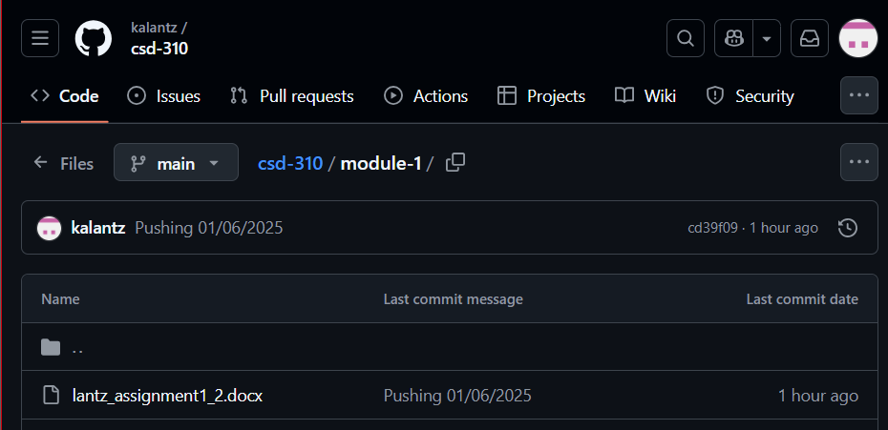

<https://github.com/kalantz/csd-310/tree/main>