Admin User Guide
Sophea Naildesign — Content Management System
Audience | Salon owner / staff
Prepared by | Kalapak Team
Version | 1.0
Date | 10 August 2026

This guide explains how to update website content without writing code.

1. How to log in
- Open your browser.
- Go to the Admin login page:
- Local / review: http://localhost:3000/admin/login
- Production: https://YOUR-DOMAIN/admin/login (replace with your live domain)
- Enter your email and password.
- Click Anmelden.
You will land on the Overview dashboard.

Default account (temporary)
Field | Value
Email | admin@sopheanaildesign.ch
Password | admin123

Change this password before the website goes public.

2. Dashboard layout
The Admin screen is organized into three clear areas:
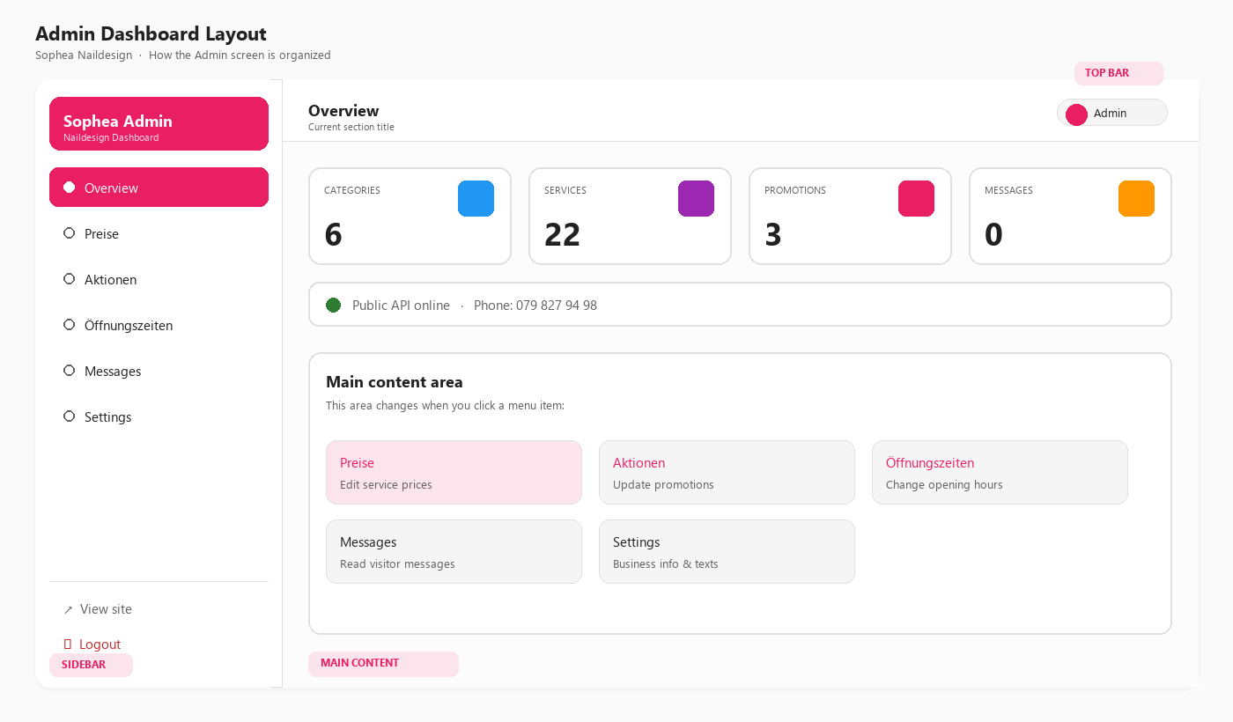
Admin Dashboard Layout — Sidebar, Top Bar, and Main Content
Area | Meaning
Sidebar | Main menu — switch between Overview, Preise, Aktionen, Öffnungszeiten, Messages, Settings
Top bar | Shows the current section title
Main content | Where you edit data for the selected menu item
View site | Opens the public website in a new tab
Logout | Ends your admin session
Mobile menu | On phones, open the sidebar with the ☰ button

3. Overview
Shows quick statistics:
- Number of Categories
- Number of Services
- Number of Promotions
- Number of Messages
- Public API status and phone number
Use this page to confirm the system is healthy after login.

4. Preise (Service prices)
Use this screen to update the CHF prices of your services.

Steps
- Click Preise in the sidebar.
- Find the category (e.g. Maniküre/Hände, Extras).
- Find the service name.
- Click the price box on the right.
- Type the new price (example: 45.00).
- Click outside the box (or press Tab).
The price is saved automatically when you leave the field.
A confirmation message appears briefly at the bottom-right.

Tips
- Enter numbers only (no “CHF” inside the box).
- Use a dot for decimals: 39.00
- Refresh the public website to see the new price (hard refresh: Ctrl + F5 if needed).

5. Aktionen (Promotions)
Use this screen to update promotional offer prices.

Steps
- Click Aktionen.
- Find the promotion card (title + highlight).
- Edit the CHF price.
- Leave the field to save.
Promotion titles and styles are managed in Settings (advanced) if deeper text changes are required.

6. Öffnungszeiten (Opening hours)
These hours appear in the website footer.

Steps
- Click Öffnungszeiten.
- Edit the text next to each day (e.g. 09:00 – 19:00 or Geschlossen).
- Leave the field to save.

Example formats
Example | Meaning
09:00 – 19:00 | Open from 9 to 19
10:00 – 18:00 | Saturday hours
Geschlossen | Closed

Keep formatting consistent so the footer looks clean.

7. Messages
Shows messages submitted by visitors (when the contact API is used).
Situation | What you see
No messages | Empty state: *Keine Nachrichten*
New messages | Cards with name, email, and message text

Recommendation: Check this page regularly if you enable contact submissions on production.

8. Settings (advanced)
Settings store business information such as:
- Business name
- Phone number
- Address
- Instagram / Facebook links
- Hero and about text
They are shown as JSON (structured text).

How to edit safely
- Click Settings.
- Change only the values between quotes — do not remove commas or braces.
- Click Save settings.
- If you see an error (JSON ungültig), undo your last edit or ask your developer to fix formatting.
Example (simplified):
{
"business_name": "Sophea Naildesign",
"phone": "079 827 94 98",
"instagram": "https://www.instagram.com/..."
}
If you are not comfortable editing JSON, ask Kalapak Team to change text for you, or request a future upgrade with form fields instead of raw JSON.

9. Daily / weekly checklist
Frequency | Task
Weekly | Review Preise if any prices changed in the salon
When needed | Update Aktionen for seasonal offers
When needed | Update Öffnungszeiten for holidays
Weekly | Check Messages
After go-live | Change admin password

10. Common questions

I logged in but the public site still shows old prices
- Confirm you left the price field (so it saved).
- Open the public site and refresh (Ctrl + F5).
- Confirm the frontend is connected to the same backend/API.

I forgot my password
Ask your developer / Kalapak Team to reset the admin password in the database or create a new admin user.

Can I add a new service myself?
The current admin UI focuses on editing prices for existing services. Adding/removing services can be done via the API or by requesting a small CMS upgrade (Add / Delete buttons).

Is the Instagram feed editable in Admin?
No. Instagram content comes from the connected Instagram account through the Elfsight widget (same approach as the reference website). Manage posts in Instagram itself.

11. Security tips
- Do not share the admin URL and password on social media.
- Use a strong unique password after handover.
- Log out when finished on a shared computer.
- Keep the browser updated.

12. Need help?
Contact Kalapak Team with:
- What you tried to change
- A screenshot of the screen / error
- Whether you are on local review or the live website

End of Admin User Guide — Version 1.0

