Table of Contents

Use Case Diagram and Description 3
Use Case Name: Calculates area/Circumference. 3
Use Case Name: Clear Fields 4
Use Case Name: Exit Application 4
Use Case Name: Display Timer 4
Finite State Machine Diagram 5
Activity Diagrams 6
Activity Diagram: (Calculates Area/Circumference) 6
Activity Diagram: (Clear fields) 7
Activity Diagram: (Exit Application) 7
Activity Diagram: (Display Timer) 8
Sequence Diagrams for each Use case 9
Flow without any error messages when calculate button is pressed 9
Flow when any error messages occur when calculate button is pressed 10
Flow when clear button is pressed by the user 10
Flow when exit button is pressed by the user 11
Flow for the timer module 11

Use Case Diagram and Description
calculates area/circumference
Clear fields
Exit Application
Application User
Application
Application
Calculates time
Displays timer
<<includes>>

Timer

Use Case Name: Calculates area/Circumference.
Summary : The application performs the validation of the user inputs and calculates the area and circumference.
Actor: Application User
Pre-Condition: Default application main screen is visible.
Description:
1.User enters the value for radius.
2.User enters the value for the length of precision of pi
3.User clicks on Calculate button.
4.If the values entered in the radius is not empty and valid then the verification for the length of the precision of pi is checked.
5.If the values entered in the precision is not empty and is valid ( i.e. between 0 and 16) then the calculation is performed.
7.If the steps 4 & 5 are succeeded, then the value of circumference and area is displayed to the user for their reference.
Alternatives: If the field values are not valid the error messages are displayed based on the invalid inputs in the field.
Post-condition: The values for the radius and circumference is calculated and displayed in the respective fields.

Use Case Name: Clear Fields
Summary : The application performs the reset for the field values for the user to continue with the new values for their calculation.
Actor: Application User
Pre-Condition: Default application main screen is visible.
Description:
1.User clicks on the clear button and then the values in all the fields are reset to their default values.
Alternatives: If the clear option doesn’t work, the fields in the application window are not reset to their default values.
Post-Condition: Now the user can enter the new values for the calculation.

Use Case Name: Exit Application
Summary : The application closes when the exit button is pressed
Actor: Application User
Pre-Condition: Default application main screen is visible.
Description:
1.User clicks on the exit button and then the application closes.
2.Displays the Home Screen.
Alternatives: If the exit operation doesn’t work then the application is not closed and it stays in the current main activity screen.
Post-Condition: Now the user is at the Home Screen wherein he can choose a different application to process.

Use Case Name: Display Timer
Summary: The application displays the user the time for three different zones.
Actor: Timer (As for every one second the timer module is triggered with help of sleep time, hence timer is the actor and not the application user)
Pre-condition: The initial system time is displayed when the application is opened by the user in the main screen.
Description:
1.When the user opens the application the system time along with the India time and pacific time are displayed.
2.On the update/change in system time these values are also changed and the respective results are displayed on the screen.
Alternatives: When this timer module is not working then the update in the time is not done based on the delay/sleep time.
Post-condition: The updating system time is displayed for all three timing zones (India, central and Pacific time)

Finite State Machine Diagram

open application

Initial state
Inputs accepted
Result
Valid
Calculate

Reset
Invalid
End/ start
Error
Exit
Clear

Calculate state
Calculate and reset state

Timer trigger

Timer

Activity Diagrams

Activity Diagram: (Calculates Area/Circumference)

Actor (User) Application/System
Enter the radius and length of precision of pi
Click on calculate
Verify radius value
Display Error Messages
Verify the precision of pi
Invalid
Display Error Messages
Valid
Calculates area
Calculates Circumference
Round off them to 8 digits
Round off them to 8 digits
Displays the result
Invalid
Valid

Activity Diagram: (Clear fields)

Actor (User) Application/System

Clicks on the clear button

Reset the values of the fields

Displays the reset values of the field to the user

Activity Diagram: (Exit Application)

Actor (User) Application/System

Clicks on the Exit button

Exit the application and displays the home screen

Activity Diagram: (Display Timer)

Actor (Timer) Application/System

Timer gives a trigger for every 3000 milliseconds
Calculates the current system time
Calculates the California time
Calculates India time
Displays the current system time, Pacific Time and India time

Sequence Diagrams for each Use case

Flow without any error messages when calculate button is pressed

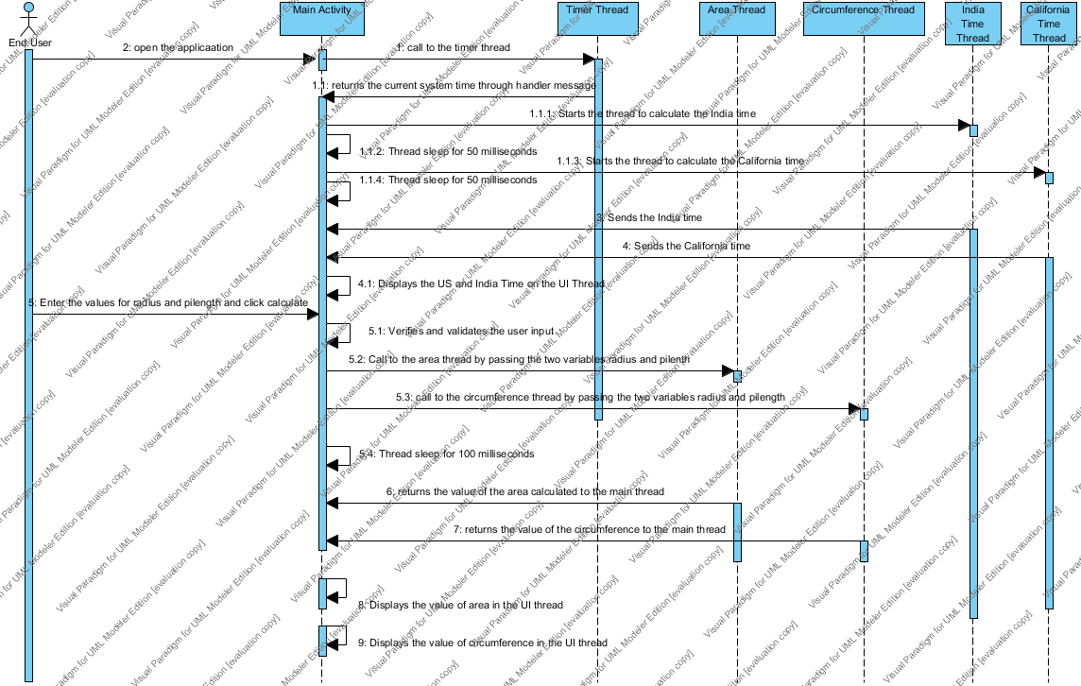

Flow when any error messages occur when calculate button is pressed

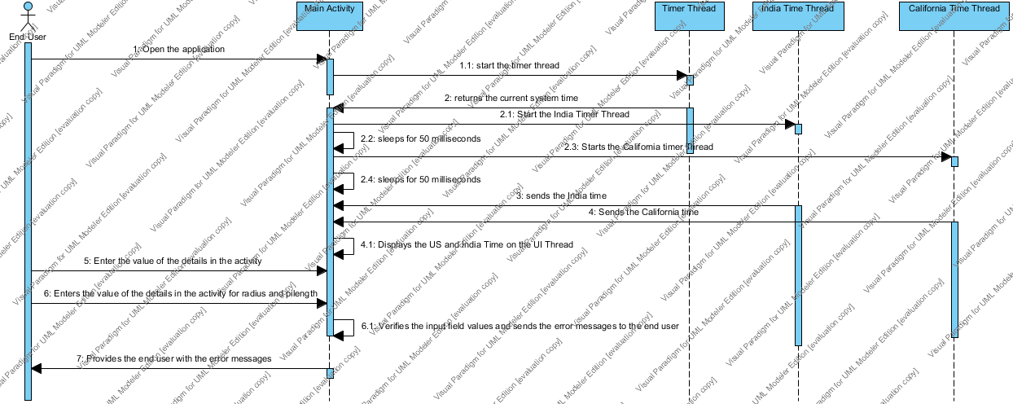

Flow when clear button is pressed by the user

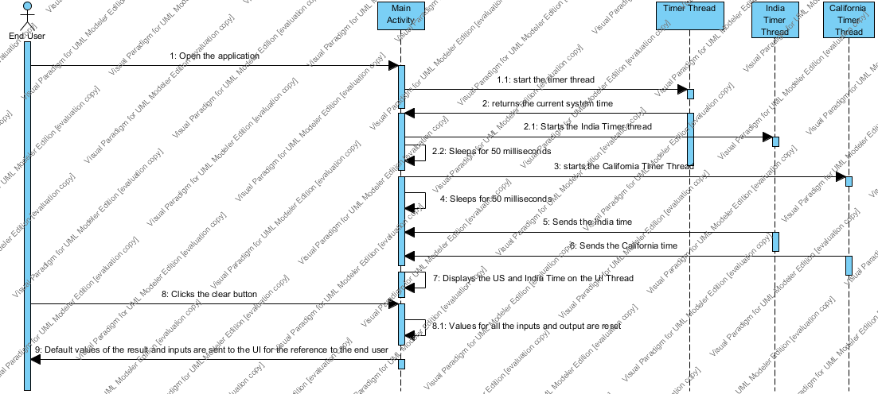

Flow when exit button is pressed by the user

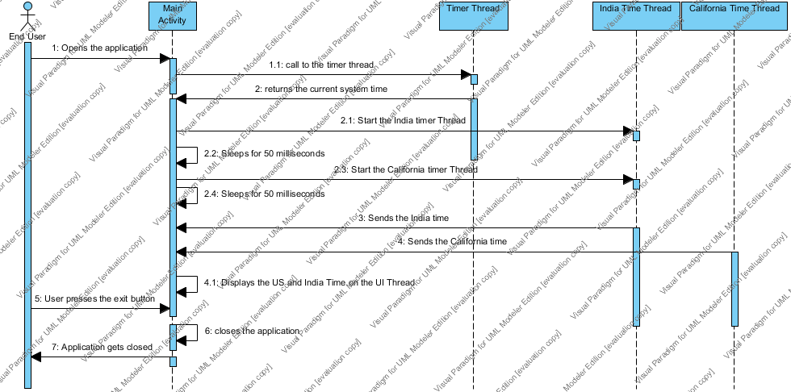

Flow for the timer module

