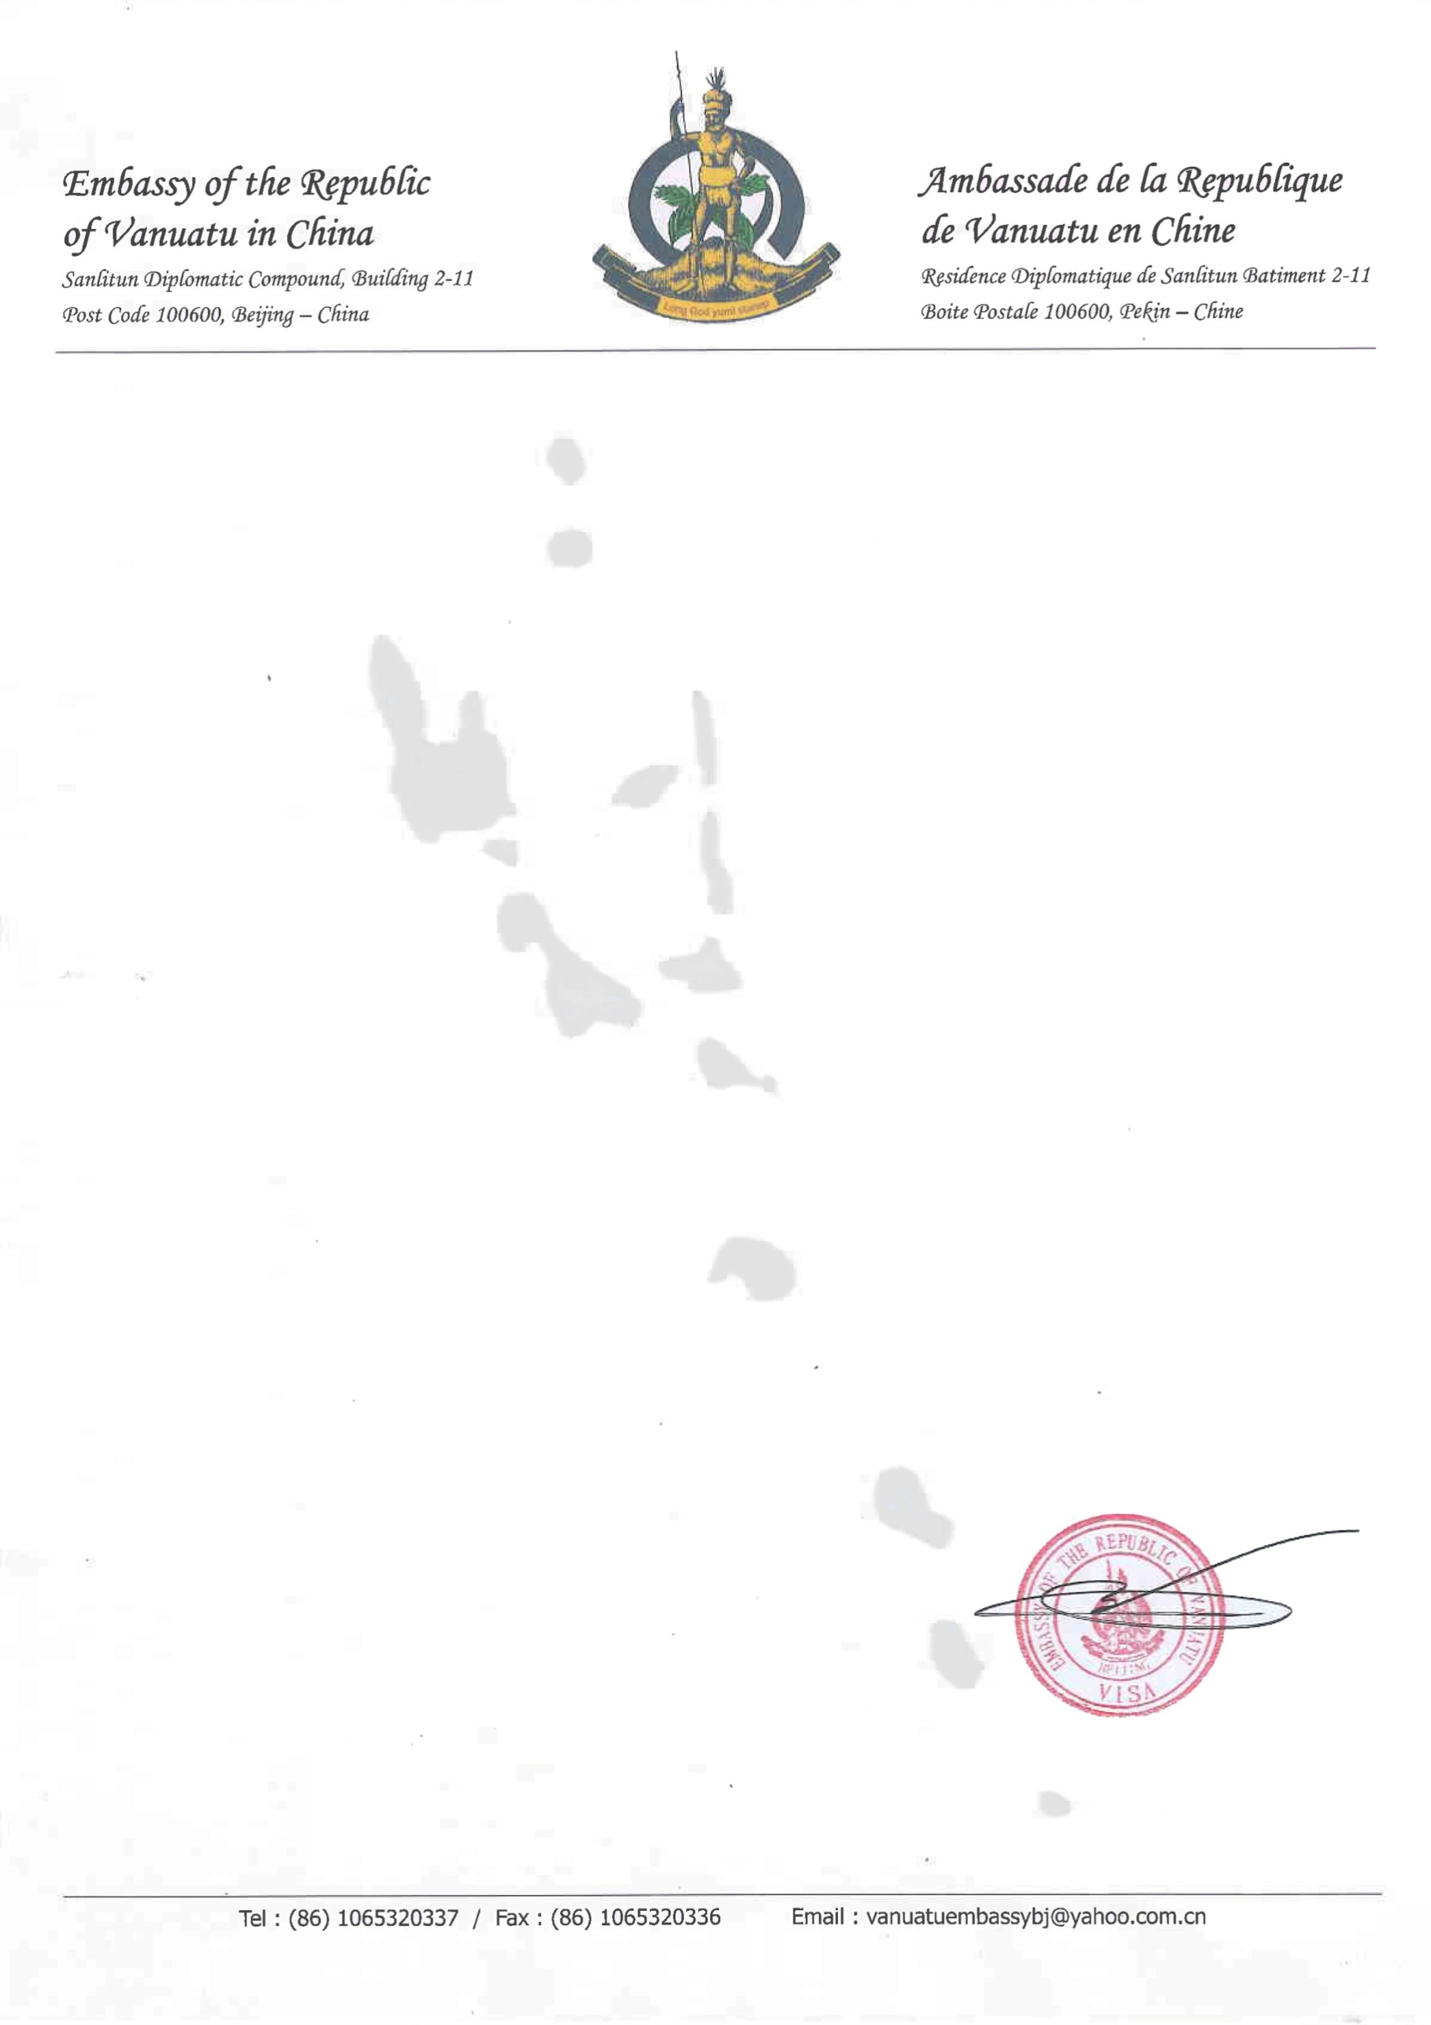

**Single Entry Visa**

Name :${name}

Visa No :${visa_no}

Date of lssue :${date_of_issue_v}

Date of Expiry :${date_of_expiry_v}

Max Days of Stay: 90 Days

Sex :${sex}

Place of Birth :${place_of_birth}

Passport No. :${passport_no}

Date of Birth :${date_of_birth}

Type :${type}

Place of lssue :${place_of_issue_p}

Passport Date of lssue :${date_of_issue_p}

Passport Date of Expiry :${date_of_expiry_p}

Visa Fee :${visa_fee}