A

Mini Project Report on

### MEDITRACK

Submitted in partial fulfillment of the requirements for the degree of

BACHELOR OF ENGINEERING

IN

**Computer Science & Engineering**

Artificial Intelligence & Machine Learning by

Disha Yadav (23106011)

Samhita Vadlamudi (23106077)

Kalash Pandey (23106049)

Bhoomi Yadav (23106022) Under the guidance of

### Prof. Mahesh Pawaskar



**Department of Computer Science & Engineering (Artificial Intelligence & Machine Learning)**

**A. P. Shah Institute of Technology**

**G. B. Road, Kasarvadavali, Thane (W)-400615 University Of Mumbai**

**2024-2025**



### CERTIFICATE

This is to certify that the project entitled “**MEDITRACK”** is a bonafide work of Disha Yadav (23106011), Samhita Vadlamudi (23106077), Kalash Pandey (23106049), Bhoomi Yadav (23106022) submitted to the University of Mumbai in partial fulfillment of the requirement for the award of **Bachelor of Engineering** in **Computer Science & Engineering (Artificial Intelligence & Machine Learning).**

Prof. Mahesh Pawaskar Dr. Jaya Gupta Mini Project Guide Head of Department



### Project Report Approval

This Mini project report entitled “**MEDITRACK*”*** by **Disha Yadav, Samhita Vadlamudi, Kalash Pandey and Bhoomi Yadav** is approved for the degree of ***Bachelor of Engineering*** in ***Computer Science &Engineering***, (AI&ML) ***2024- 25***.

External Examiner:

Internal Examiner:

Place: APSIT, Thane Date:

**Declaration**

We declare that this written submission represents my ideas in my own words and where others' ideas or words have been included, I have adequately cited and referenced the original sources. I also declare that I have adhered to all principles of academic honesty and integrity and have not misrepresented or fabricated or falsified any idea/data/fact/source in my submission. I understand that any violation of the above will be cause for disciplinary action by the Institute and can also evoke penal action from the sources which have thus not been properly cited or from whom proper permission has not been taken when needed.

Disha Yadav Samhita Vadlamudi

Kalash Pandey Bhoomi Yadav

(23106011) (23106077) (23106049) (23106022)

#### ABSTRACT

MediTrack is a web-based health monitoring system designed to assist users in tracking their symptoms, medications, and overall health progress. Many individuals, especially those managing chronic illnesses or recovering from medical procedures, struggle with maintaining structured health records. Traditional methods, such as paper logs or fragmented digital notes, often lead to inconsistencies, making it difficult for patients to monitor their health effectively. MediTrack addresses these challenges by offering a centralized and user-friendly platform that enables users to log daily health data, set medication reminders, and visualize health trends through interactive graphical reports.

The system is developed using HTML, CSS, and JavaScript for the frontend and Django with SQLite for the backend, ensuring a lightweight yet efficient solution for health data storage. SQLite is chosen for its ease of integration and reliability, allowing users to maintain accurate records without requiring complex database management. MediTrack offers features such as symptom tracking, appointment scheduling, automated health alerts, and secure data storage, ensuring a seamless user experience.

By bridging the gap between traditional healthcare systems and modern digital solutions, MediTrack empowers individuals to take proactive control of their well-being. The platform promotes treatment adherence, self-monitoring, and early detection of potential health issues, thereby enhancing communication between patients and healthcare providers. With its intuitive design and real-time tracking capabilities, MediTrack serves as a valuable tool for improving overall health management and promoting preventive care.

**Index**

|  |  |  |  |
| --- | --- | --- | --- |
| Index | | | Page no. |
| Chapter-1 | | |  |
|  | Introduction | | 7 |
|  |  |  |  |
| Chapter-2 | | |  |
|  | Literature Survey | | 10 |
|  | 2.1 | History |  |
|  | 2.2 | Review |  |
|  |  |  |  |
| Chapter-3 | | |  |
|  | Problem Statement | | 13 |
|  |  |  |  |
| Chapter-4 | | |  |
|  | Experimental Setup | | 15 |
|  | 4.1 | Hardware setup |  |
|  | 4.2 | Software Setup |  |
|  |  |  |  |
| Chapter-5 | | |  |
|  | Proposed system and Implementation | | 16 |
|  | 5.1 | Block Diagram of proposed system |  |
|  | 5.2 | Description of Block diagram | 17 |
|  | 5.3 | Implementation | 19 |
|  |  |  |  |
| Chapter-6 | | |  |
|  | Conclusion | | 24 |
|  |  |  |  |
| References | | | 25 |
|  |  |  |  |

# CHAPTER 1 INTRODUCTION

#### INTRODUCTION

Healthcare management has significantly evolved with the rise of digital solutions that enhance patient engagement, self-care, and overall well-being. For individuals managing chronic conditions, recovering from medical treatments, or aiming for a healthier lifestyle, maintaining an accurate and consistent health record is essential. However, traditional healthcare systems primarily rely on periodic doctor visits, which may not provide real-time insights into a patient’s health. Many individuals struggle with tracking symptoms, medications, and lifestyle habits, leading to missed doses, delayed medical attention, and ineffective treatment plans. Furthermore, the lack of structured self-monitoring tools makes it challenging for patients to communicate their health status accurately to healthcare providers.

To address these challenges, this project introduces a Personalized Medical Tracker, a virtual health logbook that allows individuals to systematically record and monitor their health data. Unlike physical tracking devices, this system functions as a digital self-monitoring tool, providing users with a structured platform to log medical history, track symptoms, set medication reminders, and monitor lifestyle habits such as diet, exercise, and sleep. With the increasing adoption of digital healthcare technologies, this project aims to empower individuals by offering a personalized, efficient, and accessible way to take charge of their health.

The primary objective of this project is to develop a comprehensive health tracking system that enhances self-awareness, promotes adherence to treatment plans, and improves communication between patients and healthcare providers. By integrating features such as medication and appointment reminders, graphical health reports, and trend analysis, the tracker helps users stay consistent with their healthcare routines. Additionally, a well-maintained digital log enables patients to share accurate health records with doctors, leading to better diagnoses, personalized treatment plans, and proactive healthcare interventions.

This project is particularly beneficial for patients with chronic conditions, elderly individuals, and general users seeking to improve their overall well-being. By providing a user-friendly, intuitive design, the tracker ensures accessibility for users of all age groups and varying levels of technological literacy. Ultimately, the Personalized Medical Tracker bridges the gap between traditional healthcare and modern digital solutions, encouraging better self-care, preventive healthcare, and improved health outcomes.

# CHAPTER 2 LITERATURE SURVEY

#### LITERATURE SURVEY

**Lupton, D.** (2017) proposed that self-tracking practices—where individuals collect and analyze personal health data using digital technologies—are reshaping how people understand and manage their health. She emphasized that the rise of wearable devices, health apps, and online platforms has fostered a culture of the “quantified self,” where data becomes central to self-knowledge and self-care. Lupton also discussed the implications of this trend on patient identity, embodiment, and medical relationships, suggesting that self-tracking not only empowers patients but also introduces new expectations for self-responsibility in healthcare.

**Huygens et al.** (2017) proposed that patients’ willingness to engage in self-monitoring of their health data is influenced significantly by their perception of how controllable their chronic disease is. In their study involving 627 patients across 17 different chronic conditions, they found that individuals with diseases considered more controllable—such as diabetes, asthma, and hypertension—showed higher willingness to self-monitor. Conversely, patients with less controllable conditions, like rheumatism and neurological disorders, were less inclined to self-track. Interestingly, general self-efficacy and perceived health problems did not show a significant correlation with the willingness to self-monitor. The authors concluded that perceived disease controllability is a key factor that should be considered when designing interventions to promote self-monitoring behaviors.

​Figueiredo et al. (2017) proposed that routine self-tracking of health data—defined as the consistent and regular collection of personal health information—can lead to more proactive health management behaviors. Analyzing data from the Pew Survey on Tracking for Health, they found that individuals who engaged in routine self-tracking were more likely to report positive changes in their health management practices compared to those who tracked their health data occasionally or only in response to specific events. The study identified recent visits to emergency care and the use of digital tracking tools as significant predictors of routine self-tracking behavior. These findings suggest that consistent self-tracking may empower individuals to take a more active role in managing their health, highlighting the potential benefits of integrating self-tracking features into health management applications.

Choi, S. (2023) proposed that traditional self-care models in nursing require revision to effectively integrate personal health tracking technologies. In her viewpoint article, she highlights that while existing models comprehensively address self-care concepts, they often overlook the critical role of human-technology interactions, especially pertinent in the digital age. Choi emphasizes that personal informatics and mobile health (mHealth) tools have become integral to modern self-care practices, influencing how individuals manage their health. To address this gap, she introduces a refined, digitized self-care model that incorporates self-tracking behaviors and mHealth technologies. This updated framework aims to guide future nursing interventions, facilitating patient engagement and improving health outcomes in the context of digital health.

**Pawelek et al. (2022)** explored the role of patient engagement with Electronic Health Records (EHRs) in enhancing clinical research. The authors discussed how integrating EHR data into research can improve patient involvement and data quality, making clinical studies more patient-centered. They highlighted the advantages of using EHRs for continuous, real-time data collection, which can support processes like diagnosis and treatment monitoring. However, challenges such as data privacy, consent, and ethical considerations must be addressed for successful integration. The authors concluded that effective patient engagement with EHRs can lead to better research outcomes, but careful attention to data quality and ethical concerns is necessary.

**Nazi et al. (2024)** proposed the potential of patient-generated health data (PGHD) in enhancing healthcare delivery. PGHD refers to health-related data created, captured, or recorded by patients outside of clinical settings, such as through wearable devices or mobile health applications. The authors discuss how PGHD can supplement traditional clinical data, offering real-time insights into a patient's health status. They highlight the role of electronic PGHD in improving the diagnosis and management of chronic conditions, thereby fostering more connected and continuous care between patients and healthcare providers. Despite its potential, the article acknowledges challenges in the widespread adoption of PGHD, including issues related to data integration, standardization, and ensuring patient privacy and consent. The authors emphasize the need for further research and development to fully realize the benefits of PGHD in clinical practice.

The reviewed literature underscores the potential of patient-maintained health logbooks in promoting self-care, improving communication with healthcare professionals, and enhancing patient engagement. However, challenges such as data accuracy, integration with healthcare systems, and user adoption remain critical areas of concern.

# CHAPTER 3

## Problem Statement

#### PROBLEM STATEMENT

Healthcare systems have traditionally relied on periodic doctor visits, but these provide only limited insights into a patient’s daily health. This lack of continuous monitoring is particularly challenging for individuals managing chronic illnesses, recovering from medical procedures, or striving for better health. Without a structured way to track symptoms, medications, and lifestyle habits, many patients struggle with treatment adherence, leading to missed medication doses, delayed medical intervention, and poor health outcomes.

A major challenge is the absence of a centralized, user-friendly system for recording and monitoring health data. Traditional methods, such as paper logs or scattered digital notes, are inconsistent and unreliable, often leading to incomplete records. Many individuals rely on memory, resulting in inaccurate information that makes it difficult for healthcare providers to make informed decisions. While some digital health tools exist, they are often complex, fragmented, or inaccessible to those with limited technological literacy. Many focus on isolated aspects of health, such as fitness tracking or medication reminders, but fail to provide an integrated solution, leading to inefficiencies in health management.

As preventive healthcare gains importance, there is a growing need for a seamless, structured, and accessible self-monitoring tool. To address these challenges, this project introduces the Personalized Medical Tracker, a virtual health logbook designed to help individuals systematically record, track, and manage their health data. This platform offers structured documentation of symptoms, medications, and lifestyle habits while integrating features like medication and appointment reminders, graphical health reports, and trend analysis. By bridging the gap between traditional healthcare and modern digital solutions, the Personalized Medical Tracker empowers individuals to take control of their health, enhances communication with healthcare providers, and promotes better health outcomes.

# CHAPTER 4

## Experimental Setup

#### EXPERIMENTAL SETUP

* 1. Hardware Setup
     + PC/Laptop with Windows 11 for development and testing.
  2. Software Setup
     + Frontend Development:
       - HTML, CSS, JavaScript: Used for designing and styling the user interface, ensuring a responsive and user-friendly experience.
     + Backend Development:
       - Django: A Python-based web framework used for server-side logic, handling authentication, and managing health data.
       - Node.js: Used for specific backend functionalities and API handling.
     + Database Management:
       - SQL: A relational database used to store and retrieve user health records securely.
     + Development Tools:
       - Visual Studio Code: Used for coding and debugging front-end and back-end components.

# CHAPTER 5

## Proposed System & Implementation

#### PROPOSED SYSTEM AND IMPLEMENTATION

##### Block Diagram of Proposed System

The proposed system, "Personalized Medical Tracker," is a health-monitoring web application that allows users to log symptoms, track medications, set reminders, and visualize health trends. It integrates a frontend web interface with a Django backend and a MySQL database to store and manage user health records.

Block Diagram Components:

* + - User Interface (UI):
      * Symptom Tracker, Medication Log, Reminder System, Health Reports, Profile Management
      * Users enter and manage health data, receive medication alerts, and view progress
    - Backend API (Django Server):
      * RESTful API endpoints for user authentication, data storage, and analytics
      * Handles frontend requests, processes data, and interacts with the database
    - Database (MySQL):
      * Tables for user profiles, medication logs, symptom records, and reminders
      * Secure storage of health data for future retrieval and analysis
    - Communication Flow:
      * Data exchange between frontend and backend through REST API

##### Description of Block Diagram

The block diagram outlines the key components and their interactions.

* + - User Interface (UI):
      * Built using HTML, CSS, and JavaScript
      * Includes symptom tracking, medication logging, reminders, health reports, and profile management
    - Backend API (Django Server):
      * Developed using Django and Django REST Framework (DRF)
      * Provides secure authentication, health tracking, reminders, and analytics
    - Database (SQLite):
      * Stores structured health data including user profiles, medications, symptoms, and reminders
    - Communication Flow:
      * REST API ensures smooth data exchange between frontend and backend

##### Implementation

1. Implementation Details:
   * The development follows a structured approach using modern web technologies
2. Technologies Used:
   * Frontend: HTML, CSS, JavaScript
   * Backend: Django, Django REST Framework (DRF)
   * Database: SQLite
3. Development Process:
   * Frontend Development:
     + UI designed with HTML, CSS, and JavaScript
     + Forms for symptom and medication input
     + Graphical reports for health trends
   * Backend Development:
     + Django REST Framework provides secure API endpoints
     + Database transactions handled efficiently with Django ORM
   * Testing:
     + Manual Testing: UI responsiveness and user experience validation
     + Automated Testing: API functionality and performance evaluation

Sign-in page:

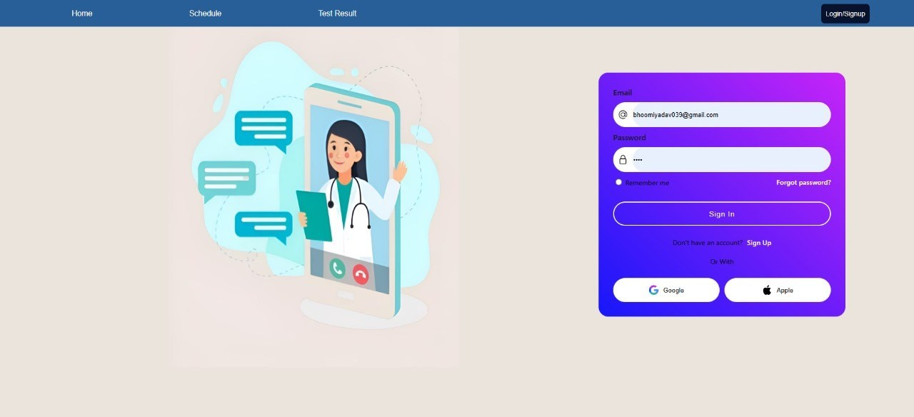

Fig 5.1: Screenshot of sign-in page

Homepage:

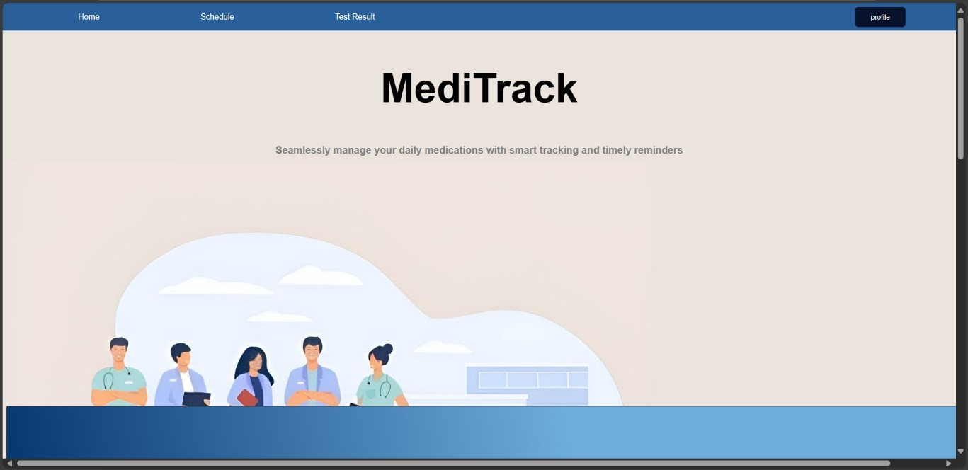

Fig 5.2: Screenshot of homepage

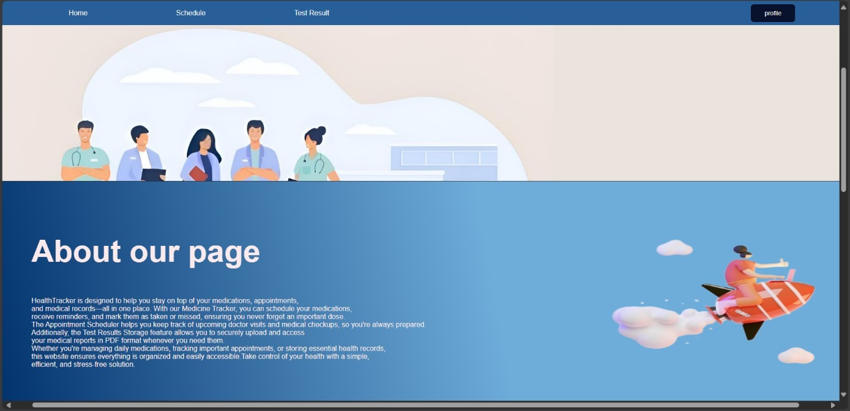

Fig 5.3: Screenshot of home page

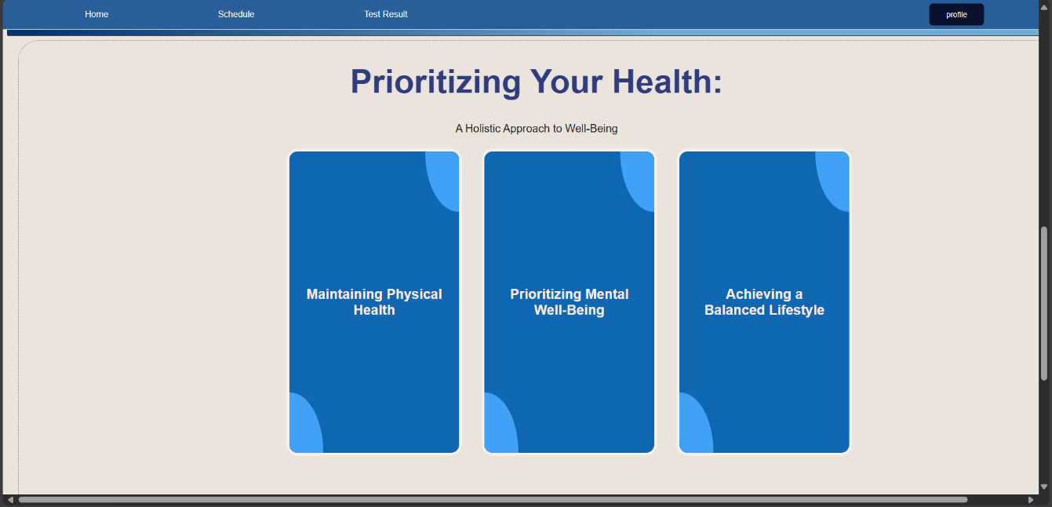

Fig 5.4: Screenshot of home page

Schedule:

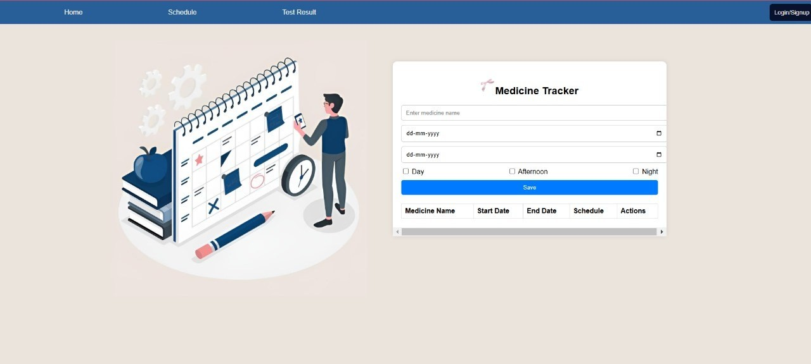

Fig 5.5: Screenshot of schedule

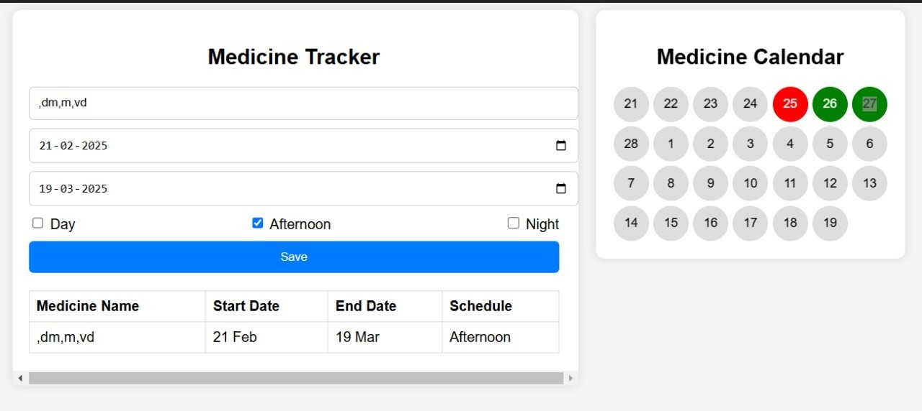

Fig 5.6: Screenshot of schedule

Test Result:

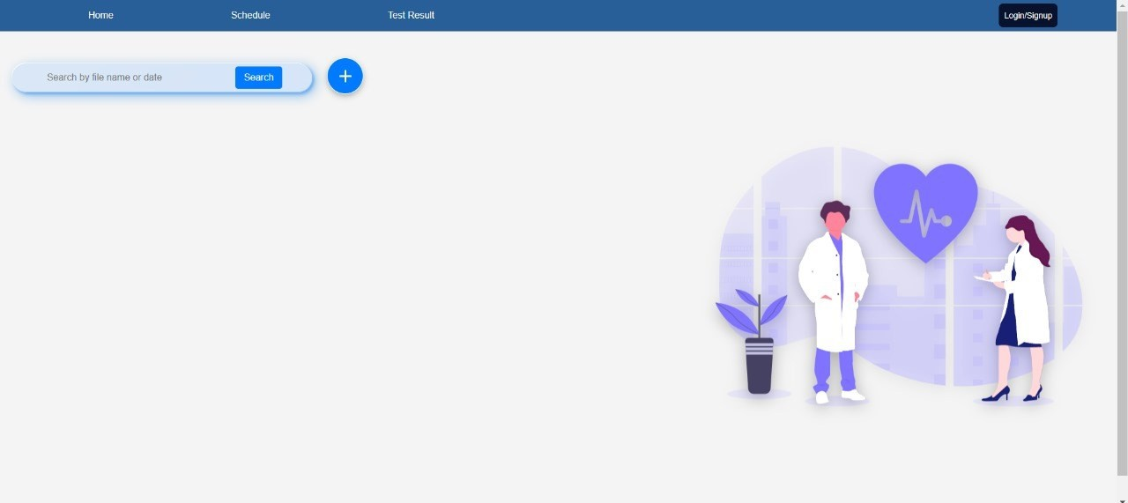

Fig 5.7: Screenshot of test result

Profile:

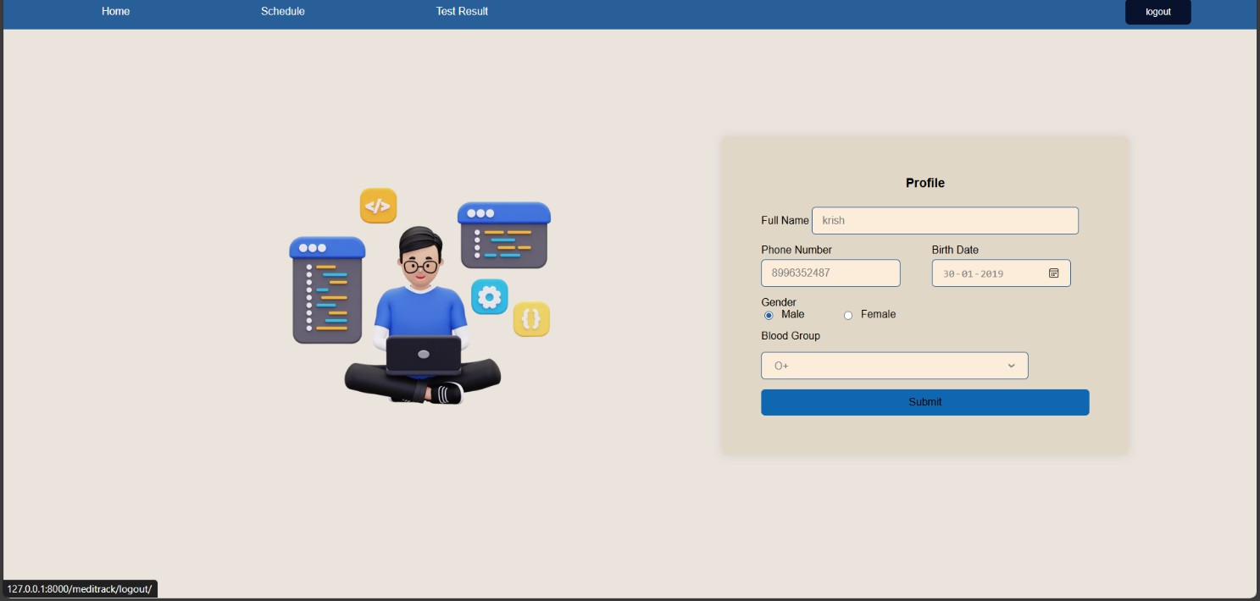

Fig 5.8: Screenshot of profile

# CHAPTER 6

## Conclusion

#### CONCLUSION

The Personalized Medical Tracker system provides a comprehensive and user-friendly solution for health monitoring, addressing the challenges of inconsistent health tracking and medication adherence. By allowing users to log symptoms, track medications, receive reminders, and visualize health trends, the system promotes a proactive approach to personal healthcare. The integration of Django for backend development ensures efficient data processing, while MySQL provides a secure and structured database for storing health records. The intuitive user interface enhances accessibility, making it easy for individuals to manage their health information effectively.

Additionally, the system’s RESTful API ensures smooth communication between the frontend and backend, enabling real-time updates and data retrieval. The implementation of graphical health reports allows users to identify patterns in their symptoms and medication effectiveness, aiding in better decision-making. Through a combination of automation, structured data storage, and seamless interaction between system components, the Personalized Medical Tracker bridges the gap between traditional healthcare methods and digital solutions. This system empowers individuals to take greater control of their health while also providing healthcare professionals with accurate and structured data for improved medical guidance and timely intervention.

**References**

[1] Lupton, D. (2016). “Self-tracking, health and medicine.” Health Sociology Review, 25(1), 11-23.

[2] Huygens, M. W. J., Swinkels, I. C. S., de Jong, J. D., Heijmans, M. J. W. M., Friele, R. D., van Schayck, O. C. P., & de Witte, L. P. (2017). Self-monitoring of health data by patients with a chronic disease: does disease controllability matter? BMC Family Practice, 18(1), 40

[3] Figueiredo, M., Caldeira, C., Chen, Y., & Zheng, K. (2018). Routine self-tracking of health: reasons, facilitating factors, and the potential impact on health management practices. AMIA Annual Symposium Proceedings, 2017, 706–714.

[4] Choi, S. (2023). Personal health tracking: A paradigm shift in the self-care models in nursing. JMIR Nursing, 6, e50991

[5] West, P., Van Kleek, M., Giordano, R., Weal, M., & Shadbolt, N. (2017). Information quality challenges of patient-generated data in clinical practice. Frontiers in Public Health, 5, 284.

[6] Pawelek, J., et al. (2022). The power of patient engagement with electronic health records as research participants. JMIR Medical Informatics, 7(7), e39145.

[7] Nazi, K. M., et al. (2024). Patient-generated health data: Challenges and opportunities. Journal of Medical Internet Research, 26(4), e10937868.