**Lower to upper and Upper to lower Code:**

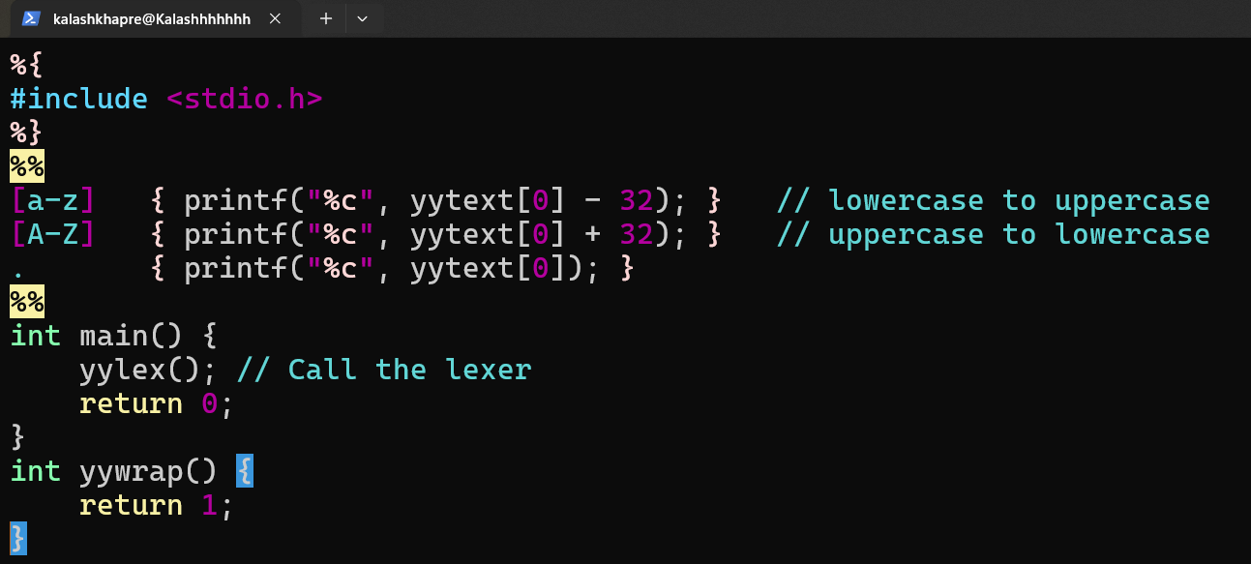

**Output: lower to upper:**

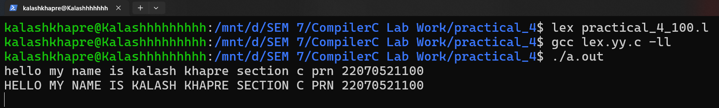

**Output: upper to lower:**

