CINEVAULT RENTALS

MySQL Database Analyst

NAME:KALA SRVANI
DATABASE USED:SAKILA

Section A — Schema Design & DDL

Q1. New Franchise Rollout

Question:
CineVault is opening a new Employee Performance tracking module, separate from the existing staff table.

a)Create a table cv_employee_perf with: perf_id (INT, PK, AUTO_INCREMENT), staff_id (INT), review_month (DATE), films_processed (INT), rating (DECIMAL(3,1)), remarks (VARCHAR(255))

Query:
CREATE TABLE cv_employee_perf (
perf_id INT PRIMARY KEY AUTO_INCREMENT,
staff_id INT,
review_month DATE,
films_processed INT,
rating DECIMAL(3,1),
remarks VARCHAR(255)
);
DESCRIBE cv_employee_perf;

Output:
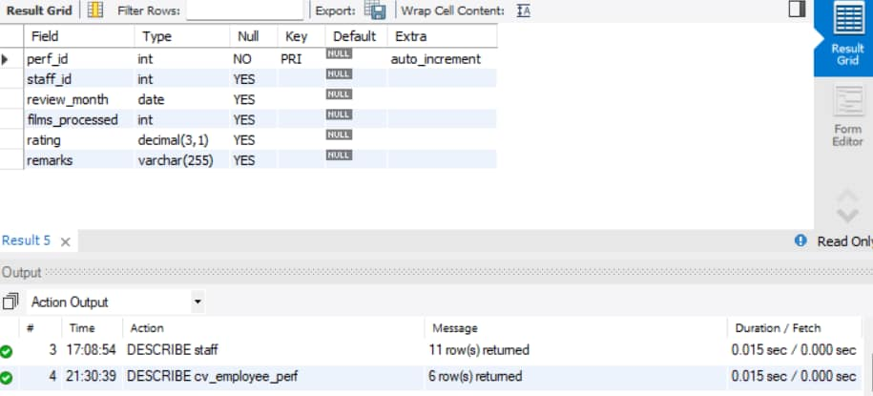

Small modification:

Query:
ALTER TABLE cv_employee_perf
MODIFY staff_id TINYINT UNSIGNED;

b) Add a FOREIGN KEY on staff_id referencing staff(staff_id).

Query:
ALTER TABLE cv_employee_perf
ADD CONSTRAINT fk_cv_employee_perf_staff
FOREIGN KEY (staff_id)
REFERENCES staff(staff_id);

Output:
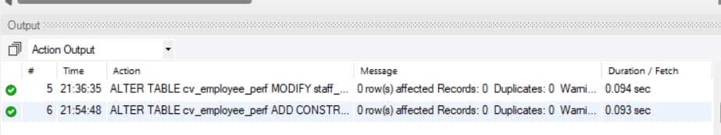

c) Management realizes rating should never be NULL and should default to 3.0. Alter the table accordingly.

Query:
ALTER TABLE cv_employee_perf
MODIFY rating DECIMAL(3,1) NOT NULL DEFAULT 3.0;
DESCRIBE cv_employee_perf;

Output:
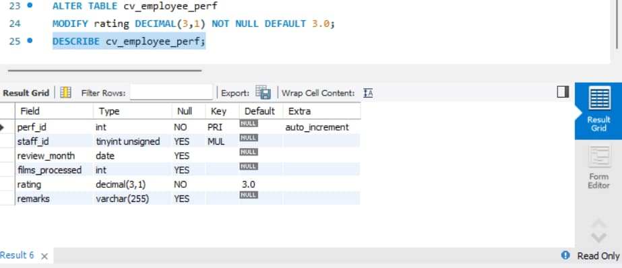

d) The remarks column is rarely used and wastes space in this design — rename it to notes and change its data type to TEXT in the same statement (or two, if your MySQL version needs it).

Query:
ALTER TABLE cv_employee_perf
CHANGE COLUMN remarks notes TEXT;
DESCRIBE cv_employee_perf;

Output:

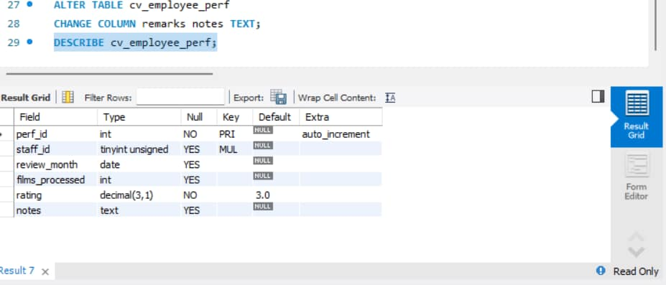

Q2. Data Type Conversion Issue

Finance reports that the rental_rate in the film table (currently DECIMAL(4,2)) is too restrictive for a new premium pricing tier going up to 999.99

a)Write the ALTER TABLE statement to widen rental_rate to DECIMAL(6,2) without losing existing data

Query:
ALTER TABLE film
MODIFY rental_rate DECIMAL(6,2);

Output:

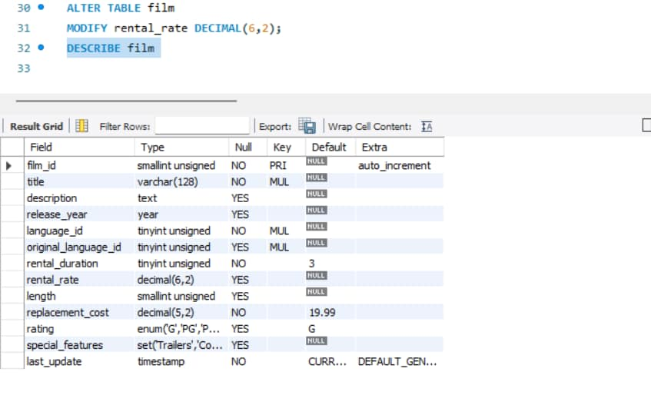

b)Write a query to convert and display the payment_date (DATETIME) from the payment table as just a DATE value (no time component) using a conversion function — do not alter the actual table

Query:
SELECT payment_id,
payment_date,
CAST(payment_date AS DATE) AS payment_date_only
FROM payment;

Output:

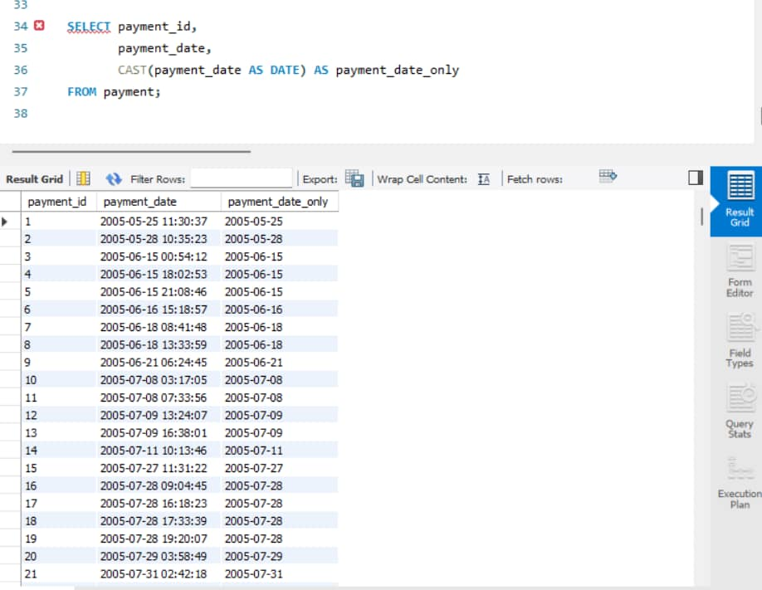

Q3. Decommissioning & Cleanup

The company is discontinuing the cv_employee_perf pilot after testing.

a)Write a query to remove all rows from cv_employee_perf but keep the table structure intact for future use.

Query:
TRUNCATE TABLE cv_employee_perf;

Output:

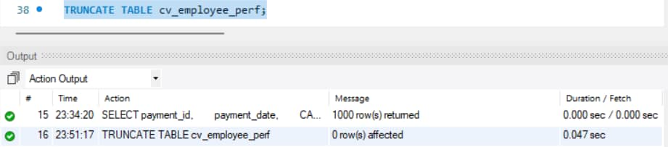

b) Six months later, management confirms the module is cancelled permanently. Write the query to remove the table entirely.

Query:
DROP TABLE cv_employee_perf;

Output:
I was not executing it because in Q7 question we requied this table

c) In 2–3 lines, explain why you'd choose TRUNCATE for (a) and DROP for (b) instead of using DELETE for both.

Explanation:
TRUNCATE is preferred for Q3(a) because it quickly removes all rows while keeping the table structure available for future use. DROP is used for Q3(b) because the table is permanently no longer required and removes the entire table structure.

Q4. Normalization Check (Conceptual + Applied)

A new intern proposes storing customer_name, customer_email, film_title, and rental_date all in one flat table called rental_log_flat for “simplicity.”

a)Identify which Normal Form this design violates and explain briefly (2–3 lines) why storing repeating customer/film details in every rental row is a problem.

Explanation:
For this flat design, the intended normalization issue is 3NF because customer and film information is being stored repeatedly instead of being kept in their respective entity tables. This causes data redundancy and can lead to update, insertion, and deletion anomalies
b) Using the existing Sakila schema (customer, film, rental, inventory) as your reference, briefly explain (2–3 lines) how Sakila already avoids this problem — name the tables/keys involved.

Explanation:
Sakila separates the information into related tables: customer stores customer details, film stores film details, inventory connects films to stores, and rental records rental transactions. Primary and foreign keys connect these tables and avoid repeating the same customer and film details in every rental row.

Section B — Data Manipulation

Q5. Onboarding New Staff

Operations hired a new store employee. Insert a new row into staff for a person of your choice, ensuring you don't break any NOT NULL or FOREIGN KEY constraints (check the table structure first). List the columns explicitly in your INSERT statement.

Query:

INSERT INTO staff
(first_name, last_name, address_id, store_id, username, password)
VALUES
('Sravani', 'kala', 1, 1, 'sravani_new', 'pass123');
SELECT*
FROM staff
WHERE username='sravani_new’;

Output:
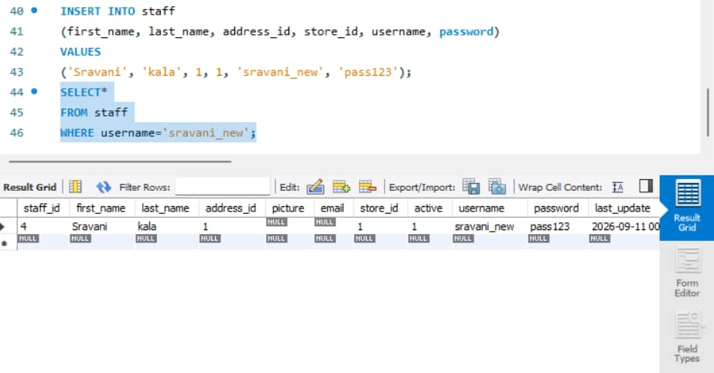

Q6. Price Correction — Bulk Update

Finance discovered that all films with rating = 'PG' were under-priced during a system migration.

a) Write an UPDATE query to increase the rental_rate of all 'PG' rated films by 15%, rounded to 2 decimal places.

Query:
UPDATE film
SET rental_rate = ROUND (rental_rate * 1.15, 2)
WHERE rating = 'PG' AND film_id > 0;
USE sakila;
SELECT film_id, title, rating, rental_rate
FROM film;

Output:
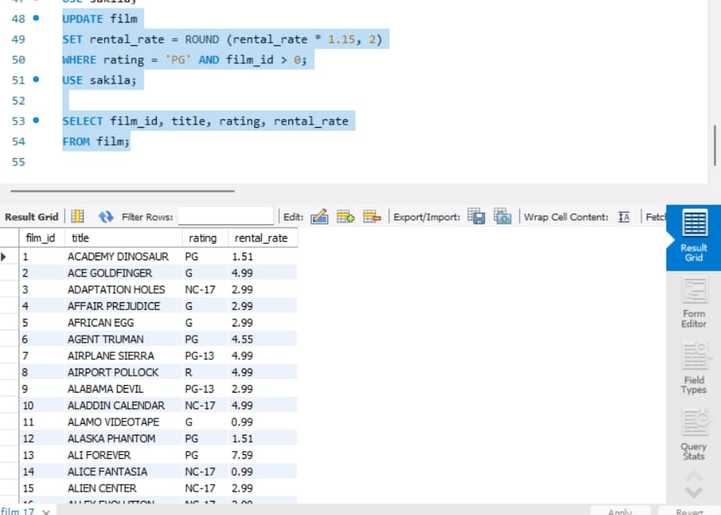

b) Finance now wants to cap the replacement_cost at 25.00 for any film currently priced above that — write the query.

Query:
UPDATE film SET replacement_cost = 25.00
WHERE replacement_cost > 25.00
AND film_id > 0;
SELECT film_id, title, replacement_cost
FROM film
WHERE replacement_cost = 25;

Output:

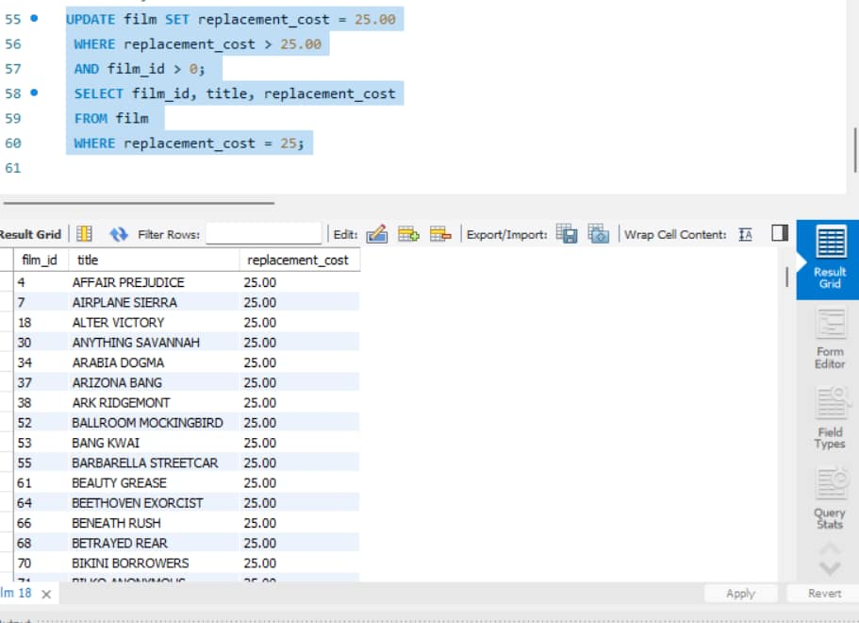

Q7. Data Cleanup — Conditional Delete

Operations wants to purge test/junk data.

a) Write a query to delete rows from cv_employee_perf where films_processed = 0 and rating < 2.0.

Query:
INSERT INTO cv_employee_perf
(staff_id, review_month, films_processed, rating, notes)
VALUES
(1, '2026-01-01', 0, 1.5, 'Test record to delete'),
(1, '2026-02-01', 25, 3.5, 'Good performance'),
(1, '2026-03-01', 40, 4.0, 'Excellent performance');

DELETE FROM cv_employee_perf
WHERE films_processed = 0
AND rating < 2.0
AND perf_id > 0;
SELECT *
FROM cv_employee_perf;

Output:
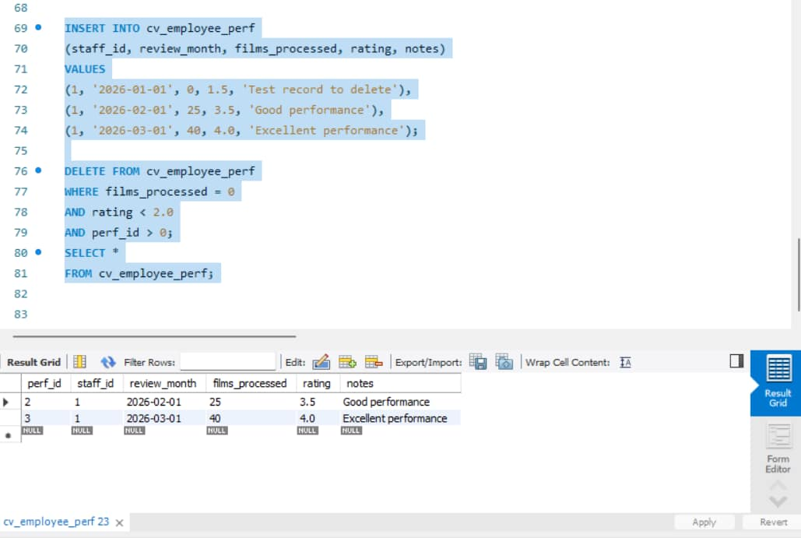

b) Explain (1–2 lines) what safeguard you should apply before running a DELETE without a WHERE clause in production.

Explanation:
Before running a DELETE without a WHERE clause in production, take a backup and verify the affected rows using a SELECT query. This prevents accidental deletion of the entire table.

Section C — Business Filtering & Operators

Q8. Marketing Segment 1 — Multi-condition Filter

Marketing wants a list of customers to target for a loyalty campaign: active customers (active = 1) who live in a district that is either 'California' or 'Texas', and whose customer_id is between 1 and 200. Write a single query using AND, OR, BETWEEN, and IN appropriately (use address/customer join).

Query:
SELECT
c.customer_id,
c.first_name,
c.last_name,
a.district
FROM customer c
JOIN address a
ON c.address_id = a.address_id
WHERE c.active = 1
AND c.customer_id BETWEEN 1 AND 200
AND a.district IN ('California', 'Texas');

Output:
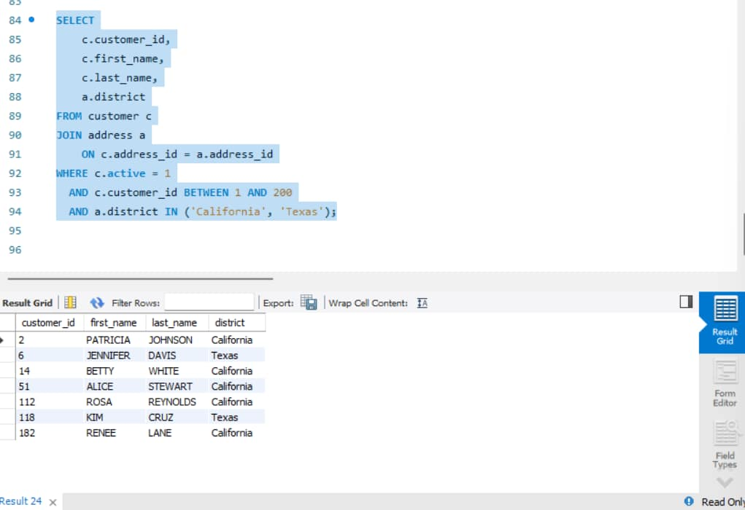

Q9. Marketing Segment 2 — Pattern & NULL Handling

Write a query to find all customers whose email contains 'sakilacustomer.org' (use LIKE).

Query:
SELECT
customer_id,
first_name,
last_name,
email
FROM customer
WHERE email LIKE '%sakilacustomer.org%';

Output:
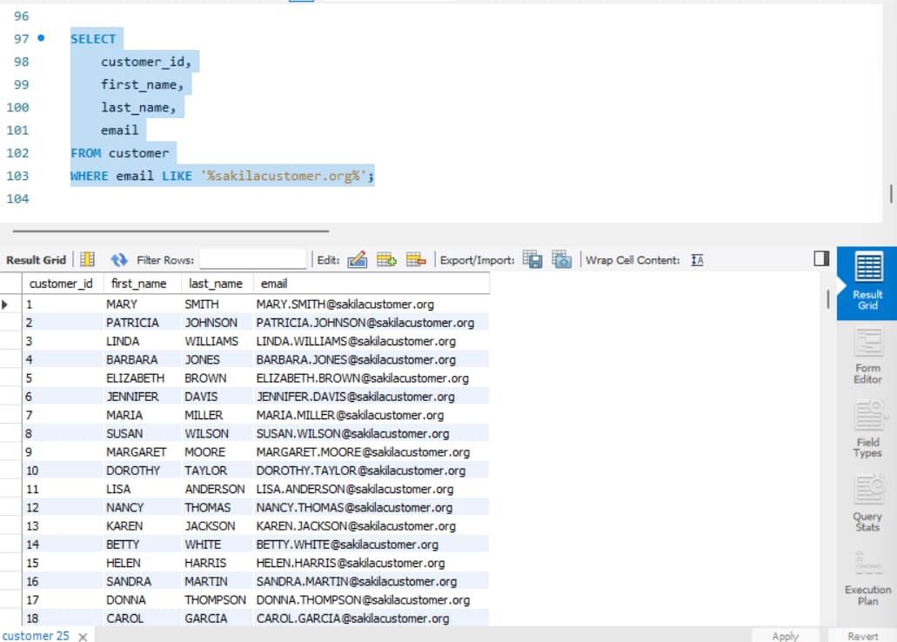

Write a query to find all films where the description does not contain the word 'Amazing'

Query:

SELECT
film_id,
title,
description
FROM film
WHERE description NOT LIKE '%Amazing%';

Output:
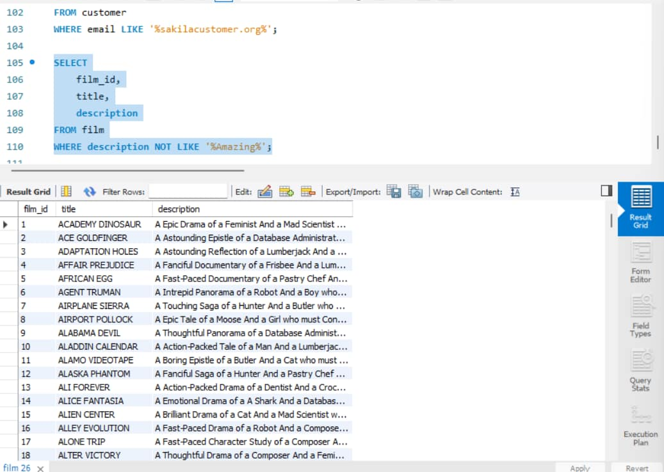

c) Write a query to list all rentals from the rental table where return_date IS NULL (i.e., currently rented out / overdue).

Query:
SELECT
rental_id,
rental_date,
inventory_id,
customer_id,
return_date
FROM rental
WHERE return_date IS NULL;

Output:
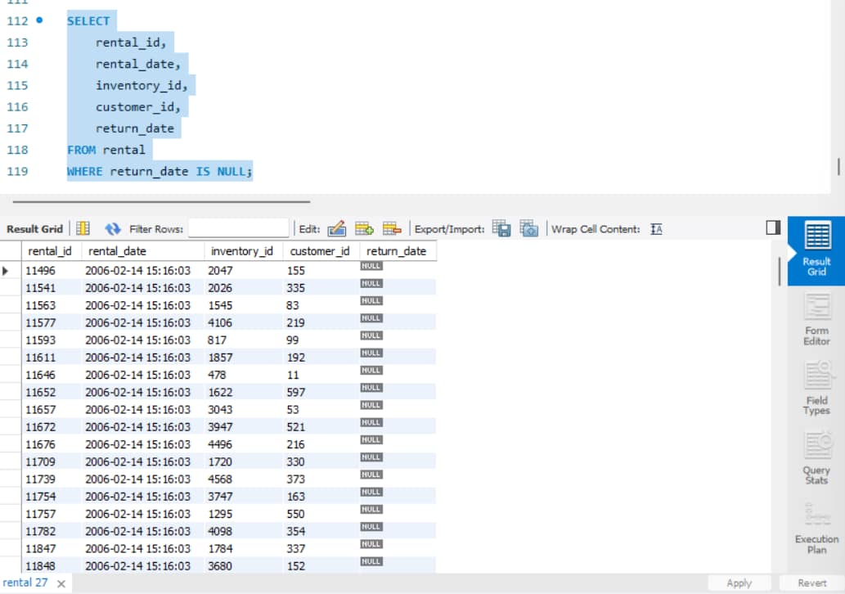

Q10. Operator Combination Challenge

Write a query to list film titles that are NOT in the 'Children', 'Music', or 'Travel' categories, have a rental_rate greater than 2.99, and a length NOT BETWEEN 60 and 90 minutes. (Use film, film_category, category.)

Query:
SELECT
f.film_id,
f.title,
c.name AS category,
f.rental_rate,
f.length
FROM film f
JOIN film_category fc
ON f.film_id = fc.film_id
JOIN category c
ON fc.category_id = c.category_id
WHERE c.name NOT IN ('Children', 'Music', 'Travel')
AND f.rental_rate > 2.99
AND f.length NOT BETWEEN 60 AND 90;

Output:
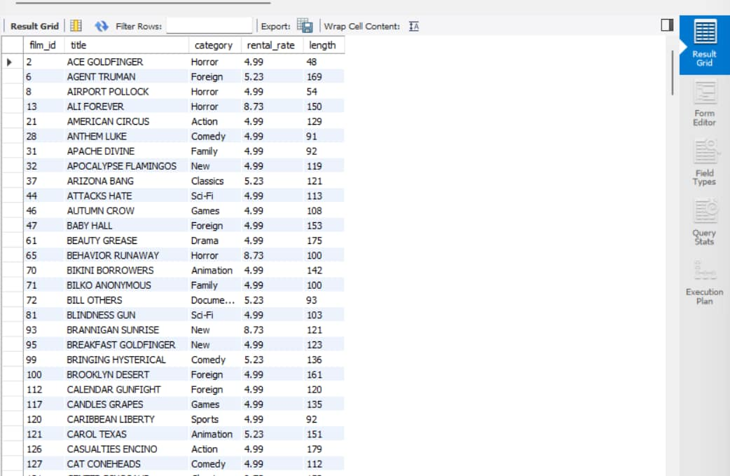

Section D — Relationship Analysis: All Joins

Q11. Inner Join — Core Report

Write a query to list film title, category name, and language name together for every film (only films that have all three linked) using INNER JOIN.

Query:
SELECT
f.film_id,
f.title,
c.name AS category,
l.name AS language
FROM film f
INNER JOIN film_category fc
ON f.film_id = fc.film_id
INNER JOIN category c
ON fc.category_id = c.category_id
INNER JOIN language l
ON f.language_id = l.language_id;

Output:
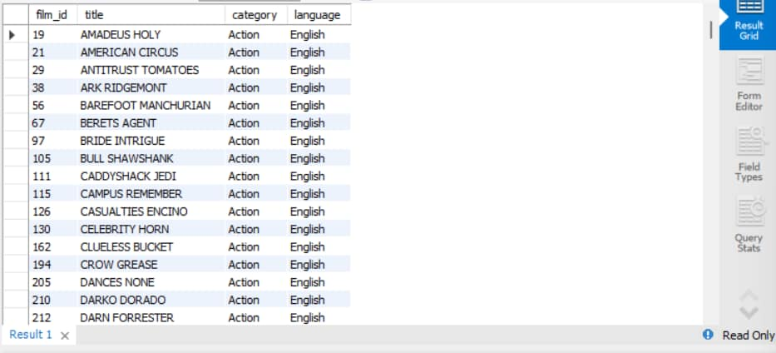

Q12. Left & Right Join — Gap Analysis

a) Using LEFT JOIN, list every customer along with their rental count — customers with zero rentals must still appear with a count of 0.

Query:
SELECT
c.customer_id,
c.first_name,
c.last_name,
COUNT(r.rental_id) AS rental_count
FROM customer c
LEFT JOIN rental r
ON c.customer_id = r.customer_id
GROUP BY
c.customer_id,
c.first_name,
c.last_name;

Output:
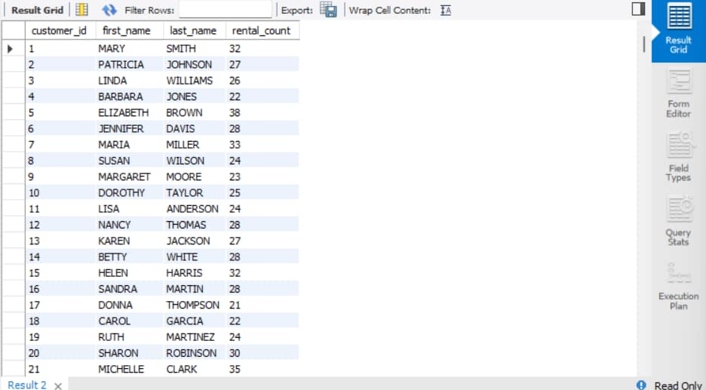

b) Using RIGHT JOIN (rewrite the same logic from the opposite table order), produce the same result — write it starting FROM rental ... RIGHT JOIN customer

Query:
SELECT
c.customer_id,
c.first_name,
c.last_name,
COUNT(r.rental_id) AS rental_count
FROM rental r
RIGHT JOIN customer c
ON r.customer_id = c.customer_id
GROUP BY
c.customer_id,
c.first_name,
c.last_name;

Output:
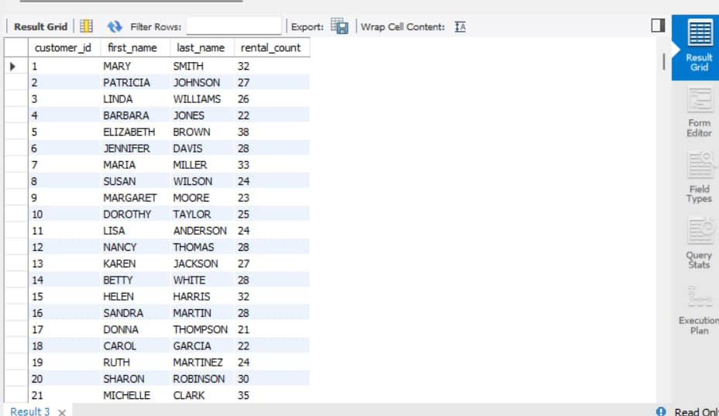

Q13. Full Outer Join Simulation

MySQL has no native FULL OUTER JOIN. CineVault wants a report of every actor and every film they may or may not be linked to, including actors with no films and films with no actors. Write a query using LEFT JOIN ... UNION ... RIGHT JOIN (or UNION of two LEFT JOINs) on actor, film_actor, and film to simulate this.

Query:
SELECT
a.actor_id,
a.first_name,
a.last_name,
f.film_id,
f.title
FROM actor a
LEFT JOIN film_actor fa
ON a.actor_id = fa.actor_id
LEFT JOIN film f
ON fa.film_id = f.film_id

UNION

SELECT
a.actor_id,
a.first_name,
a.last_name,
f.film_id,
f.title
FROM film f
LEFT JOIN film_actor fa
ON f.film_id = fa.film_id
LEFT JOIN actor a
ON fa.actor_id = a.actor_id;

Output:
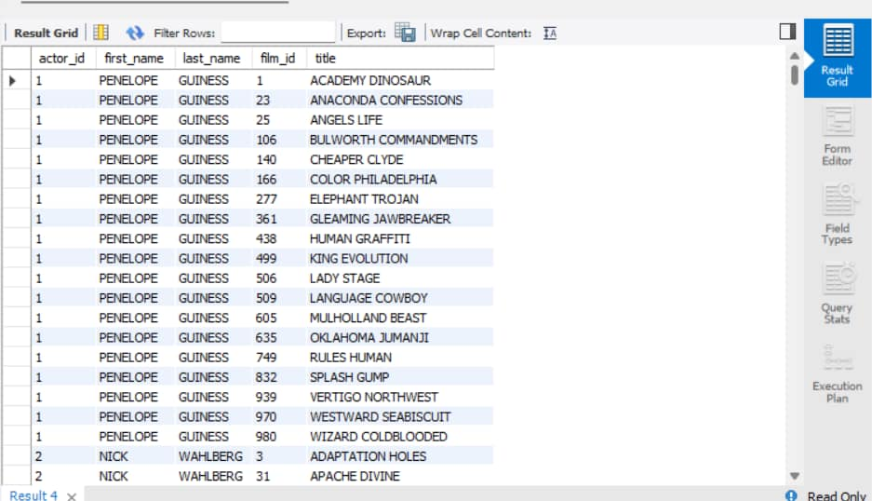

Q14. Self Join — Peer Comparison

HR wants to compare staff members who work at the same store. Write a self-join query on staff that lists pairs of staff members (s1.first_name, s2.first_name) working at the same store_id, excluding a staff member being paired with themselves.

Query:
SELECT
s1.staff_id AS staff1_id,
s1.first_name AS staff1_first_name,
s2.staff_id AS staff2_id,
s2.first_name AS staff2_first_name,
s1.store_id
FROM staff s1
JOIN staff s2
ON s1.store_id = s2.store_id
AND s1.staff_id < s2.staff_id;

Output:
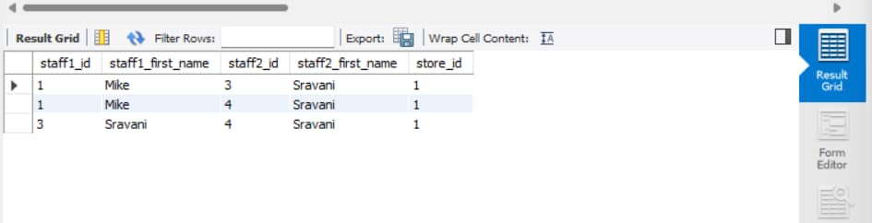

Q15. Cross Join — Scenario Planning

Marketing is planning a promotion matrix: every store combined with every film category, to decide which categories to promote at which store. Write a CROSS JOIN between store and category to generate this combination list. (Add a note on why CROSS JOIN should be used cautiously on large tables.)

Query:
SELECT
s.store_id,
c.category_id,
c.name AS category_name
FROM store s
CROSS JOIN category c;

Output:
CROSS JOIN produces every possible combination of rows from both tables, so the result can become very large and may affect performance when used on large tables.

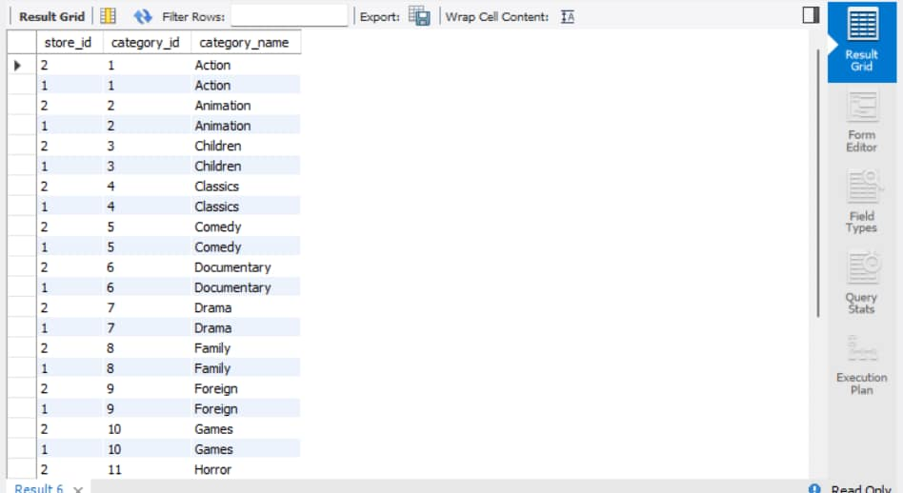

Section E — Aggregation, Grouping & Output-Based Questions

Q16. Revenue Report — Grouped

Finance wants monthly revenue trends.

a) Write a query using GROUP BY to show total revenue (SUM(amount)) per staff_id from payment.

Query:
SELECT
staff_id,
SUM(amount) AS total_revenue
FROM payment
GROUP BY staff_id;

Output:
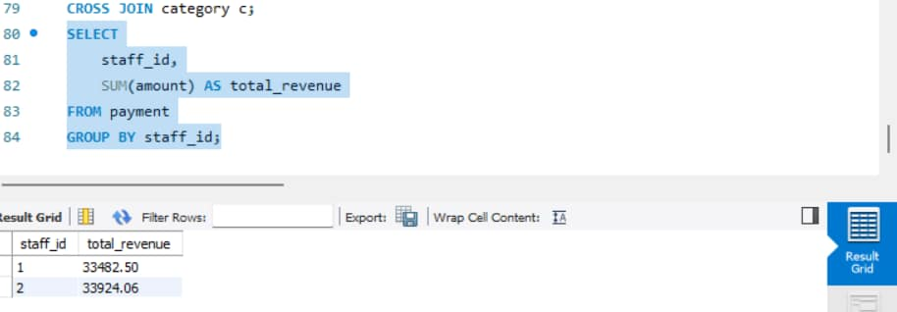

b) Extend it with HAVING to show only staff whose total revenue exceeds 15000.

Query:
SELECT
staff_id,
SUM(amount) AS total_revenue
FROM payment
GROUP BY staff_id
HAVING SUM(amount) > 15000
ORDER BY total_revenue DESC;

Output:
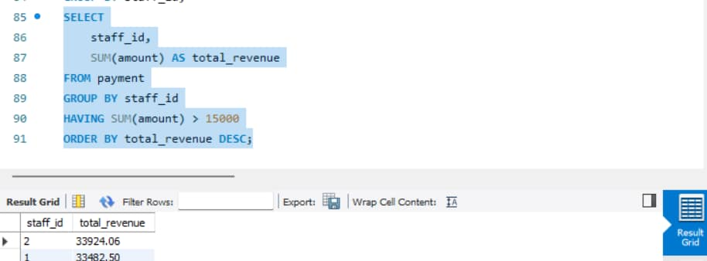

c) Now write a version without grouping — a single query showing the overall company-wide total revenue and the single highest individual payment amount, side by side (use aggregate functions without GROUP BY).

Query:
SELECT
SUM(amount) AS overall_total_revenue,
MAX(amount) AS highest_individual_payment
FROM payment;

Output:

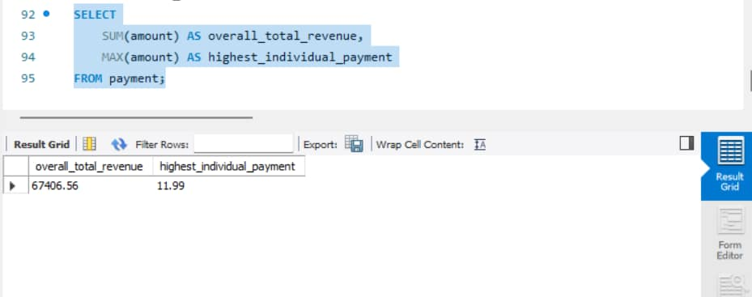

Q17. Output-Based Question — Reverse Engineer the Query

You are shown the following result set from a query run on sakila:
category_name | total_films | avg_rental_rate
Action | 64 | 3.28
Sports | 74 | 3.13
Sci-Fi | 61 | 2.99

The result is sorted by total_films descending, and only shows categories with more than 60 films.

Write the exact MySQL query that would produce this output. (Tables: film, film_category, category.)

Query:
SELECT
c.name AS category_name,
COUNT(f.film_id) AS total_films,
ROUND(AVG(f.rental_rate), 2) AS avg_rental_rate
FROM category c
JOIN film_category fc
ON c.category_id = fc.category_id
JOIN film f
ON fc.film_id = f.film_id
GROUP BY
c.category_id,
c.name
HAVING COUNT(f.film_id) > 60
ORDER BY total_films DESC;

Output:
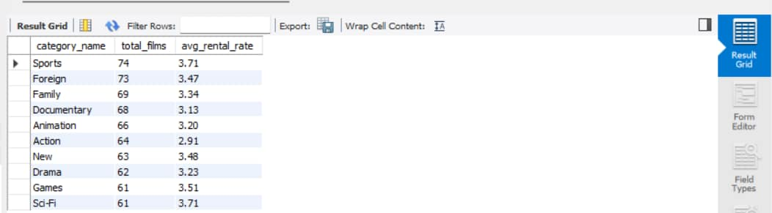

Q18. Output-Based Question — Rank the Customers
You are shown this result:
customer_id | first_name | total_spent | spend_rank
137 | Karl | 221.55 | 1
526 | Eleanor | 216.54 | 2
148 | Clara | 195.58 | 3
The spend_rank column ranks customers by their total payments, highest first, with no gaps in ranking even if totals tie.
Write the query — you must use a window function (RANK() or DENSE_RANK()), not a subquery-only approach, to generate spend_rank.

Query:

SELECT
customer_id,
first_name,
last_name,
total_spending,
DENSE_RANK() OVER (
ORDER BY total_spending DESC
) AS spend_rank
FROM (
SELECT
c.customer_id,
c.first_name,
c.last_name,
SUM(p.amount) AS total_spending
FROM customer c
JOIN payment p
ON c.customer_id = p.customer_id
GROUP BY
c.customer_id,
c.first_name,
c.last_name
) AS customer_spending
ORDER BY spend_rank;

Output:
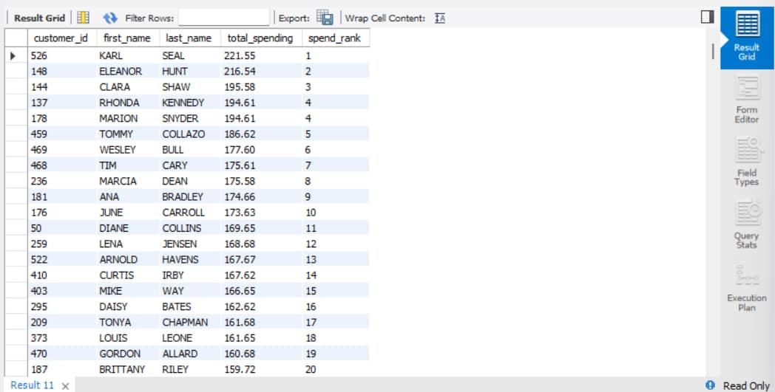

Section F — Advanced Analytics: Subqueries & Window Functions

Q19. Subqueries — Nested & Correlated

a) Nested subquery: Write a query to find all films whose rental_rate is higher than the average rental rate of their own category (hint: correlated subquery referencing the outer film's category_id).

Query:
SELECT
f.film_id,
f.title,
c.name AS category_name,
f.rental_rate
FROM film f
JOIN film_category fc
ON f.film_id = fc.film_id
JOIN category c
ON fc.category_id = c.category_id
WHERE f.rental_rate > (
SELECT AVG(f2.rental_rate)
FROM film f2
JOIN film_category fc2
ON f2.film_id = fc2.film_id
WHERE fc2.category_id = fc.category_id
)
ORDER BY f.rental_rate DESC;

Output:
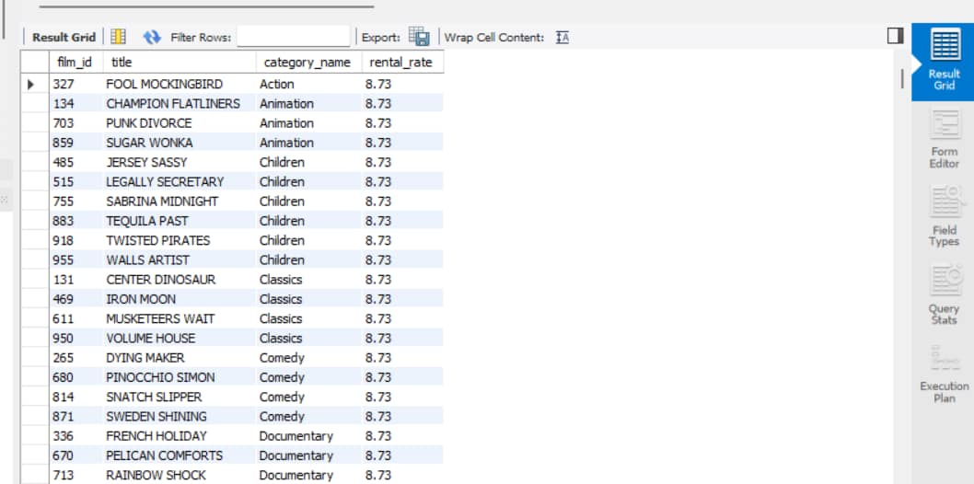

b) EXISTS subquery: Write a query to list customers who have never made a payment (use NOT EXISTS).

Query:
SELECT
c.customer_id,
c.first_name,
c.last_name
FROM customer c
WHERE NOT EXISTS (
SELECT 1
FROM payment p
WHERE p.customer_id = c.customer_id

); Output:


c) Briefly explain (1–2 lines) the performance difference between using IN with a subquery versus EXISTS when the subquery returns a large number of rows

Explaination:
EXISTS checks whether at least one matching row exists in the subquery and can stop checking once it finds a match.
IN compares a value against the set of values returned by the subquery. For large result sets, EXISTS can sometimes perform better because it can stop after finding the first match.

Q20. Window Functions — Store-Level Analysis

Operations wants to identify, for each store, the top 3 films by total rental count (a “Top 3 per Store” leaderboard).

a) Write a query using ROW_NUMBER() (or RANK()) partitioned by store_id and ordered by rental count descending, then filter to only the top 3 per store (use a CTE or subquery, since you cannot filter directly on a window function in the same SELECT).

Query:
WITH film_counts AS (
SELECT
i.store_id,
f.film_id,
f.title,
COUNT(r.rental_id) AS rental_count
FROM inventory i
JOIN film f
ON i.film_id = f.film_id
LEFT JOIN rental r
ON i.inventory_id = r.inventory_id
GROUP BY
i.store_id,
f.film_id,
f.title
),
ranked AS (
SELECT
*,
ROW_NUMBER() OVER (
PARTITION BY store_id
ORDER BY rental_count DESC, film_id
) AS rn
FROM film_counts
)
SELECT
store_id,
film_id,
title,
rental_count
FROM ranked
WHERE rn <= 3
ORDER BY store_id, rn;

Output:
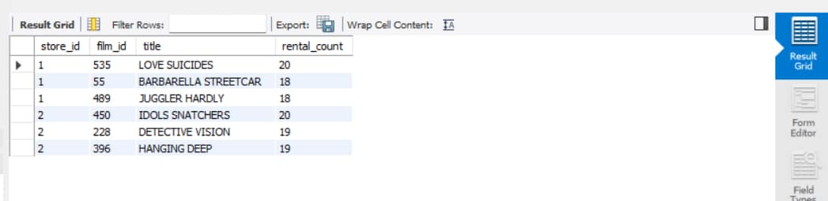

b) In one line, explain the difference between ROW_NUMBER(), RANK(), and DENSE_RANK() if two films in the same store had the exact same rental count.
ROW_NUMBER() gives each row a unique number even when values tie
RANK() gives tied rows the same rank and skips the next rank
DENSE_RANK() gives tied rows the same rank without skipping any rank.

Bonus

Write a single query combining a CTE, a JOIN, and a window function to show each customer's rental history along with a running total (SUM() OVER) of their spending, ordered by payment date.

Query:
WITH customer_payments AS (
SELECT
c.customer_id,
c.first_name,
c.last_name,
p.payment_id,
p.payment_date,
p.amount
FROM customer c
INNER JOIN payment p
ON c.customer_id = p.customer_id
)
SELECT
customer_id,
first_name,
last_name,
payment_id,
payment_date,
amount,
SUM(amount) OVER (
PARTITION BY customer_id
ORDER BY payment_date, payment_id
ROWS BETWEEN UNBOUNDED PRECEDING AND CURRENT ROW
) AS running_total
FROM customer_payments
ORDER BY customer_id, payment_date, payment_id;

Output:
