**Groovy** – Scripting language for automation jenkins configuration and management.

**Cnditional Loop structure –**

**IF , IF ELSE, FOR, WHILE, SWITCH CASE**

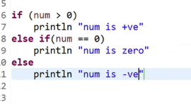

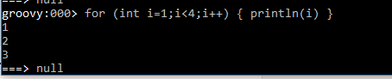

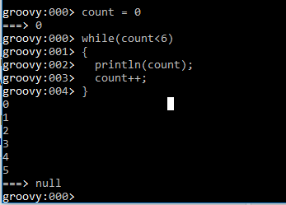

**Groovy String Operation:**

Tring Operation

name = "kalathi"

println("my name is").concat('name')

concat.split,touppercase,tolowrcase,equals('kalathi'),tolist,equalignorecas

**List Operation**

def fruit = ['apple', 'mango']

get(2)

fruit.add(4)/remove || plus/minus

pop() removes first removelast() - removes last value from list

sort()

isempty()

fruit.contains('apple')

size()/length()

num = [3,5,7,9]

**IF LOOP Example**

if (num.contains(7)) {

println "List contains number serven"

}

else {

println "List doesn't contains num 7"

}