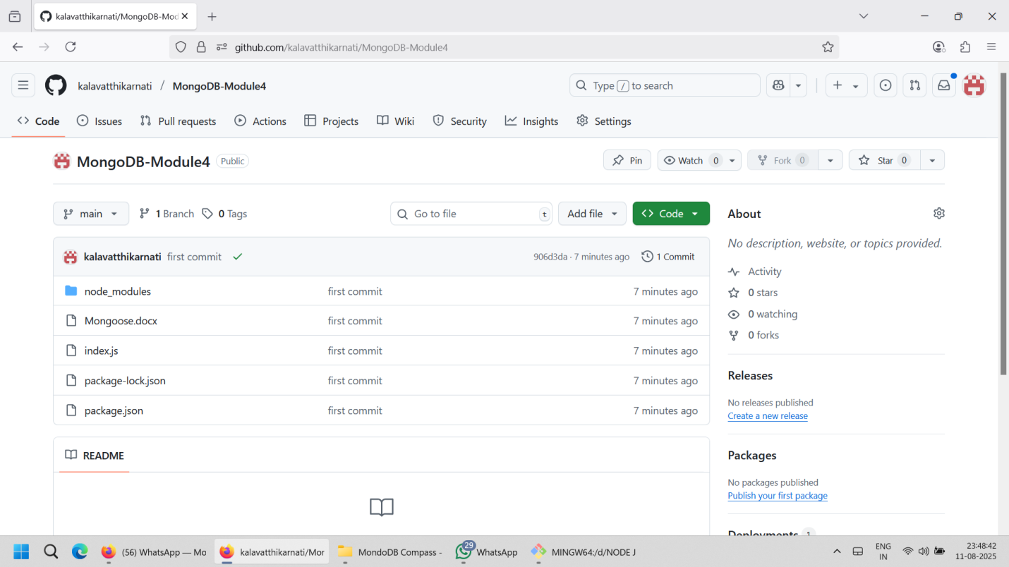

https://github.com/kalavatthikarnati/MongoDB-Module4

Insert Data into MongoDB Compass

const ex = require('express')

const app = ex()

const mongoose = require('mongoose');

const port = 3000

app.use(ex.json())

app.use(ex.urlencoded({extended:true}))

mongoose.connect(`mongodb://127.0.0.1:27017/StudentDetails`).then(()=>{

    console.log('Database connected Successfully')

}).catch((e)=>console.log('error connecting database', e))

//Insert Data

     let studSchema = new mongoose.Schema(

      {

        name: {type:String},

        email : {type:String},

        age:{type:Number}

      }

       )

       let studmodel =mongoose.model("studentData", studSchema)

 app.post('/addstd', async (req, res) => {

    try {

        const newstud = new studmodel({

            name: req.body.name,

            age: req.body.age,

            email: req.body.email,

        });

        console.log(newstud);

        await newstud.save();

        res.status(201).json({ message: 'Data saved successfully', data: newstud });

    } catch (err) {

        console.error('Error saving student:', err);

        res.status(500).json({ message: 'Failed to save data', error: err.message });

    }

});

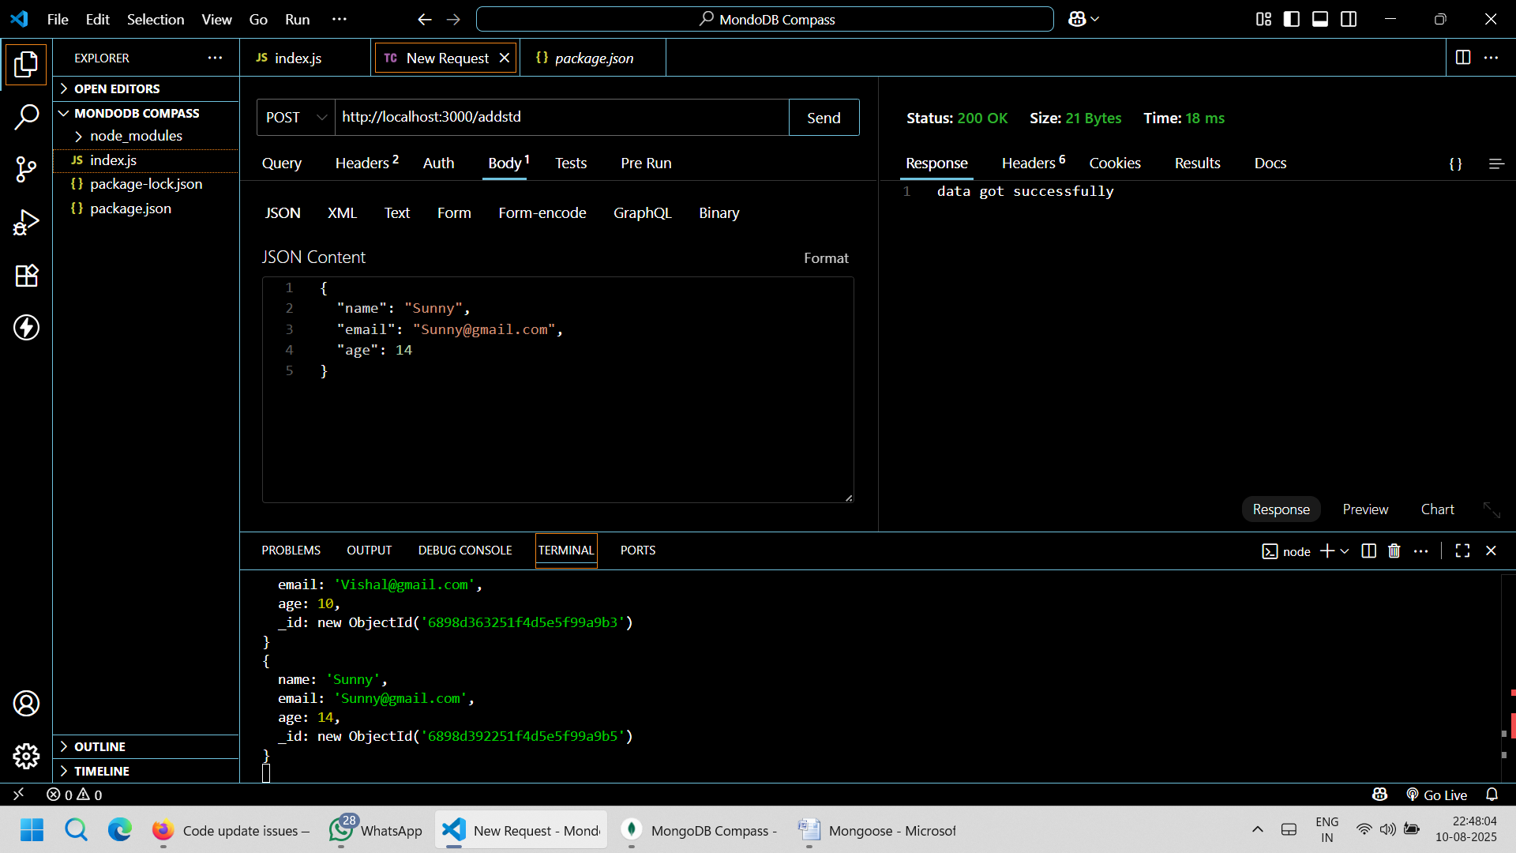

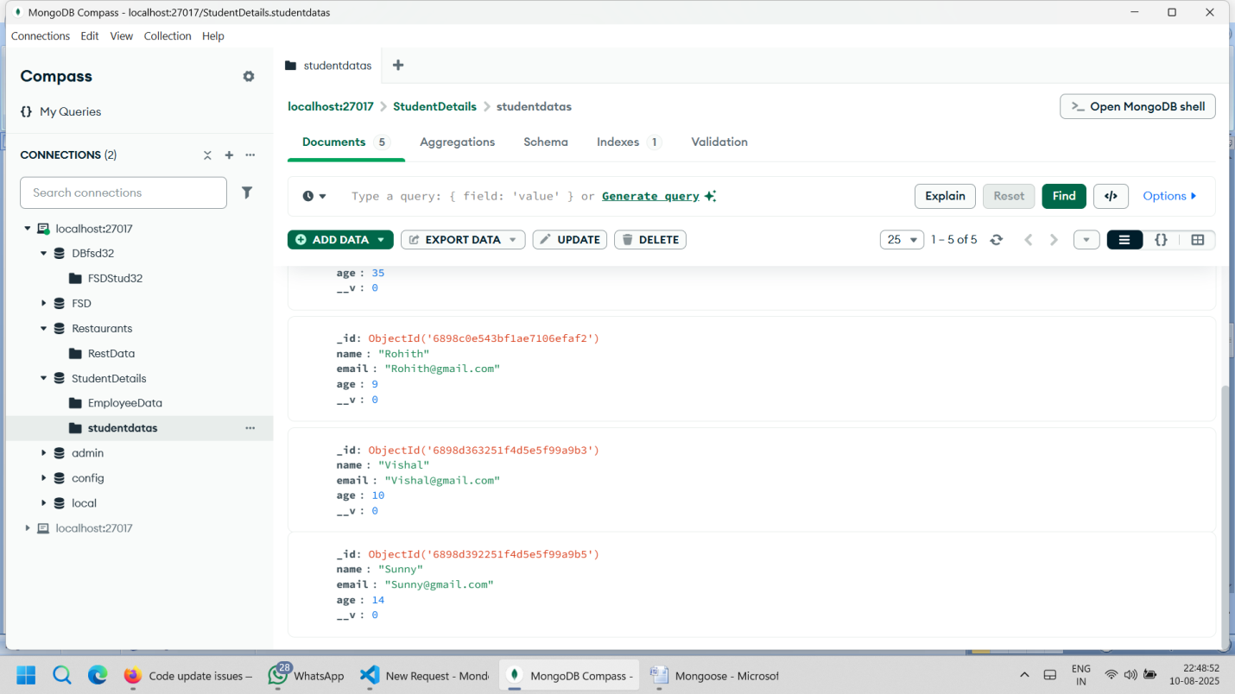

app.put('/updatestu/:id',async(req,res)=>{

            let founduser = await studmodel.findByIdAndUpdate(req.params.id,

                {name:req.body.name,email:req.body.email,age:req.body.age})

            console.log(founduser);

             res.json({"message":"updatedsuccess!","data":founduser})

        })

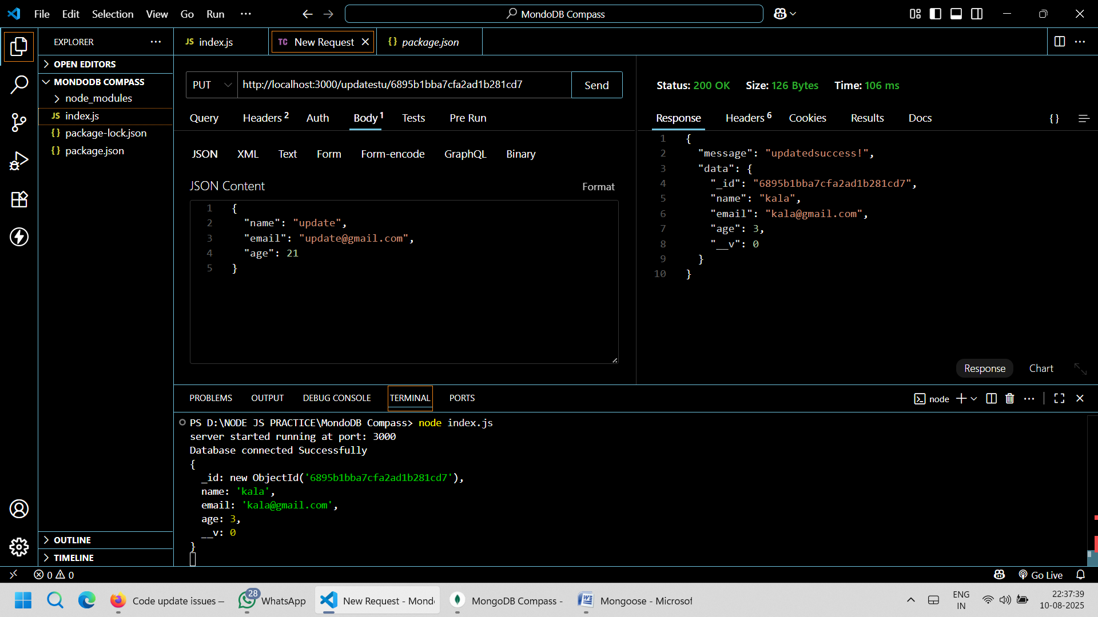

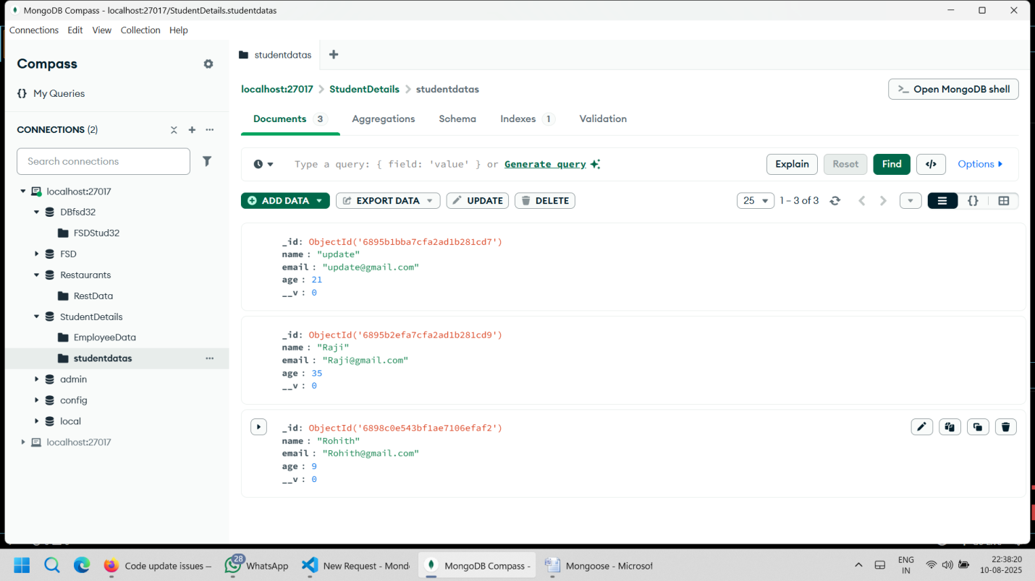

 //get all users from mongodb compass

        app.get('/getallstu', async(req,res)=>{

            const studentData = await studmodel.find({})

            res.json({"message": "data success!","data":studentData})

        })

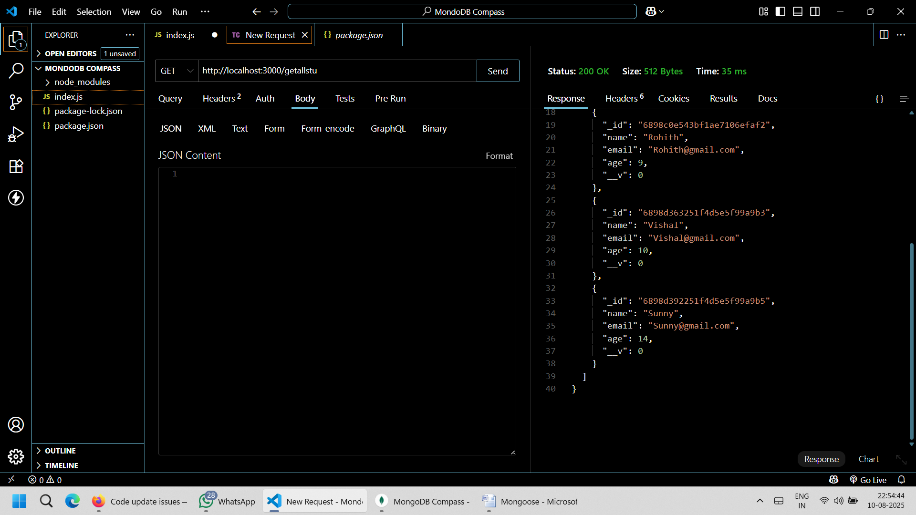

Delete

app.delete('/delstud/:id',async(req, res)=>{

        let deluser =await studmodel.findByIdAndDelete(req.params.id);

        res.json({"message":"Data Deleted Succesfully","data":deluser})

        })

