How to run the application:

1. In the terminal, navigate to the **SJSUelp** folder
2. Run the command

**bin/rails server**

Keep the terminal window open

1. In a web browser, go to the address **localhost:3000/posts**

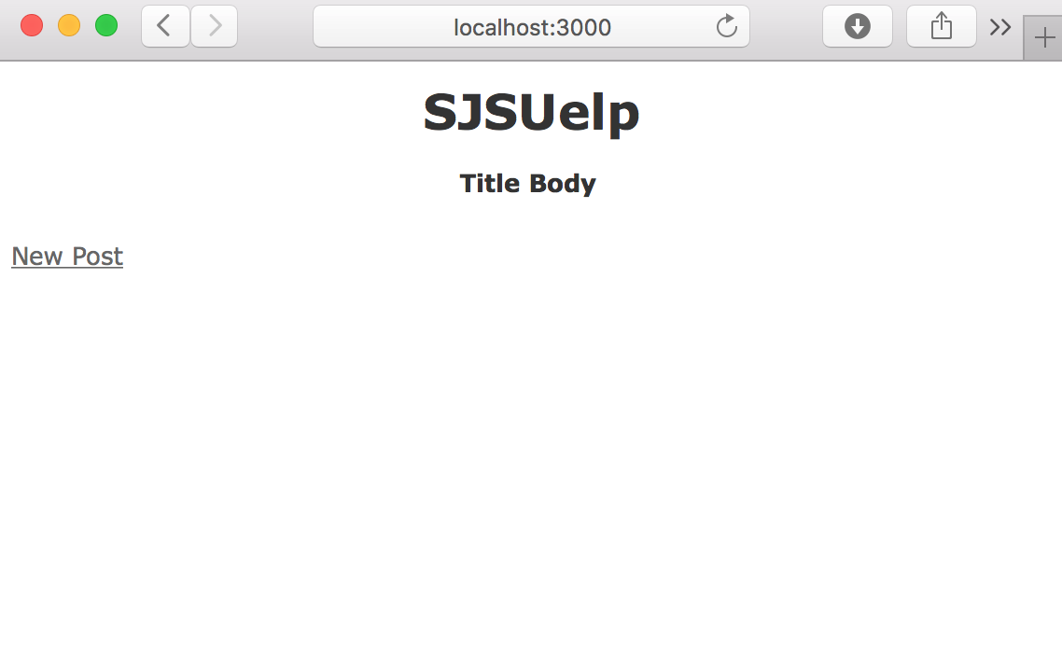

1. When you click on **New Post**, a new page opens with a form. After filling out the forms, click **Create Post**.

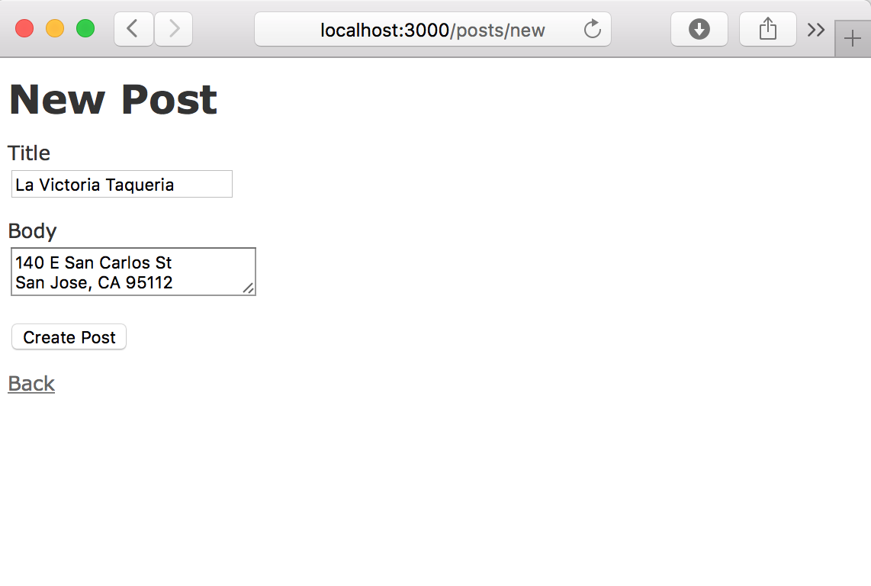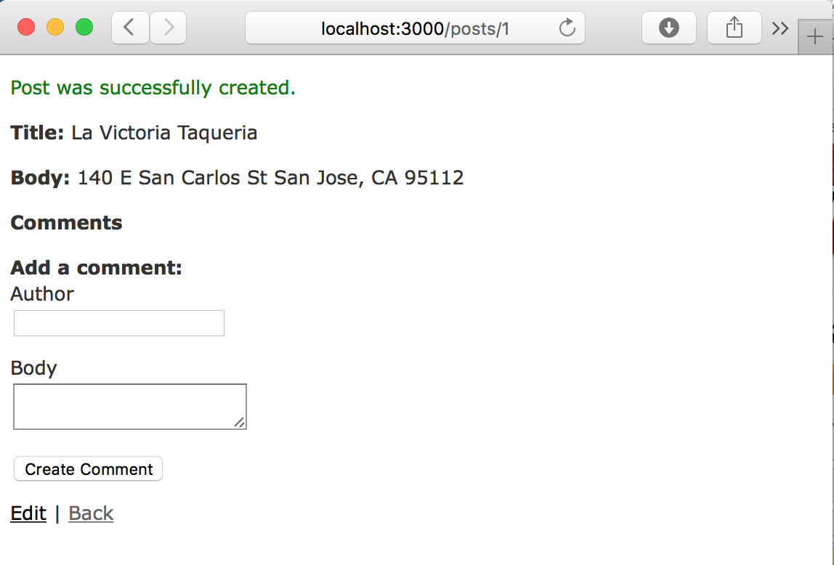

1. On each post, multiple comments can be made.

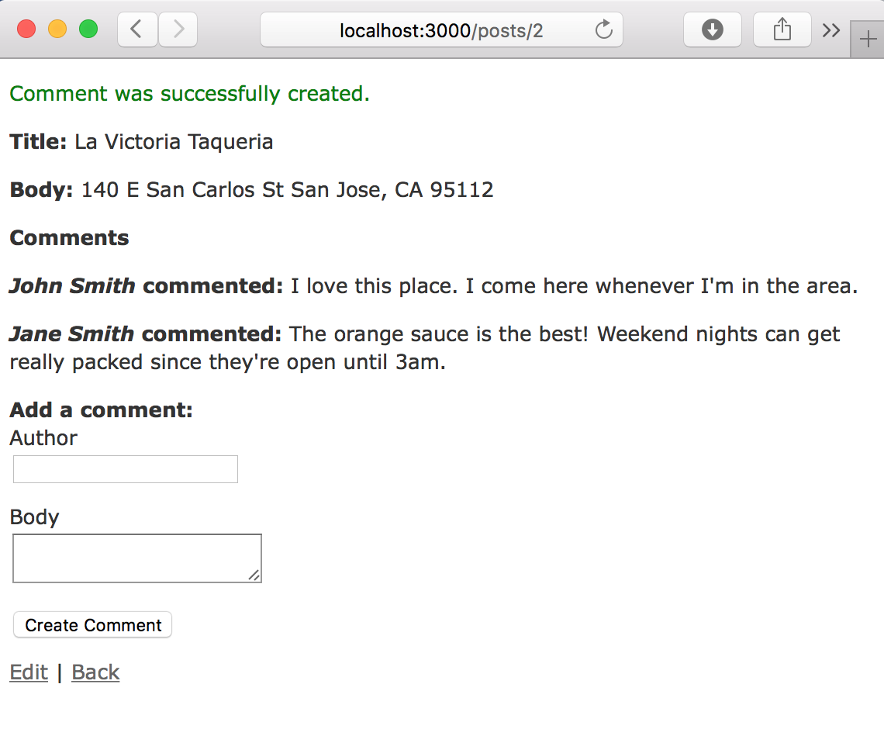

1. To edit a post, click the **Edit** link. To publish the changes, click **Update Post**.

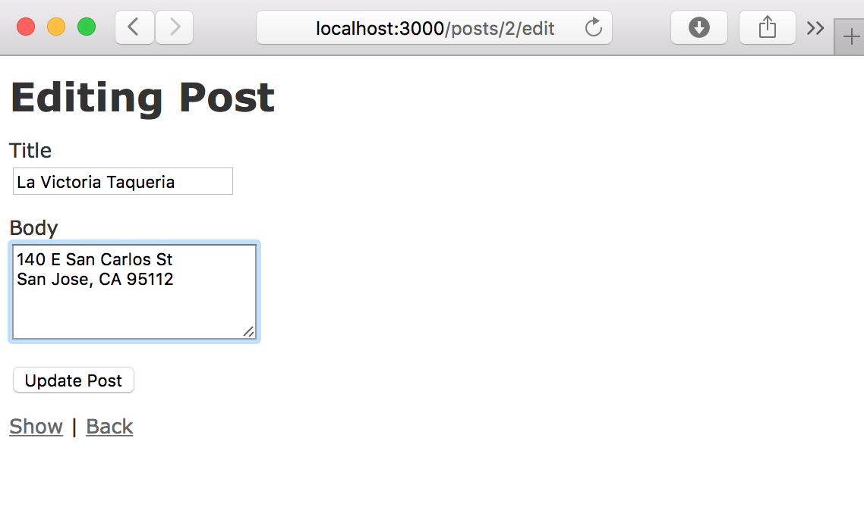

1. Click the **Back** link to reach the homepage. To view comments on each post, click the **Show** link. Each post can also be edited or deleted through the **Edit** and **Destroy** links.

