Synthetic pHEMT / MMIC Yield Correlation Ground Truth
Reference report for validating whether the AI system rediscovers the deliberately planted yield relationships in the 1,500-wafer synthetic dataset.

Planted correlations and interactions
Relationship | Parameter(s) | Type | What AI should find
Gate CD optimum | GATE2_CD_Gate_Leg_Length | Nonlinear U-shaped | Best yield near each technology's gate-length target; yield falls on either side.
PAE benefit | TOPSIN_ET_Load_Pull_P.A.E_Last | Direct positive | Approximately +0.33 sorting-yield point per +1 PAE point around nominal.
Drain-lag penalty | TOPSIN_ET_DC_PIV_Drain_Lag_1 | Threshold / negative | Little penalty below ~7; above ~7 the yield penalty increases.
Gate CD × SiN thickness | GATE2_CD_Gate_Leg_Length + SIN_Thickness_SiN_Thickness | 2-factor interaction | Simultaneous deviations from gate target and ~0.150 SiN thickness cause extra loss.
Rc × Rsh | OHMIC_ET_Rc_an_ct2 + OHMIC_ET_Rsh_an_ct2 | 2-factor interaction | Strongest yield loss when both resistance metrics are high.
Leakage threshold | ET leakage family | Threshold | Moderate penalty above ~0.20 and an additional sharp penalty above ~0.35.
Alignment process window | GATE2_Ali_Litho_Gate_to_recess_alignment | Absolute-value threshold | Small effect inside approximately ±0.035; increasing loss outside the window.
Gm stage degradation | TOPSIN_ET_Gm_max - FIC_ET_Gm_max | Derived delta | Yield decreases when TOPSIN Gm degrades by more than roughly 18 relative to FIC.
Rc × Drain Lag × low PAE | Rc + Drain Lag + PAE | 3-factor interaction | Extra penalty when Rc > 0.255, Drain Lag > 9.5, and PAE < 55 occur together.

Graphical observations
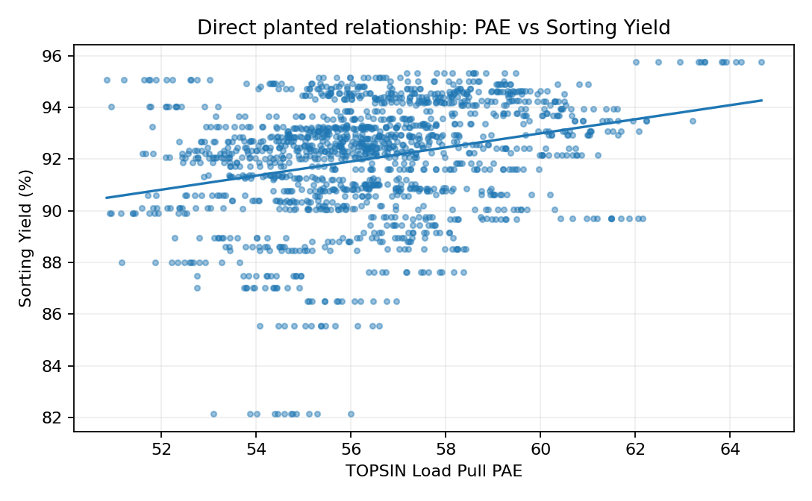
Figure 1. PAE is deliberately given a direct positive contribution to SortingYield.
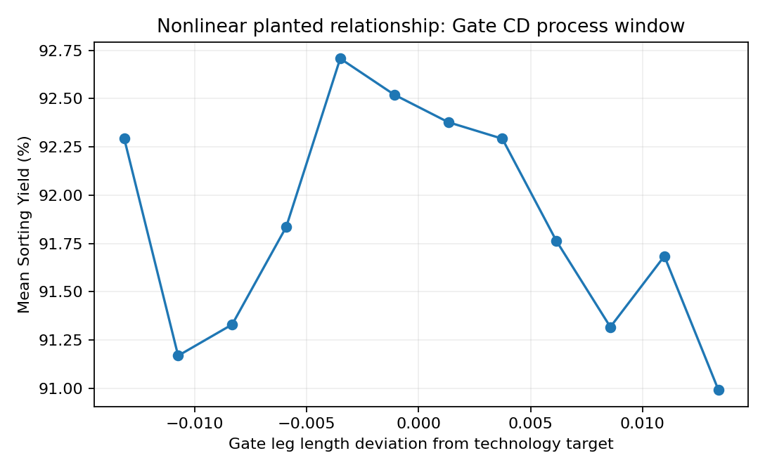
Figure 2. Gate CD is a process-window problem: deviation in either direction is harmful, so simple linear correlation can understate it.
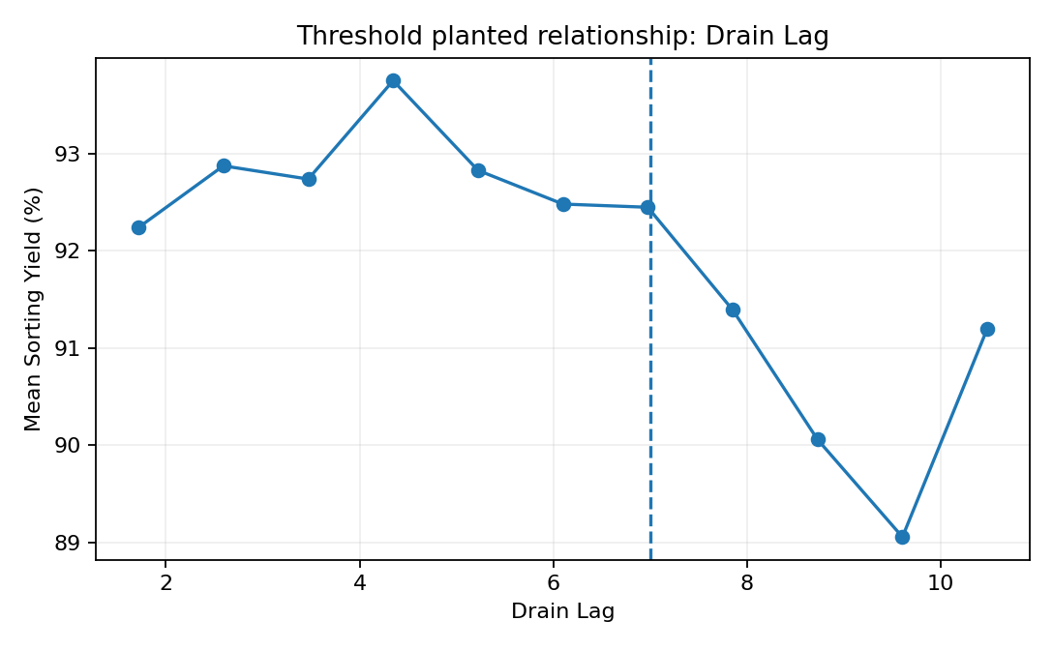
Figure 3. Drain Lag contains a threshold behavior around 7 rather than a purely linear response.
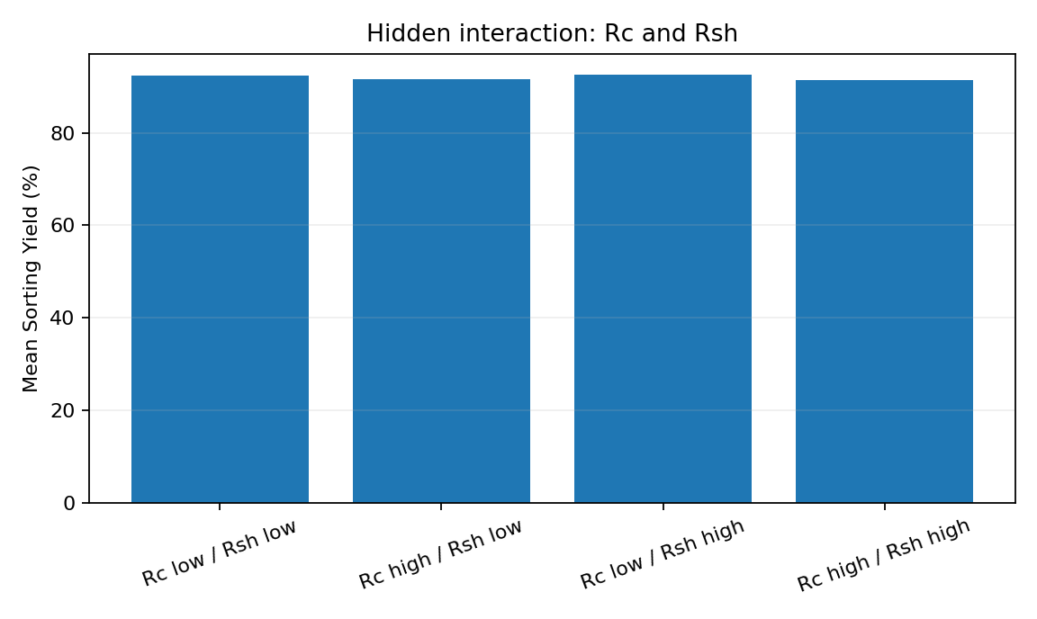
Figure 4. Rc and Rsh contain an interaction: the combined high/high region is intended to be more damaging than either variable alone.
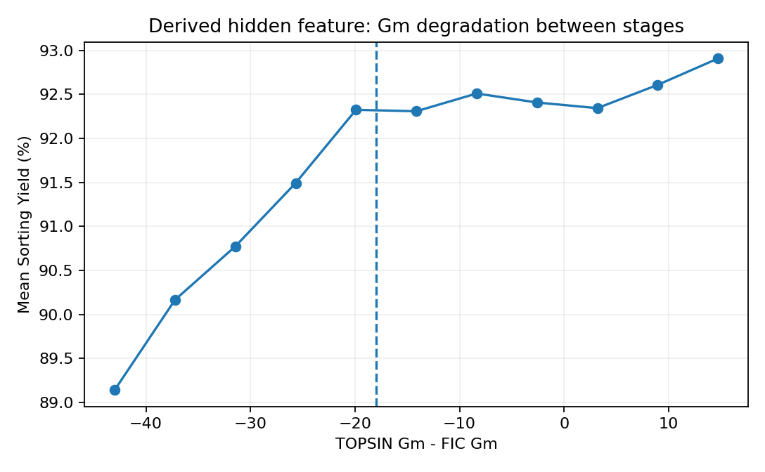
Figure 5. The model should derive or approximate a stage-delta feature. Large negative TOPSIN Gm - FIC Gm is associated with poorer yield.

How to use this report
Use SortingYield as the primary Y response. Exclude Actual Sorting Yield (%), TotalYield, LineYield, BackEndYield, VIYield, and LTYield from the predictor set when testing discovery, because these are yield outputs and can create target leakage. The objective is not only to rank single-variable Pearson correlations; the AI should identify nonlinear process windows, thresholds, interactions, and derived changes between process stages.
The numerical values are synthetic and intended for algorithm development. They are engineering-plausible training values, not production specifications or control limits for a specific pHEMT/MMIC process.

