========= creating tables ===============

create database CompanyDB;

use CompanyDB

GO

create table Employee (

EmpId int primary key,

Fname nvarchar (20),

Lname nvarchar (20),

Email nvarchar (20),

HireDate Date,

Salary int,

Dept_Id int

)

create table Department (

Dept_Id int primary key,

Dept_name nvarchar (20)

)

alter table Employee

add constraint fk_Deparatment_ID

foreign key (Dept_Id) references Department (Dept_Id)

INSERT INTO Department VALUES (1,'CSE')

INSERT INTO Department VALUES (2,'Mechanical')

INSERT INTO Department VALUES (3,'Civil')

INSERT INTO Department VALUES (4,'Architecture')

INSERT INTO Department VALUES (5,'Applied’)

========================================================================================

1. SP for inserting data into Employee

Create proc AddEpmployee

@EmpId int,

@Fname nvarchar (20) = NULL,

@Lname nvarchar (20) = NULL,

@Email nvarchar (20) = NULL,

@HireDate Date = NULL,

@Salary int = NULL,

@Dept_Id int = NULL

AS

BEGIN

set @HireDate=ISNULL(@HireDate,GETDATE())

INSERT INTO Employee VALUES (@EmpId,

@Fname,

@Lname,

@Email,

@HireDate, @Salary,

@Dept_Id

)

END

--execution of stored procedure to insert

EXEC AddEpmployee

@EmpId = 5,

@Fname = 'Gion',

@Lname='Gion',

@Email = 'Gion@gmail.com',

@Salary = 5000,

@Dept_Id = 1;

select * from Employee

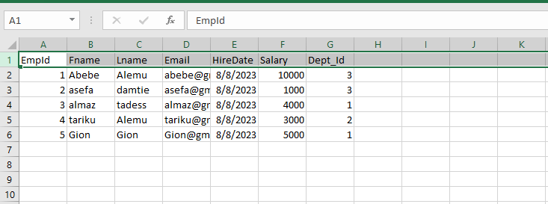

========================================================================================

2. SP for update employee salary

create proc UpdateEmployeeSalary

@EmpId int,

@Salary int

AS

BEGIN

update Employee set Salary=@Salary where EmpId =@EmpId

END

--execution of stored procedure

exec UpdateEmployeeSalary

@EmpId =1,

@Salary =7000

select * from Employee

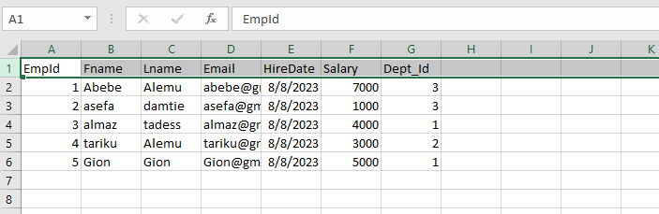

=========================================================================================

3. SP for count of Employees for a given department given the department name

--SP to count of Employees using join

Create proc GetEmployeeCountByDepartment

@Dept_name varchar (50)

AS

BEGIN

select D.Dept_name, count(*) as TotalEmployee

from Employee E

join Department D

on E.Dept_Id=D.Dept_Id

where D.Dept_name=@Dept_name

group by D.Dept_name

END

-----------OR-----------------------------

--SP to count of Employees using sub query

alter proc GetEmployeeCountByDepartment

@Dept_name varchar (50)

AS

BEGIN

select count (*) as total, Table1.Dept_name

from (select D.Dept_name,E.Fname

from Employee E

join Department D

on E.Dept_Id=D.Dept_Id

) Table1

where Table1.Dept_name=@Dept_name

group by Table1.Dept_name

END

exec GetEmployeeCountByDepartment @Dept_name='CSE'

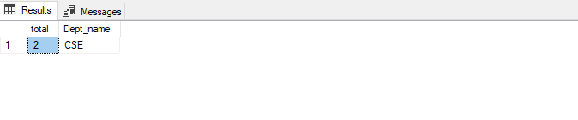

=======================================================================================

4. to delete employee

create proc DeleteEmployee

@EmpId int

AS

BEGIN

DELETE FROM Employee where EmpId =@EmpId

END

exec DeleteEmployee @EmpId =5

select * from Employee

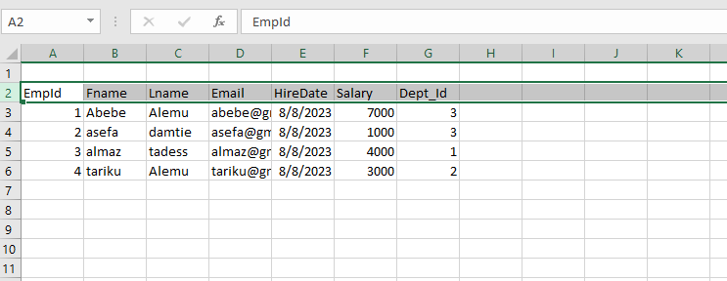

=====================================================================================

5. SP for average of salary for each department of Employees

Alter proc GetAverageSalaryByDepartment

AS

BEGIN

select D.Dept_name, count(*) as TotalEmployee,sum(salary) as TotalSalary ,avg(salary) as as AverageSalary

from Employee E

join Department D

on E.Dept_Id=D.Dept_Id

group by D.Dept_name

END

exec GetAverageSalaryByDepartment

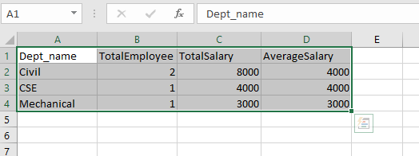

========================================================================================

6. SP to get employee details

create proc GetEmployeeDetails

@EmpId int

AS

BEGIN

select E.Fname,E.Lname,E.Email,D.Dept_name, E.HireDate

from Employee E

join Department D

on E.Dept_Id=D.Dept_Id

where E.EmpId=@EmpId

END

EXEC GetEmployeeDetails @EmpId=1

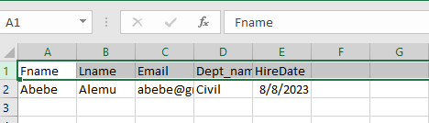

=========================================================================================

7. SP GetEmployeesWithSalaryAbove

Alter proc GetEmployeesWithSalaryAbove

@Salary int

AS

BEGIN

select Fname,Lname,Salary

from Employee

where Salary > @Salary

END

EXEC GetEmployeesWithSalaryAbove @Salary=1000

