create database university

use university

go

create table student (

roll_no int,

name nvarchar (50),

address nvarchar (50),

phone nvarchar (50),

age int,

)

--inserting data to student table

insert into student values(1,'harsh','delhi','+251900000000',18)

insert into student values(2,'pratik','bahr','+251900000000',19)

insert into student values(3,'riyanka','silguri','+251900000000',20)

insert into student values(4,'deep','ramnagar','+251900000000',18)

insert into student values(5,'sapatarhi','kolkata','+251900000000',19)

insert into student values(6,'dhanraj','barabajar','+251900000000',20)

insert into student values(7,'rohit','balurghat','+251900000000',18)

insert into student values(8,'niraj','alibur','+251900000000',19)

create table StudentCourse (

course_id int,

roll_no int,

)

--inserting data to StudentCourse table

insert into StudentCourse values (1,1)

insert into StudentCourse values (2,2)

insert into StudentCourse values (2,3)

insert into StudentCourse values (3,4)

insert into StudentCourse values (1,5)

insert into StudentCourse values (4,9)

insert into StudentCourse values (5,10)

insert into StudentCourse values (5,11)

--inner join

--returns all common rows that satisfy S.roll_no=C.roll_no

select C.course_id, S.name, S.age

from student S

join StudentCourse C

on S.roll_no=C.roll_no

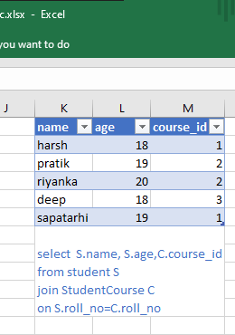

--left join

--returns all common rows that satisfy S.roll_no=C.roll_no plus remaining rows from left table (student table)

select C.course_id, S.name, S.age

from student S

left join StudentCourse C

on S.roll_no=C.roll_no

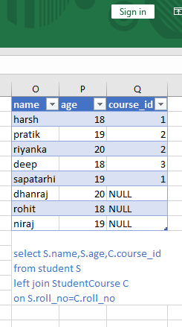

--right join

--returns all common rows that satisfy S.roll_no=C.roll_no plus remaining rows from right table (StudentCourse table)

select C.course_id, S.name, S.age

from student S

right join StudentCourse C

on S.roll_no=C.roll_no

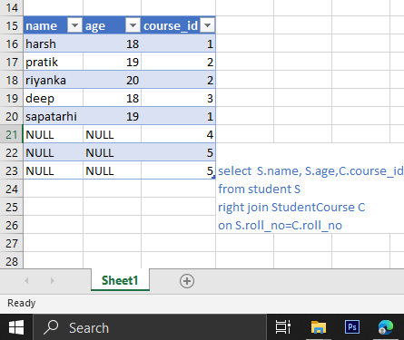

--full join or full outer join

--returns all common rows that satisfy S.roll_no=C.roll_no plus remaining rows from right table (StudentCourse table)

select C.course_id, S.name, S.age

from student S

full join StudentCourse C

on S.roll_no=C.roll_no

