Implementation & Modification in Navigation System

# Aishwarya Vijay Chougule

B.Tech Electrical Engineering Dr.Babasahe Ambedkar Technological University,

Lonere, India.

# Anushka Sanjay Kale

B.Tech Electrical Engineering Dr.Babasahe Ambedkar Technological University,

Lonere, India.

# Prashant Kumar Hake

B.Tech Electrical Engineering Dr.Babasahe Ambedkar Technological University,

Lonere, India.

# Nilesh Narayan Chakle

B.Tech Electrical Engineering Dr.Babasahe Ambedkar Technological University,

Lonere, India.

***Abstract*—Wire Harness is the interconnecting wiring in the vehicle for the transmitting electrical power and signals in the electrical system. Over the years the number of components to be connected and hence the number of circuits has increased many folds. As harness complexity increases, these legacy methods will come under increasing strain, and eventually may fail completely.” You can arguably already seeing this happen in markets such as automotive. And all that is in addition to the risks long posed by late-stage change orders. This has made the wire-harness design as the most complicated task in the vehicle design and wire harness (electrical system) integration with the other aggregates a difficult job. Many CAD tools and design software have evolved from computer companies. But they have not resolved major issues faced by vehicle OEM's and the wire- harness manufacturers. In fact, the requirements of vehicle manufacturers are not clear to the other agencies and this results in wire-harness development as a major bottleneck in any vehicle development program. An overview is given on the importance of the wire-harness design and the impact it will have on the success or failure of the final product ' VEHICLE ' when it reaches the customer)**

***Keywords*—*Implementation of Navigation System, Manufacturing Automation, Automotive wiring harness, Cutting Crimping, Assembly, Final FG***

1. INTRODUCTION

The wiring harness is the biggest and heaviest bought-in part and connects all electrical and electronic (E/E) components in the automotive vehicle, like sensors, electronic control units, batteries, and actuators. As a connecting element, the wiring harness is responsible for the energy and information ﬂow within the E/E system to fullﬁll primary car functions such as steering and braking as well as secondary car functions such as ventilation and infotainment.

The increase in the electrical and electronic content in the automobiles has resulted in the wire harness design

becoming more and more complex. From the simple function of electrical power distribution and transmitting signals, it has become a networking of multiple controllers with a vast range of sensors , actuators and their interfaces. Many luxury features used only in high-end vehicles for safety and comfort have now become standard across all makes and models. With the availability of more electronic components suitable for

automobile applications the gadgets on the vehicles are multiplying with every new model introduced in the market.

1. MANUFACTURING OF AUTOMOTIVE WIRING HARNESS

The wiring harness consists of thousands of components comprising wires with terminals and seals, connectors, fuses, relay boxes, switching units, ﬁxing components, sensor and protecting component.

1. *Wiring harness manufacturing process flow*

The wiring harness manufacturing is divided into three main areas, the cutting-crimping area & USW area, pre- assembly area, and ﬁnal assembly area. The manufacturing process starts from the cutting area, in which automated machines cut wires with different cross-sections into predeﬁned lengths(as per customer drawing), strip the cable isolation, and add seals ( as per requirement) and crimps.Then spliced wires are welded as per customer requirement and design with the help of Ultra Sonic Welding (USW). In the sub manufacturing area, workers execute special process steps, like twisting, splicing, and heat tube shrinking, either with semi-automated machines or manually.

Furthermore,they prepare small wire harness sub-assemblies. The last manufacturing area consists of multiple ﬁnal assembly lines, in which workers sequentially add wire harness components or prepared modules to a large assembly board. By performing ﬁnal assembly tasks, like wire routing wire insertion into connector cavities, and bundling multiple wires with tape, the workers realize the desired tree-like structure of the wiring harness. Finally, the wiring harness is tested regarding electrical functionality, hardware completeness and leakage. Then, the ﬁnal product is either packaged for -in sequence delivery to the automotive original equipment manufacturer (OEM), where it is installed into the vehicle, or sent to rework in case of a failed test.

1. *Wiring Harness Components*

Wire harnesses are collections of electrical wires, cables, and sub assemblies covered by exterior defined tape & that are used to connect devices to their power source.There are several types of wire harness components, each of which is

available in multiple variations to suit different applications. These components include:

* Wires
* Connectors
* Terminal
* Tapes- outer covering
* Ties
* Grommets

*Wire:*

The wire carries the current or signal that powers a device. The wire’s capacity needs to meet or exceed the voltage or bandwidth & it’s expected to transmit. Most wires are copper and can have a specially chosen coating.

*Connectors:*

Wire connectors are available in several varieties and sizes to connect different types of wires. While they are usually plastic they can be made from a variety of elements.

*Terminals:*

Terminals are the metal parts that are attached to the end of the wire to be inserted into the connector or to be attached to a point on the connecting equipment.Terminal are made up with using stamping process.

*Tapes:*

Tapes are used in wiring harness to bundle all wires together in desired tree-like structure of the wiring harness

*Ties:*

Cable ties and clamps keep the wires inside of the harness attached to from a stream of wires to a particular direction. It can also be used to attach to a structure at fixed points to minimize movement.

*Grommets:*

Grommets are insulators to keep moisture out of the connector. A grommet can be attached with the terminal or can be a part of the connector.Outer coverings/Insulators: Also referred to as tubes and sleeves, insulators provide some degree of abrasion resistance, environmental protection, and protection from electrical shock. They can be made of various materials such as nylon

1. WHEN CHOOSING A WIRE HARNESS, SOME OF THE COMPONENT QUALITIES TO CONSIDER

INCLUDE:

* Type of wire (including material & gauge)
* Insulation Material
* Environment Capabilities
* Voltage & current capacity

Wire harnesses play an essential role in almost every industry. Some of the most common industries that use wire harnesses include:

* Automotive wiring Harness
* Aerospace wiring Harness
* Electronic wiring Harness

*A. Wire harness manufacturing terms and definitions American Wire Gage (AWG):*

A standard system for designating wire diameter. Primarily used in the U.S

*Bell-mouth:*The raised portion at the front and/or back of the wire barrel crimp that provides a gradual entrance and exit for the wire strands without causing damage.

*Cable:* A group of individually insulated conductors in the twisted or parallel configuration under a common sheath.

*Cable Assembly:* A cable with plugs or connectors attached.

*Connector*: A device used to physically and electrically join two or more conductors.

*Crimp:* Final configuration of a terminal barrel formed by the compression of terminal barrel and wire.

*Crimp Height:* The measurement of the overall wire barrel height after crimping the terminal.

*Continuity:* A continuous path for the flow of current in an electrical circuit.

*Double Crimp:* The process of two or more mechanical crimping operations on the same location in a single terminal.

*Harness:* A group of wire and cables, usually made with breakouts. Furthermore, with a rubber or plastic sheath tie them together. A harness also provides interconnection of an electric circuit.

*Insulation:* A material that offers high electrical resistance making it suitable for covering components, terminals, and wires. This material also helps to prevent the possible future contact of adjacent conductors and a resulting short circuit.

*Insulation Crimp*: Area of a terminal, splice or contact formed around the insulation of the wire.

1. MANUAL WIRING HARNESS PROCESS:

As we observe there are same process of cutting ,Crimping, Welding, sub-assembly, Taping, Visual Inspection, CKT ,FG. The wire harness manufacturing process is time consuming, difficult, and task oriented. Nonetheless, as the demand for wire harnesses ad cable assemblies grow, manufacturing of these components continues to expand. That's because the wire harness is one of the most indispensable electronic and electrical components in the modern world

*Step 1: Design*

Whether hidden behind a glove box in an automobile or within the back panel of a washing machine, the wire harness A delivers power and transmits information in a streamlined, uniform way. In electronic product research and development, engineers must confront and overcome electrical issues daily to successfully bring a product to market. An integral part of

this challenge entails a custom design for each products electronic part and a step by step wire harness manufacturing process to complete the assembly. This is also the stage at which engineers must choose harness components and decide on other use specifications

*Step 2: Prototyping*

If necessary, wire harness prototyping enables an engineer or product designer to get their hands on a real-life version of their final product. They can then test the harness in its intended application before beginning the first production run, ensuring optimal performance.In wire harness manufacturing, design specifications must be met and high quality standards with sector, wire harness manufacturing processes still rely in no small part on manual assembly. Though some automation can be incorporated into the process, hand manufacturing of wire harnesses and cable assemblies are necessary due to the many intricate and time consuming steps involved in completing the process. Even though building a wire harness can be difficult and task oriented, manual production remains more cost effective.

Another reason manual production remains the primary

method of manufacturing for wire harnesses and cable assemblies is that each must be customized for each application. Wire harnesses are very specific components designed for specific larger parts. They are necessitated to resolve geometric and electrical issues in manufacturing products and to provide solutions to particular problems inherent in the overall process. Geometrically, wire harnesses are designed to fit a specific space within a much larger or alongside a greater network of electrical components and wiring. Wire harnesses also must ground and protect wires from potential internal and external damages related to electrical issues such as crossed wires, chemicals or moisture

*Step 3: Wire Cutting*

Broadly speaking, the initial step in building a wire harness is make sure the wires are cut to the right length, which is done by a wire-cutting machine.

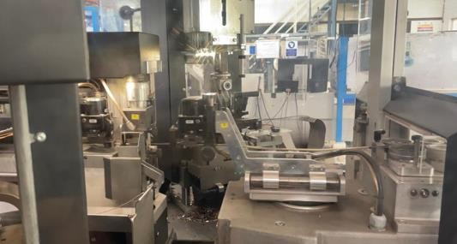

*Fig no: 1*

*Step 4: Assembly*

Lastly, the wires are gathered into a harness utilizing a workbench or assembly board to meet the design specifications. Hand manufacturing of wire harness production is necessary to route wires through sleeves and to apply fabric tape where needed, such as on branch outs from wire strands. Terminals need to be crimped onto wires, and where more than one wire needs to be attached to one terminal, multiple crimping will be necessary.

Also, the insertion of one sleeve into another is done manually, and so is fastening any strands with tape, clamps or cable ties. Hand production does not exclude the use of automation and machinery in wire harness manufacturing.

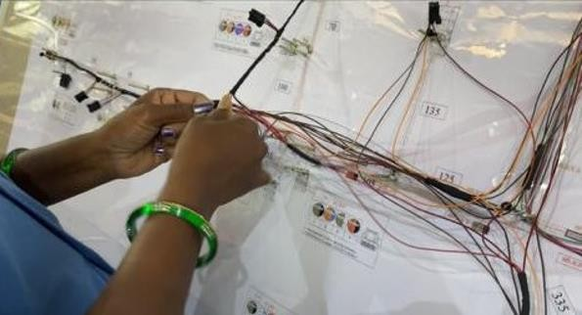

*Fig no: 2*

Cutting machines are used to uniformly cut wires to specified lengths, machines are used to crimp terminals or to partially plug wires with fitted terminals into connector modules. Solder machines are necessary for sealing wire ends as are tools to twist the wire.

*Step 5: Testing*

Once production is complete, each individual wire harness must undergo electrical safety testing for any specifications it may be subject to in real-world operation. This step is crucial in ensuring the final product performs 100% reliably.

Wire harness manufacturing is a process. Design and assembly from the drawing board to finished wire harness requires step by step planning and a good amount of manual production. Each wire harness has a specific purpose to integrate into a larger electronic network, which, in the modern world, truly does make wire harnesses indispensable.

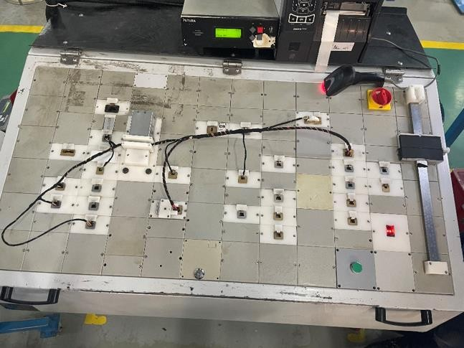

*Fig no: 3*

1. IMPLEMENTATION OF NAVIGATION SYSTEM As discussed in point no 6. is total manual process of making final product (wire harness).It consist of below processes with some manual & automation process

* *Cutting Crimping:* It is fully automated process where operator need to load & unload the applicators, wires & terminals as per requirement. And need to set required parameters as per specification given in catalogue.Cutting Crimping process is fully Automated Process
* *USW - Ultra-Sonic Welding:* Ultrasonic Welding machine is used to welding multiple wire gauges as per requirement. It is also automated system where operator need to select program as per gauge size. Wires get welded automatically with the help of Sonutrode.

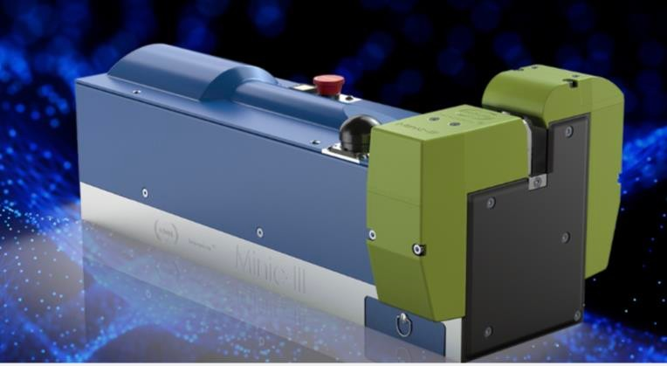

*Fig no:4*

* *Sub-Assembly process:* It is fully manual process where operator picks single wire manually and insert into a desired connector manually. It is time consuming process also frequency of interchanging of wires is more. It may increase Cost of Poor Quality.
* *Assembly Process****:*** Assembly process consist of multiple ﬁnal assembly lines, in which workers sequentially add wire harness components or prepared

modules to a large assembly board. Specified wires, when there is more than one wire going into one terminal, requires conducting multiple crimps that have to be done by hand. So does taping the harness with fabric tape at all the branch outs. Finally, the various components need to be bound or “harnessed” by hand with tape, clamps, or cable ties By performing ﬁnal assembly tasks, like wire routing wire insertion into connector cavities, and bundling multiple wires with tape, the workers realize the desired tree-like structure of the wiring harness and prepares a Final Product which is called as FG - Finished Goods. It is fully Manual Process.

* *Circuit Testing:* Once production is complete, each individual wire harness must undergo electrical safety testing for any specifications it may be subject to in real- world operation. This step is crucial in ensuring the final product performs 100% reliably.It is Semi- Automated process. It requires operators help for laying each harness on test bench.

1. IMPLEMENTATION OF NAVIGATION SYSTEM WITH AUTO-TAPING MACHINE:

Process is same except auto sub-assembly & auto taping. As compared to manual process there are less chances of mistake .So this process is better than manual process. In sub-assembly process is semi-automatic based on automation program.

1. *Introduction to Navigation System:*

Navigation system is nothing but conversion of all manual process of sub assembly to automation.That is, as in manual system we need to insert wire with the help of SWI (Standard Work Instructions) which colour of wire need to be inserted in which cavity. This is all manual process which includes manual errors , possibilities of wrong insertion & behaviour Issue.To overcome form those errors we analyzed whole manual process and set one automated process call Navigation.

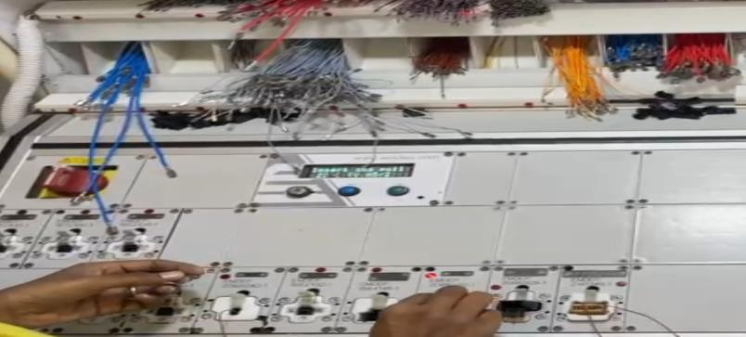

*Fig no: 5*

1. *Advantages of Navigation System:*

* Elimination of wrong insertion and loose insertion occurrence rate.
* Headcount Reduction
* ROI (Return on Investment) is minimum.
* Cost Saving ( Cost Of Labour).
* COPQ - Cost Of Poor Quality improvement.

1. *Material required for building Navigation System:*

Fixtures, LED for indication, trays, Navigation wire insertion bench.

1. *Navigation Process Flow:*

Raw Material Issue



Cutting Crimping & USW



Navigation System- Sub Assembly





Spot Taping



CSL, CKT, FG, Packing

Auto Taping Machine

*Flow Chart*

Above flow shows overall process flow of Navigation System with Auto Taping Machine

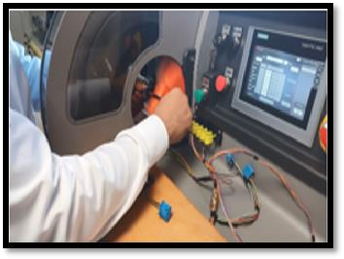

*Fig no: 6*

1. MODIFICATION IN NAVIGATION SYSTEM-

*Current Method –*

* Navigation helps for correct insertion of wires
* Operator need to arrange all required wires and required connectors.
* Connectors are inserted as per standard work.
* And for correct insertion wires navigation helps which wire is to be inserted in which connector and which cavity of respective connector.
  + Currently there is no provision for locking of connector in fixture when wrong insertion is detected. Person who has done wrong insertion can easily remove that connector and can do rework independently.
  + So that employee has no fear of any wrong insertion on Navigation Board because there is no any for escalation for wrong insertion.
  + There is no use if they are doing wrong insertion even all information and guidance is given with the help of LED bulbs which gives next insertion of respective wire.
  + There is chance of terminal damage

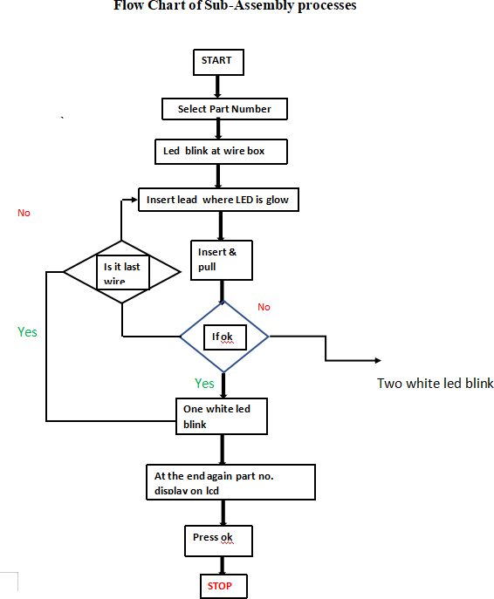

***Proposed Method –***

* + During analysis of current method we found some bottlenecks in Navigation System.
  + If any wrong insertion detected in navigation fixture isn’t

getting locked.

* + Employee is used to rework by himself/herself which may create defect in wiring harness.
  + Rework can damage lance, terminal which will not get locked in MQS (Micro Quad-lok Series) connector.
  + To avoid such concerns from customers, modification is done in navigation system.
  + Whenever wrong insertion is detected through navigation system, fixtures will get locked as harness gets locked when error is detected on EOL tester.
* Fixtures remains locked unless and until a figure print

scanner doesn’t scan for Authorized person.

* This will help to reduce wrong insertion frequency and if any wrong insertion is detected, it will be reworked by skilled rework operator.

. 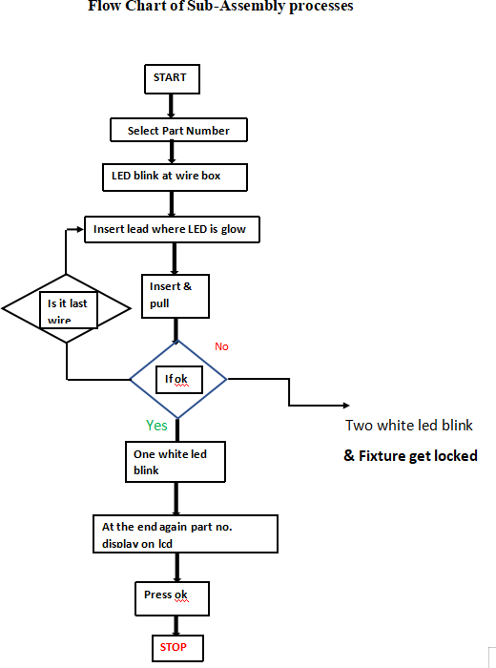

CONCLUSION

The reliability of the electrical system can be gauged

drawing specified by the designer, the electrical faults due to wire connections get totally eliminated.

To overcome all possibilities of production defective product automation in wiring harness became an essential past.Similarly, if the quality checks at wire harness manufacturer are enabling an error free and zero defect wire harness, the vehicle assembly clearance for electrical system faults will be almost nil on assembly line with automation in wiring harness .As world is growing faster and faster with automation in every aspect wherever is possible.

ACKNOWLEDGMENTS

It takes thousand voices to tell a story and similarly it takes the help encouragement of numerous people for the completion of any project. We express gratitude for all who look to be especially acknowledged for their support and assistance to us through each stage of study.We take immense pleasure in expressing our deep sense of gratitude to Prof. Udaysinh Sutar (Principal), M. J. Deshmukh (HOD- Electrical Engg) & Prof. V.P Mohite for his excellent guidance and constant encouragement.

REFERENCES

* 1. The new generation of insertion machines – a quantum leap in fully automatic wire harness manufacturing. Wire harness manufacturing with Komax machines (komaxgroup.com)
  2. Ed., The AAguirre and Raucent, 1994E. Aguirre, B. Raucent Economic comparison of wire harness assembly systems J.

Manuf. Syst., 13 (4) (1994), pp. 276-288

* 1. Hermansson et al.,

2013T. Hermansson, R. Bohlin, J.S. Carlson, R. Söderberg Automatic assembly path planning for wiring harness installations J. Manuf. Syst., 32 (3) (2013), pp. 417-422

* 1. . Lv, J. Liu, X. Ding, H. Lin Assembly simulation of multi-branch cables J. Manuf. Syst., 45 (2017), pp. 201-211
  2. Automating the Wire Harness Assembly Process - Carr Manufacturing (carrmfg.com)
  3. Automating the Assembly of Wire Harnesses (jemelectronics.com)
  4. Ways to automate increasingly complex wire harness design (techdesignforums.com)
  5. PATRICK BOYER, Harness Automation project Mgr, KOMAX corp. “Benefits of fully-automated wire harness assembly”www.cfibermfg/Wiring harness guide
  6. Design and Development Guidelines For Spaceflight Electrical Harnesses ; Procedures and Guidelines – NASA Directive

from the robustness of the wire harness layout and the consistency of the supplies received from the wire harness manufacturer.If the controls on the assembly of wire harness . ensure that the fitment is exactly identical as per the fitment

No.565-PG-. 8700.2.1B Nov 2005 (1997) 260-280.