

SCHOOL OF COMPUTING INFORMATICS

COLLAGE OF ENGINEERING AND TECHNOLOGY

DEPARTMENT OF SOFTWARE ENGINEERING

INDUSTRIAL PRACTICE REPORT

PROJECT/NAME: LETTER TRACKING SYSTEM FOR HADIYA ZONE ICT DIRECTORATE

MEMBERS OF PROJECT/TASKS

NAME ID

1. Kaleb Kaja 000833

2.. Taso Washo 000933

3. Eshetu Yonas 000872

4. muluken Shobiso 000887

5. muluken Adimasu 000886

6. Melkamu Merkeb 000860

7. Tefer G/meskel

Submitted to: Date:25th March,2021

# 1.Acknowledgment

This report has been prepared for the Industrial Practice that has been done in the Hadiya Zone Information Technology department. Firstly we would like to express our sincere gratitude to Selemawit our department Head, Mr........ our advisor and all those who helped us in various capacities in undertaking this Industrial Practice and advising to prepare the report.and Mr. Mebratu hadiya zone ICT center administrator.

Abstract

Internship or practical attachment is the most important place of study and guides students as Well as source of knowledge that gained from that organization. We have done our Practical attachment especially in software devlopement. These document include that the activity’s what we did in field practice;

# 2. INTRODUCTION AND OVER VIEW

## 2.1. BACKGROUND OF INFORMATION (ABOUT ORGANIZATION)

Hadiya Zone Information and technology (HZIT) is one of the government higher Organization or institution which was found in 2009 G.C. The HZIT is found at a town HOSSANA, which is around 230 kilometers away towards South from the capital Addis Ababa. Meanwhile, the HZIT has gone through a series of developments since its establishment. Its ICT center is present at the HZA main Building and which provides the primary management and support for computing and technology services within the Zone.

Science of Information and Technology of Hadiya Zone, like all other institutions, have a minimum package of rules and regulations for a smooth and orderly functioning.

The Science of Information and Technology of Hadiya Zone has been working hard in providing network facilities, office machine (printer and other) and other information technology.

Finally, Science of Information and Technology of Hadiya Zone is playing immense role to achieve the national growth and transformation plan (GTP) via the Science of Information and Technology vision, mission and goals.

# 2.2. INTRODUCTION TO (TASKS OR PROJECTS)

Information is very critical resource for any organization. It helps to have a better coordination and cooperation between different units of the organization and external environment. In order to provide information and facilitate online communication activities through documents (letters), information should be organized and available for anyone who wants to use and access it.

Letter tracking system is a very important issue in large organization and institution like company, office, organizations and university Etc. Many large document and letter are created, processed, updating its status, opening of new files, recording their track and exchange between different organizations.

Letter tracking system in Science of Information and Technology of Hadiya Zone deals with paper based existing letter exchange system. In order to provide information and facilitate computer based online communication activities through letters, information should be organized and available for anyone who wants to use and send request service. Letter tracking system is a web-based application to monitor the movement of image file and receipts and assist in their easy tracking. The main goal of letter tracking system is to share information by making document or letter secure, accessible, retrievable and interchangeable.

* To become a professional in Information Technology industry, industrial training is the foundation for each undergraduate student.
* It helps students to improve their practical skills related to interpersonal, problems solving, research and reporting as well as soft skills.
* Also it helps the students get exposure to the industry, apply the gained knowledge throughout the academic program and learn new updated technologies.
* In addition, it helps students’ career development and to prepare for employment after graduation, by engaging in personal and professional development planning.

We have done our industrial practice at the Hadiya Zone IT center under Software development. We have gained the practical knowledge of website developments about how to design a website for a given organization starting from interface design and farther more some functionalities gained as requirement from the people those are going to use the website,and we have extended our previous knowledge to develop web site. So, an industrial practice is an excellent supervised experience in a professional setting in which we are learning and gaining essential experience and expertise. industrial practice provides real world experience for us to explore or gain the relevant knowledge and skill required to enter into a particular career field. This report documentation includes the main aims of the industrial practice, challenges that are faced during in our field attachment period, the way to develop a website, the practices, skills.

# 2.3 Need for project /tasks

This project is needed. Because of the existing system is:

* Time consuming.
* Data shared from one person/organization to organization/person does not get response in short period of time. Because the Organization maybe located faraway from the organization that communicate with it.
* Resource wastage.
* It consumes different resources to document it and to share it through different organization.
* Need of human power.
* Human power is needed to share data between the organization.
* Information shared manually.
* The document/information shared is paper based.
* Shared data is highly exposed to accident.
* Hard to manage data.
* low letter or document security.

# 2.4. Issues in project/ Tasks

A project issue is a problem that has been encountered in executing project activities.  This problem impairs a project’s ability to successfully complete.  A project issue is almost always one of these:

* A difficulty in completing a work item/task that is already on the project’s plan, or
* The discovery that a work item/task (that is necessary for project success) was not identified or scheduled in the project plan.
* Lack of communication.
* Number of students in a group.
* Scope creep-Adding additional features or functions of a new product, requirements, or work that **is** not authorized
* Insufficient Team Skills about the industrial practice.
* Inadequate risk management.
* Challenges of Teamwork

# 2.5. Solution Approach for issues

* Reducing number of students in the group.
* defining objectives that would help to achieve the goal.
* Determine proper communication flows for project members and develop a way to inform what information needs to be informed to project members.
* The best way to eliminate any issues or negativity in a team is to create a positive work environment. Build trust in the workplace to break down barriers and establish interpersonal relationships.
* Assigning task for each of group member.
* Using time in scheduled way or time table.

2.6. Direction of Research at the hosting organization

2.6.1. Method of Data Collection

To propose this project we have used the following data collection method.

* **Interview**: - An *interview* is a conversation between two or more people where questions are asked by the interviewer to draw out facts or statements from the interview. And we have made an interview with head of hadiya Zone ICT center to get an overview of the current system and the problem of the existing system.
* **Observation: -** is an act or instance of viewing or noting a fact or occurrence for some scientific or other special purpose.
* **Documentation: -** iswritten document which is stored in the office that shows the overview of the existing system.

2.6.2. System Development Methodology

A system development methodology refers to the framework that is used to structure, plan, and control the process of developing an information system. There are different types of system development methodologies to develop information system; among these we select waterfall system development method. Because, Waterfall model is simple to implement and also the amount of resources required for it are minimal when compared to the others.  
In this model, output is generated after each stage, therefore it has high visibility. The client and project manager gets a feel that there is considerable progress.

2.7. Project or Task Overview

Part-I: Requirement of the Project or Tasks

**S**ystem Requirement is a condition or capability possessed by the software or system component in order to solve a real world problem. The problems can be to automate a part of a system, to correct shortcomings of an existing system, to control a device, and so on.

***Functional Requirement***

The following are the functional requirement that the system must meet: -

* **Admin**: the major privilege or function available here:
* First login to the system. The system authenticates him/her if it is the system main president so that the new arrived files tab is shown to him/her, if the file is accepted it will move to the below section where the Edit, Forward, Convert, Print and Archive actions will be enabled for the Administrator. After the job is done, he/she needs to. After the job is done, he/she needs to and sign to all internal and external letter or document .
* Accept letter.
* Forward letter feedback.
* Sign (put signature).
* **Letter sender**: concern all about letter sender.
* In this system they can create (send image letter).
* Request using letter image.
* View letter feedback from admin.
* View vacancies.

***Non-Functional requirement***

It describes aspects of the system that are concerned with how the system provides the functional requirements. They are:

* **Security: -** the system must allow only authorized user to access to the system by checking login information entered by the user. In our system the authorized user should have to access documents by logging into the system and this should be supported by the system.
* **Usability: -** the system should allow user to use the system without any difficulties. Therefore, our system should be user friendly and easily usable by the user by having good user interface.
* **Testability: -** Our system should have to be tested in order to evaluate its performance whenever necessary.
* **Maintainability: -** Our system should be maintainable easily in order to meet changes of user requirements and also to operate as it should have to.
* **Extensibility: -**Our system should allow additional features to be added to it easily.
* **Availability: -**Our system should be accessible to authorized user whenever they want to use it to perform document tracking activity.

2.7.2. part II: Analysis, design, and implementation of the project or tasks

*2.7.2.1. Analysis Project*

Analysis specifies what the system should do. It is a process of collecting and interpreting facts, identifying the problems, and decomposition of a system into its components.

The proposed letter tracking system, dispatch and receive letter will be computerized and online. The existing work system has been carry letter physically to Hadiya Zone Science information and technology . The proposed letter tracking system, dispatch letter in image file to Science of information and technology of Hadiya Zone and send feedback of letter to sender.

Our Project tries to do the following tasks:

* Showing letters to Science of information and technology of Hadiya Zone through their website.
* Easily exchange letters.
* Add/Delete/Update letters easily.
* Forward letters feedback from Science of information and technology of Hadiya Zone to sender.
* Manage letter.
* Showing letters feedback to user.

*2.7.2.2. Design Project*

System Design focuses on how to accomplish the objective of the system. It is a process of planning a new business system or replacing an existing system by defining its components or modules to satisfy the specific requirements. Before planning, you need to understand the old system thoroughly and determine how computers can best be used in order to operate efficiently. The existing work system has been carry letter physically to Science of information and technology of Hadiya Zone. The proposed letter tracking system, dispatch letter in image file through internet to Science of information and technology of Hadiya Zone and send feedback of letter to sender.

This accomplishment illustrated using use case diagram. A **use case** is an interaction between users and a system. It captures the goal of the users’ and the responsibility the system to its users. Use case diagram contain actor, use case, boundary and relationship.

**Actor:**

* Admin.
* User or sender of letter.

**Use case identification**

* Login
* Send letter
* Manage letter
* View letter
* send feedback.
* Manage vacancy.
* View vacancy.
* Logout.

3. PROJECT-I: Requirements

3.1. Project background and scope

We have done our industrial practice at the Hadiya Zone IT center under Software development. We have gained the practical knowledge of website developments about how to design a website for a given organization starting from interface design and farther more some functionalities gained as requirement from the people those are going to use the website,and we have extended our previous knowledge to develop web site. So, an industrial practice is an excellent supervised experience in a professional setting in which we are learning and gaining essential experience and expertise. industrial practice can be done during the academic semester and depending upon the spaced-out curriculum. There are several varieties of industrial practice: some are paid some are not and some offer credit towards graduation.. industrial practice provides real world experience for us to explore or gain the relevant knowledge and skill required to enter into a particular career field. This report documentation includes the main aims of the industrial practice, challenges that are faced during in our field attachment period, the way to develop a website, the practices, skills.

3.2. Requirement of the project or task

**Project requirements** are conditions or tasks that must be completed to ensure the success or completion of the **project**. They provide a clear picture of the work that needs to be done. They're meant to align the **project's** resources with the objectives of the organization.

***3.2.1. Functional Requirement***

The following are the functional requirement that the system must meet: -

* **Admin**: the major privilege or function available here:
* First login to the system. The system authenticates him/her if it is the system main president so that the new arrived files tab is shown to him/her, if the file is accepted it will move to the below section where the Edit, Forward, Convert, Print and Archive actions will be enabled for the Administrator. After the job is done, he/she needs to. After the job is done, he/she needs to and sign to all internal and external letter or document .
* Accept letter.
* Forward letter feedback.
* Sign (put signature).
* **Letter sender**: concern all about letter sender.
* First login or register to the system and perform function that it will concern. In this system they can create (send image letter).
* Request using letter image.
* View letter feedback from admin.
* View vacancies

***3.2.2. Non-Functional requirement***

It describes aspects of the system that are concerned with how the system provides the functional requirements. They are:

* **Security: -** the system must allow only authorized user to access to the system by checking login information entered by the user. In our system the authorized user should have to access documents by logging into the system and this should be supported by the system.
* **Usability: -** the system should allow user to use the system without any difficulties. Therefore, our system should be user friendly and easily usable by the user by having good user interface.
* **Testability: -** Our system should have to be tested in order to evaluate its performance whenever necessary.
* **Maintainability: -** Our system should be maintainable easily in order to meet changes of user requirements and also to operate as it should have to.
* **Extensibility: -**Our system should allow additional features to be added to it easily.
* **Availability: -**Our system should be accessible to authorized user whenever they want to use it to perform document tracking activity.

3.3. Technical detail and implementation issues

*3.3.1. Analysis and design*

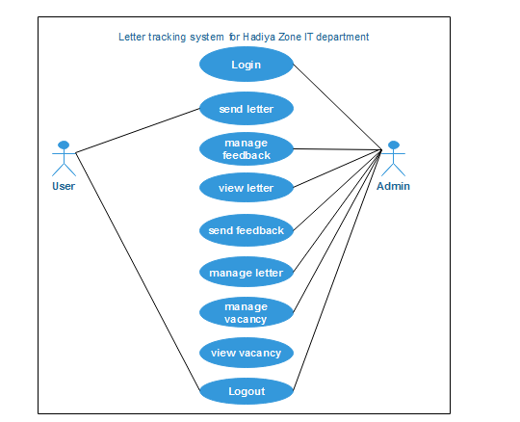

*3.3.2. modularization of project or tasks (if available)*

Modularization is a process that breaks down complex systems into small and solvable parts.

Modularization. Structured design partitions the program into small and independent modules. Thus, structured design uses an approach called Modularization or decomposition to minimize the complexity and to manage the problem by subdividing it into smaller segments.

There are two approaches in modularization:

* Top-down approach
* The problem is broken down into smaller units called module
* Each module is a self-sufficient unit that has everything necessary to perform its task.
* Bottoms up approach
* System design starts with the last level of components.
* Hierarchy of all system component is generated
* Difficult to know all lowest level components at the beginning
* Used only for very simple problems

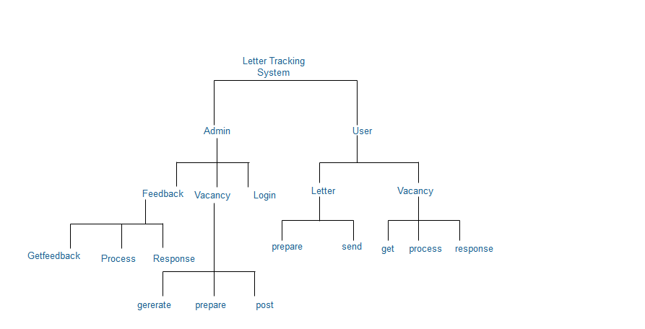

*3.3.3. features of project or tasks- brief summary.*

4. project-II IMPLEMENTATION ISSUES

4.1. Function of the project or tasks

*4.1.1. From user’s perspective*

An **industrial practice** is the phase of time for students when they are trained for their skill they are good at and it gives them a chance to apply their knowledge practically in industries.

* Apply your theory into practice
* Get a feel for the work environment.
* Boost your confidence.
* Build networks how to communicate with people in work environment
* Increase your motivation.
* Improve your CV-students who put themselves forward for an industrial practice show that they are willing to take responsibility, work hard, want to learn, and are interested in getting experience.
* Getting a job directly-work hard and take initiative and you may even be offered a position at the company after your industrial practice and studies are completed. If a manager is confident in your abilities to do a job and knows who you are, you are in with a far greater chance of getting a role than you would otherwise.
* Getting a reference or letter of recommendation.

*4.1.2. From Administrative Perspective*

1. Discover New (And Hidden) Talent

An industrial practice can open possibilities to the new and unique talent that you probably wouldn’t have found through traditional hiring methods

2. Reduce overall employee work load.

Student help the administrators when the do their industrial practice.

3. Management Practice for Senior Employees

4. Minimal Costs for Internship Programs

Internships can be very cost effective for any business, large or small. Internships can be unpaid, as some employers are not obligated to offer a monetary wage for interns, giving the employer the benefit of free labor.

5. Increase Productivity and Retention

Aside from having extra people to help with projects, interns often come with tons of energy. They’re eager to learn, ready to work, and most want the chance to prove their value with the hopes of being hired by their potentially new employer.

4.2. project Rationale and Goal

1**.** Mastering Technical Skills

A good set of goals around technical business skills would be:

* Gaining working knowledge of developing software for a company
* Learning how to build develop software solution based on one’s company requirement.
* Learning how to evaluate the existing system of one’s company.

2. Perfecting Interpersonal Skills

* Learning how to communicate with entrepreneurs, customers, and other participants of the technology

3. Building a Network of Contacts

* Building relationships with people who can serve as advisers or mentors.
* Expanding the network to include other like-minded students

4.Preparation for job searches: Students prepare resumes, write cover letters, and go through interviews as if they were applying for a job. This gives students valuable experience in preparation for employment.

4.3. Technical Details and Algorithms

4.3.1. Architectural choice

We used client server Architecture because

Over C/S has the following advantages:

* The C/S standards are open, universal and cross-platform.
* It suffices to install the universal browser at the client, because maintenance and updating take place at the server.
* So, the client does not need to change at all, enormously reducing development and maintenance costs.
* The user interface only appears at the browser, is friendly to users and easy to use, without the need to learn how to use it like the applications.
* A separate layer of Web server is added between the client and the database server to prevent the client from directly manipulating the database, resulting in greater system security.

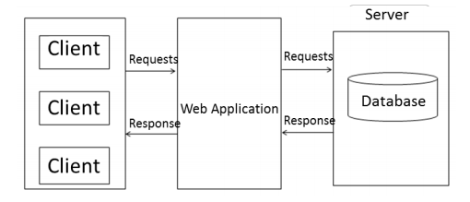

4.4 future work

Industrial practice has the great influence on the future career. It provides/allows to

* Experiencing the Working World
* Learning about Yourself  
  Do you truly know what you want to do for the rest of your life? Many industries have different career paths you can choose to go down
* Growing Your Network to communicate with other person.
* Appreciate the ethical basis of professional practice in relevant industry
* Display a capacity for critical reasoning and independent learning.

4.5. summary

The Industrial practice is a scheme that was set up to enhance and expose us to acquire adequate and relevant skills that would enable us to perform effectively in our future place of work and assignment. It is also aimed at exposing us to people from all works of life, hence enhancing our communication skills and ability to interact with people after graduation. This report is a summary of the knowledge and experiences gained during our Industrial practice which was done at Hadiya Zone Information and Technology Throughout our industrial practice period, we worked at the website development sections where we were exposed to the basics of the Hypertext mark-up Language (HTML), CSS,PHP. The training has afforded us the opportunity to be exposed and learn from our colleagues and other individuals within and outside the organization.

5. Learning from the industrial practice

The industrial practice program was quite beneficial for us. It helped us in improving our various technical skills and enhanced our knowledge in new areas. Overall, we were learned so many things from our industrial practice. Some of them are:

* Critical thinking**-**is the ability to think clearly and rationally about what to do or what to believe.
* Taking constructive criticism. well-Naturally no one likes to be criticised and performance evaluations can be quite scary. You will probably make a few mistakes and receive constructive criticism about your work from both your colleagues and your boss.
* The importance of Team work.
* We brushed up our knowledge of php, html, CSS, and java script.
* Professional communication-Working in a professional setting for the first time can be difficult to get used to. But it is the best way to learn how to navigate the working world through real-life, hands-on experience.
* New and improved skills and how to apply them.
* Responsibility and keeping commitments. Especially, working in group it is very important to keep this thing in mind.

6. applying my university Skills

* Our education/training in Wachemo university was very helpful in our industrial practice. The programming skills which we developed in WCU were very helpful in maintaining the website of hadiya zone Information and technology department.
* Courses of Database also very helpful as it covers database concept which were required in understanding how data is stored on database.
* Other concepts we used in our industrial practice program are: OOSAD (for architectural design), website development (for front end development i.e., html, java script), web design (for server-side script. i.e., php).
* The project that we are experienced in different courses encouraged us to do our tasks with in our industrial practice fluently.

7.Appendices

7.1. Appendix A: requirements for project or Task.

7.2. Appendix B: Some questions regarding Projects

7.3. Appendix C: security issues

7.4 Appendix D: Reference Guide for the project or tasks (if available).

Hadiya zone IT webiste(snnpr.hadiya.gov.et).