
SCHOOL OF COMPUTING AND INFORMATICS
COLLAGE OF ENGINEERING AND TECHNOLOGY
DEPARTMENT OF SOFTWARE ENGINEERING
PROJECT TITLE: HUMAN RESOURCE MANAGEMENT SYSTEM FOR HADIYA ZONE
MEMBERS OF PROJECT
NAME ID
1. Kaleb Kaja 000833
2. Tsion Tamene 5979/09
3. Eshetu Yonas 000872
4. Muluken Shobiso 000887

Advisor name: Dr. Anil K.

Contents
CHAPTER ONE 1
1.1. Introduction 1
1.2. Background of organization 1
1.3. Statement of the problem 2
1.4 objectives 3
1.5. Proposed system 4
1.6. Literature review and related work. 4
1.7. Scope and Limitation. 5
1.8 Methods and Tools 6
1.9 Significance of The Project 8
1.10 Beneficiaries of the system 9
1.11 Feasibility Study 10
1.12 Project Plan 12
CHAPTER TWO 17
2. Description of Existing System 17
2.1 Introductions 17
2.2 Business rules and constraints 17
2.3 Naming Convention and Definition 19
2.4 Functions or Main Activities of Existing System 19
2.5 Players of Existing System or Application 20
2.6 Organization Structure 20
2.7 Documents used in the Existing System or Application 20
2.8 Strength and Weakness of the Existing System or Application 20
CHAPTER THREE 23
Requirement Specification and Analysis 23
3.2. Description of the proposed system or application 23
3.2.1. User characteristics 24
3.3. Requirement Specification 25
3.3.1. Functional Requirement 25
3.3.2. Non-Functional Requirement 27
2.3.3. Non-functional requirements 28
3.4.3. Use-case Diagram 31
2.4.1. Use case diagram 31
3.4.4. Description of Use-Case 32
2.5.1. Sequence diagram 33
CHAPTER FOUR 38
4. System Design 38
4.1 Introduction 38
4.2 Design Issue for your system 38
4.2.1 Design Considerations 38
4.2.2 Design Goals 38
4.3. Design Pattern 42

Acronyms meaning

HRMS……………………………………human resource management system
SNNPR…………………………………. South nation nationalities and people region
HR……………………………………….human resource.
CSS. …………………………………… cascading style sheet
PHP …………………………………….. Hypertext preprocessor
HTML …………………………………... hypertext markup language
OOSD ……………………………Object oriented system development
OOA …………………………….. Object oriented Analysis
OOD ……………………………… Object oriented design
COCOMO……………………………….constructive cost model

CHAPTER ONE

1.1. Introduction
As there are many problems that human beings face throughout their life, it is obvious that we can use computer to solve many of the problems. When saying this, as the computer is the modern technology and problem solver. Nowadays hadiya zone human resource management use manual system and they are facing difficulty in their daily activities. So we can solve this problem by developing new system for hadiya Zone human resource management system. The proposal we have prepared is also the precondition for solving many of the problems of Human Resource Management System for hadiya Zone that is currently handled manually. Therefore, this work that is performed manually needs to be automated to reduce the problems happened.
The proposal includes the profile of the office and also the systems performances are described. In addition, the conditions like the problems in the office, our objective and scope of the project clearly specified .Finally, the tools and techniques we will use and the schedule is summarized as possible as to finish the project in the given time by using these methodologies.

1.2. Background of organization
Hadiya Zone is established in 1984 E.C. It is located in southern nation and nationalities of peoples region. It is 160 km far from the Hawassa, SNNPR town and 232 km from Addis Ababa. Hadiya Zone human resource was established with the establishment of hadiya zone.
Hadiya Zone human resource has much responsibility like keeping record of every employee and other workers, posting notice to absorb new employee, etc. registering new employee, evaluation, placement, and update employee information are also included in their daily responsibility. That is the number of employees during its establishment was not as much the number of as current day employees. Therefore, keeping every record manually was not very difficult. However, currently, because of expansion of faculties, departments and other employees increased simultaneously. So, keeping every record manually became difficult and complex.

1.2.1. Background of the system
In the existing system, all information is recorded on the papers documentation formats manually. Therefore the current system of the organization needs not more attention to reduce the work overload for the office on registering new employee they go here and there office to office for registration. Searching the specific employees information is also another more tiredness work for the HR office since it needs checking when a modification, update, deleting and arranging in orders. The main functions of the system are:
- Registering new employee/hiring employee
- Vacancy notice
- Describe the employee placement
- Modify employee information
- Evaluation
- Reward
- Retirement
- Professional development
- Recruitment
- Managing payroll
- Tracking and managing employee benefits
- Discipline/punishment
- Leave management

1.3. Statement of the problem
Nowadays, the numbers of employee have been increasing all the time. So, these affect the overall performance of the data storing process. These imply data storing will have more complexity and difficulty for manage for employee data. The main problem of HR office of hadiya zone is dealing with their daily job manually. Doing manual has a side effect and has many problems throughout the work. For this reasons the problems that the office currently facing is:
- Difficulty of searching and modifying employee information if they need.
- Time consumption because of manual work for simple jobs.
- Mistakes happened since the work has done manually (lack of accuracy).
- Lack of reliability because of manual work.
- Since the work is done manually buying the paper, pen pencil and etc. needs more cost.
- There is redundancy of data
- Need large space to store file
- Human energy loss
- Loss of employee data due to natural disaster or human error
- Difficult for preparing to organize the report
- Security issue problem
- Less customer satisfaction.

1.4 objectives
1.4.1. General objective
General Objective of our project is to develop web-based online human resource management system for hadiya zone.
1.4.2. Specific objective
The specific objectives of our project are:-
- Study and analyze the limitations of the existing system.
- Suggest alternative solutions in order to address the current problem.
- Understand functional and non-functional requirements of the system.
- Develop a system that facilitates fast report generation.
- Increase to the work efficiency of the office.
- Develop a system that makes retrieval of data efficient.
- Implementation of the proposed system in efficient way.
- Giving recommendation on further studies to be conducted on the areas of human resource management system.

1.5. Proposed system
After observing the current manual system and identifying all the problems that occurred during all activities of the existing system, the project team has decided to design a web-based system for them. Since the web-based system is fully flagged online at any time, it will solve the problem and limitation of the current manual system. And also the proposed project takes care of all the requirements of HR office and is capable to provide easy and effective storage of information related to employee.
The project uses information technology for managing all of the employee’s data. That will make more performance and more reliability of data storing. Therefore, this project is best for the HR office to organize and simplify the access of data and easy modification of the records of employee.

1.6. Literature review and related work.
We reviewed more documents i.e. articles, business rules and proclamation and project that done before. The following are some of literatures among those.
Sage HRMS, formally known as Sage Abra, is built for mid-size organizations which has core Human Resource functions such as talent management, work force management and learning management system in order to optimize employee lifecycle (HRMS, Sage HRMS, 2011).
Fi-es HRMS is developed locally in Maldives, and is in use in Maldives and other countries. This system has attendance management, calculating leave, absent days. System has reporting capabilities to generate monthly reports. Fi-es help the organization speeding up the decision making of the organization (fi-es, 2012).
HRMS for soddo referral hospital by Information System, 2008 E.C. is developed for wolaita soddo referral hospital which has human resource functionalities such as Registering new Employee, Updating employee information, Search employee information, Generate report, Employee placement.
HRMS for debre birhan university by computer science student, in 2011 E.C. which has human resource functionalities such as managing employee profile, vacancy announcement, Employee placement, leave management.

1.7. Scope and Limitation.
1.7.1. Scope of project
This project focuses on HRMS for hadiya zone particularly on:
- Registering new Employee
- Updating Employee information
- Search employee information
- Delete employee
- Generate reports
- Employee placement
- Vacancy notice
- Evaluation and Reward.
- Retirement.
- Professional development.
- Discipline/punishment
- Leave management
- Payroll management.
- Amharic language support.
1.7.2. Limitation of project
- The system can only be accessed if there is an internet connection.
- Expense management is not included.
- Our proposed system is limited to only English and Amharic Language.
- Proposed system not includes online examination for hiring new employee.

1.8 Methods and Tools
Now days there are many tools and techniques available for developing software. But we are concerned on the programming courses and techniques we have learned.
This section discusses the use of software tools and techniques to alleviate the problems of development

1.8.1 Requirement gathering techniques/methods
Data collection methods are the most important part of our project to find the main requirements of system and how to understand the system works. To gather the information we use data collection methods that mentioned as following
- Interview: To determine the objective and scope of the system we have interviewed the HRM officer and those responsible employees for handling HRM and we will also interview for additional information.
- Analyzing existing document (forms and queries): In addition to the interview we have observed existing documents that include organizational rules form and queries for allocating and controlling resources used by the system and in future we will analyze the existing documents as need of our system.
- Observing the working environment: Finally we have observed the working environment to assure those requests gathered using the interview and existing document stated above.

1.8.2 System Analysis and Design Methods
In this project, our team planned to use object oriented system development methodology (OOSD) for the design.
This technique has several phases some of them are:
- Object Oriented Analysis (OOA)
During this phase the team uses to model the function of the system (use case modelling), find and identify the business objects, organize the objects and identify the relationship between them and finally model the behavior of the objects in detail.
- Object Oriented Design (OOD)
During this phase our team uses Microsoft Visio software and edrawmax software to refine the use case model and rational rose for designing the sequence, collaboration, activity diagrams and to model object interactions and behavior that support the use case scenario.
1.8.3 Requirement Validation and Verification
Validation: Are we building the right product?
Building the right product implies creating a requirement specification that contains the needs and goals of stakeholders of the software product. Our requirement is valid because we gather it from the organization directly.
Verification: Are we built the product right?
If you do not collect requirements correctly it increases the gap between expected and delivery output/outcome. so we are collect requirements directly from stakeholders(users) of the system. Therefore our requirement is verified.

1.8.4 System Implementation Method
Implementation is an understanding of a technical specification or algorithm as a program software component or other computer systems through computer programming and deployment. In our project, implementation exists for a given specification or standard. so the team is in a position of converting all documents gathered and designed into the code so that the system would be implemented for the user to be used for the purpose it developed. To implement it, the organization must have a server on which the system would be hosted because this system can run on an internet site with connection available or internet connection.
Implementation is the phase where objectives of physical operations of the system turned into reality i.e. real working model. The process of converting as a new system into an operational one is known as system implementation. This includes all those activities that take place to convert from an old system to a new system. The model will be translated into source code, which includes implementing the attributes and methods of each object and integrating all the objects such that they function as a single system.

1.8.5 Development Environment and Programming Tools
The development environment is the environment that is responsible for developing the software. The development environment of this product will be net beans or eclipse to develop platform-independent software. Development Environments are:
Sublime text (visual studio)
Programming Tools are the programming languages that we will use to develop our system. These are
PHP: - for back end
XAMPP: - as server
HTML: - to describe the structure of the interface
Java script: - for form validation for the interface
CSS for:-
- Used to describe the presentation of documents
- Define sizes, spacing, fonts, colors, layout, etc.
- Improve content accessibility
- Improve flexibility.

1.9 Significance of The Project
Currently, we are living in a world that most of the thing is handled by technology. So, our system also adding great value to overall working environment of hadiya zone human resource office. Therefore, HRM System for hadiya zone gives many purposes some of them are:-
- Reduce the workload in the present system.
- Reduce time wasted in the data processing.
- It increases popularity and attracts the employee.
- Facilitates accessibility of information.
- It creates the opportunity for giving different feedback
- It is used to give effective and efficient services to employee.
- It enables to decrease the duplication's of data inputs
- It allows creating a secure, comfortable and easy way of data storage
- It also proclaims for the employee if there is new things or messages through the system etc.

1.10 Beneficiaries of the system
For HR Office: -
- Avoiding improper resource consumption like paper, pen…
- Avoiding data loss because of improper data storage
- Enhance security mechanisms to protect employee information.
- Simple process for posting job vacancy.
- To handle the applicant effectively and support the smooth functioning of the business.
- reduces work over load of the office
For Employee: -
- Can view notification send by the department and HR office from anywhere at any time
- Can be able to fill in leave application form in the appropriate fields online.
- Can also view their personal information through the system.
For Applicant: -
- Multiple channels to access services from the institution
- Simplified process for registering online
- Can view posted information’s from anywhere at any time.
For Department: -
- Facilitates fast and efficient retrieval of data
- Avoiding improper resource consumption like paper, pen, ledger…
- Reduced workload of the office activities such as preparation of reports
- Simplified process for managing employee information.
For Developers:-
- The proposed system will enhance and deepen our knowledge of programming and system development. This will improve our skills in analyzing and solving problems which may we apply in the real world.
- It helps students to improve their practical skills related to interpersonal, problems solving, research and reporting as well as soft skills.
- The proposed system will beneﬁt the future researchers by making this as their future reference in conducting similar studies.

1.11 Feasibility Study
The feasibility study is an evaluation and analysis of the potential of the proposed project which is based on extensive investigation and research to support the process of decision making.
1.11.1 Technical Feasibility study
The system is technically feasible; this is in the sense that the project team contains enough number of manpower and tools such as programmers, testers, debuggers and the programming tools. The proposed platform has sufficient capacity for future needs. The system is to be developed by using technological system development techniques such as PHP, CSS and MySQL database to solve problems and the system is developed with skill enough capability to develop the project in addition to this if the system is damaged for different reasons it will be easily fixed by the employees of the organization.
The system uses a technique to maintain security and backup of the system. There are many data encryption techniques or algorithms to secure the data. Among them the algorithm that we will use to make the system secure is hashing algorithm and to protect our system from unauthorized user we use session tracking. So unauthorized user cannot access and modify data in our system. The method we used to back up the file is physical backup method because the physical backup is the best way to backup and restore the large data. Therefore the system will be technically feasible.

1.11.2 Economic Feasibility study
Cost benefit analysis: The system which we are going to develop will have economic benefit. Those economic benefits may be tangible or intangible
- Tangible benefit: This means the concrete benefit that can be expressed in terms of dollars or birr. So the system proposed to develop will decrease a lot of birr that was expensive to buy the hard copy document material such as paper, pencil, rubber, and so on. Also reduce the loss of data that means if it reduces the loss of data it also reduces the cost of replacing the lost data. For example if the Zone have 1000 employees to handle these amount data there must be many people to manage the data and a lot of paper, pen ,and pencil will be bought. But after the system developed the data can be managed with one person and in one computer in very short time.
- Intangible benefit: Those benefits that cannot be expressed in terms of birr or dollar. e.g. time, knowledge… etc.
1.11.3 Operational Feasibility study
The system we develop will really solve the existing system problems. The system normally automates the existing processing system. Those employees have somewhat computer knowledge workers hence they can easily understand and use our system. Therefore, the system will be designed to be operationally feasible. In addition the system is practical and applicable.
1.11.4 Legal Feasibility study
Assuming ourselves as someone that has full privileges to perform such activities, and having enough deep knowledge about the problem, the law cannot permit us to work with and giving solutions to such problems. So we could.

1.11.5 Political Feasibility study
Political feasibility is used to predict the probable outcomes of a proposed solution to a policy problem through examining the actors, events and environment involved in all stages of the policy-making process.
This project purposely develops for eliminating the drawbacks and limitation that exists in the previous system which is manual and to initiate the user's interest to use the system. So, there is no impact on political as well as legal issues. Our system is not conflicting with the government of the past and the current because our system is based on previous activities in the Hadiya Zone human resource management and is politically accepted.
1.11.6 Schedule Feasibility study
Schedule Feasibility study is all about the probability of a project to be completed within its scheduled time limit, by a planned due date. If a project has a high probability to be completed on time, then its schedule feasibility is appraised as high.
It enables our project to organizational deadlines; our project will be completed in four month.
We scheduled our project into two parts in terms of time.
Part one: From March 25, 2021 up to April 25, 2021 G.C chapter one to chapter three.
Part two: From April 26, 2021 up to July 23, 2021 G.C Chapter for up to six.
Depending on this schedule our project is definitely feasible.

1.12 Project Plan
1.12.1 Time Schedule
Anything that is done without plan and schedule is like the person that his eyes cannot see (blind). Therefore, the schedule is the eye of any project.
To finish our project in time we have planned it as follows.
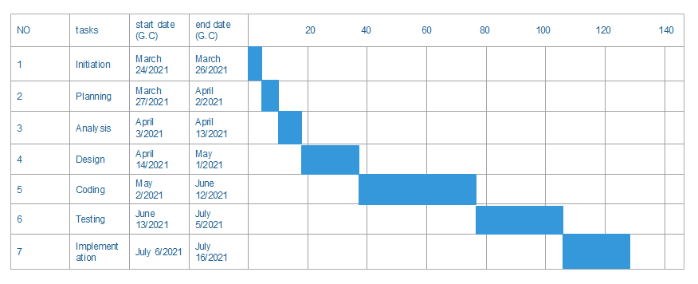
Table1. Time schedule
PERT CHART
We can schedule a task using the PERT (Program Evaluation Resource Techniques)/critical path.
Tasks/activity | Assign variables | Immediate predecessor | Expected time
initiation | A | - | 3
planning | B | - | 6
Requirement gathering and analysis | C | A | 10
System Design | D | A, B | 17
coding | E | D | 40
Testing and maintenance | F | C, E | 27
Implementation (deployment) | G | E | 11
Table1. 1 Program evaluation resource techniques
The network diagrams of the above activities are given below:
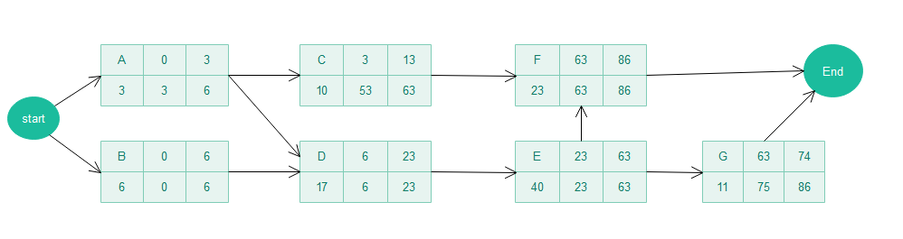
Figure1. 2 network diagram
To determine the critical path of the above activities given table below
Activities | ES | EF | LS | LF | LF-EF/LS-ES
A | 0 | 3 | 3 | 6 | 1
B | 0 | 6 | 0 | 6 | 0
C | 3 | 13 | 53 | 63 | 1
D | 6 | 23 | 6 | 23 | 0
E | 23 | 63 | 23 | 63 | 0
F | 63 | 86 | 63 | 86 | 0
G | 63 | 74 | 75 | 86 | 23
Table1. 2 Activities critical paths
The Critical paths of the above activities are B-D-E-F.

1.12.2 Budget Plan
The project we are planning to do needs some software and hard ware. And also require other material such as paper, pen, pencil, air time that are used when gathering the information, design our system manually and so on.
Generally, we can express in the following table.
Item | Quantity |  | Unit cost per item(birr) | Total cost(birr)
Printing | 220 paper |  | 2 | 440.00
Paper | 1 mass |  | 110 | 110.00
Pen | 10 |  | 5 | 50.00
Mobile card | 20 |  | 10 | 200.00
CD(RW) | 5 |  | 25 | 125.00
Transport | 5 |  | 80 | 400.00
Contingency |  |  |  | 1000.00
Pencil | 10 |  | 2 | 20
PC | 4 |  | 19,000 | 76000
Flash disk |  | 2 | 250 | 500
Cell phone |  | 4 | 5000 | 20000
Internet |  |  |  | 1000
TOTAL |  |  |  | 99,845
Table3: Cost of project table
For the successful accomplishment of the project, the costs associated with each item required have been estimated. For Software cost estimation we can use the COCOMO approach of cost estimation techniques.
Software cost estimation involves answering the following questions:
1. How much effort is required to complete each activity?
2. How much calendar time is needed to complete each activity?
3. What is the total cost of each activity?
We can answer the above question depending on the Constructive Cost Model (Cocomo) of LOC approaches.
To calculate estimation we can consider three main points of project modes these modes are organic, semi-detached and embedded modes form these three project modes we use semi-detached because the group team has both experienced and inexperienced.
We can calculate using this formula:
Effort=ab (kLOC)^bb
Time =cb*(KLOC)^db
People(average staffing)=Effort/Time.
Project | Ab | Bb | Cb | db
Organic | 2.4 | 1.05 | 2.5 | 0.38
Semi- detached | 3.0 | 1.12 | 2.5 | 0.35
Embedded | 3.6 | 1.20 | 2.5 | 0.32
Table1. 3 Cost estimation techniques
Our projects will estimate as 1.8KLOC so to calculate the effort and development time depending on the above software product.
Effort=3.0 (1.8KLOC)^ 1.12=5.79PM
Time=2.5(1.8KLOC)^ 0.35=3.07 [calendar]
People=5.79/3.07 =1.88.programmers

CHAPTER TWO

2. Description of Existing System

2.1 Introductions
Describing and understanding the major functions of the existing system provides a way to identify problems in the existing system, to provide alternative solutions for the problem identified, to select the realistic solution among the alternative solution and to decide the functional requirements of the proposed new system.
In this chapter the existing system of hadiya zone HRMS was clearly defined by answering how existing system is working? In what way the employee managed? What are techniques being used to handle personnel file? What are the business rules of the existing system? And what are the problems in the existing system? After studying the existing system it is possible to understand that how the proposed system can solve the existing system problems. Studying the existing system will also use to determine both functional and non-functional requirements.

2.2 Business rules and constraints
2.2.1 Business Rule
In every organization or institution, there are rules and policy, which used to govern all activities in specified workflow and control the workflow, performed in the working environment. The main rules are:-
BR1: Employees evaluation (day of presence and absence) must be approved by department head.
BR2: Each Employee must have a unique ID.
BR3: When employees are leaving the organization by any means, they have to handover the organization resources or duties in proper manner.
BR4: Reports must be prepared and generated within a specified schedule.
BR5: Whenever the Employee is absent from his/her job the salary must be reduced, if he/she have no permission from department head.
BR6: To get employee, the departments who needs employee should write an application letter for their vacant position to HR department
BR7: when the vacant position is announced to external applicant on notice board or on mass media, it should have to persist externally for consecutive 5 to10 work days.
BR8: To be employed applicants should bring a clearance letter from previous Employer.
BR9: when the human resource hired the new employee to that of departments who needs an employee they must send a letter that has full documents about the new employee.
BR10: Access of information depends on the authority of the user.
BR11: the employee must have full reason to apply leave application.
BR12: if the employee wants to leave from the institution for different reason first they must apply to the department and the department must send their application to the human resource.
2.2.2Constraints
The constraint is the element factor or a subsystem that works as a block. It restricts an entity, project, or system from achieving its potential (or higher level of output) concerning its goal. Some of the constraints are:-
- Time: - The time required to produce a deliverable system that the team estimated the project is plenty of time and, in reality, the time given to finish this project is very short.
- Virus: -virus may attack our files.
- Unavailability of staff members by different case when we want to gather information.
- Loss of willingness of stakeholder to provide the real information about the system.

2.3 Naming Convention and Definition
- HRMS: - human resource management system
- ID:- Identification Number
- PHP: - hypertext preprocessor
- BR: business rule
- LAN: -local area network
- OHRM: online human resource management system

2.4 Functions or Main Activities of Existing System
The major and fundamental functions of the existing HRM system of Hadiya zone are the following:
- Employee registration:-Registering the new Employee to make the member of the organization and specifically in which department he or she works in.
  - It is done when new employee join the organization after fulfilling the required evaluation criteria and procedures. The work is done by the HR officer.
- Update employees’ information: - Whenever employees acquire new skills or certificates the profile need to be changed based on the employee credentials/ID, the administrator updates every employee information as per new data.
- Search employee information: - Searching employee information is done when the employee needs to get his/her file, and also when the office needs to look at employee’s information for various purposes.
- Generate reports: - This process starts when necessary information is gathered from different departments. The HRM office is responsible to generate the reports about the employee daily, monthly, annually.
- Recruitment: - training new employee about the work flow when they join the organization and train the existing employee when there is any policy change.
- Vacancy notice: - HR manager announces vacancy for applicants when there is vacancy in any department.
- Evaluation: -department evaluates employee performance.
- Reward: - the HR manager rewards employee based on his/her performance.
- Leave management: -managing the application for leave from organization.
- Professional development: -it is done based on the employee work experience and duration.
- Managing payroll: -HR manager calculates payroll of employee based on absence, tax, overtime, holiday, late come etc.

2.5 Players of Existing System or Application
- Employee: - is a person who takes works in the organization.
- Admin or HR Manager: - in the current system, the HR office manager who is responsible regarding manage about the HR.
- Applicant:- is a person who apply for job
- Department head:-responsible to evaluate the employees in the department.

2.6 Organization Structure
Organization structure is the diagrammatic representation of the organization from top to bottom as follows:

Hadiya Zone
Sectors
Woreda /district
Trade and market development
Natural and agriculture resource
Health
ICT
…
HR and civil service
Good governance
Reform & support
HRMD
HIV prevention
Inspection
Gender issue
HRM
HR data and statistics
Review
Head office

2.7 Documents used in the Existing System or Application

The existing system use file and forms that are used to perform different operations such as to register employee and approve application from applicant. The documents in the existing system shown as follow:
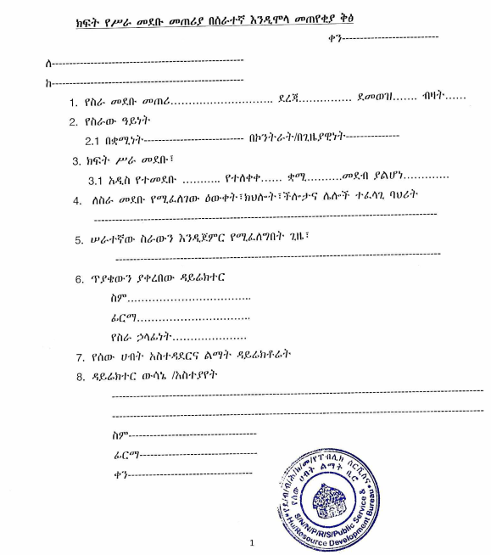

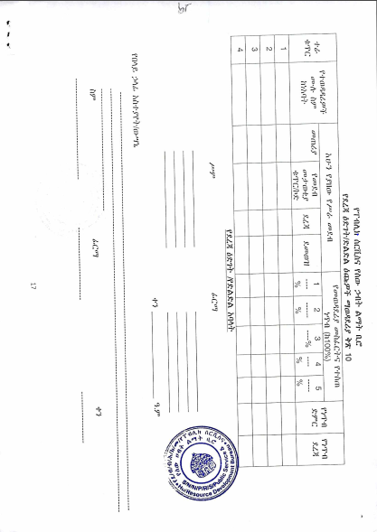

2.8 Strength and Weakness of the Existing System or Application

2.8.1 Strength of the Existing System or Application
Some aspects could be considered to be strengths of the existing system, some of them are:
- The Business Rule: In the existing system of HRM the Organization have their policies and guidance rule; the OHRMS for hadiya zone also follow these rules to be automated.
- Make a payment: because the online payment is out of our scope payment process for the HRMS of hadiya zone is through manual which is preserved from the current system.
- The technological aspects like internet connections are not required for the customers as well as for the office.

2.8.2 Weakness of the Existing System or Application
The existing HR management system for the hadiya zone is done manually due to lack of experience, Budget and system development skill. So the existing system has the following drawback.
- Because of the existing system is manual data handling and file searching is difficult for the offices .
- The current system does not use software.
- More space and time needed to keep all records of employees and there is no use of the database for file storage paper takes a massive amount of room
- Difficulty in modifying and editing data regarding the employee: The existing employee record is difficult to be edited and updated. The information is very difficult to retrieve and search a particular employee’s information; the user has to go through various lists of all employee information. This results from time-consuming.
- There is no data redundancy control, for example, the same registration number can be assigned to different employee due to human errors.
- Division of responsibility because it requires large human power
- It requires division of different classrooms such as file recorded room, HR staff room, secretary room and others
- Reduced quality of work because of the service provider has different office

2.8.2.1. Alternative Solutions
There are different alternative systems of a possible solution for the Human resource management system such as:
- Web-based human resource management system
- Mobile-based human resource management system
- Free mobile SMS based
- Desktop based human resource management
We select human resource management system for the hadiya zone HRMS (Web-based only) There are different reasons why we select an online human resource management system for the hadiya zone HRMS (Web-based only). Even though when we look at the web-based system it only considers the community who lives areas in which a high amount of internet connection exists and broadly uses a personal computer to access the system easily.
The mobile-based has its advantages and disadvantage, for instance, developing the system is very advisable in case of addressing the system to the whole of the people but the system becomes complex for the customers and it becomes difficult to retrieve data from the system through mobile easily than using computers.
The free mobile SMS based also cannot address the whole of the system functionality through free SMS, but if we use the only web-based system it is fastest to retrieve data and it becomes more acceptable for different reasons such as:
- It is an easy way of access data
- Retrieving data purely and so on are the basic reason why we select only web-based.

CHAPTER THREE

Requirement Specification and Analysis
3.1. Introduction
Requirement gathering is a way of collecting information to improve the traditional system by the new system. In this project, our team used an object-oriented system development methodology in which it incorporates two principal phases. These principal phases are Object-Oriented Analysis an Object-Oriented Design. In this chapter, we will discuss the first phase of the methodology: Object-Oriented Analysis (OOA).
This chapter describes an overall description of the project which is mainly to the constraint of the system, functional and non-functional requirement will be included. Then Use case modeling with their description and the development of Activity diagrams and sequence diagrams are performed. Lastly, Requirement Validation and Verification will be explained.

3.2. Description of the proposed system or application
The proposed system is entitled to developing OHRMS for the Hadiya Zone by using a web-based system. The proposed system takes care of all the requirements of employee Registration and is capable to provide easy and effective storage of information related to employee.
The proposed system uses information technology for managing all of the employee’s data and that will make more performance and more reliability of data storing. Therefore, this project is best for the HR office of hadiya zone to turn their employee managing system to the more organized form and simplify the access of data, data management and easy modification of the records of employees.

3.2.1. User characteristics
Four types of users interact with the system: applicant, employee, HR Officer, and department head (manager). Each of these four types of users has a different use of the system so each of them has its own requirements.
- The employee: uses this website to get the service from organization. This means that the employee who was registered in to this site can access the services.
- Applicant: uses this site/system to apply for job, to view vacancy notification etc.
- The HR officer: control the whole system and those people in the hierarchy that is the system and manages the account. They will view employee comment and manage employee data, and the responsibility of managing the departments.
- The department head will also use this website to view the message from the employee within the department, to prepare/generate report of employee attendance and performance.

3.2.2. Constraints
When developing and implementing the system, the constraints that we might face are: -
- The information of all user must be stored in a database
- The design of the pages should be self-descriptive, which means it should not mislead the user from using it correctly.
- Also, the color used as background should not be harmful to the eyes of the user.
- Lack of electric power.
- Lack of Internet connection or LAN.
- It's not suitable for disabled people, like blind people.
- The person that doesn't have computer skills cannot operate the system.
- The system doesn't work for those who haven't a valid account.

3.2.3. Assumption and Dependencies
To use this online human resource management system, every user must have the basic skill to use a computer or android phone and some knowledge on how to use the computer. Some of other assumption and dependency of our projects given as bellow:
Assumption
- It assumed that the user gets the appropriate information about how to use web applications
- There should be a network service/connection.
- The system users should be honesty, especially communication.
- If one user login to the system he/she must log out from the system.
Dependency
To use our system, the user must have fulfilled the following criteria.
- There must be an internet connection to access the system.
- User should have some basic knowledge about using the laptop.

3.3. Requirement Specification

3.3.1. Functional Requirement
The functional requirement explains and describes the interaction between the system and the users or in general with the environment. A functional requirement is a requirement that describes “what the system should do?” That means what the human resource management system for hadiya zone should do.
The new system will have the following functional requirement:-
- View Report: HR manager, employee and department view the report.
- Login: the user must log in to use the system.
- Generate report: HR manager and department head generate the report in the hierarchy
- View feedback: department head and HR manager can view the feedback sent by any applicant or employee.
- Send Feedback: - employees and applicants can send feedback on the services for the HR officer or department head.
- Payroll System: -calculating employee salary including bonus, deduction. i.e tax, late come, absence.
- View notification: - System should display notices or news on screen.
- Logout: users able to log off the system for data security.
- Posting announcements: the system post vacancy announcements and notice for the applicants in order to make them informed.
- Register applicant online: The system registers applicants’ who wants to be hired in the institution with appropriate information. Without coming to the office they can be able to register online by using the system.
- Placing new employee: the system is able to record the new employed applicants and able to place to their respected position.
- Manage employee information: The system is able to search, delete and update the hired employee information when it is needed. And also the department can assign project team for every employee in his department.
- Leave Application/Approval
- Leave application- The user is able to fill in leave application form in the appropriate fields.
- Leave approval- The HR manager are able to approve leave applications based on the reasons stated.

3.3.2. Non-Functional Requirement
Non-functional requirements are requirement, which has no essential for the system, but it can support and give more quality for the system.
The performance of the system will highly depend on the performance of the hardware and software components of the installing computer and the speed of internet access. When we consider the timing relationships of the system the load time for user interface screens shall take no longer than two seconds. It makes fast access to system functions.
The login information shall be verified within five seconds causes' efficiency of the system. Returning query results within five seconds make the search function more accurate.
Software quality attributes such as:
- Reliability: The system shall be highly reliable by performing all the functionalities expected by the end-users. This is the most quality attribute needed by the end-users.
- Efficiency: The extent to which, the software system handles capacity, throughout, and response time. Our system is efficient because the response time is very small if there is a fast connection i.e. not more than 5 seconds.
- Usability: Our system has usability because provide an easy-to-use, easy to learn and easy to understood the function of the system.
- Integrity: Our system is integrity because the only system administer has the right to change system parameters, such as managing an account, etc.
- Robustness: Our system is a strength full to handle system functions accurately and maintain the database without facing unexpected failures and it is also error-tolerant.
- Availability: HRMS for hadiya is going to be available 24 hours per day, therefore, it will give full operation service regarding of HRM system
- Portability: The HRMS System for Hadiya Zone we will develop is so web based system, it is portable for different kinds of operating system. Therefore, our system is platform-independent.
- Maintainability: Whenever our system is needed to be changed or if it is needed to add some other extra functionality, the current developed system is going to be kept as it is and correct defects with making changes.
Another Non-functional requirement
- Safety and Security requirements
There are several user levels in HRM of hadiya zone; Access to the various subsystems will be protected by a user login screen that requires a user name and password.to make the system more secured we used password hashing method to store it in database. This gives different views and accessible functions of user levels through the system.
- Error handling method
The system have error handling mechanisms that is, as errors occur it will not stop functioning rather provide error manages and should guide the user through what to do next.

3.4. System Modeling
System modeling is the process of developing abstract models of a system, with each model presenting a different view or perspective of that system. It is about representing a system using some kind of graphical notation, which is now almost always based on notations in the Unified Modeling Language (UML). Models help the analyst to understand the functionality of the system; they are used to communicate with customers.
3.4.1. Actor Identification
The actor is an external agent that interacts with the system. Actors of the proposed system are the following
- Applicant:-
- Create an account: applicant must registered to the system to apply for work.
- View vacancy: applicant can view vacancy posted by HR manager.
- Feedback:
- Apply:
- Department officer:
- Log in to the system and manage the employee within the department
- Generate report: the officer generates a daily report to the HR Admin.
- Send notification: He sends a notification to employees suppose if any meeting or conference is there.
- Evaluation: - including performance, attendance, reward and punishment
- Retirement
- HR manager:-
- control the whole system.
- View report: He views information what going on the each department.
- Generate report: the Admin generates reports and send to finance and Zone adminstrator to approve the payroll of employee and assign budget for each and every sector.

- Employee:-
- View position: employee can view the position he/she is assigned to work in it.
- Leave request : asking for leave in different case
- View leave approval: employee can view the response of his/her leave request response
- Manage profile.
3.4.2. Use-case Identification
Use Cases are an effective technique for narrating the ways a system works in fulfilling a User
Story/Requirement. Use Cases explain what happens when someone uses the system to (try to) achieve a goal; this will help us understand how it should work in detail. Use cases of the system are the following.
Login | View Feedback
Create Account | Leave request
Forget Password | Payroll system
Update Profile | Approve leave
deactivate | attendance
punishment | Post vacancy
Send Feedback | View vacancy
Logout | Post screening info
Generate report | View screening info
View report | Delete account
Table3. 1 System use cases

3.4.3. Use-case Diagram
Use case diagram shows the interaction between the actors (applicant, department, and employee, HR manager) and the use cases which are found in our proposed HRM system. Use case diagrams describe what a system does from the viewpoint of an external observer.
Thus a Use Case Scenario is a description that illustrates, step by step, how a user is intending to use a system, essentially capturing the system behavior from the user's point of view.
In order to create relevant use cases for the system, the following actors for the system have been identified:
- applicant
- Employee
- Human Resource manager
- Department
Use case diagram
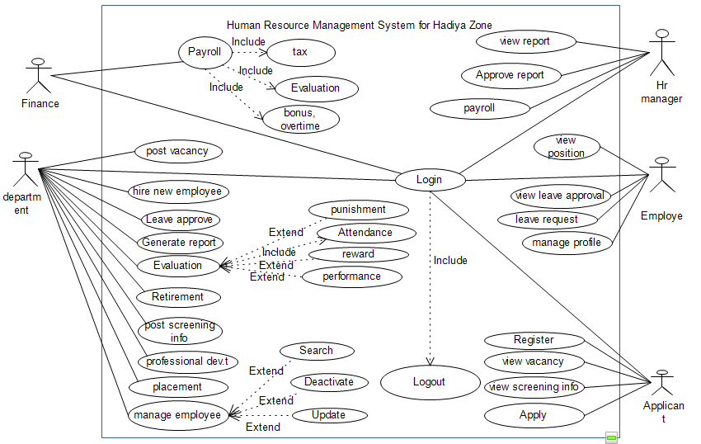

3.4.4. Description of Use-Case
Use case description explains in detail the general flow of use case diagrams. Each table contains the use case name, use case ID, the actor that initiates and interacts with the use case, and flow of event that shows the interaction between the actor and the use case which enables the user to easily understand the functions of the proposed system.
Use case description for creating an account
Use case Name | Register
Use case identifiers | UC #1
Actors | Applicant
Precondition | This use case is done by the applicant in order to register for applying to the vacant position.
Description | Describes how the actor able to creates an account for acting.
The basic flow of the event | Actors Request  1. The Actor click sign up button  3. The Actor fills information.  4. The actor presses button/submit. |  | System Response  2. The system displays create account form.  5. The system validates the provided information  6. The system creates a new account successfully.  7. The use case ends
Alternative events | A5. If the Actor enters invalid information,  A7. Use Case ends. | A5.1 The system displays the message “Please try again”.  A5.2 Go to step 3
Post condition | If there is no Exception/error, Registered successfully  Otherwise, applicant not registered successfully
Table3. 1 Use case Description for Register.
Use case description for Login
Use case Name | Login
Use case identifiers | UC #2
Actors | HR Manager, department HR, employee, finance
Precondition | The user must have at least correct username and password.
Description | This use case is to enable users to have access to the system and used to ensure security for login into the system.
The basic flow of the event | Actors Request  - The users browse/open the application/web.  3 User press Login link.  - The user enters the User Name and password  6. The user Presses Login Button | System Response  - Display home page  4. Display Login form  7. Authenticate User name and password.  8. system displays target page  9. Use Case ends
Alternative events | A7. If the users enter invalid information,  A9. Use Case ends. |  | A7.1 The system display the message “Please try again”.  A7.2 Go to step 4
Post condition | the main page will be displayed then user gets access to its privilege and after finishing his/her work he can logout.
Table3. 2 Use case Description Login.
Use case Description View report.
Use Case Name | View report
Use Case Identifier | UC#3
Actor | HR manager, finance
Precondition | The user must be logged in to the system to view the report.
Description | This use case describes how the manager views the report generated by the system.
The basic flow of Event | Actor Request  1 Actor press view report Button  3 Actor views the report  4 The actor exits the system | System Response  2. The system displays the report  5 Use case end
Alternative flow Event | A3. If the report doesn't exist. |  | A3.1 System not able to display the report
Post condition | The report is viewed Successfully
Table3. 3 Use case Description View report.
Use case description for Post Placement/position
Use Case Name | Post Placement
Use Case Identifier | UC#4
Actor(s) | Department HR
Precondition | The department human resource manager must login to record and place the new employed applicant information.
Description | The department human resource manager will record the new employed applicant’s information and place them to their position.
The basic flow of Event | Actor Request  Step1: click the placement and registration page from menu  Step3: fill the all employee information and place to their position.  Step 4:click submit button |  | System Response  Step2: display placement and registration page  Step5:display save successful message  Step7: finish placement and the use case end
Alternative Flow of Event | A6. If the actor enters invalid information | A6.1 The system prompts the user to re-enter the valid information by returning to the basic flow of event 3  A7. Use case end
Post condition | Display registration and placement.
Table3. 4 Use case description for post placement
Use case description for Deactivate employee
Use Case Name | Deactivate Employee
Use Case Identifier | UC#5
Actor(s) | Department HR.
Precondition | The department must login to the system to Deactivate employee.
Description | This use case is done by the department Hr when they need to deactivate employee profile information
The basic flow of Event | Actor Request  Step 1: the department Hr click deactivate employee link  Step3: enter id.  Step5: click deactivate button. |  | System Response  Step2: the system displays the form to enter id.  Step4: display the employee information.  Step6: The system deactivate the employee.  Step7: the system display successfully page.  Step8: end use case.
Alternative Flow of Event | A6. If the actor enters invalid id. | A6.1 The system prompts the user to re-enter the valid id by returning to the basic flow of event 3  A8. Use case end
Postcondition | The employee information will be deactivated by department Hr.
Table3. 5 Use case description for Send Notification
Use case description for apply leave
Use case Name | apply leave
Use case identifiers | UC #6
Actors | Employee
Precondition | The user must login to the system and must have full reason to apply leave.
Description | This use case is done by the employee when they want to leave from the institution.
The basic flow of the event | Actors Request  Step1: click leave application page from menu  Step3: fill all information needed to apply leave.  Step 4:click apply button |  | System Response  Step2: display leave application form  Step5: display successfully applied message.  Step7: finish applying and the use case end
Alternative events
Post condition | The employee application will be saved to the database.
Table3. 6 Use case description for apply leave

 | Use case Name |  | approve leave application
 | Use case identifiers |  | UC #7
 | Actors |  | Department Hr
 | Precondition |  | the user must login to the system
Description |  | The department give response for the leave request from the employee
The basic flow of the event |  | Actors Request  Step1: click view leave application page from menu  Step3:read the reason for applying leave  Step4:check leave status  Step5: approve the leave application. |  | System Response  Step2: display leave application page  Step6: finish approving and the use case end
 | Alternative events |  | A4. If the user doesn’t have access privilege to use the system, user is not authenticated and is denied access to the system.
 | Post condition |  | Application is viewed and display response message to the employee.
Table3. 7 Use case description for send employee leave
Use case description for generate report
Use case Name | Generate report
Use case identifiers | UC #8
Actors | Department Hr
Precondition | The department Hr must login to the system
Description | Department Hr will generate report to the necessary activities
The basic flow of the event | Actors Request  Step1: Department hr clicks the generate report menu.  Step3:The Department Hr select the form type  Step5:fill the form  Step6: The Department Hr clicks send button. |  | System Response  Step2: The system display report type  Step4: the system displays the form  Step7: The system displays successful message and the use case end
Alternative events
Post condition | Application is viewed and display successfully approved message to the user.
Table3. 8 Use case description for generate report

3.5. Requirement Analysis
To produce a model of the system which is correct, complete and consistent we need to construct the analysis model which focuses on structuring and formalizing the requirements of the system.

3.5.1. Activity Diagram
The activity diagram is another important diagram in UML to describe the dynamic aspect of the system. It a follow chart to represent the flow of information one activity to another activity but it is not exactly a flow chart as they have some additional capabilities. These additional capabilities include branching, parallel flow, etc.
An activity represents an operation on some class in the system that results in a change in the state of the system. Typically, activity diagrams are used to model workflow or business processes and internal operation. Because an activity diagram is a special kind of statechart diagram, it uses some of the same modeling conventions. These additional capabilities include branching, parallel flow, etc.
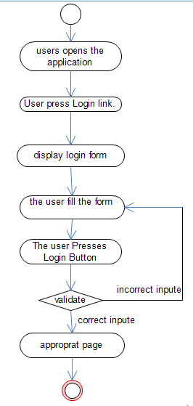
Figure 3.2. Activity diagram For Login
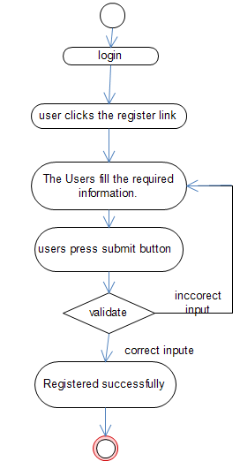

Figure3. 4 Activity diagram for registration

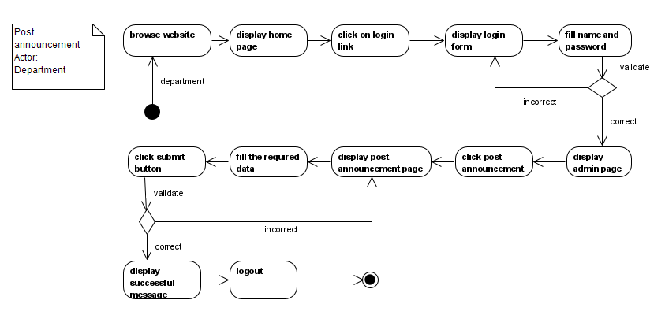Figure 3.3 the activity diagram for post announcement

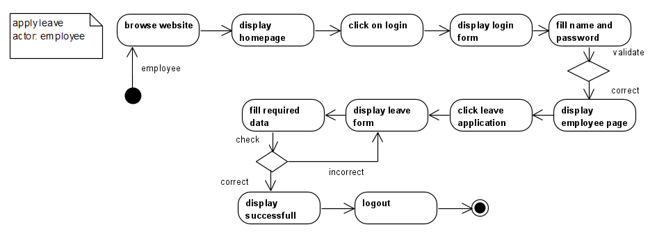Figure 3.2 the activity diagram for apply leave
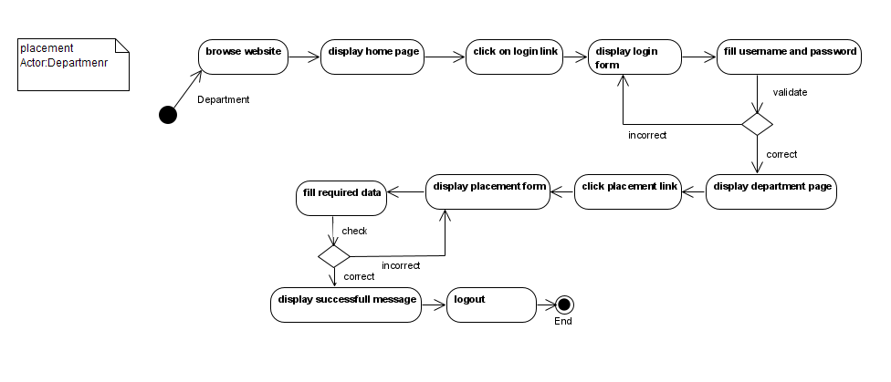
Figure 3.3. The activity diagram for post placement/position

3.5.2. Sequence Diagram
A sequence diagram is an interaction diagram that shows how objects operate with one another and in what order. It is a construct of a message sequence chart. A sequence diagram shows object interactions arranged in time sequence. It depicts the objects and classes involved in the scenario and the sequence of messages exchanged between the objects needed to carry out the functionality of the scenario.
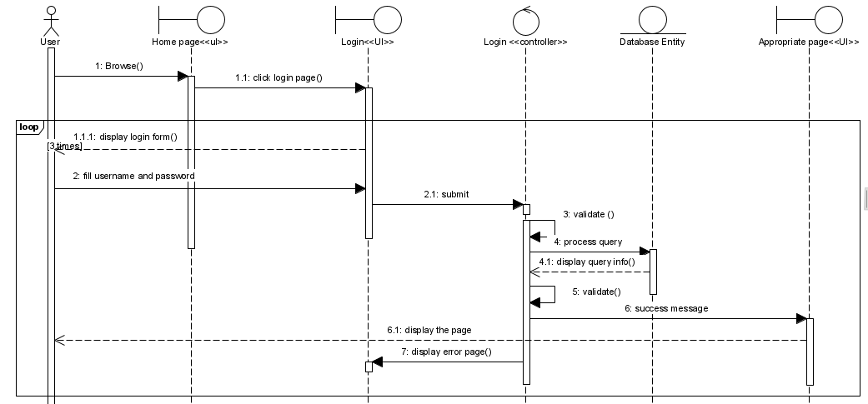
Sequence diagram for login
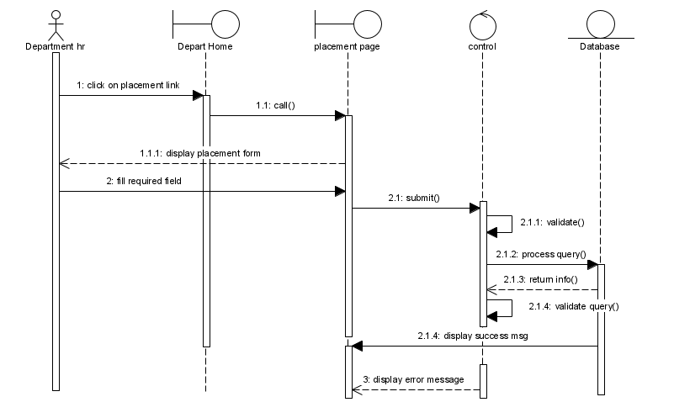
Sequence diagram for post placement
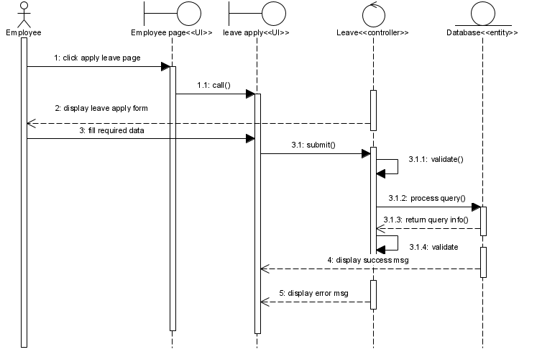
Sequence diagram for apply leave
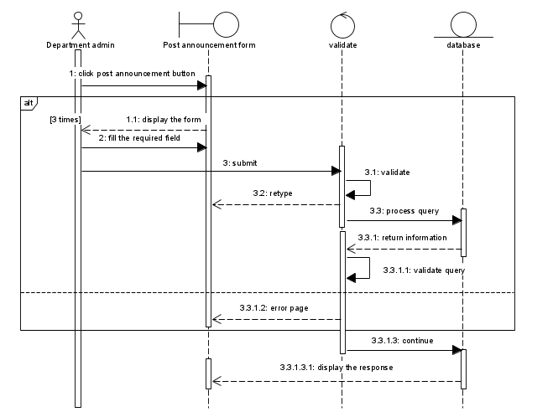
Sequence diagram for post announcement
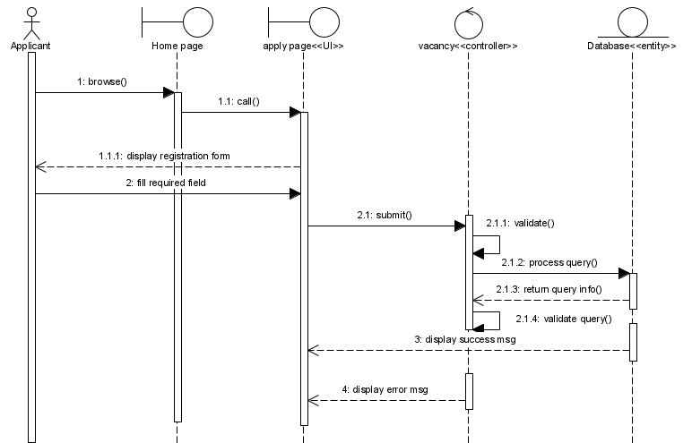
Sequence diagram for apply for vacancy

3.5.3. Requirement Validation and Verification
It's a process of ensuring the specified requirements meet the customer needs. It's concerned with finding problems with the requirements. These problems can lead to extensive rework costs when they are discovered in the later stages or after the system are in service.
The cost of fixing a requirements problem by making a system change is usually much greater than repairing design or code errors. Because a change to the requirements usually means the design and implementation must also be changed and re-tested.
During the requirements validation process, different types of checks should be carried out on the requirements. These checks include:

3.5.3.1. Validity checks
The functions proposed by stakeholders should be aligned with what the system needs to perform. This validation process is concerned with checking the requirements for omissions, conflicts, and ambiguities and for ensuring that the requirements follow quality standards. The validation guidelines which we suggest are as follows:
- To check that the requirements are acceptable to all system stakeholders.
- Increase your confidence that the specification represents a system that will meet the real needs of the system customer.
- The system should provide the functions which best support the customer's needs
- Checking a final draft of a requirements document which includes all system requirements and where known incompleteness and inconsistency has been removed.
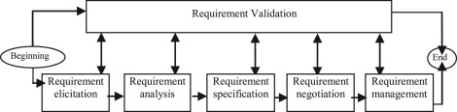
Figure3. 14 Validity requirement

3.5.3.2. Consistency checks
Requirements in the document shouldn't conflict or different descriptions of the same function. There should not be different meanings of any single requirement stated at different places/contexts in SRS. That is, there should not be contradictory constraints or dissimilar descriptions of the same system function at two different locations. We use this technique in our project to check the consistency of our project.
- No two or more requirements contradict each other which mean consistence terminology
- Requirements in the document should not conflict
- Verify that requirements link to existing documents. Verify that requirements link to valid locations (e.g., bookmarks, line numbers, anchors) within documents
- Requirement uses terms in a manner consistent with their specified meanings
- The requirement should be understood in the same way by every person who reads it.
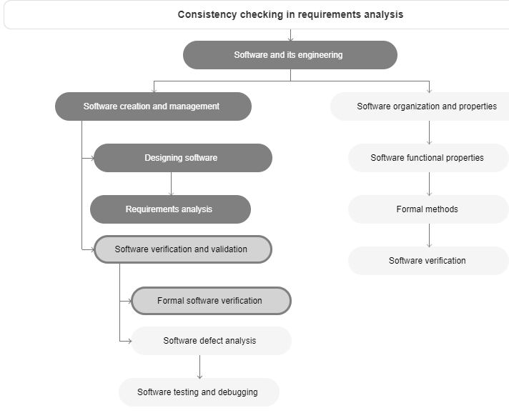
Figure3. 15 Consistency checks

3.5.3.3. Completeness checks
Check Completeness is to check that a complete set of requirements has been developed and documented that defines all system functions that are needed to satisfy the stakeholder needs with their associated performance, environmental, and other non-functional requirements. We use this technique in our project to check the completeness of our project.
- A requirement must have all relevant components
- All requirement should be written at a consistent and appropriate level of detail
- The requirement must be complete and should be defined (which means the type of requirement should be defined).
- It implies that all users' needs will be met when the system is implemented.
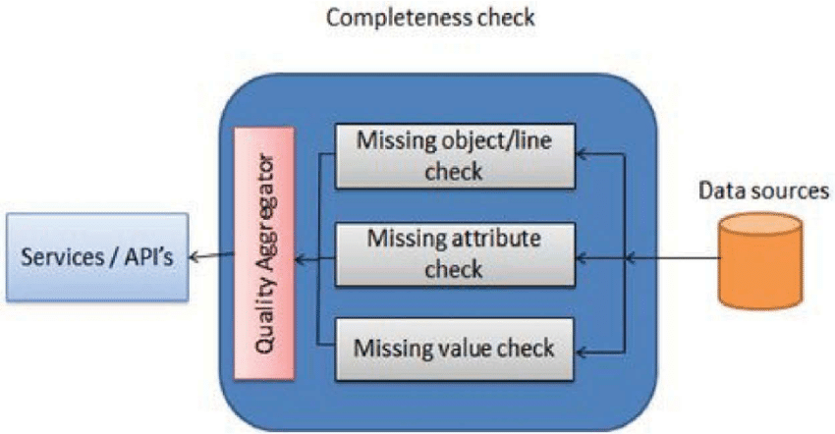
Figure3. 16 Completeness checks

3.5.3.4. Realism checks
It must be ensured using existing technology that the requirements can be implemented. Schedule and budget constraints for system development are also to be considered. In our project, we used realism checks for implementing requirement reality.

3.5.3.5. Verifiability
Requirements should be written so that they can be tested. This means you should be able to write a set of tests that demonstrate that the system meets the specified requirements. In our project we used verifiability to check that:
- Checking our product against some standards and conditions imposed on this product and of its development.
- Verify whether or not the products of the given phase fulfill the specifications established during the previous phase.
- Verify whether or not the products of the given phase fulfill the specifications established during the previous phase.
We conclude that Requirements validation and verification is a fundamental activity of the requirements engineering process. Different validation techniques have been discussed above. To complete the software projects successfully without correctness and completeness problems in requirements.so in our project we use the v-v model as follows and the process.

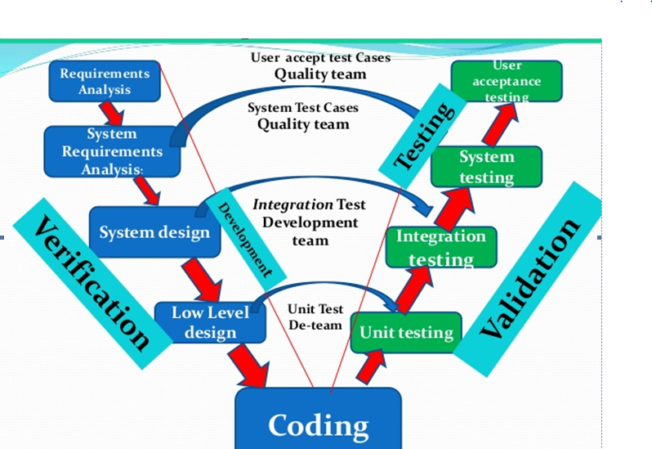
Figure3. 17 general Verification and Validation diagram
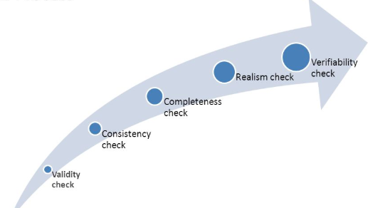
Figure3. 18 Requirement validation process (phase) diagram

CHAPTER FOUR

4. System Design

4.1 Introduction
System design is process of describing, organizing, and structuring system components at the architectural design level and detailed design level. The design converts functional models from analysis into models that represent the solution. The design may use structured or OO approaches. The purpose of designing is to show the direction of how the system is built and to obtain clear and enough information needed to drive the actual implementation of the system. It bridging the gap between the desired and existing system in a manageable way.
This chapter covers issues related to the design of the new system which is the building block of the system. It also transforms the analysis model into the system design model. The result of the system design is the model that includes a clear description of each strategy. Generally, this chapter helps build the system and the information needed to devise the actual implementation of the project. The output of the design is the system specification. The system specification is like a set of blueprints that follow when we developing our system.

4.2 Design Issue for your system

4.2.1 Design Considerations
Different design goals, trade-offs‘, dependencies and constraints from the client, end-user and
developer‘s perspectives are addressed as follows.

4.2.2 Design Goals
The goal of this design document is to change the system requirement into the intended new
system. And to bring tangible and intangible benefit, the Customer has got satisfaction in
Services that are delivered. First of all, the system is simple to deploy. Furthermore, the system
It had been simple for admin, and external user.
To generate a good system, it is very significant to have a good design. The design must
Have a goal that states the dreamed (needed) quality that must be incorporated.
These design goals play a great role in generating an efficient system.
Some of the major goal are
Integrity
HRMS we expected and design to achieve integrity by planning the following:
The system should be able to protect and preserve the transaction. HRMS is
Easily integrating with any applications.
- Integrity is achieved by the OO paradigm (OO style)
Accessibility
- The system available to the users at work time if internet connection and electric power exist.
Scalability
- In our project when we are designing the system, we are trying to scalable the system.
The system should be able to scale up from 1 user up to several concurrent users.The system can handle these users at once. Scalability achieved by the peer to peer style.
Availability
- In OHRMS we expected and design to achieve system availability by doing the system has to be relying on at work time. There is no place for the extended downtime.
Throughout
- When a system can maximize the product or service delivered within a given time, it has reached maximum throughout. The current working system has a low level of throughout because it can only handle the limited number of employee (users) at a time.
Maintainability
- The system maintainability is the ease with which a product can be maintained to: correct defects or their cause, repair or replace faulty or worn-out components without having to replace still working parts, prevent the unexpected working condition and make future maintenance easier. The ease or difficulty with which a software system can be modified is known as its maintainability.
- The maintainability of a software system is determined by properties of its source code
Reliability
- Here we are trying to develop a reliable system. This means it is relatively defected free and access to anybody without happening defect.
Reusability
- In our project, we are trying to achieve reusability by creating reusable classes and
Methods and adding their functionalities into classes and methods. These classes and
Methods easily modified and reused.

Portability
- In our system portability is achieved by portable to the various operating environment.
The system is portable enough to be moved over to a new server with minimal downtime.
High Performance
- The system shall perform its operations within a minimum amount of time. The system shall be
Interactive and the user get the expected result within few seconds. The system will be accessed
By users inside the office. For better response and throughout, it should be given more emphasis for the faster access to the system across the network.
Good Documentation
- The activities and outputs of each system development stage in the project workflow will be properly documented for the successful completion of the project. These documents Produced at the end of each stage shall be organized and compiled together at the end of the Project for future reference, system maintenance, and system support.
Well Defined Interface
- A well-defined interface is a system interface that involves an interaction with another System or interaction of the system and users. In our project, the user interface of the system shall be user-friendly and easy enough to work with. The system provides web interfaces that are compatible with browsers like Internet Explorer, Mozilla Firefox, Google Chrome, etc.
Increase Productivity
- High productivity (increasing productivity) means accomplishing more with the number of resources or archiving higher productive output. In our project, you can increase productivity by using the system effectively and efficiently using a systematic manner.

Relationship between Design Goal
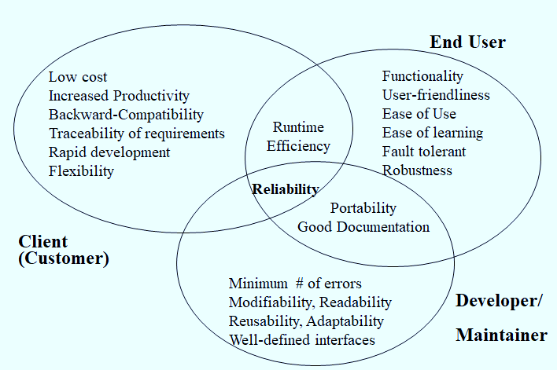
Figure4. 1. Relationship between design goals
4.2.3 Design Trade-offs
Functionality v. Usability
The system favors usability compared to functionality yet it doesn‘t mean that the system loses its proper functionality. Rather the developing team will endeavor to maintain the basic requirements of the system along with high usability. The system will avoid lavish functionalities, which are not a must for the system‘s existence, for the sake of encouraging basic system utilization.
Security v. Usability
- The administration part of the system is accessible only for the authorized Administration office according to their Assigned right. An Unauthorized user should not access the administration page by any means. Some of the resources and activity shall be restricted and allowed only for authorized users. Therefore, the system shall have a user identification method and it should grant or deny access to users as per the privilege of the prospective user.

4.3. Design Pattern
In software engineering, a software design pattern is a general, reusable solution to a commonly occurring problem within a given context in software design. It is not a finished design that can be transformed directly into source or machine code. Rather, it is a description or template for how to solve a problem that can be used in many different situations. Design patterns are formalized best practices that the programmer can use to solve common problems when designing an application or system. There are 23 software design pattern are there from this we select MVC pattern, observer pattern because
- It helps the developer easy modification of the model
- It helps the developer to eliminate design smell and code smell
- Code Re-Usability at Its Best
- the modification does not affect the entire model
- Faster development process;-MVC supports rapid and parallel development
The design pattern of our project is described diagrammatically as follows.
The MVC model has three components that are: - View, Controller, and model
- View: –user supplies username, password to the controller via the view. The users of HRMS are applicant, employee, Hr manager , finance.
- Controller:- check the username, check the password and pull user information.
- Model:- returns user information to the view to display appropriate or landing page.
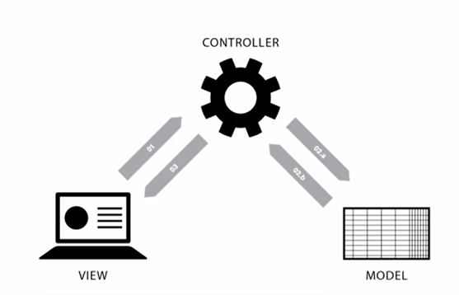
Figure4. 2 Design pattern of the system (OTRLMS)

4.4. Class Diagram
The class diagram is static. It represents the static view of an application. It is used to shows relationships between classes, objects, attributes, and operations. A class diagram is one of the most useful types of diagrams in UML as they map out the structure of a particular system by modeling its classes, attributes, operations, and relationships between objects.

4.5 Database Model
A database model shows the logical structure of a database, including the relationships and constraints that determine how data can be stored and accessed. Individual database models are designed based on the rules and concepts of whichever broader data model the designers adopt. Most data models can be represented by an accompanying database diagram.

4.5.1 Entity Relationship Diagram (ERD)
An entity-relationship diagram (ERD), also known as an entity-relationship model, is a graphical representation that depicts relationships among people, objects, places, concepts or events within an information technology (IT) system. An ERD uses data modeling techniques that can help define business processes and serves as the foundation for a database. It provides a visual starting point for database design. ERD of our project is described as follows.
????

?
?
?

4.5.2 Persistence Modeling
Persistence data management represent by the Persistence model. It is a model that describes the persistent data aspects of a software system. Persistence modeling is used to communicate the design of a database to both users and other developers. Our system includes the basic table that handles the data of the system implemented using xamp server.

?
?
?
?

4.5.3Mapping with Normalization
First Normalized Form
1NF is the most basic of normal forms - each cell in a table must contain only one piece of information, and there can be no duplicate rows.
Example: Suppose an employee wants to create their login account and details store in the user_account table and the administrator creates login account details of license_officer and tax_officer employees and store in user_account table. It creates a table that looks like this:
?
?
Bizu yikeral
?
Second Normalized Form
A database is in second normal form if it satisfies the following conditions:
- It is in first normal form
- All non-key attributes are fully functional dependent on the primary key
??
?
?
?
Third Normalized Form
A database is in third normal form if it satisfies the following conditions:
- It is in second normal form
- There is no transitive functional dependency
?
?
?
?

4.6 Subsystem Decomposition
System decomposition or(making subsystem) of the HRMS into smaller subsystems with a strong coherence. The different subsystems have loose coupling. By reviewing the user‘s functional requirements, we have decomposed the system into subsystems. Manage employee, payroll management, manage attendance, manage the account and generate report
?
?
?
?

4.7Deployment Diagram
A deployment diagram is a UML diagram type that shows the execution architecture of a system, including nodes such as hardware or software execution environments, and the middleware connecting them. Deployment diagrams are typically used to visualize the physical hardware and software of a system. Our system deployment diagram described as follows.

?
?
?

4.8 System Architecture (Layered Architecture of the System)
Architectural design is concerned with understanding how a system should be organized and designing the overall structure of that system. In the model of the software development process, architectural design is the first stage in the software design process. It is the critical link between design and requirements engineering, as it identifies the main structural components in a system and the relationships between them. The output of the architectural design process is an architectural model that describes how the system is organized as a set of communicating components.
4.8.1. Overall System Architecture
For system developers, they need system architecture diagrams to understand, clarify, and communicate ideas about the system structure and the user requirements that the system must support. The reason select client-server architecture is it provides the following function:-
- It provides security
- It provides scalability
- Integration service
- Shared resource among different platform
- Easy maintenance
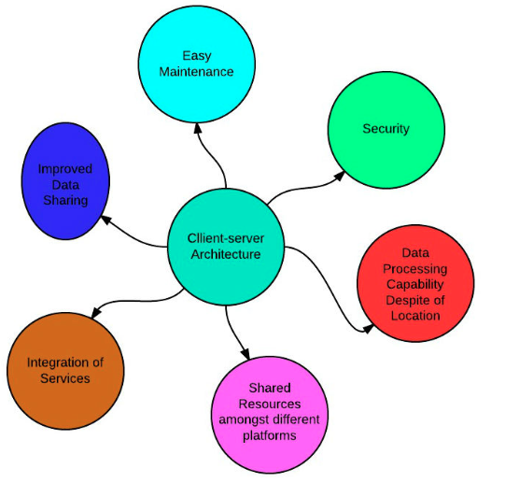
The designed system follows client-server architecture with third-tier architecture such as the client, the web application server and the database server tier. In the system, we can observe that the user interacts with the application through a graphical user interface.
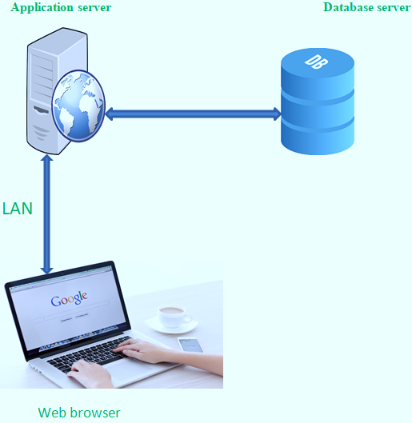
Figure4. 9 Overall system architecture

4.8.2. Detail of Architectural Pattern and Style
Architectural pattern
An architectural pattern is a general, reusable solution to a commonly occurring problem in software architecture. Our group team selects three-tier architecture because it is improved scalability. And Enhanced Security: Through the implementation of several layers, it enhances data security on a service-by-service basis. As clients do not interact with the database directly, it provides less risk and conflict with unauthorized data. And also provide flexibility, availability, and performance. Architectural pattern of our project looks as follows.
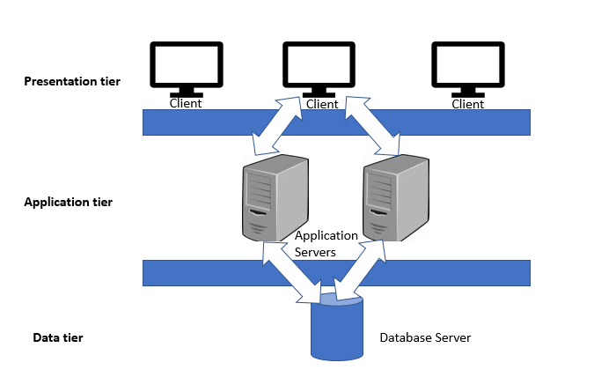
Figure4. 10 Architectural style
Architectural Style
An architectural style defines a family of systems in terms of a pattern of structural organization; a vocabulary of components and connectors, with constraints on how they can be combined. Our team selects Client/Server Architectural Style. The reason select client-server architecture style is it provides Data integrity and database consistency, Database security. The architectural style of our system looks as follows.
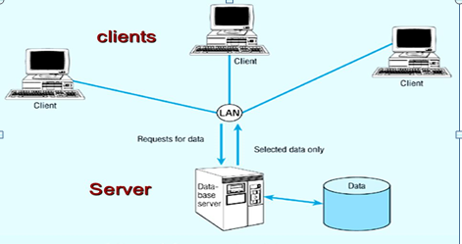
Figure4. 11 The architectural style of the system

4.9User-Interface (UI) Design
?
?
//
/?
?
?
?

4.10 UI Flow Diagramming
UI Flow Diagramming used to model the interactions that users have with your software. The user Flows diagram helps the user to organize paths, that they will follow using your website or app. The user flow diagram is the fastest way for creators to plan customer journey paths and improve user experience. Our project user flow diagram is represented accordingly:
?
?
?
?

CHAPTER Five

IMPLEMENTATION AND TESTING
5.1. Introduction
In this chapter we mainly focuses on the implementation part and testing part, implementation and testing concerned with the type of material (Hardware and software required), techniques to develop the system, algorithm for the system, code samples of the system, some testing techniques, startup strategy for the new installed system are briefly described in this part of documentation.
The functional system from the design phase above is the key input to the implementation phase. The deliverable of the implementation phase (the project) is the operational system.

5.2. Algorithm Design
The important aspects of algorithm design include creating an efficient algorithm to solve a problem in an efficient way using minimum time and space. An algorithm is a series of instructions, often referred to as a “process,” which is to be followed when solving a particular problem.
?
?
?
?

5.3. Sample Code
Coding includes implementation of user interface, implementation of database and logical implementation. In the following interface implementation, database implementation and logical implementation are discussed in context of the whole system
?
?
?
?
?

