Jacob Wenner
Jan. 5, 2026

The purpose of this document is to document the process of conducting high volume campaigns with the Center for High Throughput Computing (CHTC) resources available on UW-Madison campus. This is a multistep process that uses several different Python files as well as CHTC-specific files. An attempt has been made to document the process as thoroughly as possible, but if any questions remain please reach out to Jacob Wenner at jnwenner@gmail.com or jwenner@wisc.edu. This author assumes that the user is already familiar with the sub-workflows of both running SRLIFE simulations locally and submitting jobs on the CHTC.
All of the referenced files should be available in the folder this document is stored in. The files used here represent the most current method for conducting campaigns. Undergraduate researcher Brett Pagel used these files to collect data for alternative conduction ratios, as presented in Section 2.4 of the dissertation. Contact Prof. Mike Wagner for access to Brett Pagel’s research folder.
Code in this folder used a Linux operating system to run SRLIFE.

Our goal is to run an SRLIFE simulation and collect stress timeseries and strain range results. Simulations can take several hours, depending on conditions used. For this reason, we use CHTC resources to run large numbers of simulations in parallel.
Step 1: Generate the HDF5 receiver object file with setup_main__sine_temp_BCs.py
SRLIFE requires users to input the receiver, panel, and tube information. We also must provide thermal boundary conditions and a few other pieces of information. Ultimately, all of the input information is packaged into a “receiver” object for SRLIFE. Use “setup_main__sine_temp_BCs.py” to generate a series of receiver objects with a peak total temperature differences dT and fluid temperatures Tf according to the user-specified for loop range (see lines 43-46). Most inputs are set with an input case file. We include an example case file called “test_case_file.csv”. This setup file specifies boundary conditions for the inner and outer tube surfaces according to circumferential position, axial position, and timestep. Thermal loading conditions correspond to those discussed in the dissertation document. Helper functions to build the boundary condition temperature arrays are stored in “BoundaryConditions.py".
If the code functions correctly, an .hdf5 receiver file is generated for every specified Tf/dT input and all files are stored in a local folder.
Step 2: Move HDF5 files from local PC to CHTC drive.
The receiver files must be accessible to the CHTC system. This document assumes that the user is already approved by the CHTC and the CHTC has created a folder for the user on their system. More information on that process is accessible here: https://chtc.cs.wisc.edu/uw-research-computing/form. For Linux, FileZilla can be used to move files from your local computer to the user’s CHTC folder using a secure protocol. The author used the following settings shown in the screenshot:
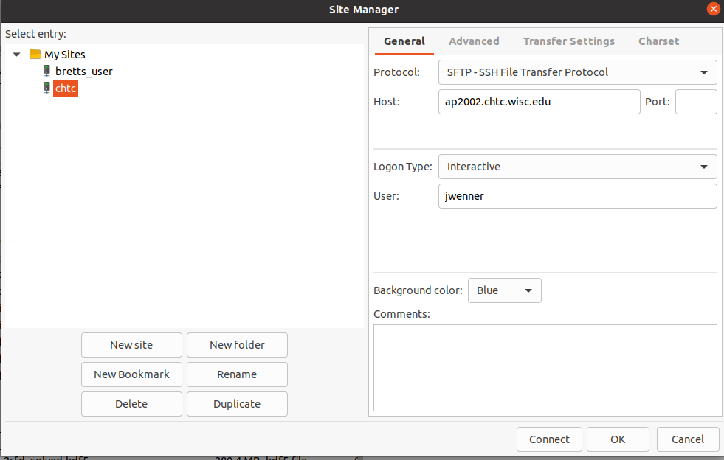
Note that the host name will change depending on the server that CHTC assigns you to when your account is setup.
If performed correctly, all the .hdf5 files are copied over to a location within the user’s CHTC folder.
Step 3: Run All SRLIFE Simulations in CHTC
The CHTC manages a large number of computational resources available for general research use. Think of the HTC system as a middle man that finds workers to complete requested tasks. When we submit jobs to the HTC system, we are asking the system to find available computers within the network and transfer our jobs to those available computers. The HTC system will return job output once the computers have completed our jobs. This step follows the general workflow of submitting HTC jobs with HTCondor, which is generally described here: https://chtc.cs.wisc.edu/uw-research-computing/htcondor-job-submission.
Users can interact with the HTC system via SSH through programs like PuTTY. Once all files and code is made available in the CHTC account and properly debugged, the user can initiate the FEA campaign by typing a single command in PuTTY: condor_submit srlifeRunAllDeltaTs.sub .This command tells the HTC system to create and carry-out a series of jobs as defined in the submit (.sub) file.
Correct execution results in a single results .csv file from each job.
Setup Required before Completing Step 3
Each of our jobs represents a single SRLIFE simulation. Significant setup is required to properly define a job for a host computer. In essence, all the steps a user performs to be able to locally run an SRLIFE simulation must be packaged and sent to a host computer for that computer to be able to run the job. The following files listed in bullet point must be available in the HTC system for jobs to be properly executed.
- chtc_main_P2.py – this reads in an hdf5 receiver file, specifies solving settings, performs the FEA simulation, and returns all requested timeseries results. Primary results include von Mises stresses and strains at the crown. THIS FILE SPECIFIES THE SELECTED DEFORMATION MODEL. See SRLIFE documentation for more information on the deformation model options.
- srlife-containter2.sif (place in staging folder)- SRLIFE and its required supporting packages must be installed on the host computer to execute chtc_main_P2. Additionally, the host computer also needs the correct version of Python to be installed on the host computer. We can accomplish all of this by providing the host computer an Apptainer image file (.sif). See https://chtc.cs.wisc.edu/uw-research-computing/apptainer-htc for more details on this. Note that the .sif needs to be in a staging folder. This folder is in a different location in the HTC system than where the other user files are typically located. Users can get a staging folder by requesting CHTC to make one for them.
- srlifeRunAllDeltaTs.sub – this file describes the set of jobs that a user is requested. Our executable command is defined by the .sh file (see below definition) and the provided argument is .hdf5 receiver file.
We configure the sub file to submit multiple jobs with a single command, according to https://chtc.cs.wisc.edu/uw-research-computing/multiple-jobs. Our specific .sub file is asking the HTC to complete a series of SRLIFE simulation jobs corresponding to the number of runs in modelList.txt. Each line in modelList contains a .hdf5 file name. For example, if the modelList.txt file resembled the example model list (model_list_example.txt), the HTC system would create 14 jobs, with each job’s input .hdf5 corresponding to a line in the .txt file.
- srlifeRunAllDeltaTs.sh – this is the executable, which can be thought of as the commands you might enter if locally running the job through your own command line. We specify the directory structure and instruct the host computer to run chtc_main_P2.py in python3 using the provided .hdf5 file.

Step 4: Post-process the CHTC Output Data
Move the simulation results files back to your local computer via Filezilla – or another equivalent software – and place in a results folder. Raw simulation results must be processed into daily creep damages and strain ranges to calculate the expected creep and fatigue damage and lifetimes.
Use post_process_parametrics_v5.py to generate extrapolated 20 day creep damage and strain range at the crown position .csv files for every simulated day/cycle. Note that the helper module “post_process_helpers.py” also must be accessible.

Step 5: Generate DMG tables, LTE tables, and a damage map.
Use “make_damage_map.py” to accomplish these tasks. This script implements the assumptions necessary to extrapolate lifetime as well as summarizes this information into datasets for use in the damage_tool presented in the author’s dissertation.
The damage table provides fourth day fatigue damage, 20th day creep damage, predicted lifetime, and damage ratio as functions of temperature difference and fluid temperature. The lifetime table simply provides the number of predicted cycles as a function of fluid temperature and temperature difference.
Note that “plot_damage_map” must be present to generate damage maps. Additionally, other damage map plotters are available in other chapter folders of this work that improve damage map appearance.

