**Wireless Computing**



**Using IoT As a Tool to Monitoring Package For Ecommerce**

**By :**

**Kaleb Clement Sembiring (001201800051)**

**IT 4**

**Package Monitoring For Ecommerce**

1. **Introduction**

For a seamless eCommerce shopping experience, it is essential to deliver the product promptly to the customer. And that’s where a professional courier service plays a vital role. [Tracking a package](https://www.shiprocket.in/shipment-tracking/) or courier involves a tedious process of localizing packages and containers, and different parcels at the time of sorting and delivery. It helps to verify their movement and source, and have an estimate of the estimated delivery date. The primary objective of this parcel tracking system is to provide customers with information about the details of the route of the package, delivery status, estimated delivery date, and the estimated time of delivery.

Package tracking developed historically because it provided customers information about the route of a package and the anticipated date and time of delivery. This was important because mail delivery often included multiple carriers in varying environmental circumstances, which made it possible for a mail to get lost

1. **Background**

The internet of things (IoT) is also called the internet of objects is a means for making connections between things, sensors, actuators, and other smart devices to facilitate human-to-object and object-to-object communications. The IoT is a network of physical devices, communications, machines, and other items installed with electronics, software, sensors, actuators, and network connectivity which allow objects to gather and exchange the data. Each item is unequivocally identifiable via its fixed computing system, however, can interoperate within the existing internet infrastructure. Experts expect that by 2020 the IoT will comprise approximately 30 billion items. Having collected all the definitions about IoT we can define our version as follows: IoT offers the capability of fixing sensors, actuators and software to any object and thing surrounding us that we can touch, or see in our life and use, monitor and operating the data existing in those objects in any situation, anytime and in any area.

There are four main types of IoT architecture: three-layer architecture, middleware-based architecture, service-oriented architecture (SOA) architecture, and five-layer architecture. Among these four sorts of architecture, the most typical one is the three-layer architecture. For this reason, we decided to focus on this architecture rather than the others. As suggested by its name, the three-layer architecture consists of three simple layers, which are as follows:

* Application Layer
* Network Layer
* Sensor Layer

**Application Layer**

The network layer sends the data to this layer and receives the data. Then the data is utilized to provide the demanded operations or services. For instance, the application layer is able to provide a storage service to back up accepted data into a database or supply an analysis service to assess the received data for prognosticating the forthcoming state of physical devices. Several applications fall in this layer, for instance, smart homes, smart wearables, smart grids, smart transportation, smart cities and others can be classical examples of this.

**Transmission Layer**

The transmission layer or the network layer is used to obtain the data processed by the sensor layer and to define ways to transfer information and data to the IoT hub, devices, and applications through integrated networks. The network layer is the most important layer in the IoT architecture, the reason being that a variety of devices (switches, hubs, cloud computing performance, gateways etc.), and different communication technologies (ZigBee, Bluetooth, LTE, 5G, 6LoWPAN, Wi-Fi etc.) are combined in this layer. The network layer must provide data to or from different objects or applications, through gateways or interfaces between heterogeneous networks, and use different communication technologies as well as protocols.

**Sensor Layer**

The sensor layer, also referred to as the perception layer provides the connections with physical items and components by means of actuators, sensors and other sensing technologies such as RFID, WSN, GPS, etc. The main gist of it is that the sensor layer provides the physical and digital world to get in touch with each other. Its prime goals are to unite the things in the IoT network and to measure, gather, and process the main data linked with these items by means of ready smart objects, transferring the processed data to the upper layer through the layer interfaces.

1. **Objective**

One vital element of successful supply chain management is shipment tracking. Both the sender and the recipient can benefit from the transparency and accountability brought by consignment tracking systems. Utilising mapping websites and GPS mobile devices to schedule vehicles allows business owners to have an insight on carrier performance, transportation costs and market trends as they manage their logistics as well as synthesise shipments and create real-time connections with customers. Shipment tracking gives peace of mind to customers as they receive information on the whereabouts of their orders throughout the shipping and delivery process. And the advantages of shipment tracking to both the businesses and the customers:

1. **Reduce Potential Cost Caused by Delays and Missing Packages**

Shipment tracking allows the sender to be in control of their transportation and locate freight at any point in its journey. Shipment tracking technologies put businesses at ease with their capacity to monitor the status of packages sent in the mail and avert the risk of items going missing through the entire delivery process. Moreover, business management is provided with a ‘bird’s eye view’ of potential problems and delays that would mitigate unexpected costs.

1. **Maximises Performance and Efficient Processes**

Shipment tracking technologies provide maximum production efficiency when integrated with warehouse logistics and other business systems such as purchase order systems. Potential delays in delivery can be relayed to customers more smoothly by utilising the information on the shipment’s progress. Additionally, business owners will be able to easily determine which mode or carrier is the most reliable.

1. **Provides a Better Costumer Experience**

Businesses can enhance their customer experience by generating positive sentiments when they are capable of properly and efficiently notifying users of the status, location and estimated time of arrival of their delivery. Although some customers tend to just complete their order and not think about it again until it arrives, most would still appreciate sufficient information about their order throughout the whole shipping and delivery process.

For this project we need Barcode Sensor and GPS Sensor. The Barcode Sensor is used to input data items to the shipping warehouse where the sender and costumer can see the item have inputed or not. The barcode scanner type that we use is Pen Type Readers or Barcode Wands, In this type of barcode reader there is a photo encoded next to the tip of the pen. To read, the code is placed on the tip of the pen and then shifted to all the bars in a stable manner, then the diode can measure the intensity of the light reflected from the light source and produce waves that correspond to the width of the bar and the spacing in the code. After that the barcode reader sends waves to the decoder then translates it and sends it to the computer in a simple data format.

For the GPS Sensor it will track the package wheter it moving accordingly or not, this also usefull for the costumer to predict how long it takes to arrive to their address. So GPS sensor basically is like a map tracker that integrated on Google Traffic Service.

The GPS Sensor are below:

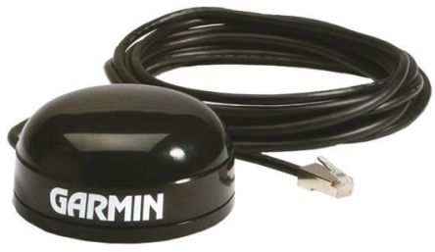

The Barcode Wands Sensor are below:

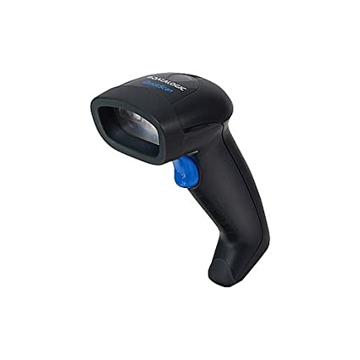

1. **Description**

Package monitoring can be call by package logging or package tracking, is the process of localizing [shipping containers](https://en.wikipedia.org/wiki/Shipping_container), [mail](https://en.wikipedia.org/wiki/Mail) and [parcel post](https://en.wikipedia.org/wiki/Parcel_post) at different points of time during sorting, warehousing, and [package delivery](https://en.wikipedia.org/wiki/Package_delivery) to verify their [provenance](https://en.wikipedia.org/wiki/Provenance) and to predict and aid delivery. This will be usefull for the costumer to predict and track their package until when it will arrive. It’s also usefull for the sender to know if the package is delivered or not.

**How Package Monitoring System Work:**

1) Barcode Generate

The first step to the process, as soon as a product is handed over by the online seller to their courier company for delivery, a barcode is generated for the same and attached to it. A barcode is a unique ID that has all the details related to the parcel, like, pick up and destination details, buyer’s contact details, etc.

2) Scan Barcpde Details

The next step is when the item is loaded for the delivery, its bar code is scanned by the [courier company](https://www.shiprocket.in/carrier-integrations/), and this data is stored in the tracking system of that courier company’s website.

3) Storing the scanned data

As soon as the barcode is scanned, all the information related to the courier is stored in the tracking system, like, the time it left the courier agency (at seller’s location) for delivery, where it came from, where it is destined to, etc.

4) Receiving the Product

After leaving the courier agency at the seller’s location, the shipped item reaches to another branch of the courier agency at the buyer’s location.

5) Re-scanning the Bar Code

As soon as the new courier agency receives the product, it scans the barcode and stores the parcel details in the tracking system, which includes information related to its received time.

6) Out for Delivery

At this location of the courier company, the received item is scanned again when it is ready to be sent [out for delivery](https://www.shiprocket.in/blog/pay-on-delivery/). The scanned information is stored back in the tracking system, which includes the time the products left that courier agency for delivery.

7) Product Delivery

Once the product is delivered to the end user or buyer, the tracking system is updated with the delivery status of item (for example, ‘Delivered’ in this case), delivery time, recipient’s name, etc.

1. **Conclusion**

the purpose of the monitoring package is to make it easier for both the sender and receiver, as well as improving customer quality and minimizing losses from late fees and package loss.