**1) Create on Bash script to check if a directory is available or not.**

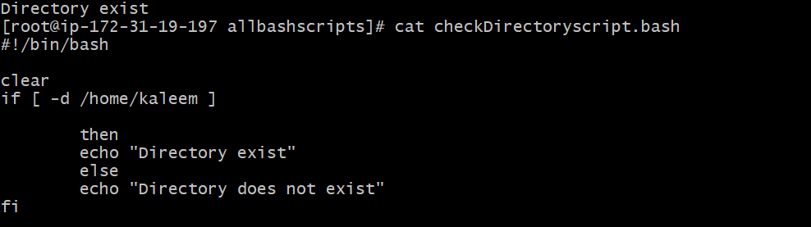

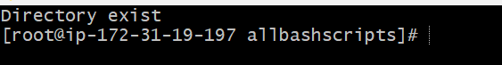

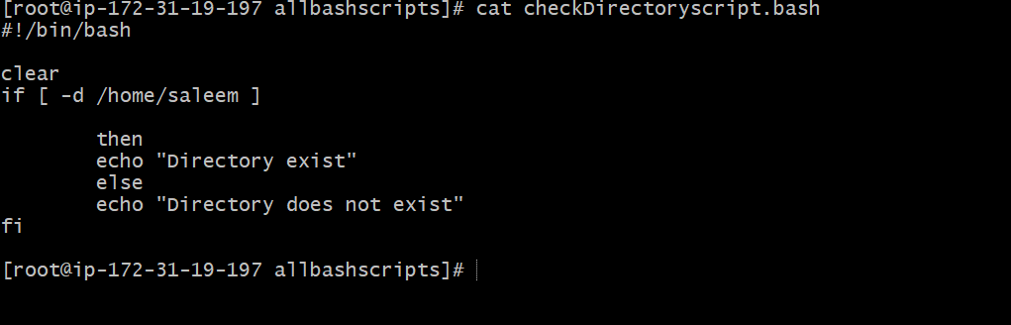

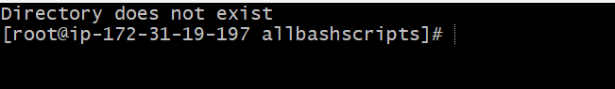

**2) Create a bash script which will create multiple files.**

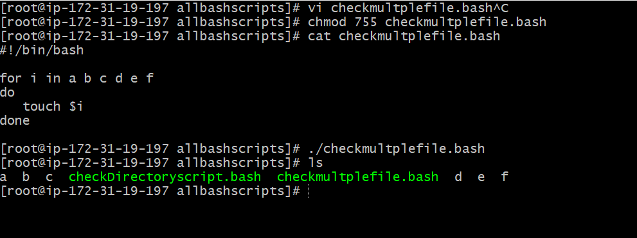

**3) Create a bash script to take backup of a directory.**

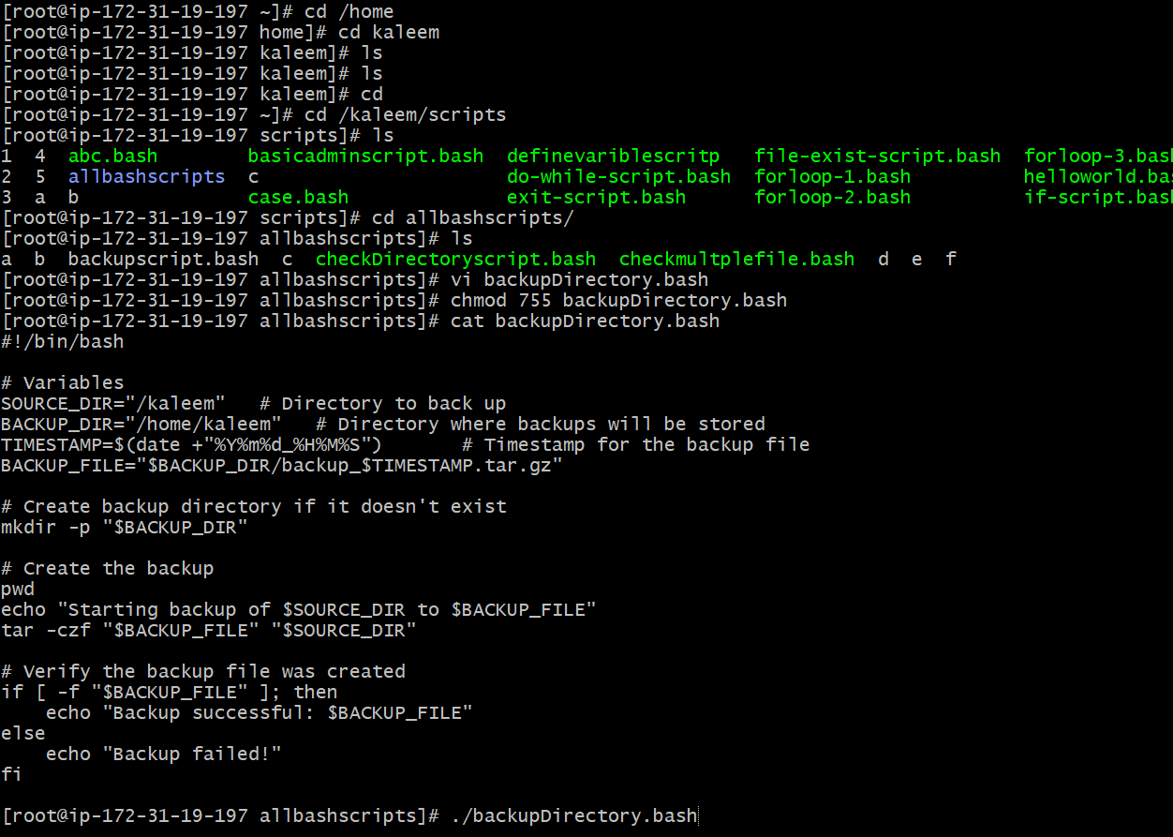

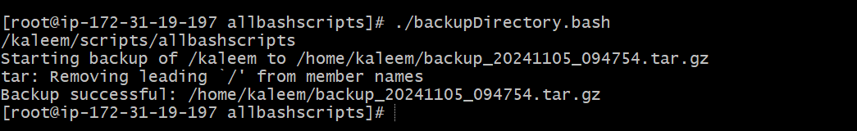

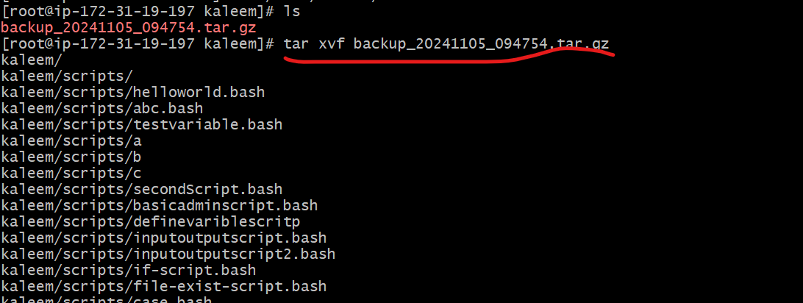

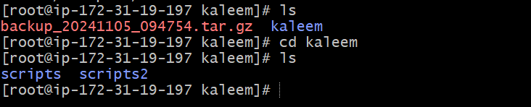

**4) Create a bash script to install nginx in ec2 server.**

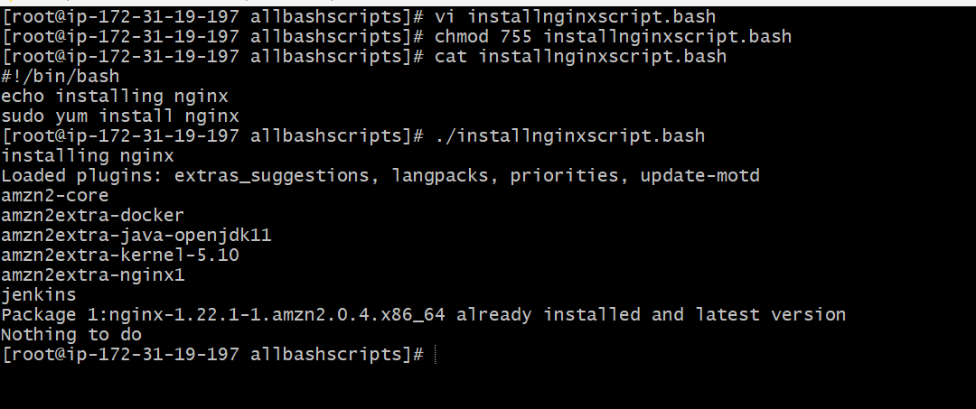

**5) Create a bash script to install ApacheTomcat in ec2 server.**

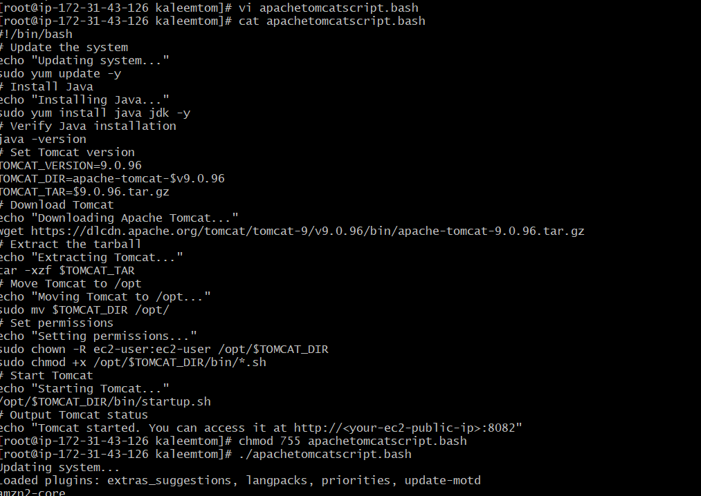

**6) Create a bash script to check list if nginx service is running or not,if not running** **then script should start the service.**

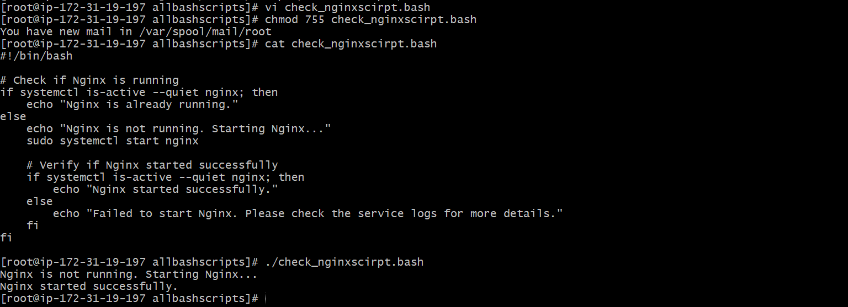

**7) Create a bash script for calculator.**

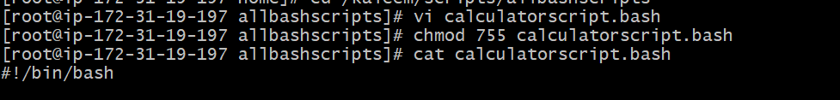

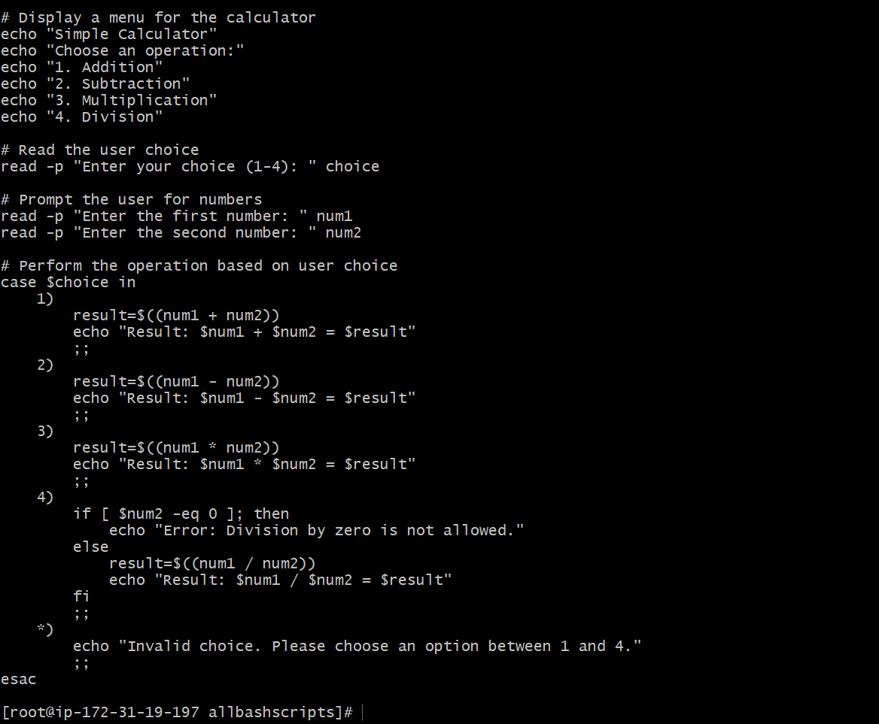

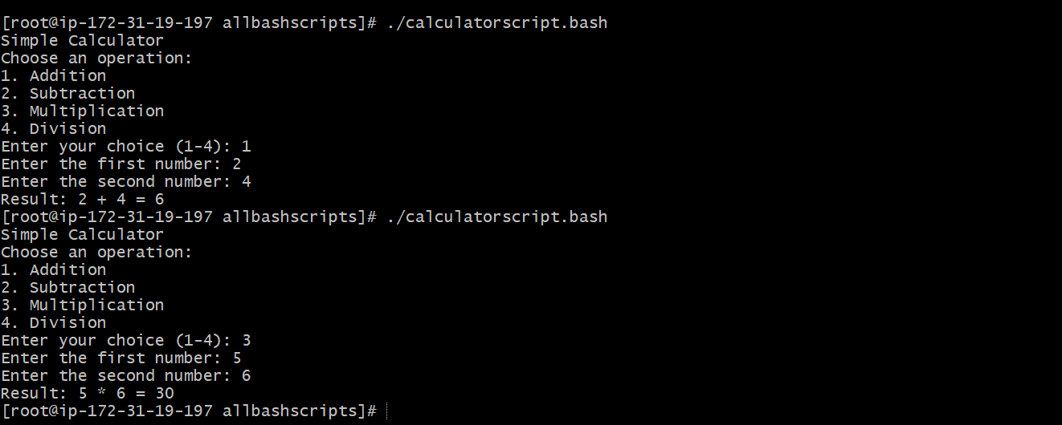

**8) Create a bash script to check if directory is avaialble or not,if not then create a directory.**

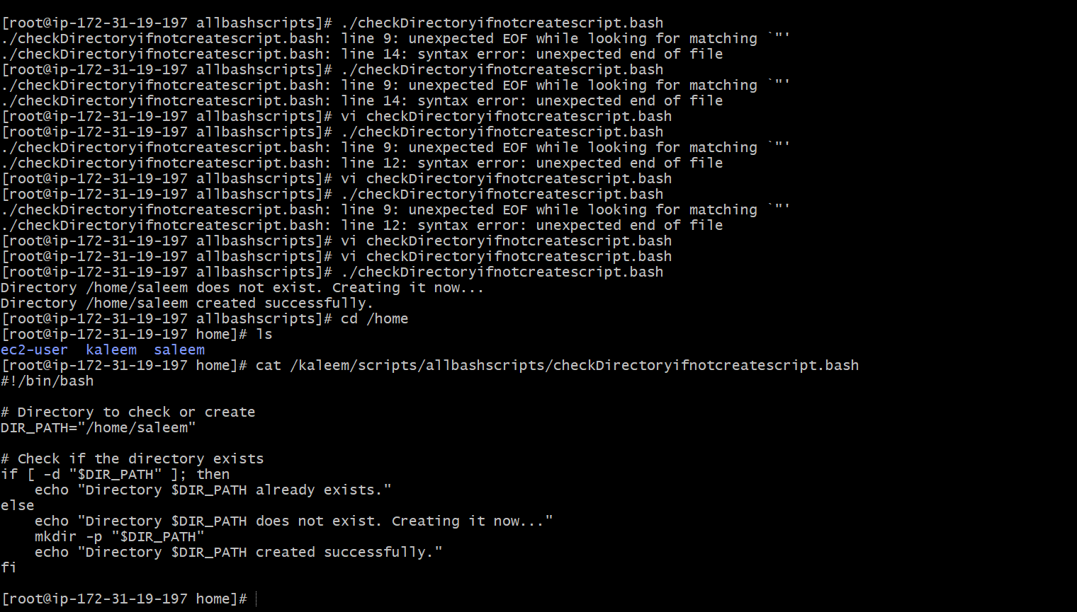

9) Create bash script to delete last 3 lines for a file.

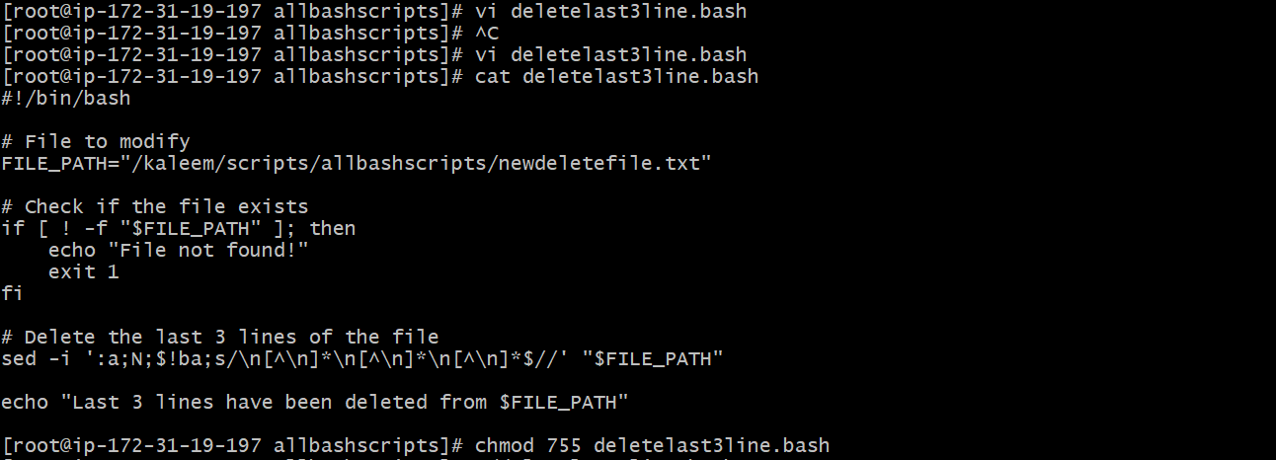

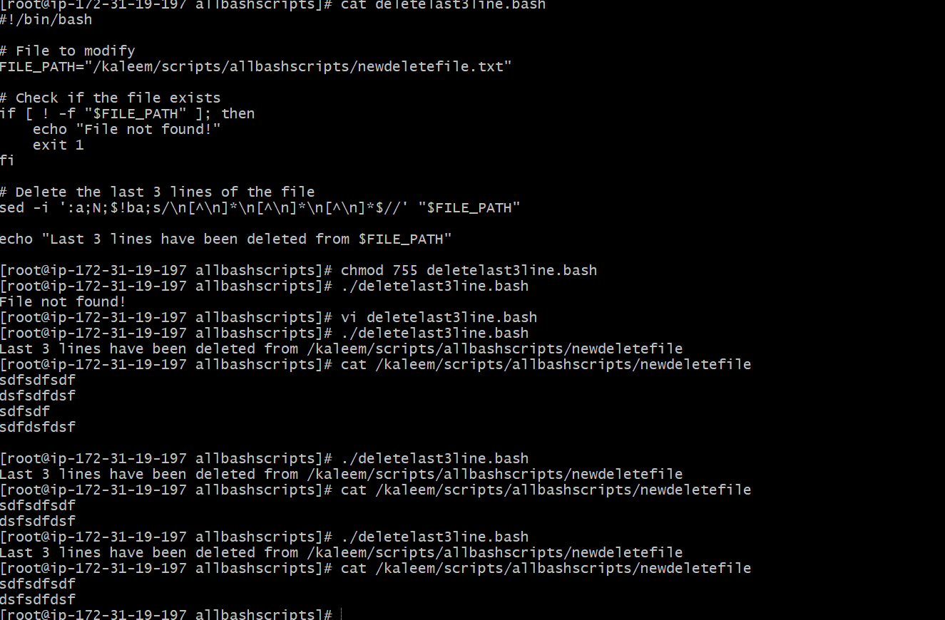

Exercise Crontab Entries :

1. April 5th Midnight

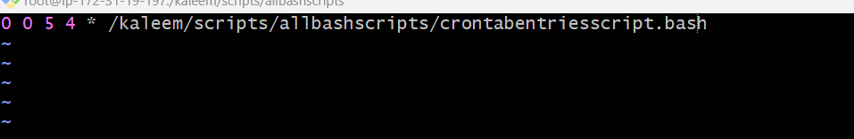

1. 5 th of Every November,Jan,June if it is a Thursday.

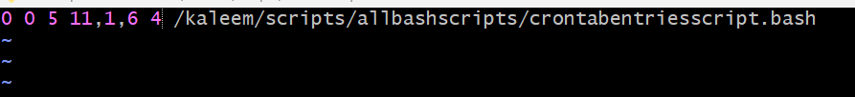

3) At 05 and 27th minutes of 9,10,11 hours everyday.

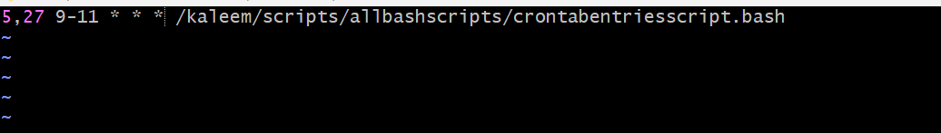

4) 34 min. of 9th hour on 15th Aug.

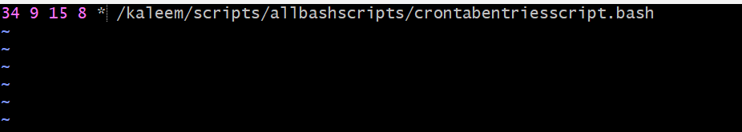

5) Every midnight

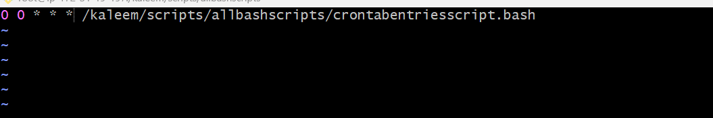

6) Every Weekend ( Saturday night 11.59 )

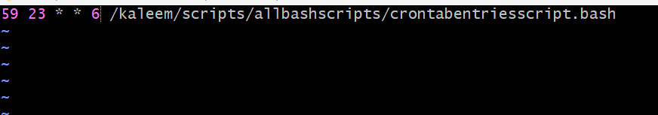

7) After every reboot

