**GIT HUB-1**

1. check git version

You can install using commands

Yum install git

Apt install git

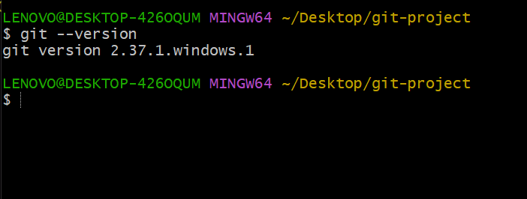

1. .git status

Track the changes or check the changes in your repository

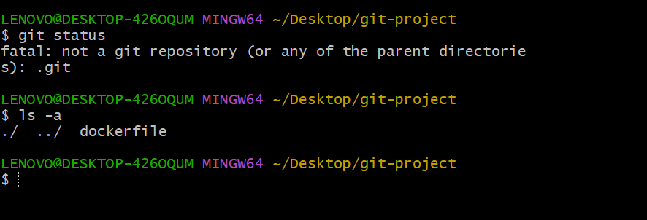

1. .git init

Initialize the directory and it had created one directory called .git

Configuration details are stored in git repository

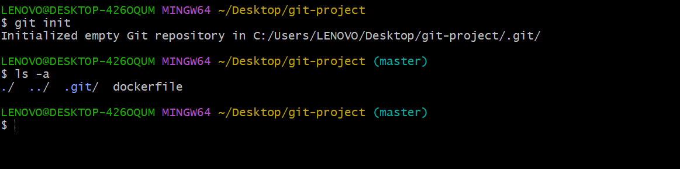

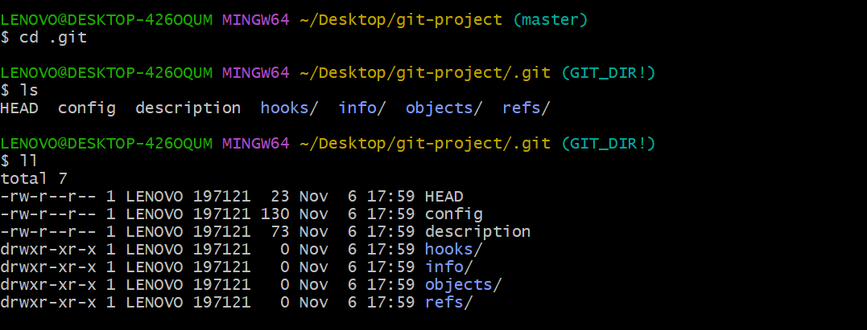

Now git able to track our changes

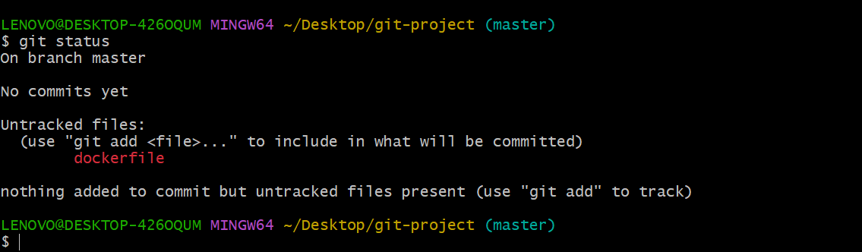

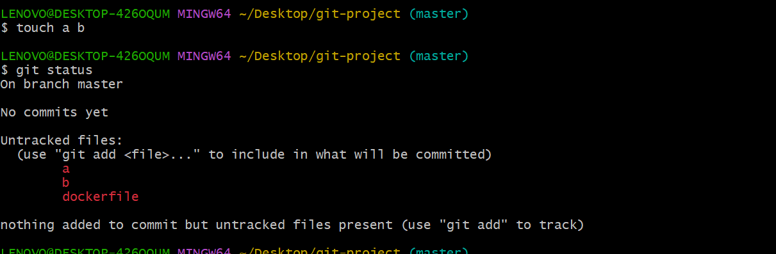

If we delete .git directory it will untrack the changes

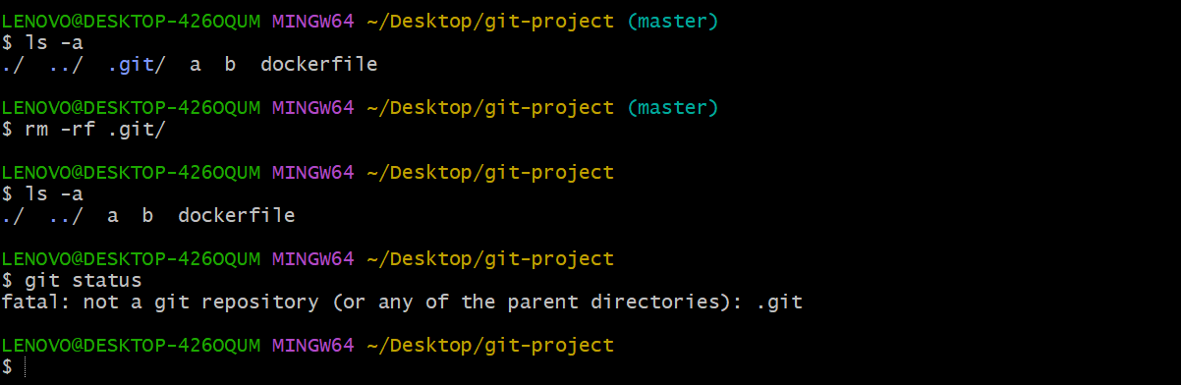

1. git config

list git user info

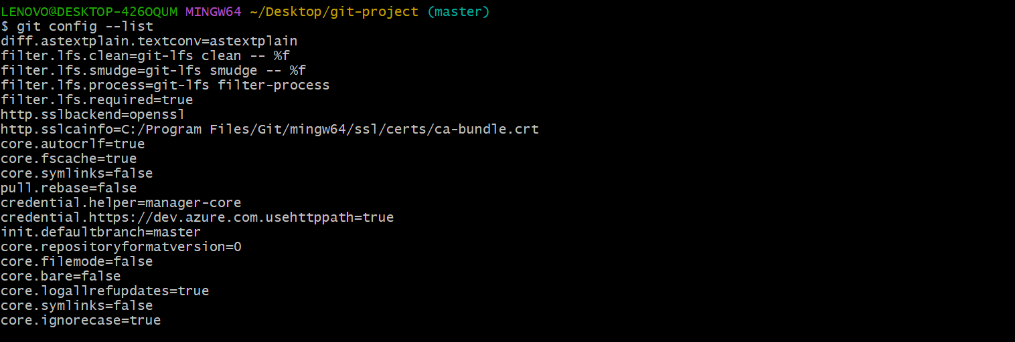

Here we need to configure our username and email id without that we cannot push the code and also its one time activity

Add name and email to git, to understand the user name and email

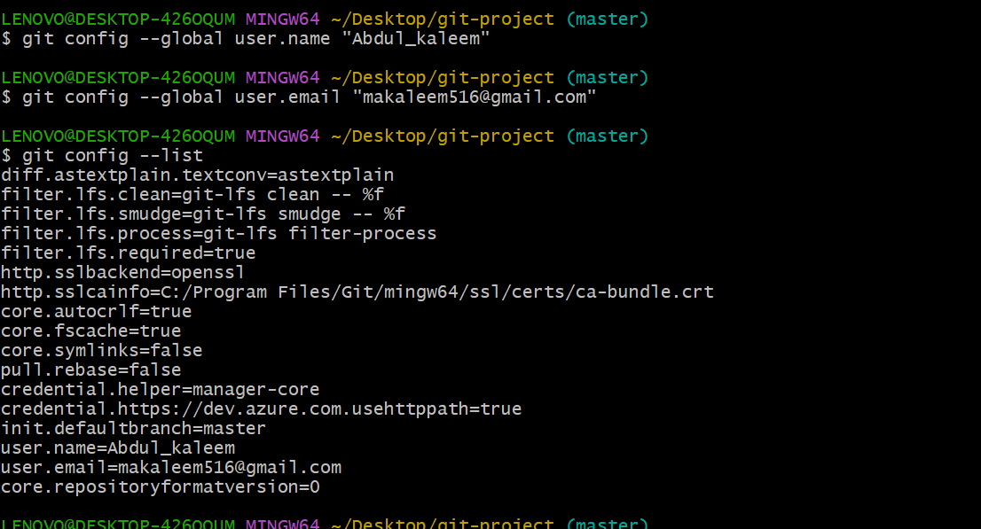

1. Git add

Add changes to the local repository

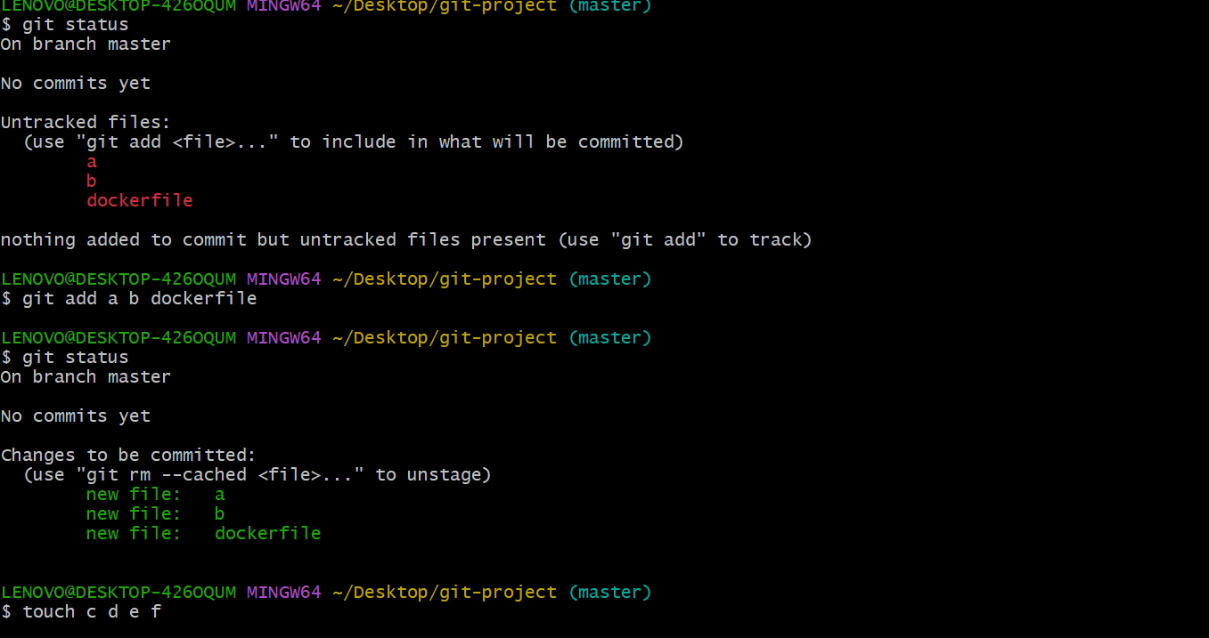

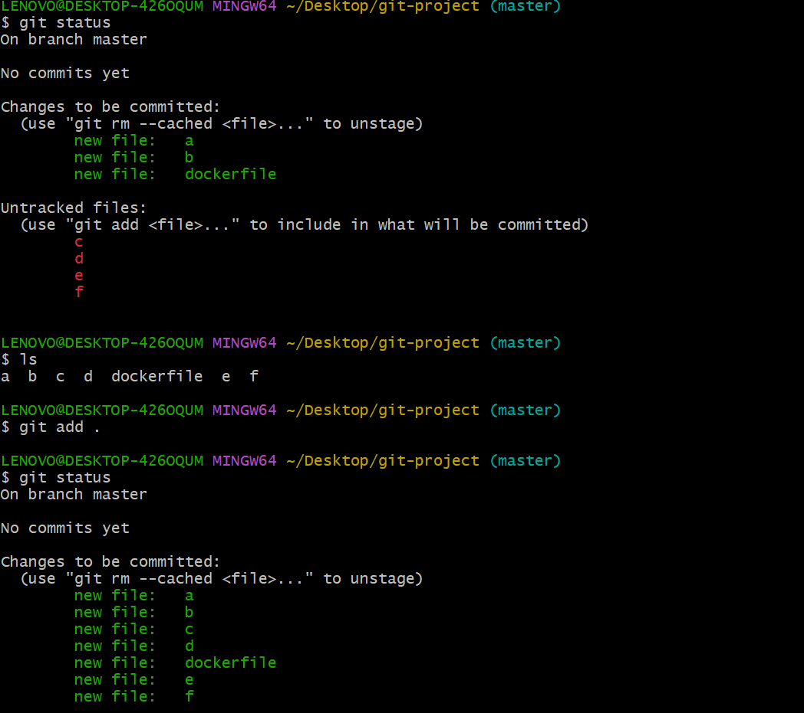

1. Git commit

Commit changes to the local repository

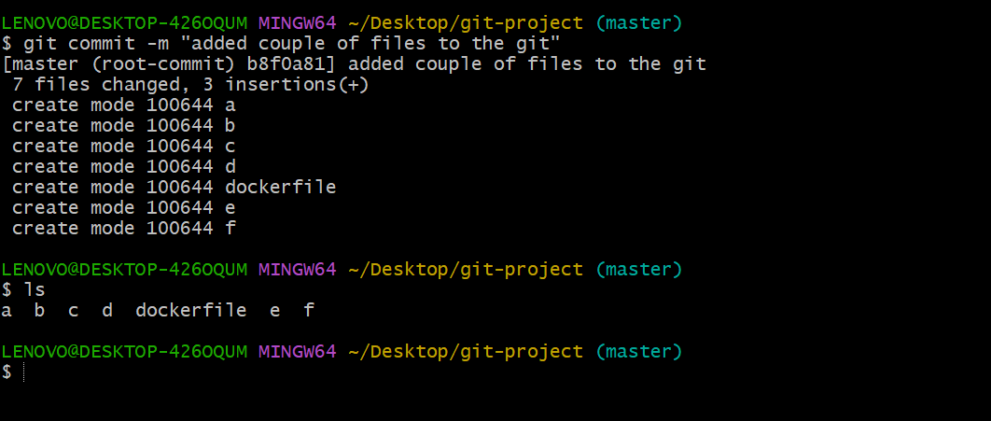

1. Git log

Git log is used to print all the logs whatever changes we did

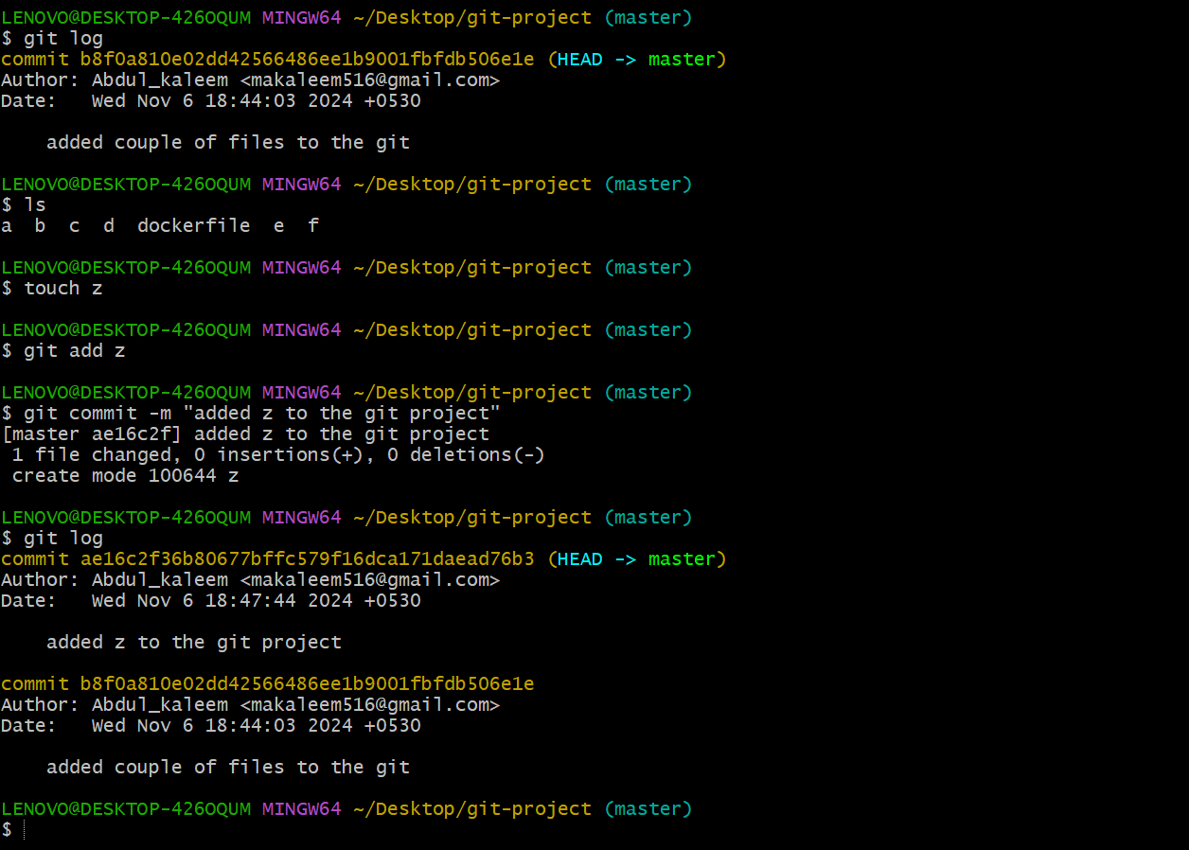

To check top 3,4 we use this command

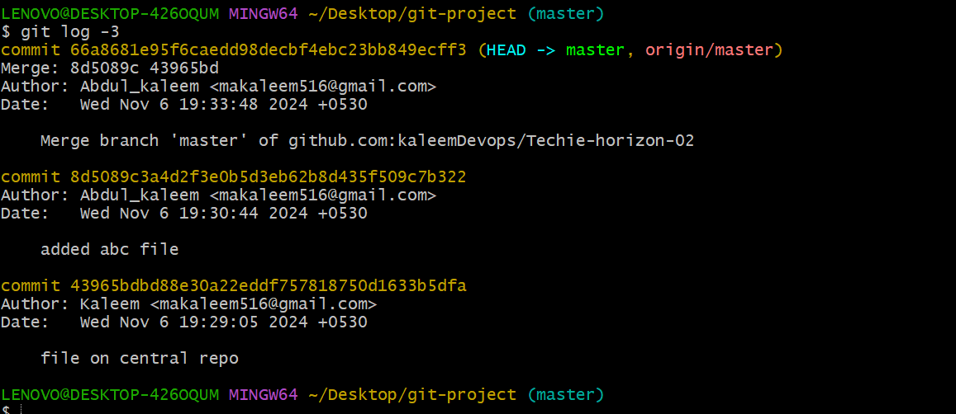

1. How to create git repository

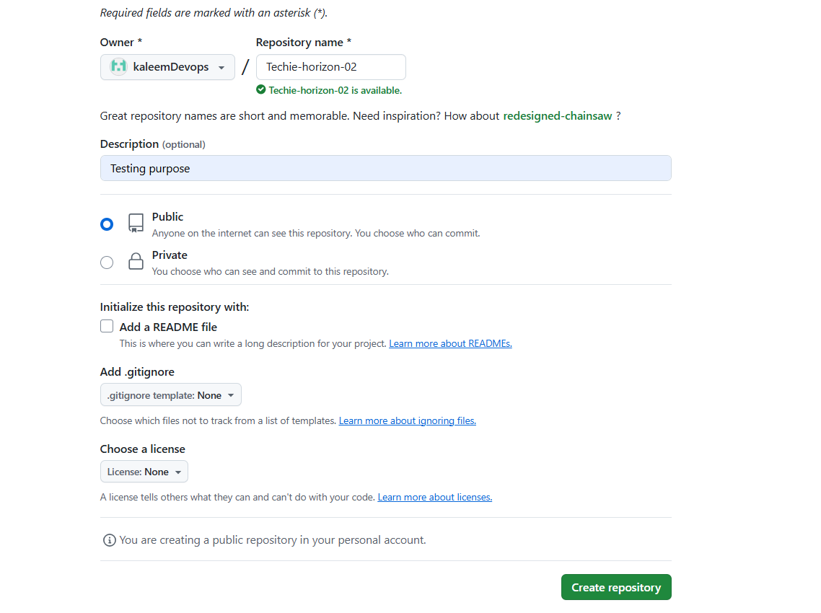

Now we can check here repository name

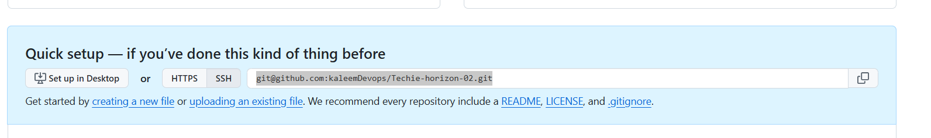

here we can user https or ssh but https uses password but ssh we can add and we can user that to access commands

now any one access my public repository https://github.com/kaleemDevops/Techie-horizon-02

1. Git push

Git push is used to push the code to central repository,

But here we have not configure ssh so we cannot push the code please follow the other steps given in the document

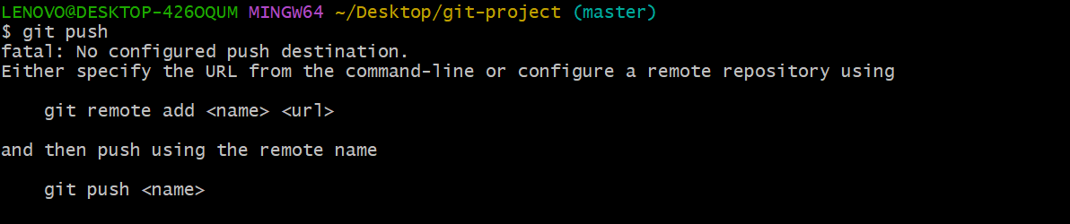

Here we have added destination in step 10 but not added ssh key please check step 11 for that

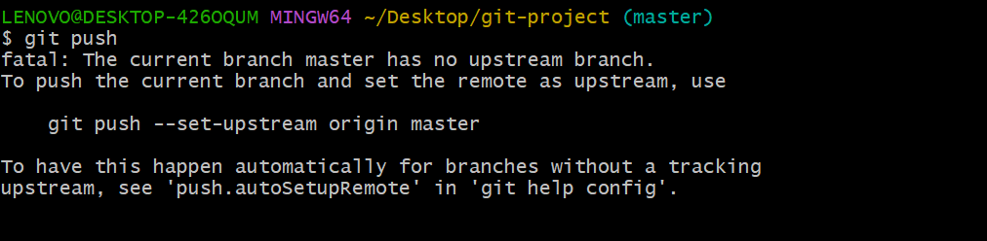

Now successful code pushed to git repo

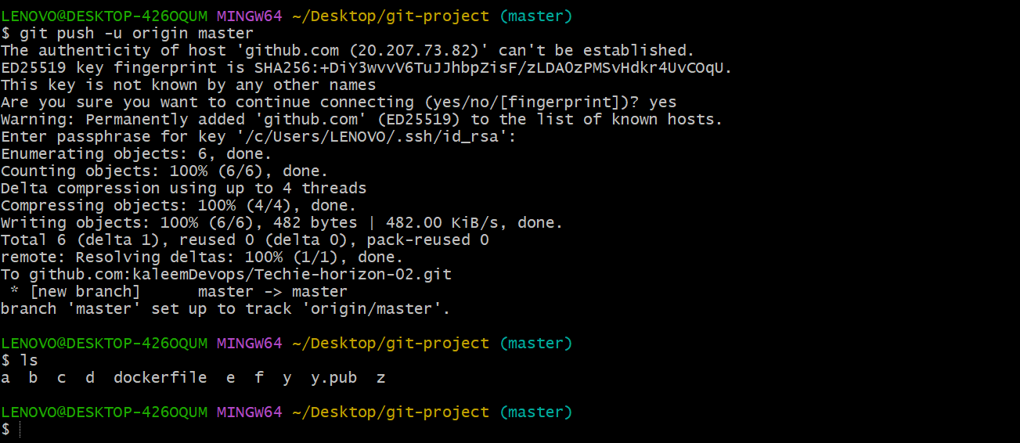

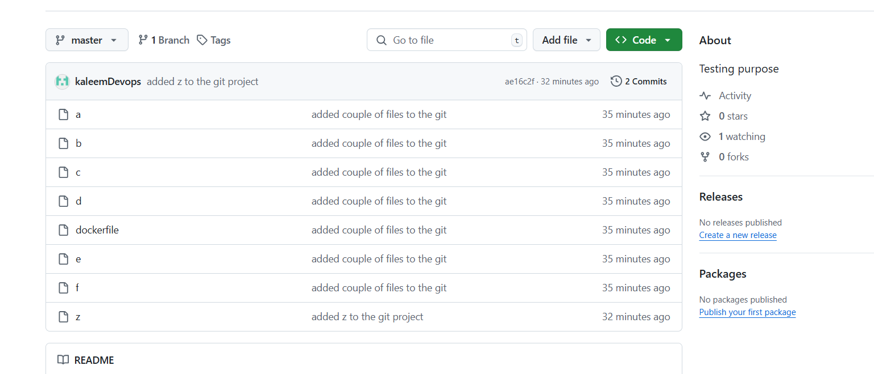

Delete and push the code and check the repo

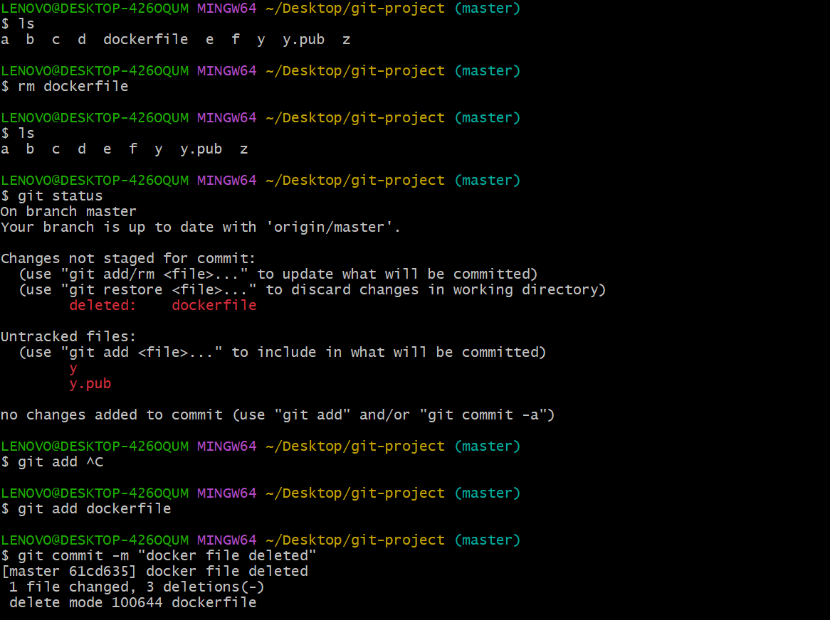

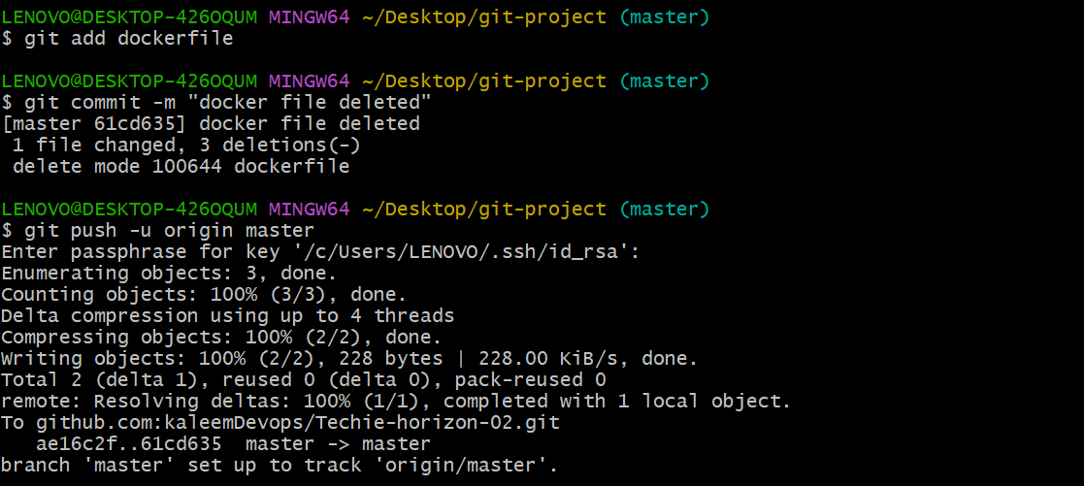

Now docker file deleted from central repo

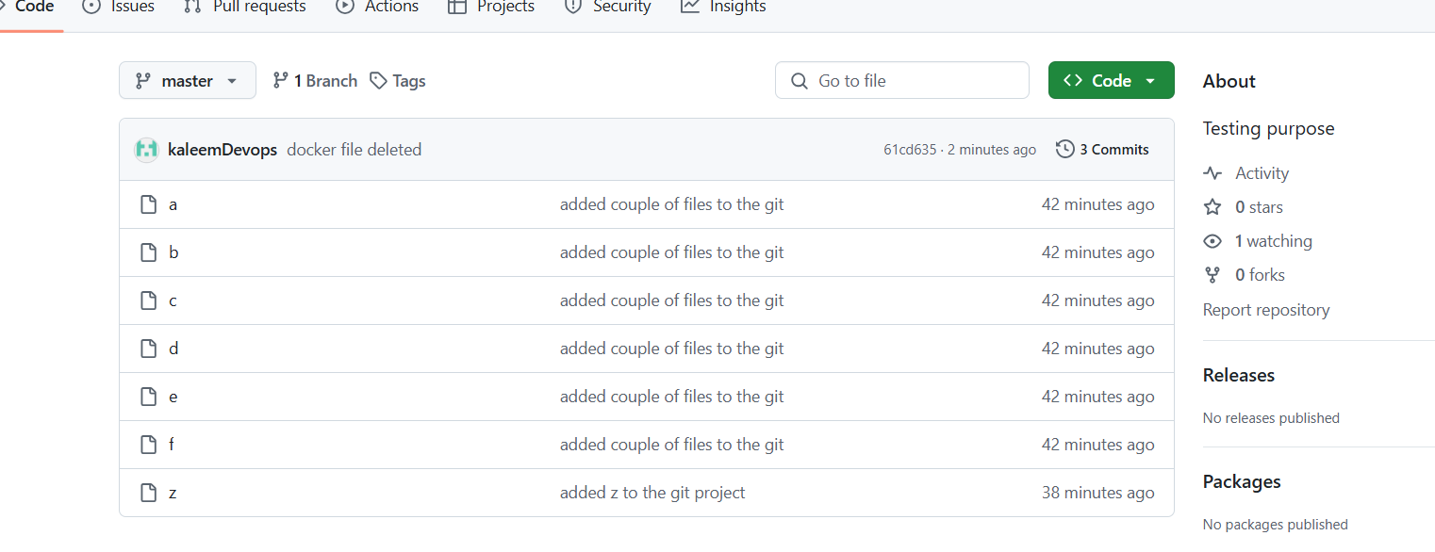

Add new file in git repo and check  
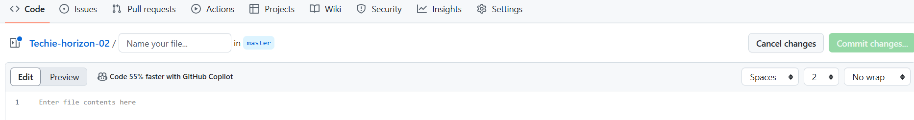

Add new file through commands

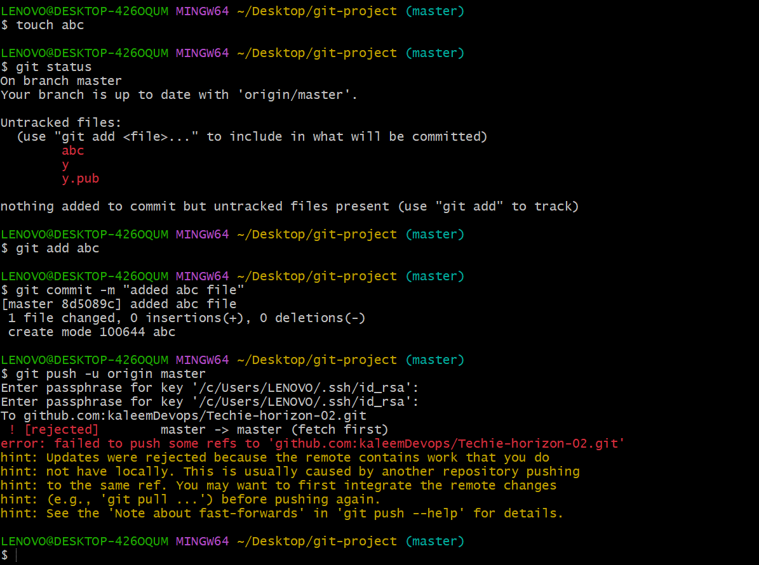

Then pull first then push the code

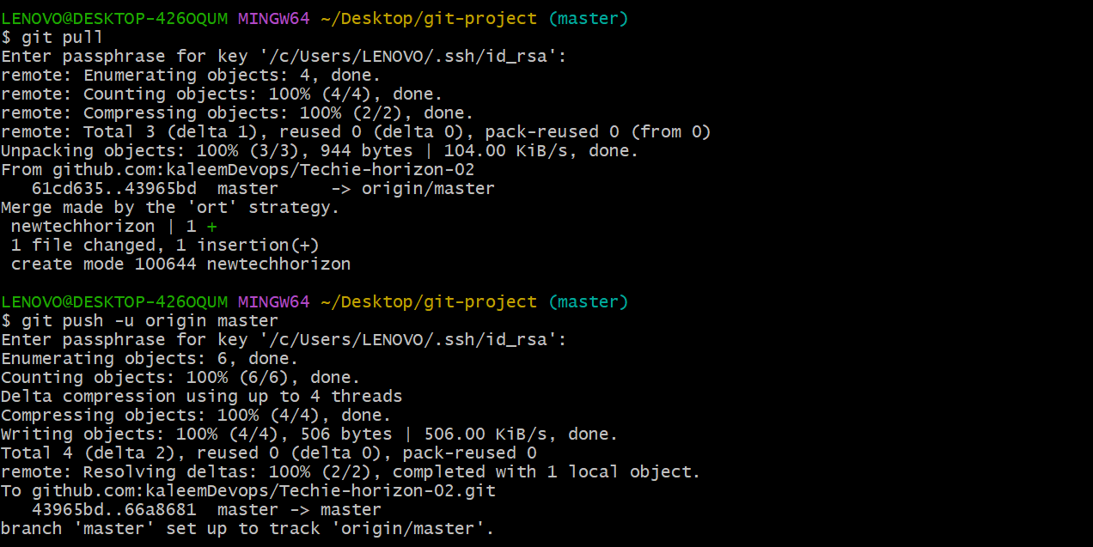

1. Git remote

This remote command to check and add destination where we can push the code

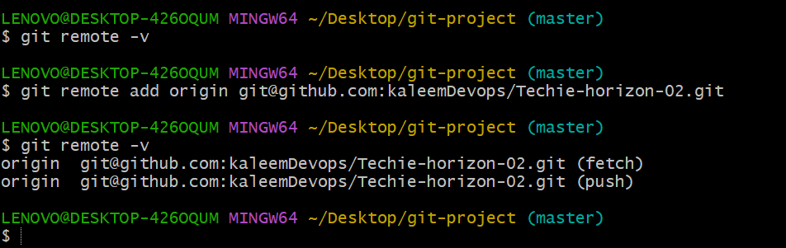

1. Ssh key generate

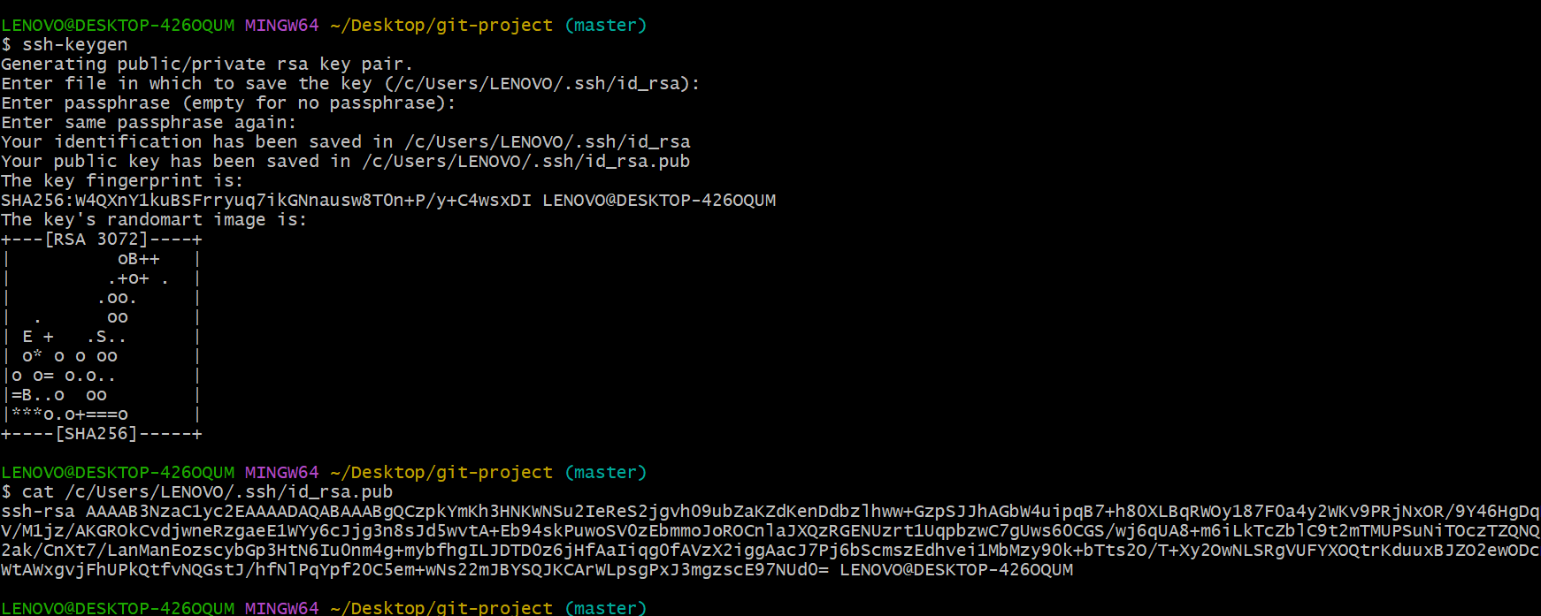

Then git hub goto setting then ssh and gpg keys addkey

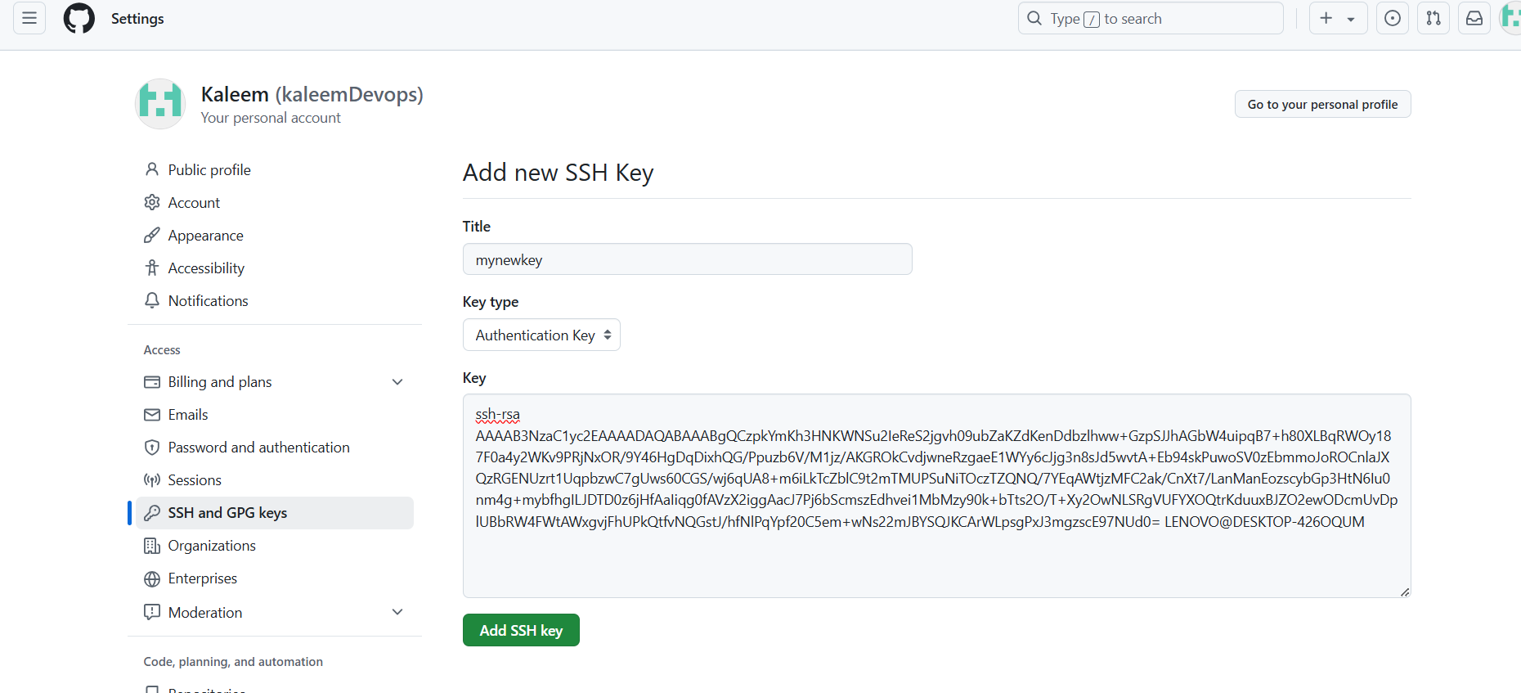

Now ssh key added and it will not ask everytime to when code push to repository

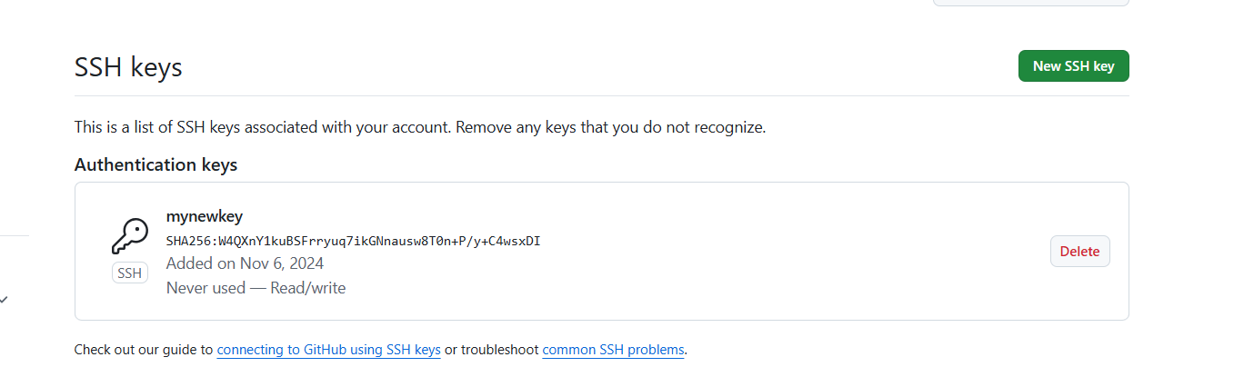

1. Git pull

Git pull will pull the changes from central repository



1. Git clone

To clone the full reposity to local machine

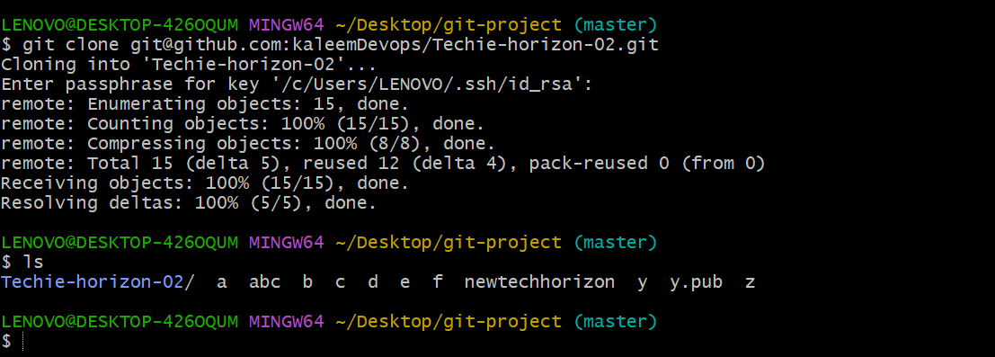

1. Git revert

Revert will revert the file from central repo

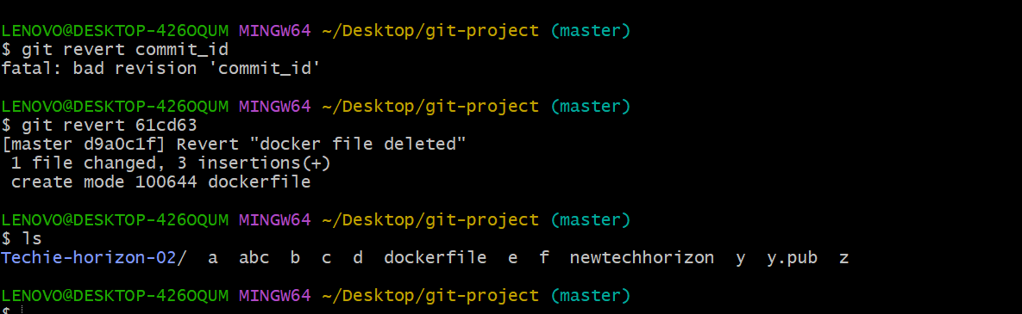

1. Git reset

It will changes the file from tracking to untrack area

