1. Launch one Linux instance in aws

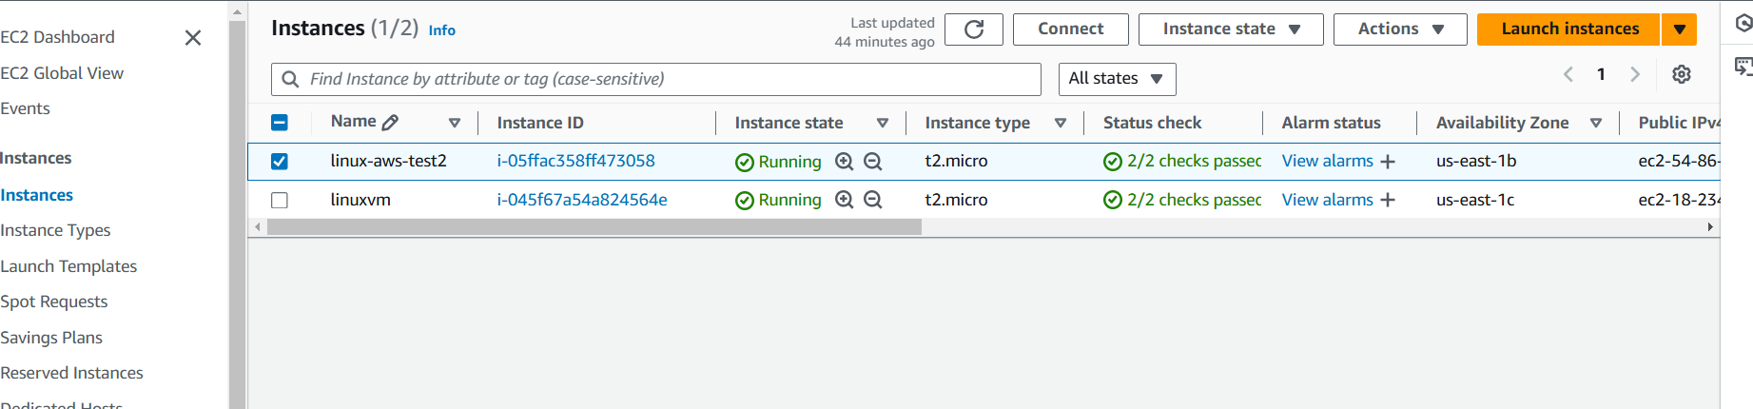

1. Create on file with name Techie_horizon

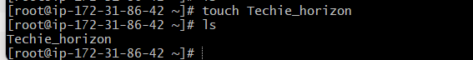

1. Copy the file "Techie_Horizon" from aws instance to windows machine

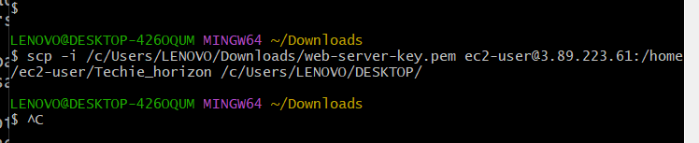

Run this command in widowns not aws

$ scp -i /c/Users/LENOVO/Downloads/web-server-key.pem [ec2-user@3.89.223.61:/home/ec2-user/Techie_horizon /c/Users/LENOVO/DESKTOP/](mailto:ec2-user@3.89.223.61:/home/ec2-user/Techie_horizon%20/c/Users/LENOVO/DESKTOP/)

1. Install Jenkins in the server created in step 1.
2. Install httpd,nginx,Apache Tomcat.

Already done in coming task