# Lab 9: Command-Line Interface

Goal

In this lab, you’ll get used to the basics of Jenkins CLI, so that it becomes one of the tools in your toolbox.

Step 1. Download jenkins-cli.jar

Go to http://localhost:8080/ , click “Manage Jenkins”, and then further click “Jenkins CLI” to get to the Jenkins CLI web page (alternatively, you can directly go to this page by navigating to http://localhost:8080/cli)

Download jenkins-cli.jar by clicking the link.

Step 2. Run the help command

Open command prompt by running “cmd.exe” from “Run…” in the start menu.

Copy the downloaded jenkins-cli.jar into the current directory for the convenience (tip: if you drag a downloaded file into the command prompt, it’ll paste as a full path name. This makes the copy easier.)

Run the following command and verify that it’s producing output (all in one line).

C:> java –jar jenkins-cli.jar -s http://localhost:8080/ help 2>&1 | more

Set Jenkins URL as the ‘JENKINS_URL’ environment variable so that you don’t have to keep retyping long URL:

C:> set JENKINS_URL=http://localhost:8080/  
C:> java –jar jenkins-cli.jar help

It should produce the same output.

Step 3. Run a build

Let’s execute the “gameoflife-freestyle” project we created earlier from command line. The -s option makes the command wait for the completion of the build.

C:> java –jar jenkins-cli.jar build –s gameoflife-freestyle

For extra credit, try the command again, but this time manually abort a build while it’s going on. CLI will report a failure. Try also running with the -c option, and verify that the build is skipped.

Step 4. Create a job

Let’s programmatically create a job. Creating a job from CLI requires you to define a job in the XML format. Writing this from scratch is too hard, so we’ll do cut&paste.

Navigate to http://localhost:8080/job/gameoflife-freestyle/config.xml in the browser. You should see the XML definition of this job. From a context menu, select “view source” to reveal the raw XML, then copy&paste it into notepad.

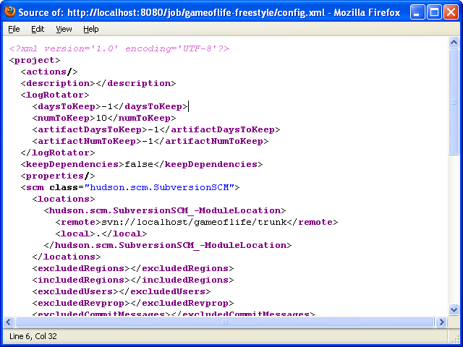

While you are at Notepad, try making some changes to this XML. A very easy change is to add something inside the description element. Jenkins tolerates errors in XML well, so long as it’s well-formed, so try making other changes if you can. Make sure you don’t have whitespace in front of the <?xml …?> declaration, for that breaks well-formedness.

Save this document to somewhere (say “c:\job.xml”) and remember its location.

Go back to the command prompt, then execute the following command (all in one line).

C:> java –jar jenkins-cli.jar create-job gameoflife-copy < c:\job.xml

From the browser, verify that you have the new job named ‘gameoflife-copy’.