# **Monitoring**

Goal

This lab will cover how to monitoring your CloudBees Jenkins Enterprise instance with the CloudBees Monitoring plugin.

Step 1: Using the built-in dashboard

The CloudBees Monitoring plugin comes with a default view that will provide details on System Load, JVM HEAP usage, etc. This view, even is not customizable, is a great help to see what it is possible to achieve with the plugin.

The first step is to create a view in the $JENKINS_URL/newView screen using the **Jenkins Enterprise Metrics Dashboard** and name it **Default Metrics**: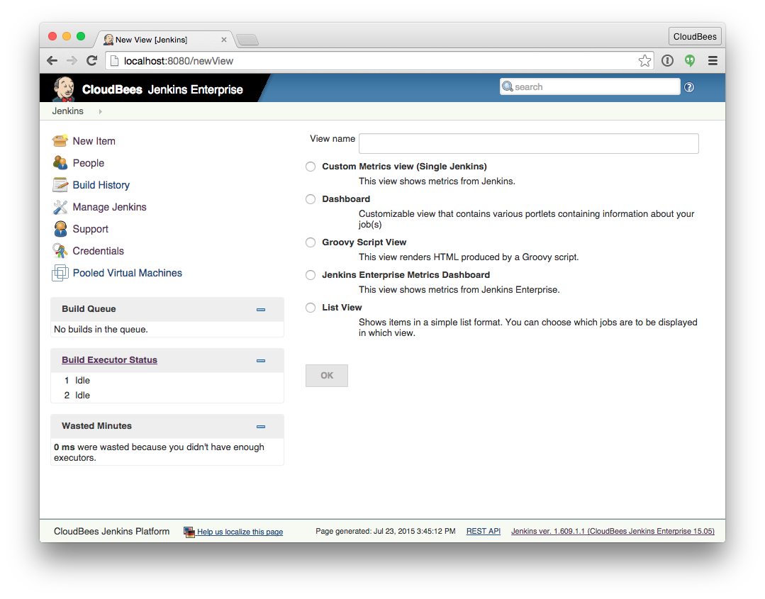

Once the view is create, the configuration page doesn't offer other modifications than the view name and the view description.

As said, the view offer multiple graphs to have details on the instance health and usage:

Step 2: Recreate the default view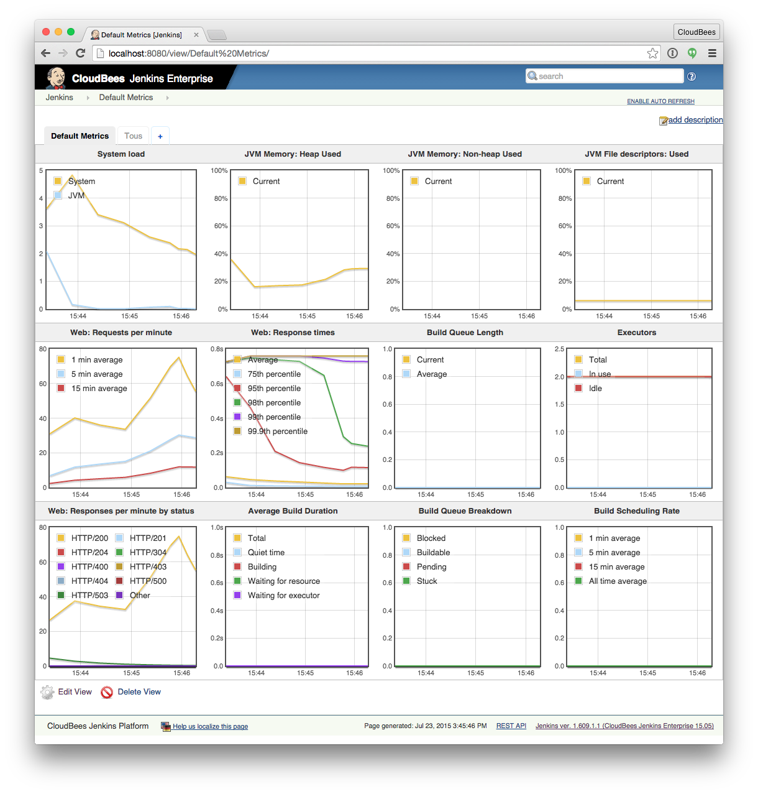

Using a **Custom Metrics View**, it is possible to re-create the previous view. To do that create a new view on $JENKINS_URL/newView, name it **Custom Metrics**:

Change the setting to use 4 columns and then add one by one the graphs composing the **Default Metrics** view.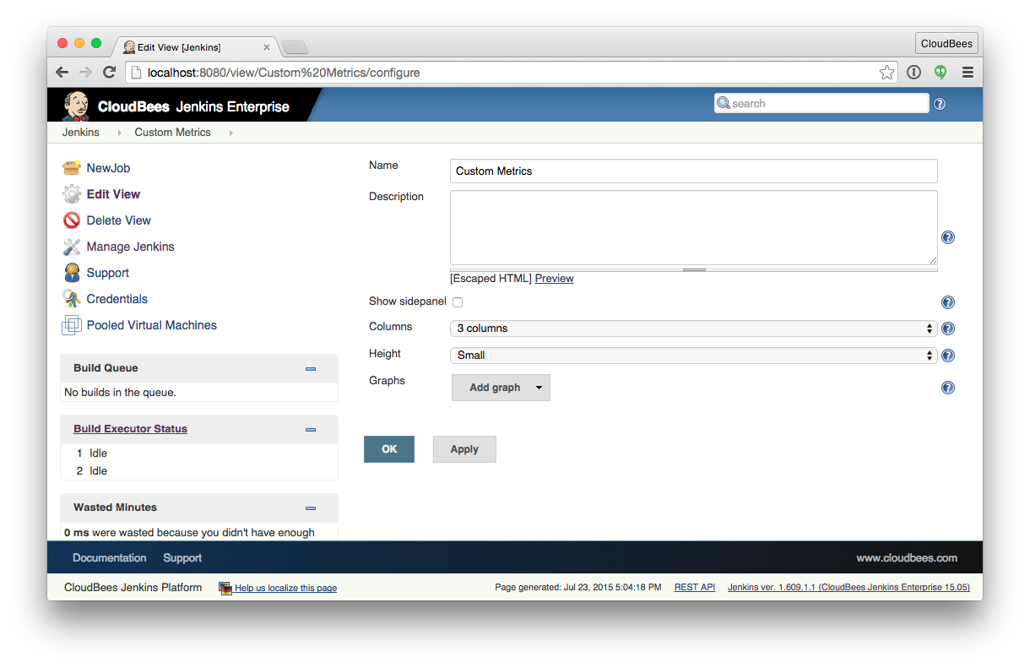

The main advantage of this new **Custom Metrics** is that we can make the graphs or smaller by changing the *height* and the number of columns used.

Step 3: Create the dashboard you need

Beside of the pre-defined graphs, it is possible to build your own graphs.

We will create a new dashboard which will consist of a single row composed of:

* a graph showing the total number of threads in the JVM as well as a breakdown by thread state
* a graph showing build scheduling rate as per the standard metrics dashboard

First, you need to create a new view, as previously, named it **Complex Metrix**. On the configuration page, select **2 columns** and set the height to **Medium**.

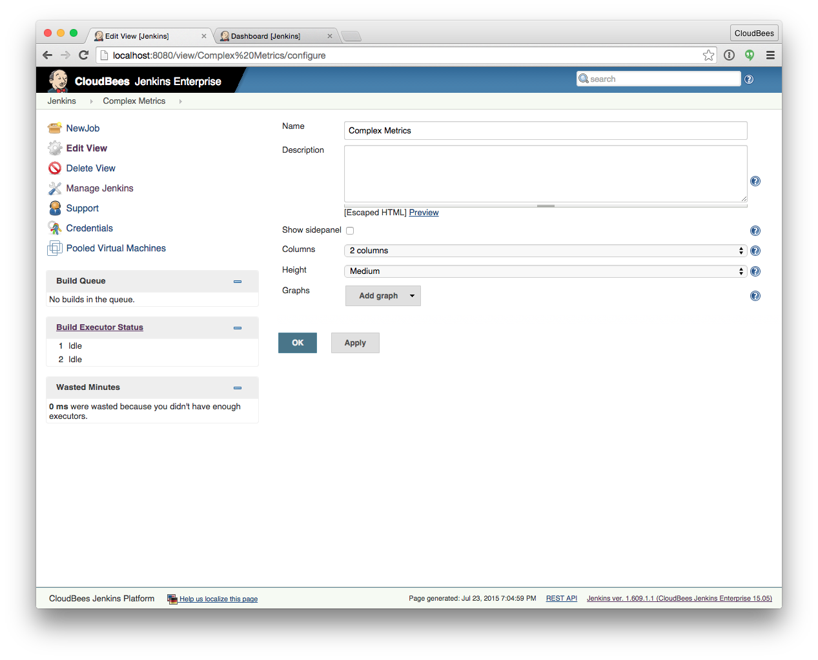

On the *Add graph* button, select the **Simple graph**:

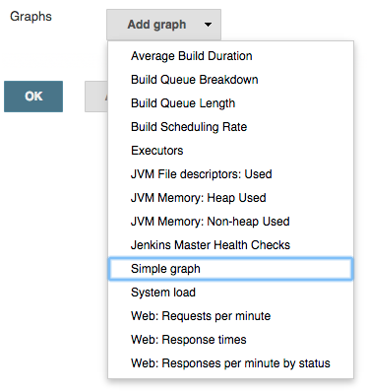

Now, we add a new **Basic series** using the path vm.count and the label **Total threads**. It will provide us the total count of threads currently running. We need this to be able to compare the following **Aggregate series** that will capture each type of threads running. To do that, we will use the regexp

vm\.([a-z]+)\.count

to be able to use the thread description in the label as

$1 threads

We will end with the configuration

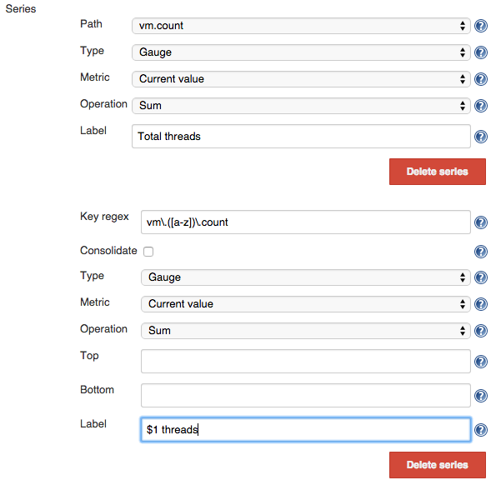

Those series compose the first graph of the dashboard. The second one is the built-in **Build Scheduleing Rate**, which we add using the **Add graph** button.

Once selected, we can save the dashboard and see the following result:

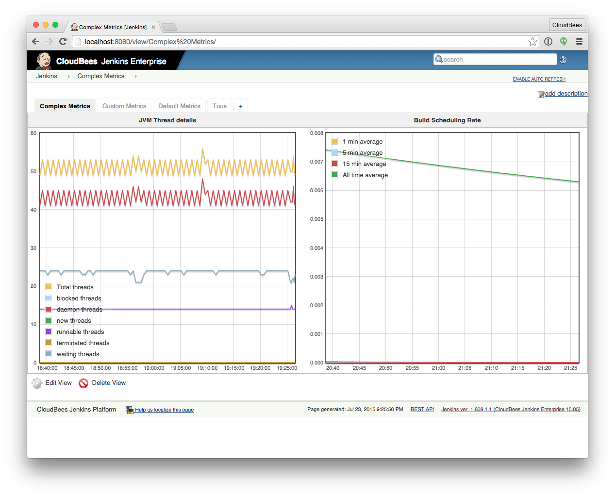

Extra

We have created all the views on the Jenkins root level, but the views can be created in a folder. You may need this with **RBAC** plugin to restrict who can access and see those metrics in your organization.