# Taking Backups with the CloudBees Backup Plugin

Goal

This lab will cover how to create backups on CloudBees Jenkins Enterprise masters with the CloudBees Backup Plugin.

Step 1. Creating a backup job

The first step is to create a backup job, which is a new Jenkins job type provided by the CloudBees Backup Plugin. To do this, click on the “New Item” link in the left-hand menu of the CloudBees Jenkins Enterprise page.

Name the item “backup” and select the job type “Backup”, then save your configuration by hitting the “Ok” button.

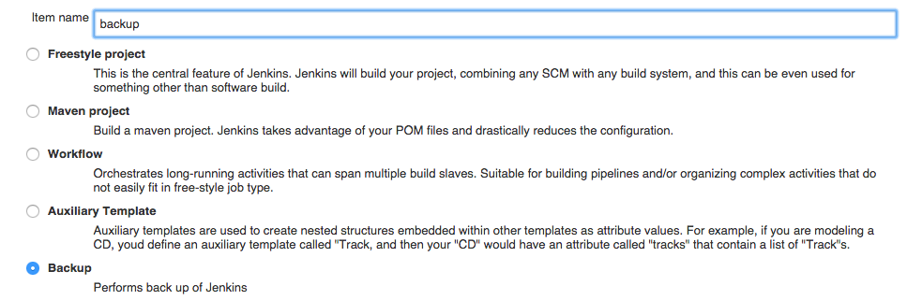

Step 2. Scheduling backups

Backups are like most any Jenkins job in that they can be triggered or run on a schedule. For this lab, we will configure a polling schedule for the backup job.

Go to the job’s configuration screen and scroll down to the “Build Triggers” section. Select the “Build periodically” option and, for the purposes of this lab, set the schedule as:

* * * * *

This will cause the job to be triggered every minute. In a real-life use case, it would be more realistic to create backups on at least a nightly schedule:

H 23 * * *

Step 3. Taking backups

Backups are a build step in the backup job type, so to create a back up you will have to scroll to the “Build” section and click on the “Add build step” button, then select “Take backup” from the menu.

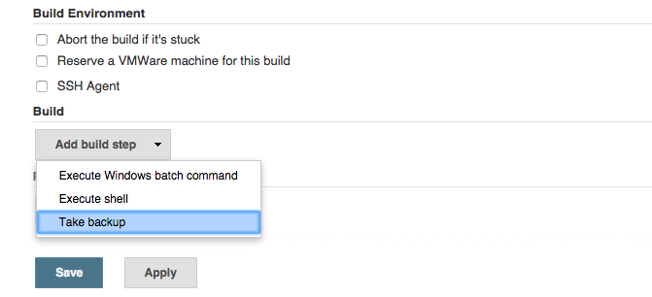

This will create a menu of options for configuring the backup. You can pick which types of Jenkins items should be preserved this backup job, where the backup archive should be stored, a retention policy for the backups, and what format the archives should take.

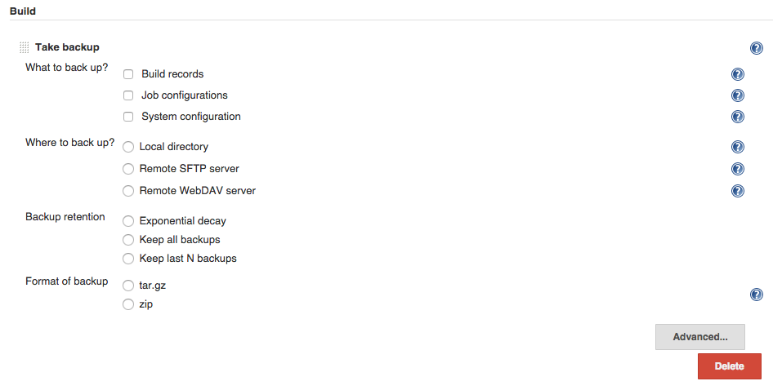

For the purposes of this lab, we will create a backup of the “Job configurations” on the CloudBees Jenkins Enterprise master. Select “Job configurations”, local directory, and exponential decay for your settings. The local directory must be a directory outside of the $JENKINS_HOME, for example:

C:\CloudBees\tools\jenkins-data

Once you have picked a suitable directory, click “Save” and watch as a new backup is created and stored in your chosen directory every minute.