# Setting up CloudBees Jenkins Operations Center

Goal

This lab will cover how to create client masters and shared slaves in the CloudBees Jenkins Operations Center product.

Presteps

Please install and log into the CloudBees Jenkins Operations Center product. You will also need to have a network-visible machine that can be used as a slave.

Step 1. Creating client masters

Client masters are Jenkins masters which are being managed by CloudBees Jenkins Operations Center. For this management to take place, the administrator must create an object representing that Jenkins master in the CloudBees Jenkins Operations Center dashboard.

To do this, click on the “New Item” link in the left-hand menu, much like you would to create a new Jenkins job. You will now create a master, which we will name “master-1” as a “Client Master” object.

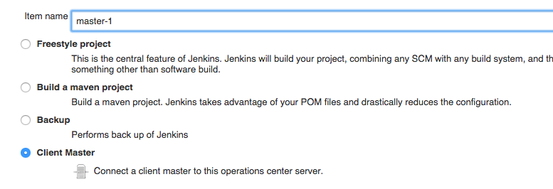

Once you’ve named it, you’ll have the option of configuring one or many users/emails as “master owners” who will be alerted if the client master goes offline. This parallels the “master owner” concept offered by the CloudBees Nodes Plus plugin.

You will also have the option to specify whether this client master has its own CloudBees Jenkins Enterprise license and there doesn’t need to be issued one (“No license”) or whether a license should be issued with caveats (“License, no dedicated”, “License, fixed dedicated”, “License, floating dedicated”).

For this exercise, select the “No License” option.

You will also have the ability to configure whether a client master should have a limited plugin selection using the Custom Update Center plugin. For this lab, leave this option unchecked and click “Save”.

You’ll now be prompted to specify the “Client Master URL”, which is the URL for your CloudBees Jenkins Enterprise master.

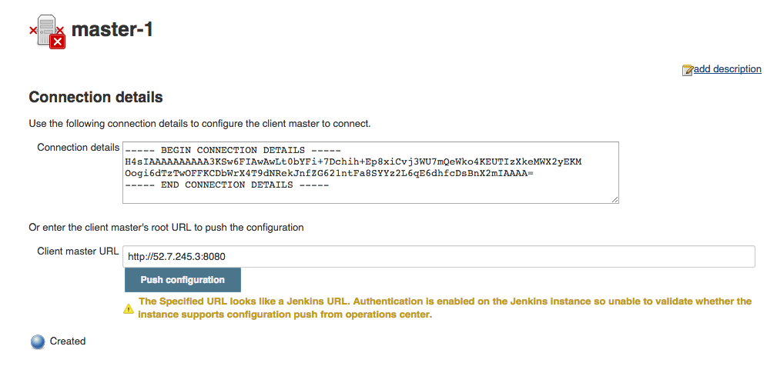

Once this information is copy/pasted to the field, click on the “Push Configuration” button. You will be logged into your CloudBees Jenkins Enterprise master, then prompted to confirm that you would like this master to be managed by CloudBees Jenkins Operations Center. Click “Yes” to confirm.

You will now be logged into the CloudBees Jenkins Enterprise master, but you will see a new breadcrumb in your navigation bar:  
Macintosh HD:Users:tracykennedy:Desktop:Screen Shot 2015-06-05 at 11.45.37 AM.png

Where “Jenkins” now represents the root level or top page of the CloudBees Jenkins Operations Center master and “master-1” represents the same in your CloudBees Jenkins Enterprise master.

Step 2. Creating shared slaves

Log back into the CloudBees Jenkins Operations Center master by clicking on the “Jenkins” breadcrumb. We will now create a shared slave object, which is a dashboard-level object like the client master we just created.

Once again, click on the “New Item” link in the left-hand menu, but select the “Shared Slave” object type and name it “shared-slave-1”. Now click “okay”.

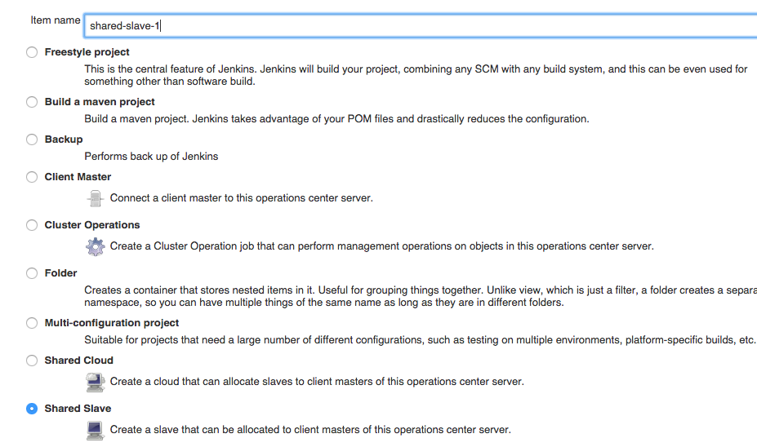

You will now be brought to the shared slave configuration screen, where you will specify slave-specific settings like number of execution threads for the machine, the remote file system root for the machine, any labels that described the machine, and the credentials needed to connect to the machine.

For the purposes of this lab, specify that the slave have 3 executors, that the remote FS root is “/”, and connect over SSH to your slave machine. Now “Save” your settings.

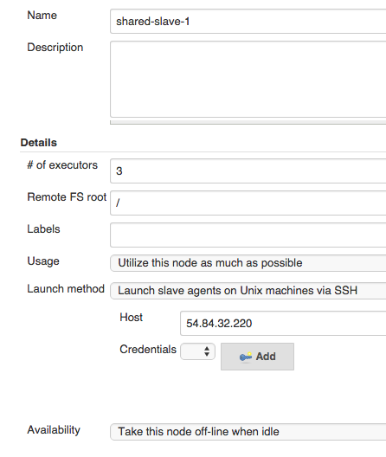

Once saved, CloudBees Jenkins Operations Center will attempt to connect to the slave and launch a slave agent on the specified machine. If the connection is successfully made, you will be redirected to the top level page of CloudBees Jenkins Operations Center and you will have both a “master-1” client master and “shared-slave-1” object.

