# Cluster Operations with CloudBees Jenkins Operations Center

Goal

This lab will teach users the basics of using cluster operations with CloudBees Jenkins Operations Center to take back ups and install plugins on masters.

Pre-steps

You will need a CloudBees Jenkins Operations Center master that is pre-configured with a CloudBees Jenkins Enterprise client master and an update center called “cjoc-updates”. Log in as “harry”.

Step 1: Creating a cluster operation

A cluster operation is a new job type that is exclusive to CloudBees Jenkins Operations Center, so to begin you will need to log into CloudBees Jenkins Operations Center and click on the “New Item” button.

Name this cluster operation “cluster-operation” and select the “Cluster Operations” job type, then click “Ok”.

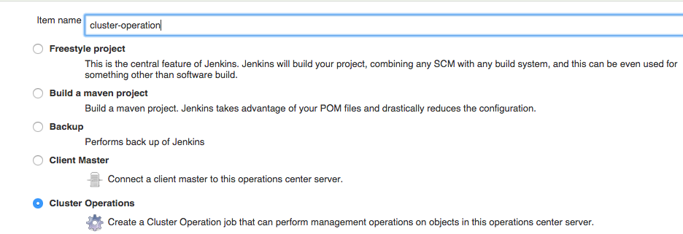

Step 2: Scheduling the operations

Like all Jenkins jobs, cluster operations can be triggered or scheduled. For the purposes of this lab, we will choose the “Build periodically” option to schedule when this operation should run. We will schedule this operation to run every 5 minutes:

5 * * * *

In a real-life use case, it would make more sense to either run the job based on a trigger or on a far less frequent basis, such as once a night for backups, once a week for plugin updates, and once every 3 months for Jenkins core updates.

Step 3: Selecting a master

Instead of having a “Build Steps” section like most jobs, cluster operations have an “Operations” section. Operations can either be performed against masters managed by CloudBees Jenkins Operations Center or an update center configured on the same.

To start, we will create an operation against our client master, so click on the “Add Operation” button and select the “Masters” option. This will cause a menu of items related to master operations to display. For this lab, we will run a backup operation on our only client master, so select “Using a specified update center” as the source criteria and the “cjoc-updates” update center should appear as the default choice.

Filters allow further targeting of specific masters, but in this case it is unnecessary so ignore that section for now.

Step 4: Creating a cluster operation backup

Now we will configure what steps to run against our selected master. Click on the “Add Step” button under the “Steps” section and select the “Backup Master” option. The options for a cluster operation backup are the same as for a CloudBees Backup Plugin backup directly on a master. For the purposes of this lab, opt to only backup “job configurations” to a local directory outside of the $JENKINS_HOME, like

C:\CloudBees\backups

And select the exponential decay policy.

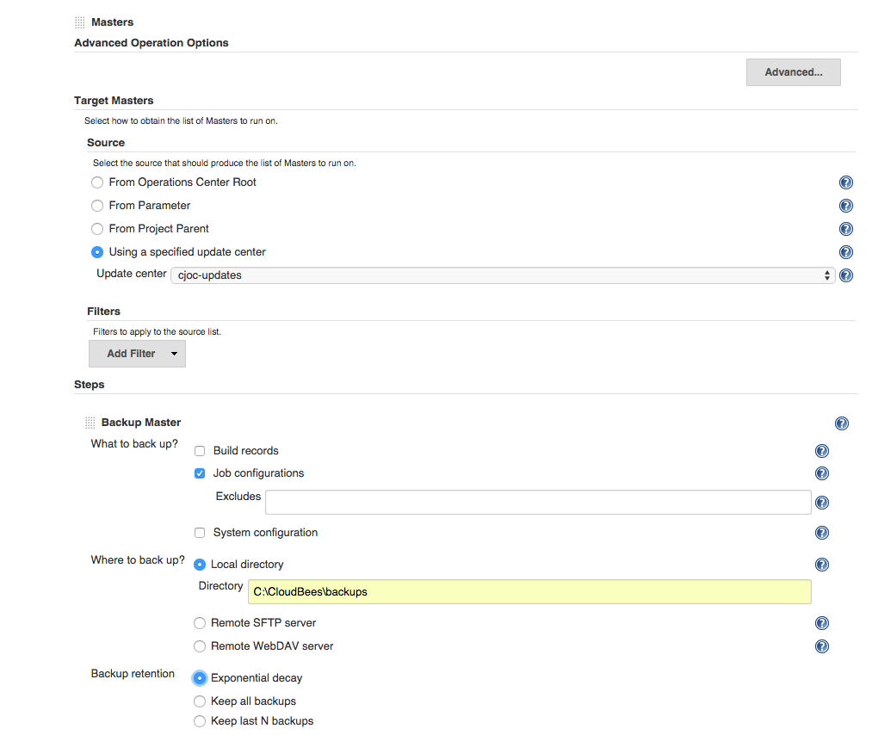

Step 5: Selecting an update center

We will now add an operation to this job, but one that runs against an update center. To do this, scroll past the configured Master operations until you see the “Add Operation” button. Click the button and select “Update Centers” from the dropdown menu.

To target out one update center, it is easiest for this lab to select the “Using a specified update center” option again and taking the default “cjoc-updates” as our selection. Filters will again be unnecessary since this is the only available update center.

Step 6: Creating a plugin update cluster operation

We now want to force our custom update center to update on the schedule that we are triggering this job on. Click on the “Add Step” button and add the following steps:

* Refresh upstream sources
* Pull new versions

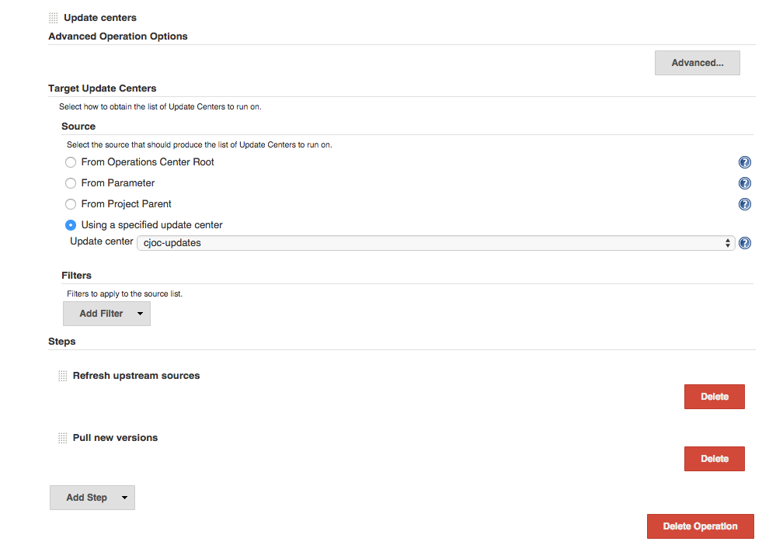

This will allow our update center to refresh itself and always have the latest plugins from the CloudBees Enterprise update center already pulled.

This completes the actions needed to run against this update center, so scroll down again until you see the “Add Operation” and select the “Masters” cluster operation.

This time you will be forcing the master to upgrade its installed plugins. Select the following steps:

* Refresh update center metadata
* Upgrade all plugins
* Restart Now

This will cause the specified client master to get a list of the latest plugins from its upstream update center, upgrade all plugins to the newest version, and then restart the CloudBees Jenkins Enterprise master without consideration for any in-flight builds.