# Lab X: Generate a support bundle

Goal

The aim of this lab exercise is to learn the most important ways to generate a bundle and to do a quick inspection of one of them.

Step 1. Check arguments defined in Jenkins.xml

Open the Jenkins configuration file under $JENKINS_HOME/jenkins.xml.

Check in this file what is the path defined for the $JENKINS_HOME and what memory arguments are passed to the JVM to check later that this is reported by the support bundle.

Now, open a Windows terminal and check the Java version installed in the machine.

Macintosh HD:Users:Felix:Downloads:java-version.png

Step 2. Generate a support bundle from GUI

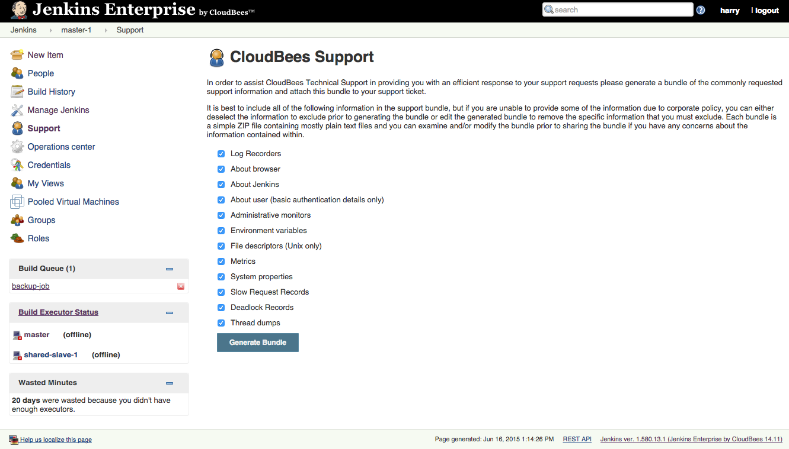

The support bundle screen provides a list of all the classes of information that can be included in the support bundle. Most of the times, if you are generating the support-bundle for yourself, there is not any confidential risk so best is to include all the selected information.

Now, it is time to unzip the support bundle and navigate through it. You can check in the about.md file that the JVM startup parameters and the $JENKINS_HOME reported are the ones defined in jenkins.xml.

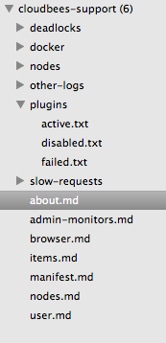

Step 3. Generated support bundles when Jenkins doesn’t start

If your Jenkins instance is not able to start correctly, this is usually because of some class-loading conflict among the set of plugins that you have installed in your instance. Normally such class-loading conflicts will just result in one of your plugins failing to load, however in some extreme cases a plugin failing to load can cause a second plugin to render the UI of your Jenkins instance inaccessible.

In such cases, the latest support bundle will be available, which will make easier the correct restoration of your Jenkins to an accessible state.

The support bundles are the files $JENKINS_HOME/support/ support_YYYY-MM-DD_hh.mm.ss.zip where YYYY-MM-DD and hh.mm.ss are the UTC date and time respectively when the bundle was generated.