E-COMMERCE CUSTOMER BEHAVIOUR ANALYSIS
A Data Analytics Project Using Microsoft Power BI
PROJECT REPORT

  - Made by: [kaleeswaran.J]
  - GitHub : [https://github.com/kaleeswaran7/Customer_behaviour_Analysis]

Report Contents
- Abstract
- Introduction
- Problem Statement
- Objectives
- Tools and Technologies
- Dataset Description
- Data Preparation
- Dashboard Design and Visualisations
- Findings and Observations
- Recommendations
- Limitations
- Conclusion
- References

Abstract
This project analyses customer behaviour using a structured e-commerce customer dataset and Microsoft Power BI. The dataset includes customer demographics, city, membership type, spending, items purchased, average rating, discount usage, days since last purchase, and satisfaction level. The objective is to turn these fields into an interactive dashboard that helps users explore revenue patterns, customer satisfaction, discount usage, and purchasing recency. The report describes the dataset, preparation process, dashboard design, observed results, and practical recommendations. Numerical findings should be updated from the final dashboard wherever a visual or measure differs from the figures recorded during preparation.

Introduction
Understanding customer behaviour helps businesses make informed decisions about customer experience, marketing, and retention. By analysing spending, membership groups, satisfaction, and time since the last purchase, a business can identify patterns that deserve further investigation. This project uses Power BI to present customer information in visual form so that patterns can be understood more quickly than by reviewing rows of spreadsheet data alone.

Problem Statement
Customer data can be difficult to interpret when it is stored only in a spreadsheet. Without a consolidated view, it may be challenging to compare revenue across cities or membership groups, understand the distribution of satisfaction levels, and identify customers who have not purchased recently. This project addresses the problem by creating a Power BI dashboard that summarises key customer and revenue indicators.

Objectives
- Analyse customer spending and revenue by city and membership type.
- Summarise customer satisfaction levels.
- Compare satisfaction categories for customers with and without discounts.
- Examine days since last purchase as an indicator of purchasing recency.
- Highlight customers who may warrant follow-up using clearly defined criteria.
- Present findings in a visual dashboard to support data-informed decisions.

Tools and Technologies
- Microsoft Excel: source dataset and initial review.
- Microsoft Power BI Desktop: dashboard creation and visual analytics.
- SQL Query: data inspection, cleaning, and transformation.
- DAX: measures and calculated columns, where applicable.

Dataset Description
The project The fields used in the analysis are Customer ID, Gender, Age, City, Membership Type, Total Spend, Items Purchased, Average Rating, Discount Applied, Days Since Last Purchase, and Satisfaction Level. The dataset supports customer-level analysis; it does not contain a full order history or transaction dates, so the analysis should not be presented as a time-series sales analysis.
uses an e-commerce customer behaviour dataset containing approximately 350 customer records.

Data Preparation
The dataset was reviewed before building the visuals. Column names and data types should be checked to ensure numeric fields such as Total Spend, Items Purchased, Average Rating, and Days Since Last Purchase are interpreted correctly. Categorical fields such as Gender, City, Membership Type, Discount Applied, and Satisfaction Level should be treated as categories where appropriate. Two records were observed with a blank Satisfaction Level. These should be handled transparently—for example, by retaining them as blank/unknown or applying a justified replacement rule. Any replacement should be documented and should not be used to imply a satisfaction response that was never recorded.

Dashboard Design and Visualisations
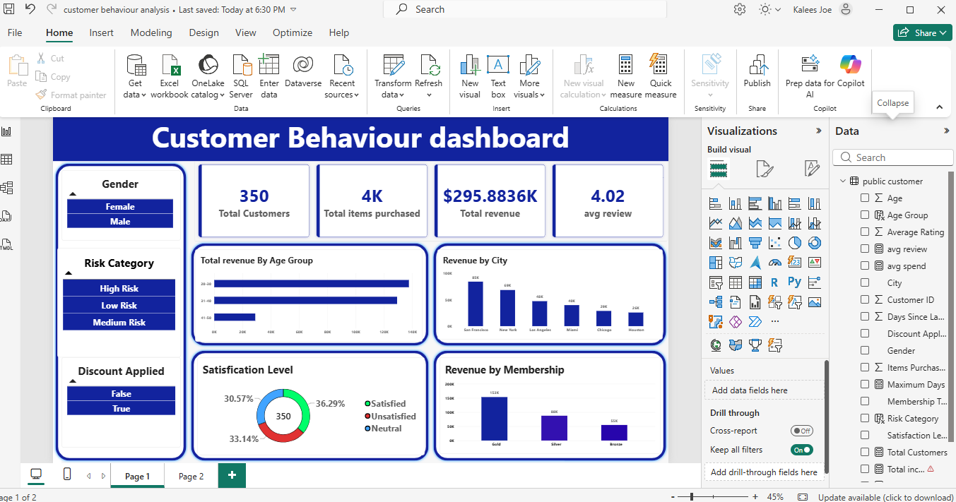
The dashboard brings together customer and revenue analysis. Include a screenshot of the final Power BI report page in this section.
8.1 Revenue by City — compares the total spending recorded for customers across cities and helps identify locations with higher recorded revenue.
8.2 Revenue by Membership Type — compares total spending among membership groups and shows which group contributes the greatest total spend in this dataset.
8.3 Customers by Satisfaction Level — displays the distribution of satisfaction categories. Blank or unknown values should be labelled clearly if they are shown.
8.4 Discount Applied vs Satisfaction Level — compares satisfaction categories between customers who received discounts and those who did not. This is a comparison, not proof that discounts caused a particular satisfaction outcome.
8.5 Days Since Last Purchase by Satisfaction Level — compares purchase recency across satisfaction groups.
A larger number of days may indicate inactivity, but does not by itself prove that a customer has churned.
8.6 Customer Risk Table — can list Customer ID, City, Membership Type, Total Spend, Days Since Last Purchase, Satisfaction Level, and Average Rating for customers who meet the project's stated follow-up criteria.
Any risk category is a rule-based indicator, not a validated churn prediction.

Findings and Observations
During dataset review, two records had missing Satisfaction Level values. In the discount-versus-satisfaction counts recorded during preparation, customers with Discount Applied = True included 116 Unsatisfied and 59 Satisfied records. Customers with Discount Applied = False included 107 Neutral and 66 Satisfied records, along with two records with a blank satisfaction value. These counts should be rechecked against the final Power BI visuals before submission. They suggest that satisfaction categories differ between the two discount groups, but they do not establish that discount usage caused satisfaction or dissatisfaction.
The completed dashboard should also be used to record the highest-revenue city, the highest-spending membership type, the most common satisfaction category, and any customer groups with a longer time since last purchase. Insert the actual values from the final visuals in the spaces below:
- Highest recorded revenue city: [San Francisco ($84.6668k)]
- Highest recorded revenue membership type: [Gold ($153.4039k)]
- Highest recorded revenue by age group : [20-30 ($137.6117k)]
- Satisfaction level of customers : [Satisfied (36.29%), Unsatisfied (33.14%), Neutral (30.57%)]

Recommendations
- Review customer satisfaction results and investigate common reasons for dissatisfaction using additionalcustomer feedback if available.
- Compare the performance of discount campaigns using more information, such as purchase frequency, profitmargin, and campaign costs, before changing discount policies.
- Consider tailored engagement for customers with a long time since their last purchase, while treating recencyas a signal rather than proof of churn.
- Recognise valuable customers using transparent criteria, such as spending and membership status, and avoidrelying on one metric alone.
- Validate data types, missing values, and totals before presenting dashboard findings to stakeholders.
- If future analysis is required, collect transaction dates and order-level records to analyse sales trends and buildmore reliable retention measures.

Limitations
The dataset contains customer-level attributes and summary measures rather than a complete history of individual orders. As a result, the project cannot reliably establish changes in revenue over time, calculate customer lifetime value from transactions, or confirm churn using inactivity alone. The two blank Satisfaction Level records also limit the completeness of satisfaction analysis. Risk categories should therefore be described as rule-based flags for review, not as a predictive model.

Conclusion
This project demonstrates how Microsoft Power BI can be used to convert customer data into a dashboard for exploring spending, membership groups, satisfaction, discount usage, and purchasing recency. The dashboard provides a consolidated view that can help a business ask more focused questions and prioritise further investigation. The usefulness of the conclusions depends on data quality, correct aggregation, and interpretation of the visuals. Future work could include transaction-level data, time-based analysis, and customer feedback to strengthen the insights.

References
- Microsoft Learn, Power BI documentation: https://learn.microsoft.com/power-bi/
- Project dataset: E-commerce Customer Behavior dataset supplied for this project.

Made by: [kaleeswaran.J]GitHub : [https://github.com/kaleeswaran7/Customer_behaviour_Analysis]

