STATE OF AI READINESS
Australian Small Business, 2026

Original research combining first-party survey data from 54 Australian small business owners with findings from the Anthropic Economic Index, the GDPval benchmark, Deloitte Access Economics, IDC's Agentic Evolution forecast, MCP adoption data, and field observations from 12 months of AI implementation engagements across the Sunshine Coast and South East Queensland.

54  SMBs Surveyed | $44B  GDP Opportunity | 4.1x  AU AI Over-Index | 5%  Fully Enabled

Published by Tech Horizon Labs
April 2026 | techhorizonlabs.com

Prepared by Huxley Peckham, Founder & Principal
Australian Government National AI Centre Directory | ACS Member | GoodFirms Verified

Executive Summary
Australia is one of the world's leading adopters of AI. Per capita, Australians use Claude more than four times what population size would predict, ranking seventh globally. But beneath the headline adoption numbers lies a critical gap: while two-thirds of Australian SMBs report using AI in some form, just 5% are fully enabled — meaning they have AI embedded in core processes, provide staff training, and maintain centralised data systems.
The economic stakes are enormous. Deloitte Access Economics estimates that if just 1 in 10 Australian SMBs advanced one rung on the AI maturity ladder, Australia's GDP would increase by $44 billion annually. Businesses moving from basic to intermediate AI use see a 45% profitability increase; those moving from intermediate to enabled see a 111% increase.
This report synthesises five data sources to map the real state of AI readiness:
- First-party survey data from 54 Australian small business owners across 15+ industries (July 2025 – March 2026).
- The Anthropic Economic Index (January and March 2026), including the Australia-specific country brief.
- The GDPval benchmark (OpenAI, October 2025), evaluating AI model performance across 44 occupations.
- Deloitte Access Economics (November 2025), surveying 1,000+ Australian SMBs on AI adoption and profitability.
- Bain & Company Technology Report (2025), defining the new three-layer AI tech stack reshaping business software.
- Enterprise AI deployment reports (2026), analysing ROI composition and the shift from efficiency to opportunity returns.

$44 Billion
The annual GDP opportunity if just 1 in 10 Australian SMBs advance one level in AI maturity. Businesses that do see up to 111% profitability increases. (Deloitte Access Economics, 2025)

Key Findings
- The coordination gap is the real barrier. Integration with existing systems (46%), data quality (42%), and change management (39%) are the top three barriers to AI agent adoption. The problem isn't access to tools — it's knowing how to connect them.
- Australian businesses use AI differently. 8 percentage points less coding, significantly more management (+2.3pp), office administration (+1.3pp), and business documents (+1.6pp). This is a business operations story.
- Manual repetitive tasks dominate pain points. 65% of surveyed owners identified manual tasks as their primary challenge — ahead of AI integration (50%) and content creation (40%).
- AI models are approaching human expert parity. Claude Opus 4.1 matched experts 47.6% of the time on GDPval. Current Opus 4.6 has advanced further — this is a floor, not a ceiling.
- The tech stack is collapsing. $2 trillion in software market cap evaporated in 12 months as AI agents absorb traditional SaaS functionality. The per-seat pricing model is breaking.
- AI video is democratising content. The AI video generation market hit $788M in 2025 and is growing at 19% CAGR. Tools like Agent Opus now produce professional video from a text prompt — saving SMBs 14 hours and ~$1,500 per project.
- MCP is now foundational infrastructure. Anthropic's Model Context Protocol hit 97 million monthly SDK downloads by March 2026 — a 4,750% increase in 16 months. Every major AI provider now ships MCP-compatible tooling. With 5,800+ servers in the ecosystem, the integration layer for AI agents is no longer experimental.
- The agentic evolution has a timeline. IDC forecasts that by 2037, 65% of enterprise applications will operate as 'Agents as Apps' — fully autonomous software. Today, 80% of applications are still traditional or basic AI-enhanced. The window for SMBs to build capability before this shift is 3–5 years.
- The capability overhang is real. There is a 7x productivity gap between AI power users and laggards. Frontier models can do far more than most businesses extract — the bottleneck is skills, data quality, and trust, not technology.
- The ROI equation has shifted. Time-savings as a share of AI ROI dropped from 19.9% to 13.6%. New capabilities now account for 26% of returns. The question is no longer 'how do I save time?' but 'what can I now do that I couldn't before?'
- Two paths to agent-ready business. MCP protocol (97M downloads, 5,800+ servers) connects your existing tools. Skills and project architecture — markdown files, plan docs, CLI tools — teach AI how your business works. Both paths matter.
- Most AI training is broken. The ACCC is suing Microsoft over Copilot bundling affecting 2.7 million Australians. Government employees are trained on tools running older models without knowing it. The training market is split between business coaches who lack technical depth and tech specialists locked into single platforms.

1. The Australian AI Landscape
Australia punches well above its weight in AI adoption. According to the Anthropic Economic Index (March 2026), Australia accounts for 1.6% of global Claude.ai traffic — ranking eleventh worldwide — with an AUI of 4.1. That means Australians use Claude at more than four times the rate their working-age population would predict.

Usage Is Concentrated — and Queensland Is Third
Within Australia, usage clusters heavily in two states: New South Wales (37.2%) and Victoria (30.8%). Queensland accounts for 17.7%, making it the third-largest state for AI adoption.
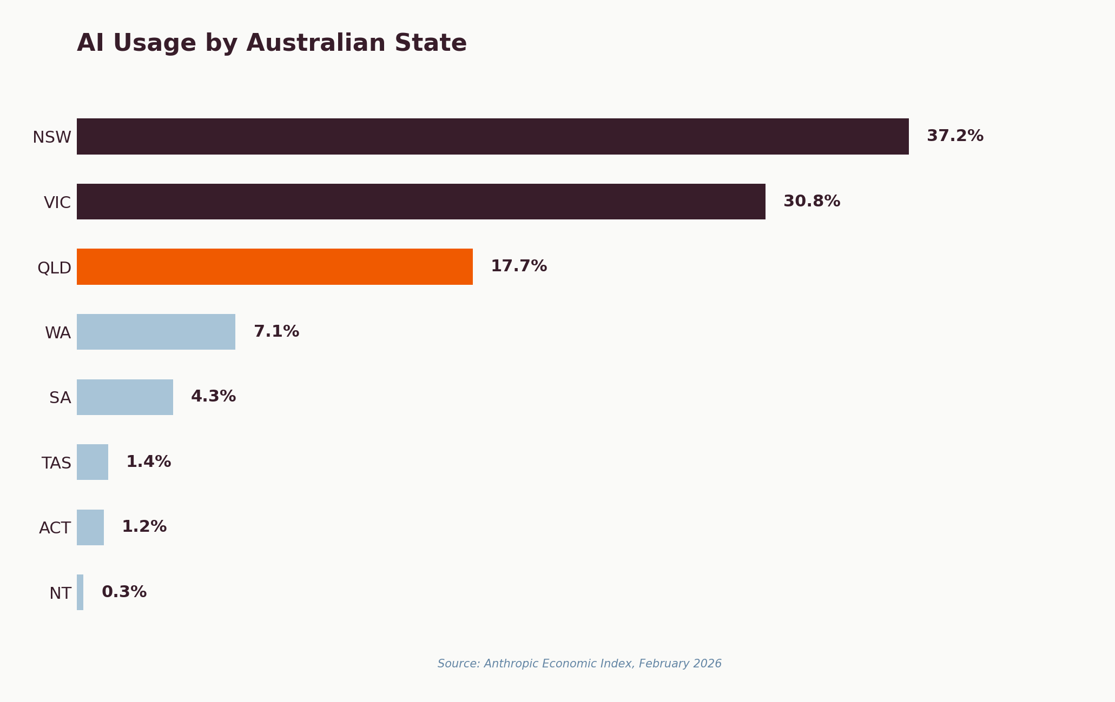
Figure 1: AI usage by Australian state/territory. Source: Anthropic Economic Index, February 2026.
The implication for Queensland businesses is clear: the state is already a significant AI market, but relative to population, adoption has room to grow.

What Australians Actually Use AI For
The most striking finding is what Australians are not using AI for. Coding is 8 percentage points below the global baseline. Instead, Australians over-index on business operations:
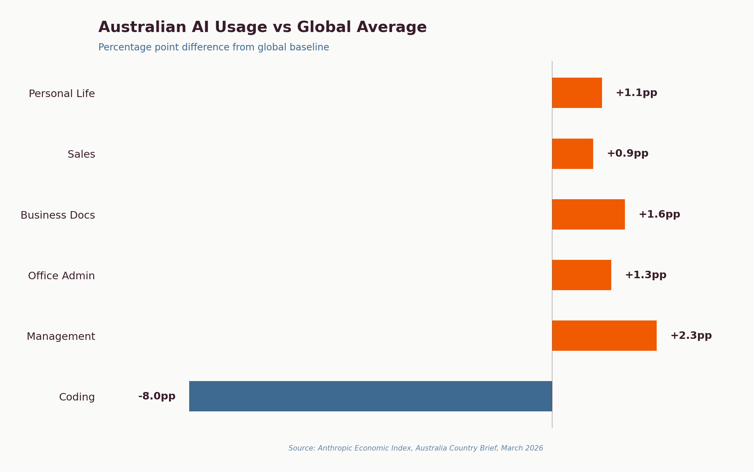
Figure 2: Australian AI usage vs global average. Source: Anthropic Economic Index, March 2026.
This profile reveals that Australian AI adoption is fundamentally a business operations story. The businesses driving adoption aren't tech companies writing code — they're services firms, health practices, tourism operators, and professional services businesses.

What We're Seeing on the Ground
This pattern maps directly to client engagements across the Sunshine Coast and SEQ. A talent management agency's real value wasn't AI-generated content — it was systematising candidate screening, compliance workflows, and client reporting. An exercise physiology clinic's biggest win was automating the phone-call-to-booking pipeline consuming 15+ hours per week.
An insurance brokerage described their current systems as 'prehistoric.' They weren't looking for cutting-edge research — they needed someone to connect their existing tools and build workflows their team could actually use.
"Australian usage is more diverse than the global aggregate, almost entirely because of a lower share of coding-related work; offsetting gains are spread across office, sales, management, and personal life categories."
— Anthropic Economic Index, Australia Country Brief, March 2026

2. What Australian SMBs Are Actually Struggling With
Between July 2025 and March 2026, Tech Horizon Labs collected structured responses from 54 Australian small business owners across workshops, the Noosa Council Business Boost program, and AI readiness assessments. Respondents span 15+ industries.

The Top Five Pain Points
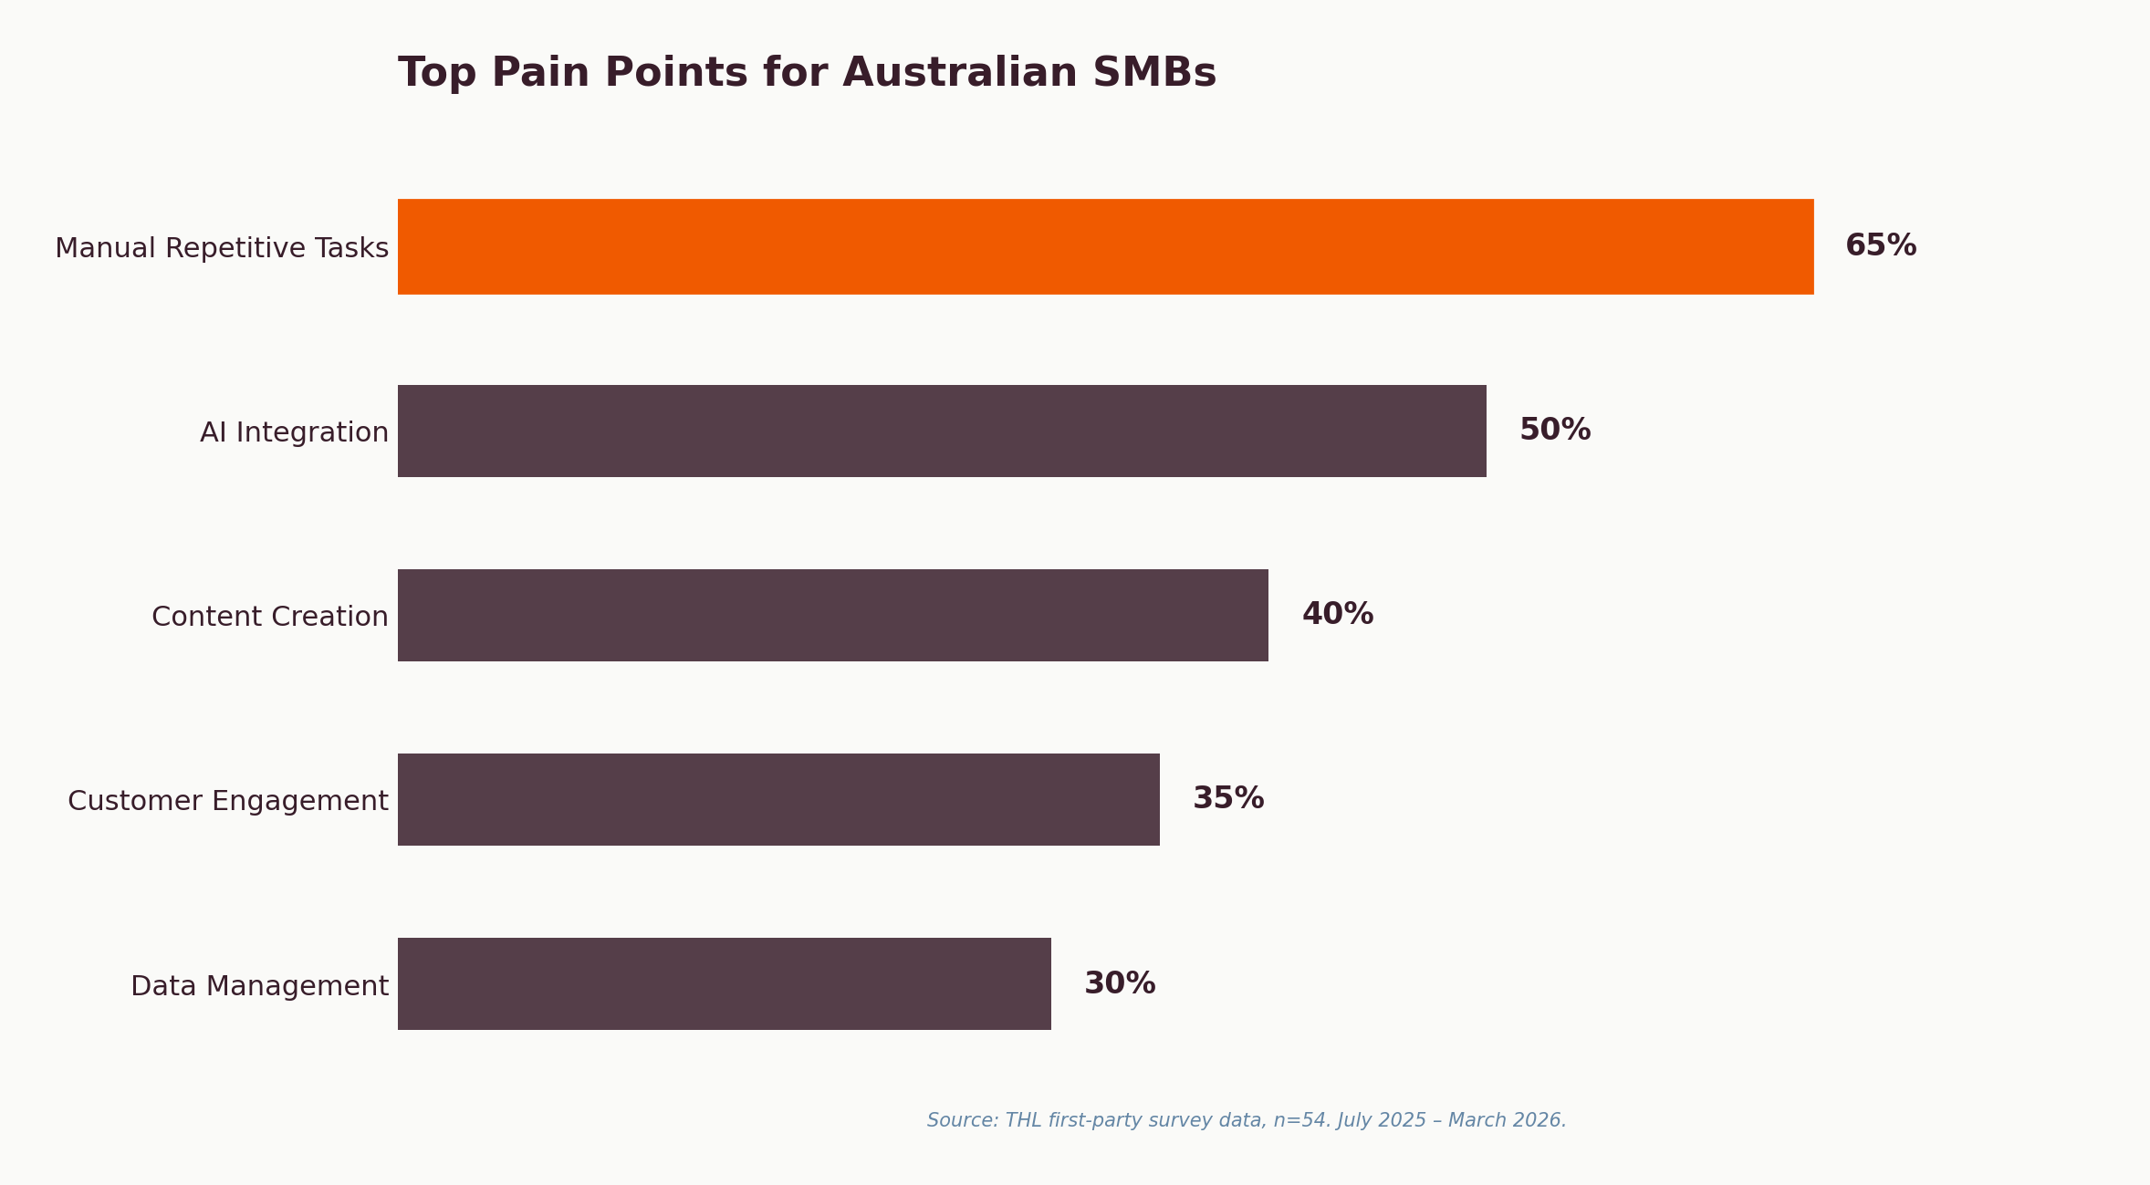
Figure 3: Pain point distribution. n=54. THL first-party survey data, July 2025 – March 2026.
The number one pain point — manual repetitive tasks — aligns precisely with the Anthropic data showing Australian businesses over-indexing on administrative AI usage. The second and third pain points reveal the real bottleneck: integration and expertise.
We see this consistently. An engineering firm owner spends hours writing proposals that follow the same structure every time. A fitness business owner sent us a Loom video walking through every manual task in her clinic and asked 'which of these can AI actually do?' The answer: most of them.
61%
of Australian SMBs using AI are stuck in the 'ChatGPT Plateau' — using AI for ad hoc tasks without systematic integration into business processes.

Industry Distribution
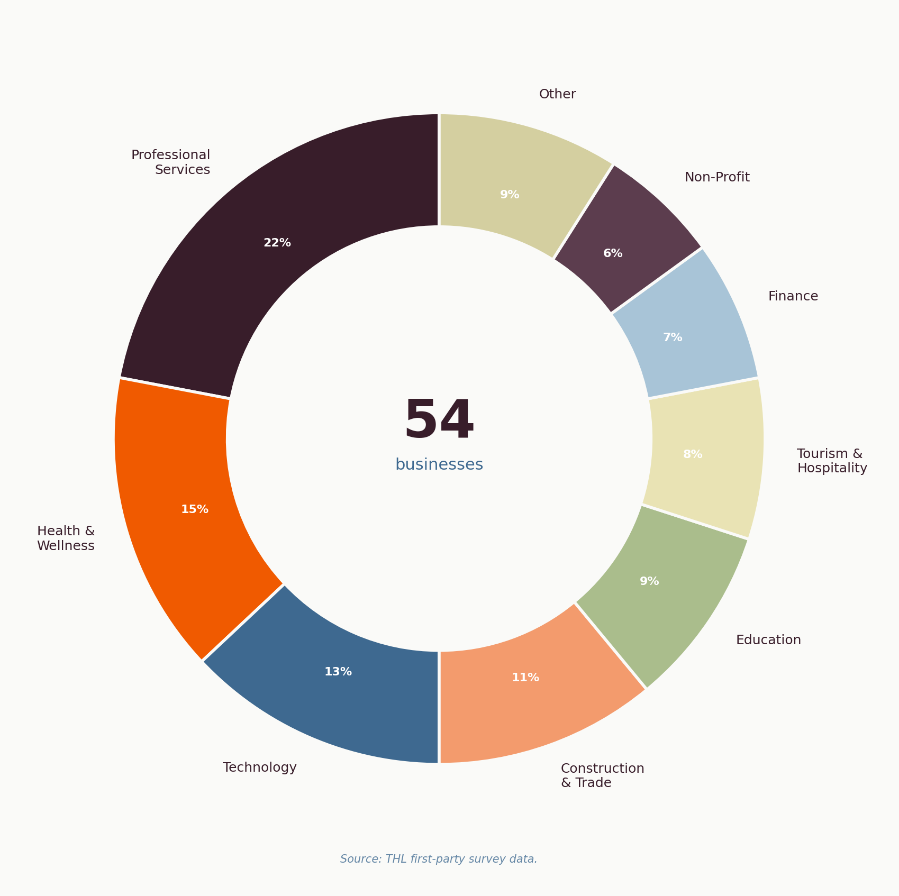
Figure 4: Industry distribution of THL survey respondents. n=54.
The consistent theme across all verticals: these are operational challenges, not technology challenges. From a hydraulic lift company migrating from ChatGPT to Claude for compliance workflows, to a non-profit building cyber resilience strategy — every industry has the same core need.

The Adoption Gap by Business Size
The gap between micro and medium businesses is stark. Deloitte's research shows 90% of medium businesses (51-200 staff) will use AI by 2026, compared to just 18% of micro businesses. This is where the competitive divide is widening fastest.
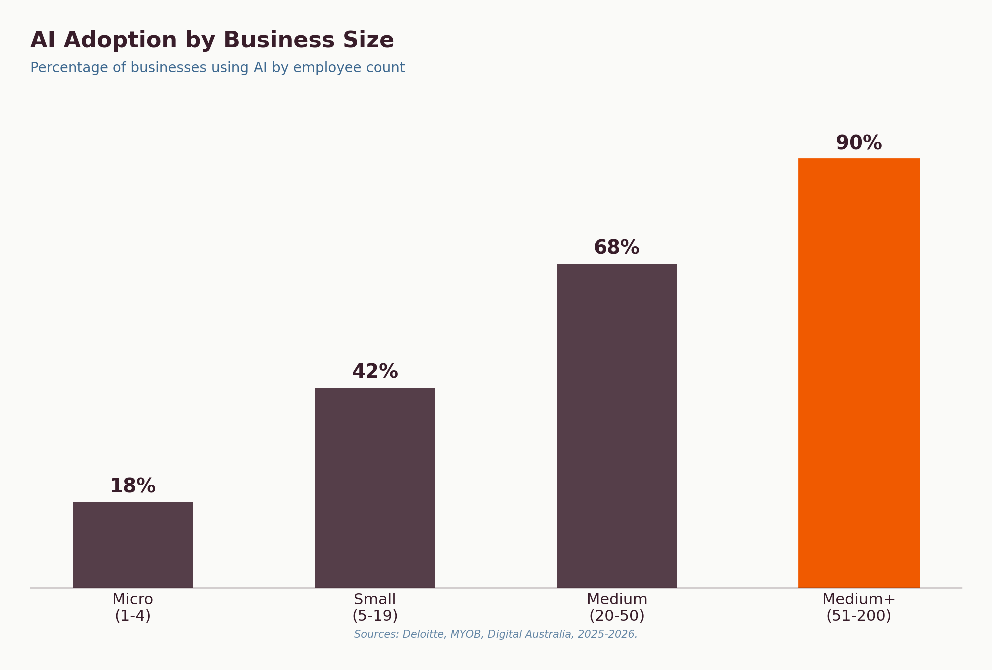
Figure 5: AI adoption by business size. Sources: Deloitte, MYOB, Digital Australia, 2025-2026.
60%
of small businesses now use AI — more than double the share in 2023. But adoption doesn't equal integration. AI agents are now accessible to businesses with as few as 5 employees at $20/month per agent.

3. AI Models Are Now Doing Real Work
The GDPval benchmark (OpenAI, October 2025) provides the most rigorous evaluation to date of how AI performs on real-world, economically valuable professional tasks.

The Headline Numbers
- 1,320 real-world tasks across 44 occupations and 9 sectors, created by experts averaging 14 years of experience.
- 47.6% win rate for Claude Opus 4.1 against human experts in blind pairwise comparisons.
- Average task duration: 7 hours for an expert. These include financial analysis, compliance reviews, client proposals, and project documentation.
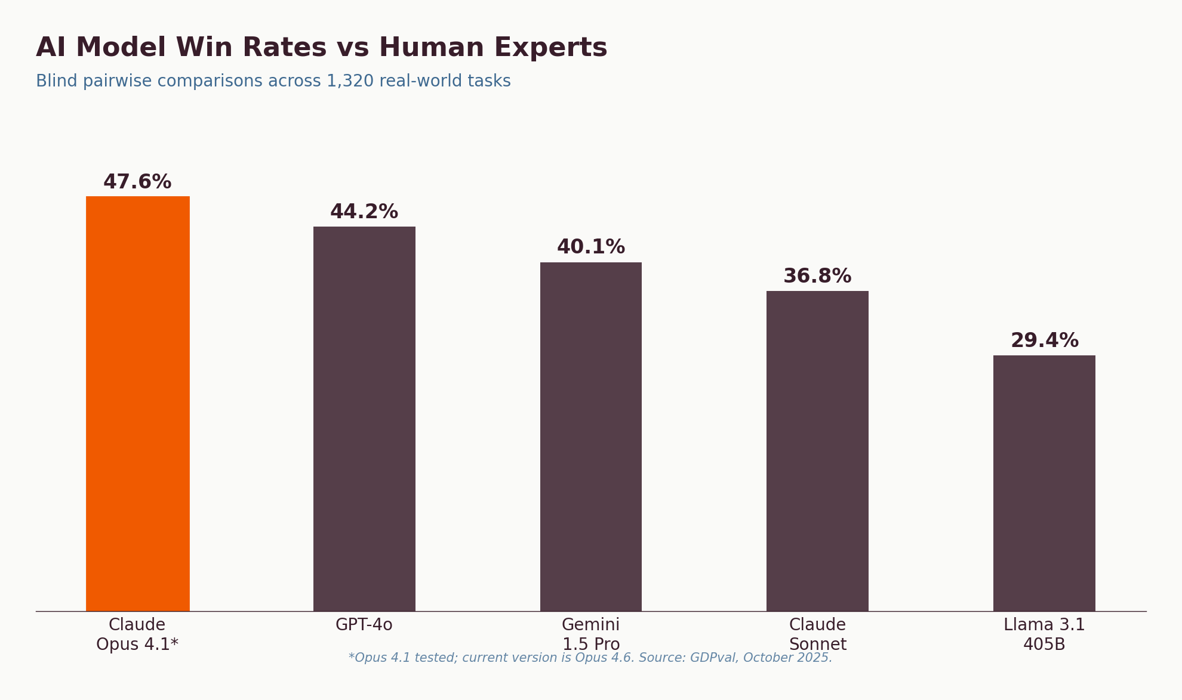
Figure 6: AI model win rates vs human experts (GDPval, Oct 2025). *Opus 4.1 tested; current version is Opus 4.6.
Important context: GDPval tested Claude Opus 4.1 (October 2025). The current version is Opus 4.6 — multiple generations of improvement. The 47.6% figure represents a floor of current capability. Claude now holds 32% enterprise market share (2026).

The Collaboration Pattern
Both Anthropic and GDPval data point to the same conclusion: AI works best as a collaborator. Australia's low autonomy score (3.38/5) shows professionals maintain decision-making control while using AI to accelerate execution. A 'try it, fix if needed' workflow delivers speed and cost improvements simultaneously.
2.7 hours
Average estimated time to complete an Australian Claude user's task without AI — 20% shorter than the global average. Australians are already targeting practical, time-saving applications.

4. The Readiness Gap: Where Most Businesses Get Stuck
Our data reveals a clear pattern. Most businesses follow a predictable trajectory — and most get stuck at the same point.

The Four Stages of SMB AI Adoption
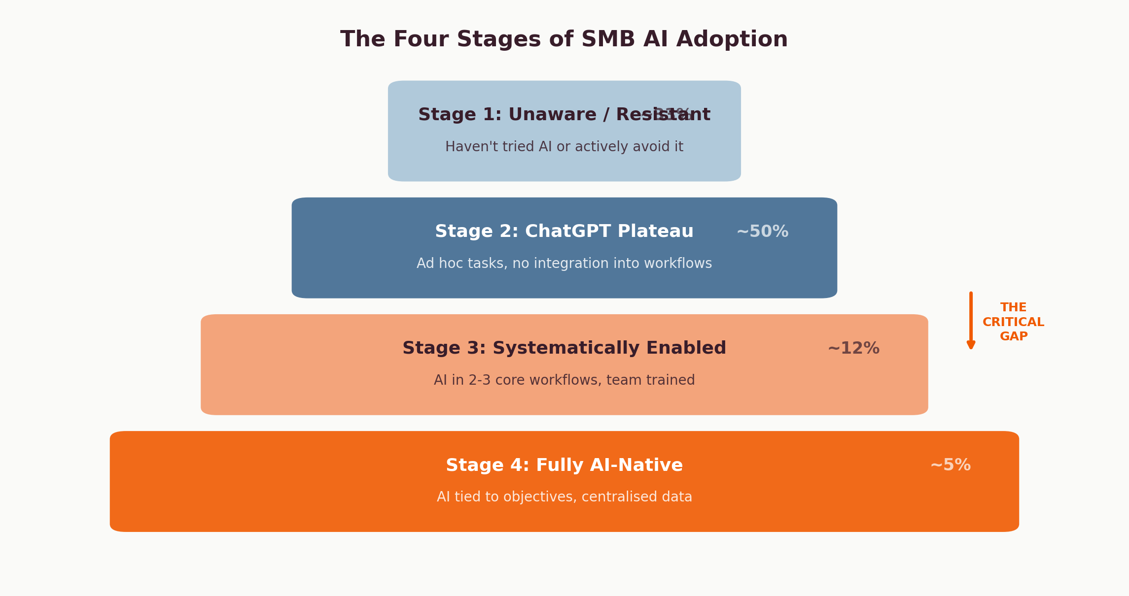
Figure 7: The four stages of SMB AI adoption. The critical gap is between Stage 2 and Stage 3.

Stage | Description | % of Market (est.) | Key Barrier
1. Unaware / Resistant | Haven't tried AI or actively avoid it | ~33% | Mindset / awareness
2. ChatGPT Plateau | Ad hoc tasks, no integration | ~50% | Integration knowledge
3. Systematically Enabled | AI in 2-3 core workflows, team trained | ~12% | Scaling / governance
4. Fully AI-Native | AI tied to business objectives, centralised data | ~5% | Continuous improvement

The Profitability Case
Deloitte Access Economics quantified what moving between these stages is worth. The profitability increases are not incremental — they're exponential:
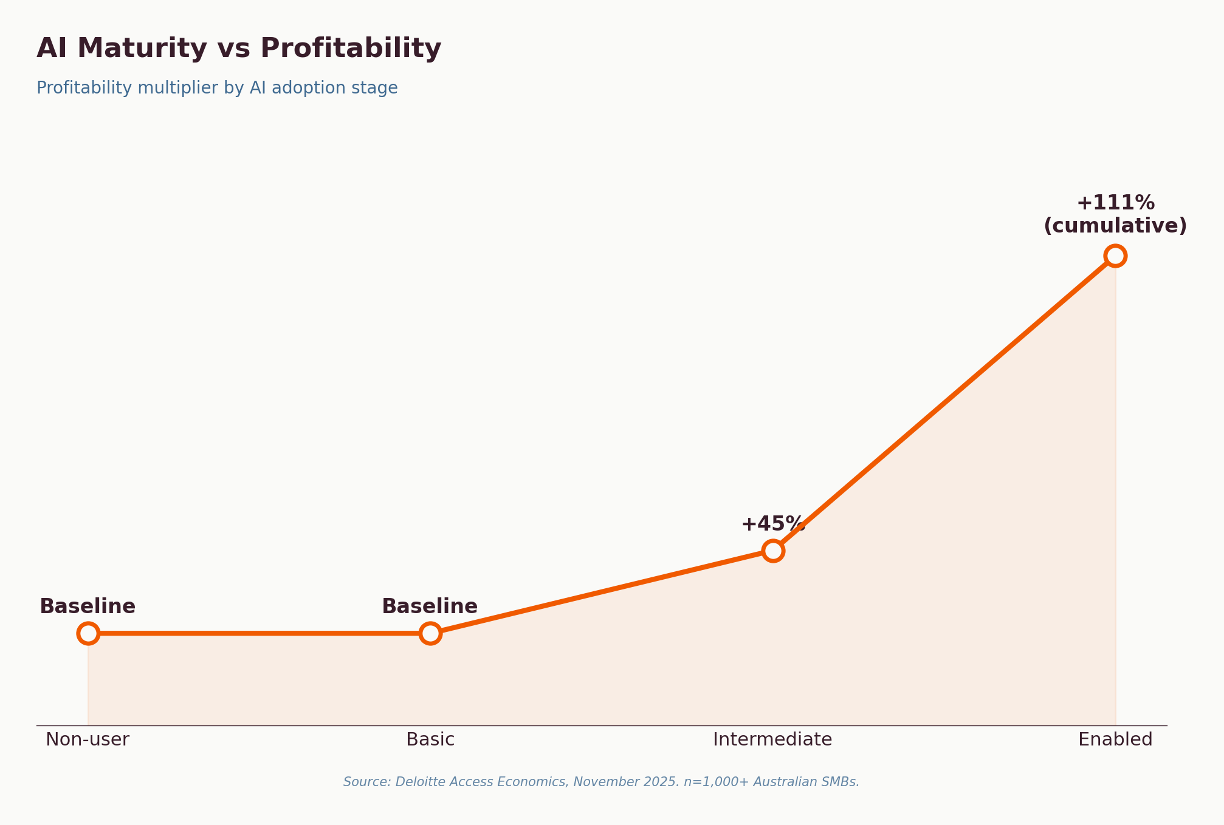
Figure 8: AI maturity vs profitability. Source: Deloitte Access Economics, November 2025.
A business moving from basic to intermediate AI use sees a 45% profitability increase. Moving from intermediate to enabled delivers 111%. This isn't theoretical — it's measured across 1,000+ Australian SMBs.

What's Blocking the Transition
The barriers are consistent globally and locally:
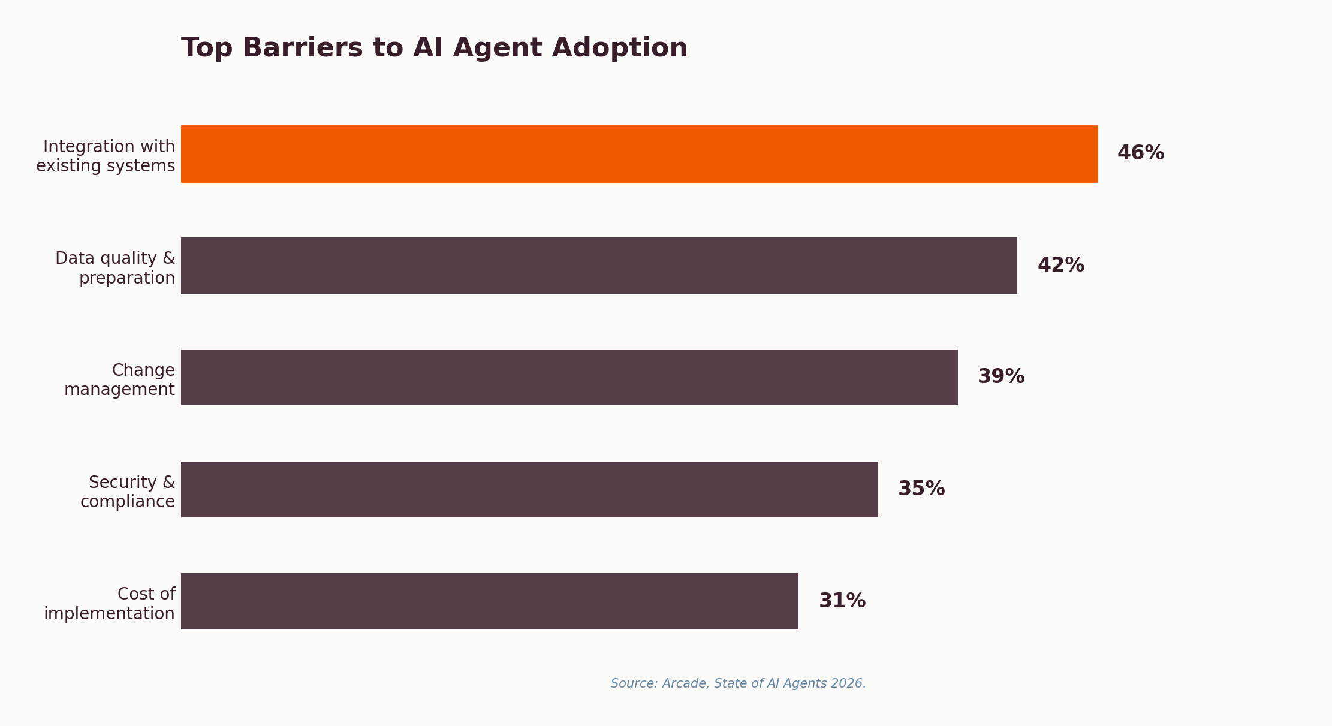
Figure 9: Top barriers to AI agent adoption. Source: Arcade, State of AI Agents 2026.
Integration with existing systems tops the list at 46%. This maps exactly to our survey data where 50% cited 'struggling to integrate AI into workflows.' The barrier is not awareness, cost, or willingness — it's the technical gap between knowing AI exists and making it work in a 10-person business.
"The AI divide is real and widening. Large enterprises have data science teams and AI at scale. SMBs — the backbone of the economy — are struggling to start."
— Tech Horizon Labs, The AI Divide, 2026

5. The New AI Tech Stack
The technology landscape is undergoing its most significant structural shift since the move to cloud computing. Understanding the new architecture is essential for any business making technology decisions in 2026.

The Stack Collapse
Between January 2025 and February 2026, approximately $2 trillion in market capitalisation evaporated from the software sector — the largest non-recessionary drawdown in 30 years. In a single week in February 2026, $1 trillion was wiped from software stocks. The trigger: AI agents are absorbing the functionality that traditional SaaS tools were built to deliver.
Microsoft CEO Satya Nadella declared that 'applications as we know them are going away in favour of agents.' When AI agents can execute complex workflows independently — drafting proposals, managing pipelines, handling compliance — companies need significantly fewer software licences. This breaks the per-seat pricing model that powered SaaS industry growth. IDC predicts 70% of software vendors will abandon pure seat-based pricing by 2028.

The Agentic Evolution Timeline
IDC's 'Agentic Evolution of Enterprise Applications' forecast (February 2025) maps the trajectory that every business will navigate. The shift isn't sudden — it's a 12-year transition from traditional software to fully autonomous agents. But the critical preparation window is now.
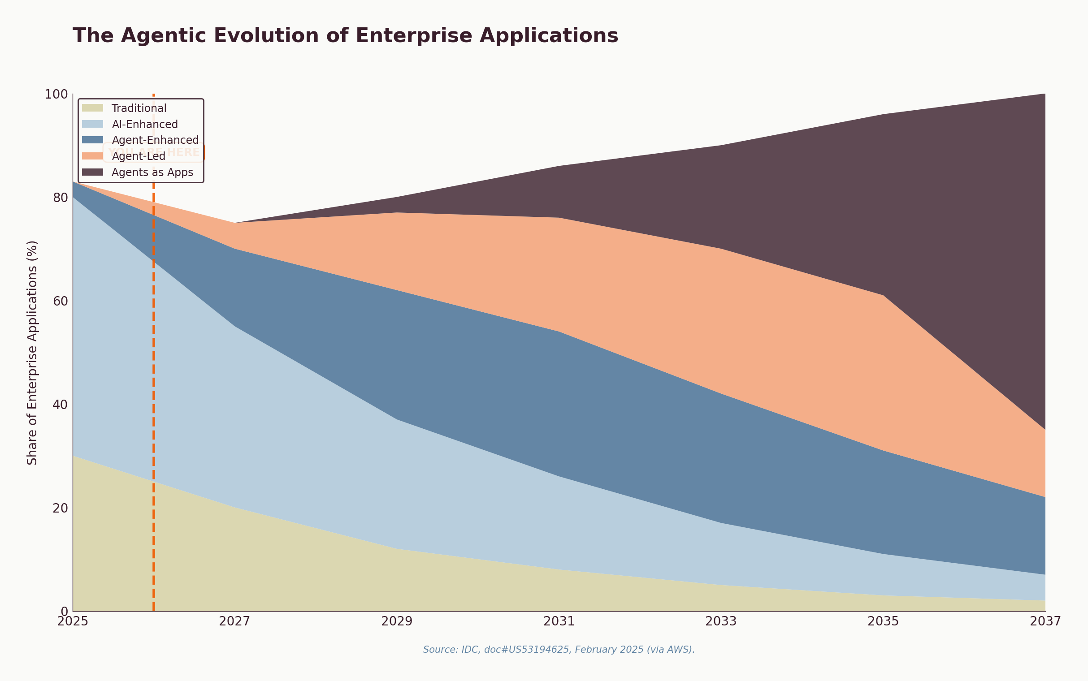
Figure 10: The agentic evolution of enterprise applications. Source: IDC, doc#US53194625, Feb 2025.
Phase | 2025 Share | 2027 Projection | What It Means for SMBs
Traditional | 30% | 2% | Standalone software with no AI. Rapidly shrinking.
AI/Ad-Enhanced | 50% | 5% | Current state for most SMBs — AI assists but doesn't act. Being absorbed.
Agent-Enhanced | 3% | 15% | AI takes actions within defined boundaries. Where leading SMBs are moving now.
Agent-Led | 0% | 13% | AI handles multi-step workflows with human oversight. The 2028-2031 frontier.
Agents as Apps | 0% | 65% | Fully autonomous software agents. The dominant model by 2037.

For a 10-50 person business, the practical takeaway is clear: the transition from 'AI-Enhanced' (where most sit today) to 'Agent-Enhanced' is the critical move of 2026-2028. Businesses that build agent-ready infrastructure now — structured data, connected systems, trained teams — will be positioned for each subsequent phase. Those that wait will face increasingly expensive catch-up.

The Three-Layer Stack
Bain & Company's 2025 Technology Report defines the new architecture as three layers:
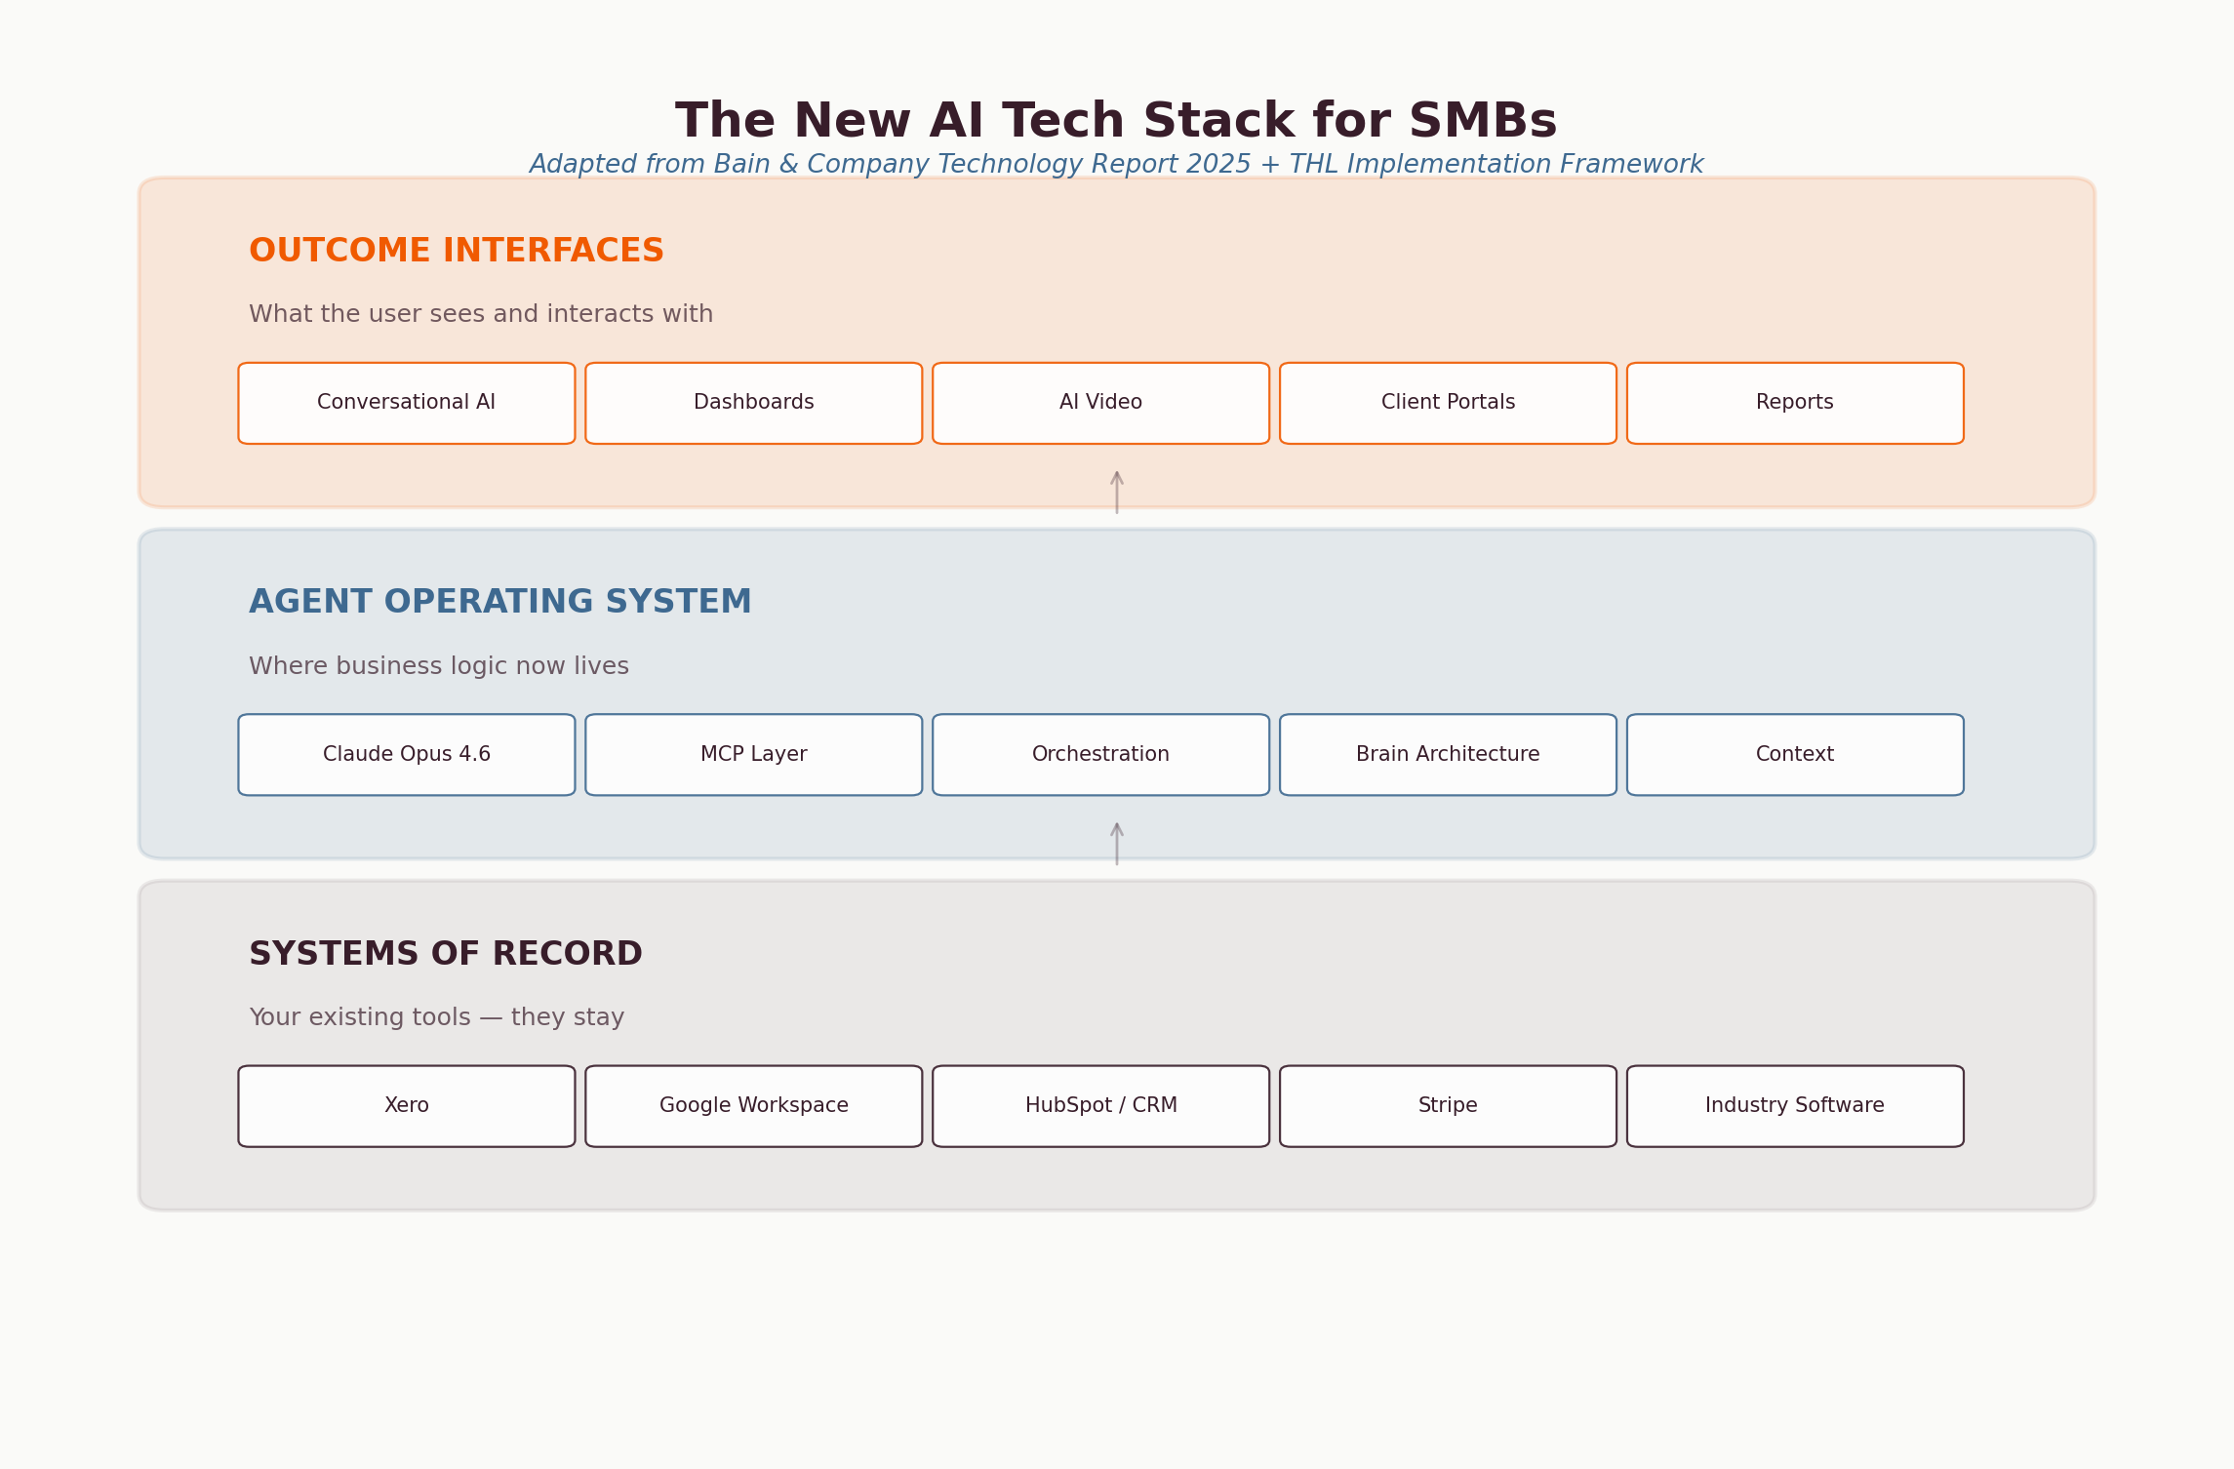
Figure 11: The new AI tech stack. Adapted from Bain & Company Technology Report 2025 + THL implementation framework.
Layer 1: Systems of Record
Your existing tools — Xero, HubSpot, Google Workspace, Stripe, industry-specific software. These store core data and enforce business rules. They don't go away; they become the data foundation that AI agents read from and write to.
Layer 2: Agent Operating System
This is where business logic is moving. Instead of living inside individual SaaS tools, business rules now live in an AI layer powered by foundation models like Claude Opus 4.6. This layer orchestrates work by planning tasks, maintaining context, and invoking tools through protocols like Anthropic's Model Context Protocol (MCP). For SMBs, this means a single AI system can manage CRM updates, email drafts, financial analysis, and document generation — work that previously required separate tools and manual handoffs.
Layer 3: Outcome Interfaces
What the user sees: conversational AI interfaces, automated dashboards, AI-generated video and content, client portals. The shift is from 'I need to learn 10 different tools' to 'I tell the AI what outcome I need and it handles the execution across all my tools.'

What This Means for Your Business
For a 10-person Sunshine Coast business running Xero, HubSpot, Canva, and Gmail, the practical implication is:
- Your existing tools stay. Systems of record aren't being replaced — they're being connected through an AI layer.
- Business logic moves to AI. Instead of manually moving data between systems, AI agents handle the orchestration.
- Integration becomes the product. The value isn't in any single tool — it's in how they're connected and automated.
- You need architecture, not just tools. The businesses winning aren't buying more software — they're building a coherent AI system.

MCP: The Infrastructure Standard That Won
Every AI agent architecture needs a way to connect to external tools — your CRM, email, calendar, accounting software. This is the integration layer, and in 2026 a clear winner emerged: Anthropic's Model Context Protocol (MCP).
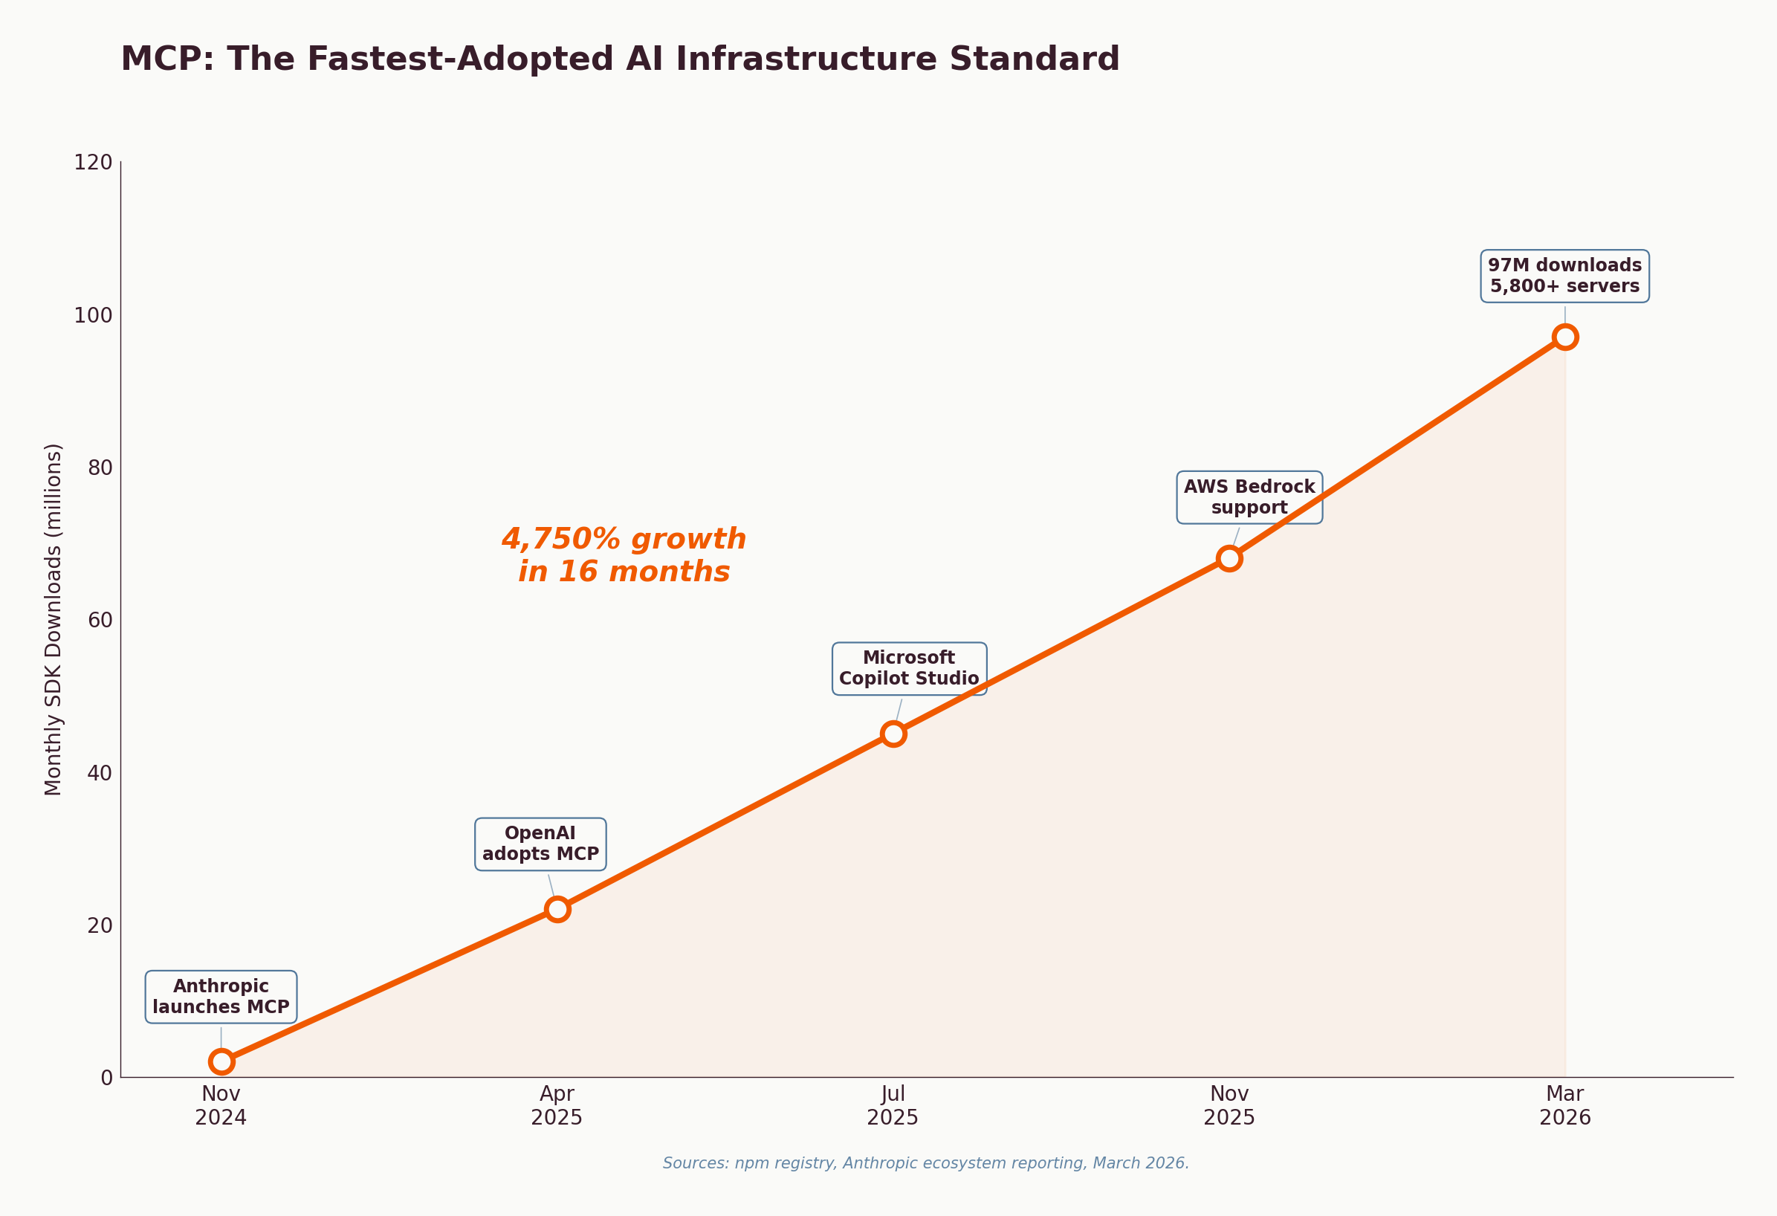
Figure 12: MCP monthly SDK downloads. Sources: npm registry, Anthropic, industry reporting.
MCP hit 97 million monthly SDK downloads by March 2026 — growing 4,750% in 16 months. The adoption curve mirrors foundational infrastructure protocols like REST APIs and npm itself. With 5,800+ MCP servers in the ecosystem, the integration work for most business applications is already done.

What This Means Practically
- Your tools are already connected. If you use Slack, Google Workspace, Stripe, HubSpot, Xero — MCP servers already exist for these. The plumbing is built.
- You don't need to build integrations. MCP eliminates the custom API integration work that previously made AI agent deployment expensive for SMBs.
- The ecosystem is production-ready. This isn't beta software. Major providers including OpenAI, Google, Microsoft, and AWS all ship MCP-compatible tooling.
- Preparation matters. At Tech Horizon Labs, we help clients prepare for and deploy MCP-based agent architectures where they make sense — alongside direct connectors and other integration patterns from Google Cloud and AWS. The right approach depends on your specific systems and goals.
97 Million
Monthly MCP SDK downloads as of March 2026. With 5,800+ servers covering most business applications, the AI agent integration layer is no longer a bottleneck — it's a solved problem.

6. The AI Agent Architecture for SMBs
What does a systematically AI-enabled small business actually look like? Based on our implementation framework — adapted from Daniel Drescher's 'Thinking in Layers and Aspects' — we decompose the system into what the business needs (Application Layer) and what delivers it (Implementation Layer).
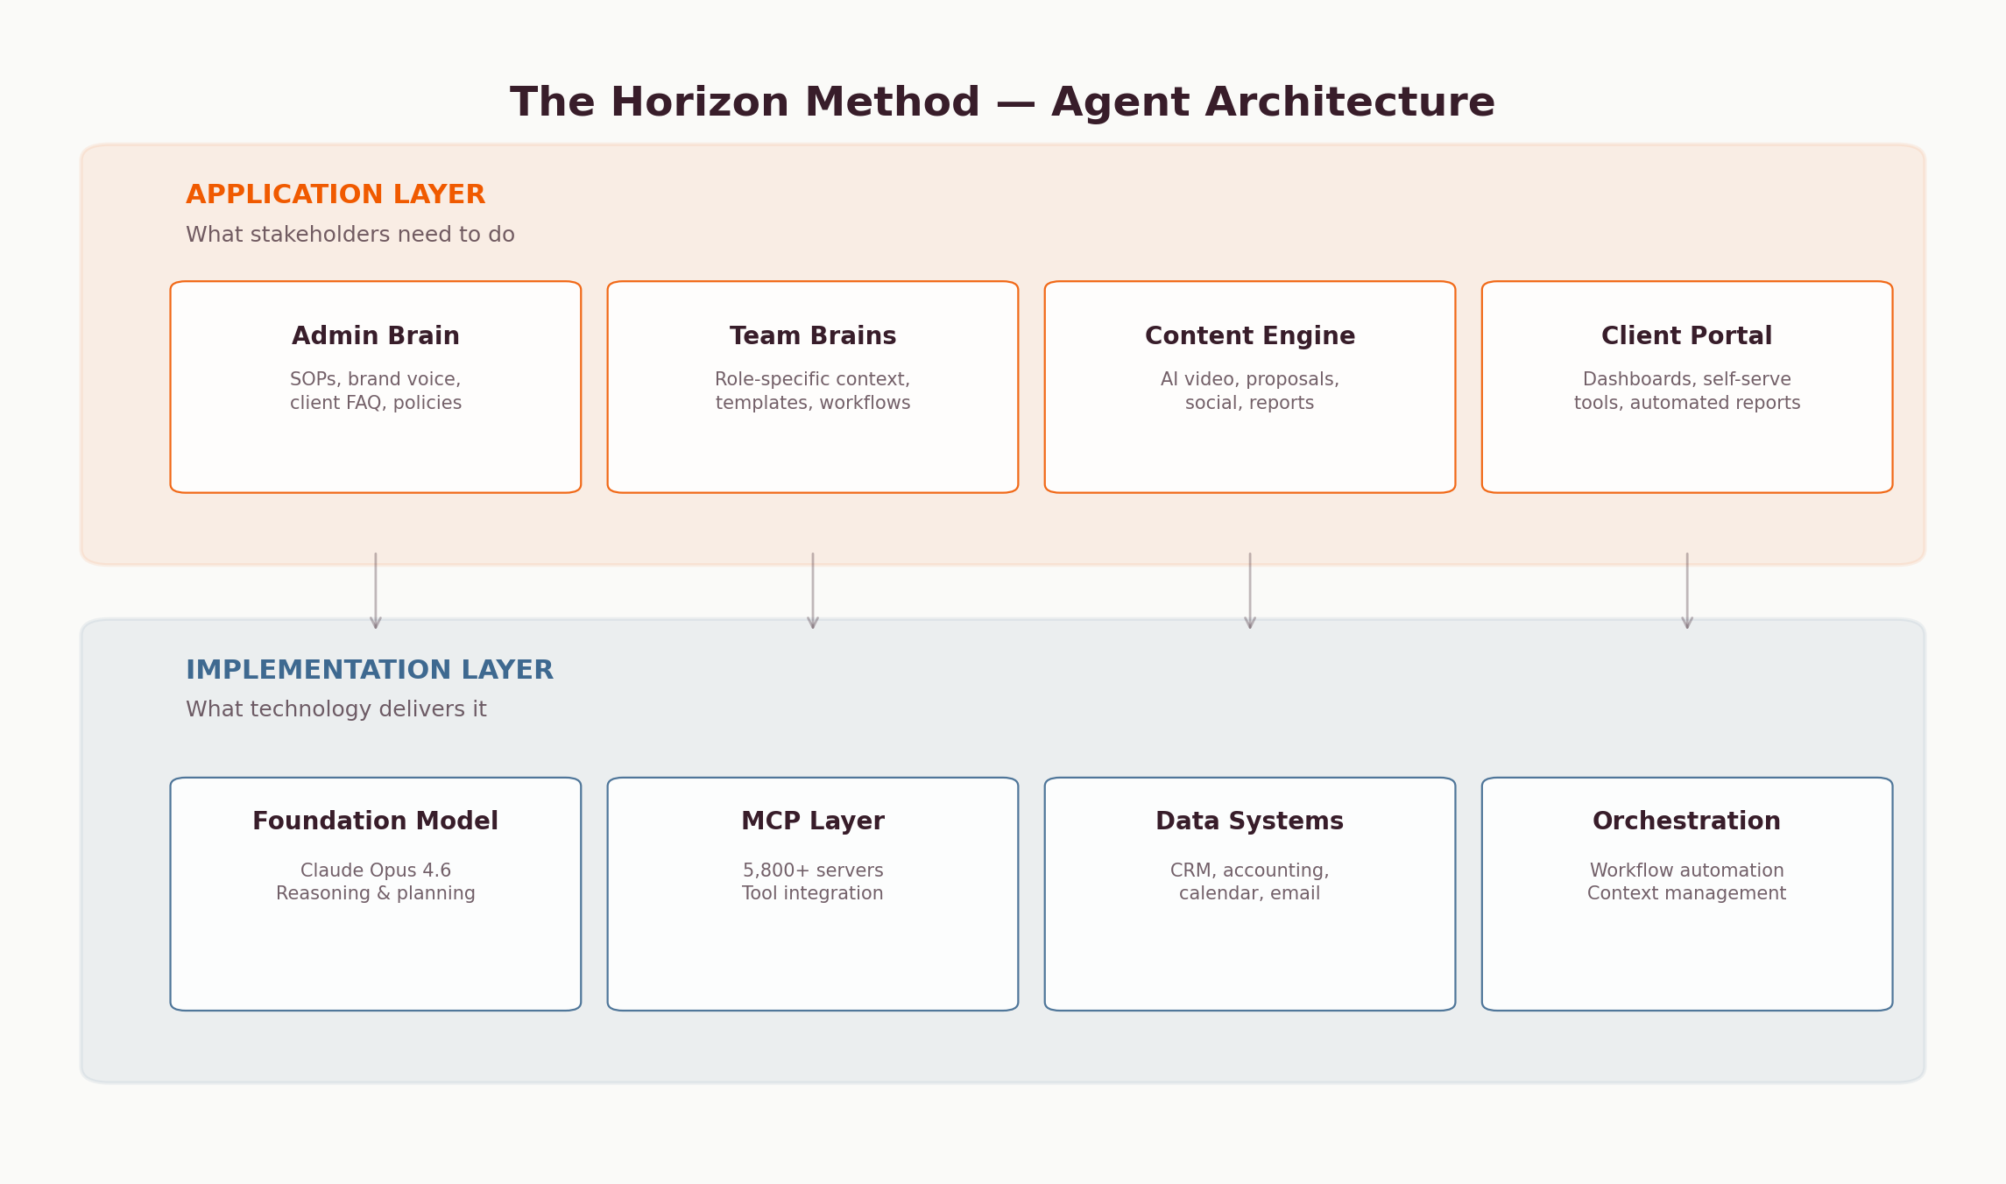
Figure 13: The Horizon Method agent architecture. Application Layer (what you need) → Implementation Layer (what delivers it).

The Brain Architecture
At the core of every AI-enabled SMB is what we call the Brain Architecture — a structured knowledge system that gives AI the context it needs to be useful:
Admin Brain
The company's central knowledge base: brand voice, SOPs, client FAQ, product catalogues, team structure, policies. This is the foundation — without it, AI generates generic output. With it, AI generates output that sounds like your business.
Team Brains
Role-specific contexts built on top of the Admin Brain. A sales brain has proposal templates, pricing logic, and competitor intel. An operations brain has workflow triggers, approval chains, and client onboarding sequences.

Content Engine
AI-powered content production across all formats. This is where tools like Agent Opus enter the picture — taking the structured knowledge from your Brain Architecture and producing professional video content, proposals, reports, and social media posts at scale.
Client Portal
The external-facing layer: automated reports, dashboards, self-serve tools. This is the outcome interface that clients see — powered by the agent layer working behind the scenes.

The Drescher Framework Applied
For each stakeholder in your business, we map two dimensions:
Layer | Question | Example (Health Practice)
APPLICATION | What does this person need to DO? | Book appointments, manage follow-ups, generate compliance reports, nurture client relationships
IMPLEMENTATION | What technology delivers it? | Claude Opus 4.6 + MCP → Google Calendar, Practice Management System, Medicare integration, automated email sequences

Then for each layer, we evaluate functional aspects (what the system does) and non-functional aspects (how well it does it — speed, reliability, security, ease of use). This gives every business a clear, structured view of where AI fits and what it replaces versus augments.
Gartner forecasts that 40% of SMBs will deploy at least one AI agent by end of 2026, up from ~8% in early 2025. Already, 73% of SMBs that adopted AI agents in 2025 reported measurable productivity gains within 90 days. The agentic AI market is projected to grow from $7.8 billion to over $52 billion by 2030. The businesses that build this architecture now are building a competitive moat.

7. The AI Content & Video Layer
The most visible output of an AI-enabled business is content — and the content layer is evolving faster than any other. AI video generation in particular has crossed a critical threshold for SMBs.

The AI Video Market
The AI video generation market reached $788 million in 2025, growing at 19% CAGR toward $3.4 billion by 2034. But the headline numbers understate the practical impact: 89% of businesses now use video as a marketing tool, and AI is collapsing the cost and time to produce it.
Metric | Traditional Video | AI-Generated Video | Savings
Production time | 40-60 hours | 2-4 hours | 14 hours avg saved per project
Cost per video | $2,000-5,000+ | $50-500 | ~$1,500 avg savings
Time to first draft | 1-2 weeks | Minutes | 60-80% reduction
Skill required | Video production team | Text prompt + brand assets | No specialist needed

How It Works: The Four-Layer Prompt Framework
AI video tools like Agent Opus combine 8+ video generation engines, automatically selecting the optimal model for each scene. The quality of output depends on the quality of input — and this is where most SMBs get stuck. The framework:
- Layer 1 — Topic + Format: What the video is about and what type (explainer, thought leadership, promotional, news). Specific beats vague every time.
- Layer 2 — Audience + Tone: Who's watching and how it should feel. 'Australian business owners 35-55, curious about AI but not technical' produces very different output than 'make it professional.'
- Layer 3 — Source Material: The single biggest quality lever. A full script or blog post as input produces dramatically better results than a topic description. This is where the Brain Architecture pays off — your SOPs, case studies, and frameworks become video scripts.
- Layer 4 — Style + Constraints: Duration targets, visual style, specific phrases to include or avoid, brand assets to reference.

The Content Flywheel
For SMBs, the real power of AI content isn't any single video or post — it's the flywheel effect when structured knowledge meets AI generation:
- Research report → 10+ LinkedIn posts (each data point is a post), 3-5 short videos, a workshop outline, and a gated lead magnet.
- Client engagement → Anonymised case study → video testimonial script → social proof content.
- Workshop delivery → Recording → AI-edited clips → thought leadership video series → Academy content.
A single piece of structured content, fed through the Brain Architecture and the AI video layer, produces weeks of multi-format output. This is how a one-person consultancy competes with agencies that have dedicated content teams.
1 Report → 20+ Assets
This report has already generated 18 charts, a lead magnet, a workshop outline, 10+ social post angles, and a video script framework. Structured knowledge compounds. This is the content flywheel in action.
49%
of marketers worldwide now use AI for image and video generation daily. For SMBs without dedicated content teams, AI video is the equaliser. (HeyGen, 2026)

8. The Capability Overhang — and Why 'Saving Time' Is No Longer Enough
There is a growing gap between what AI systems can do and what businesses actually get from them. OpenAI calls this the 'capability overhang' — and it's the defining challenge of 2026. Power users report a 7x productivity multiplier over laggards who barely engage beyond occasional chat prompts. The difference isn't the tools. It's the integration, the context, and the mindset.
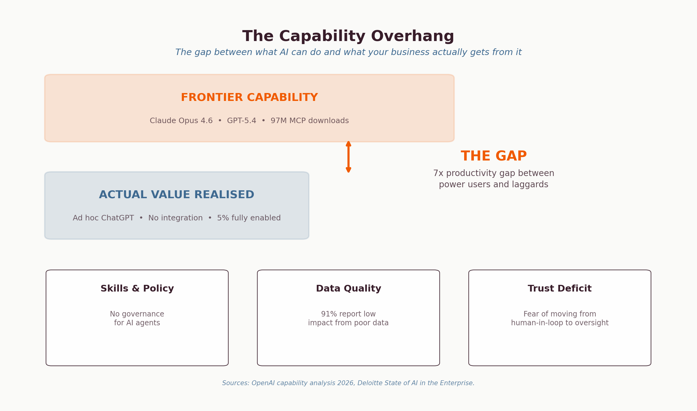
Figure 14: The capability overhang. Sources: OpenAI capability analysis, Deloitte State of AI in the Enterprise, 2026.

From Efficiency AI to Opportunity AI
The most important strategic shift of 2026 is the move from 'Efficiency AI' to 'Opportunity AI.' In 2025, the primary ROI metric was time-savings — it accounted for 19.9% of reported AI value. By early 2026, that share dropped to 13.6%. What replaced it? New capabilities — the ability to do things that were previously impossible — which jumped to account for 26% of ROI.
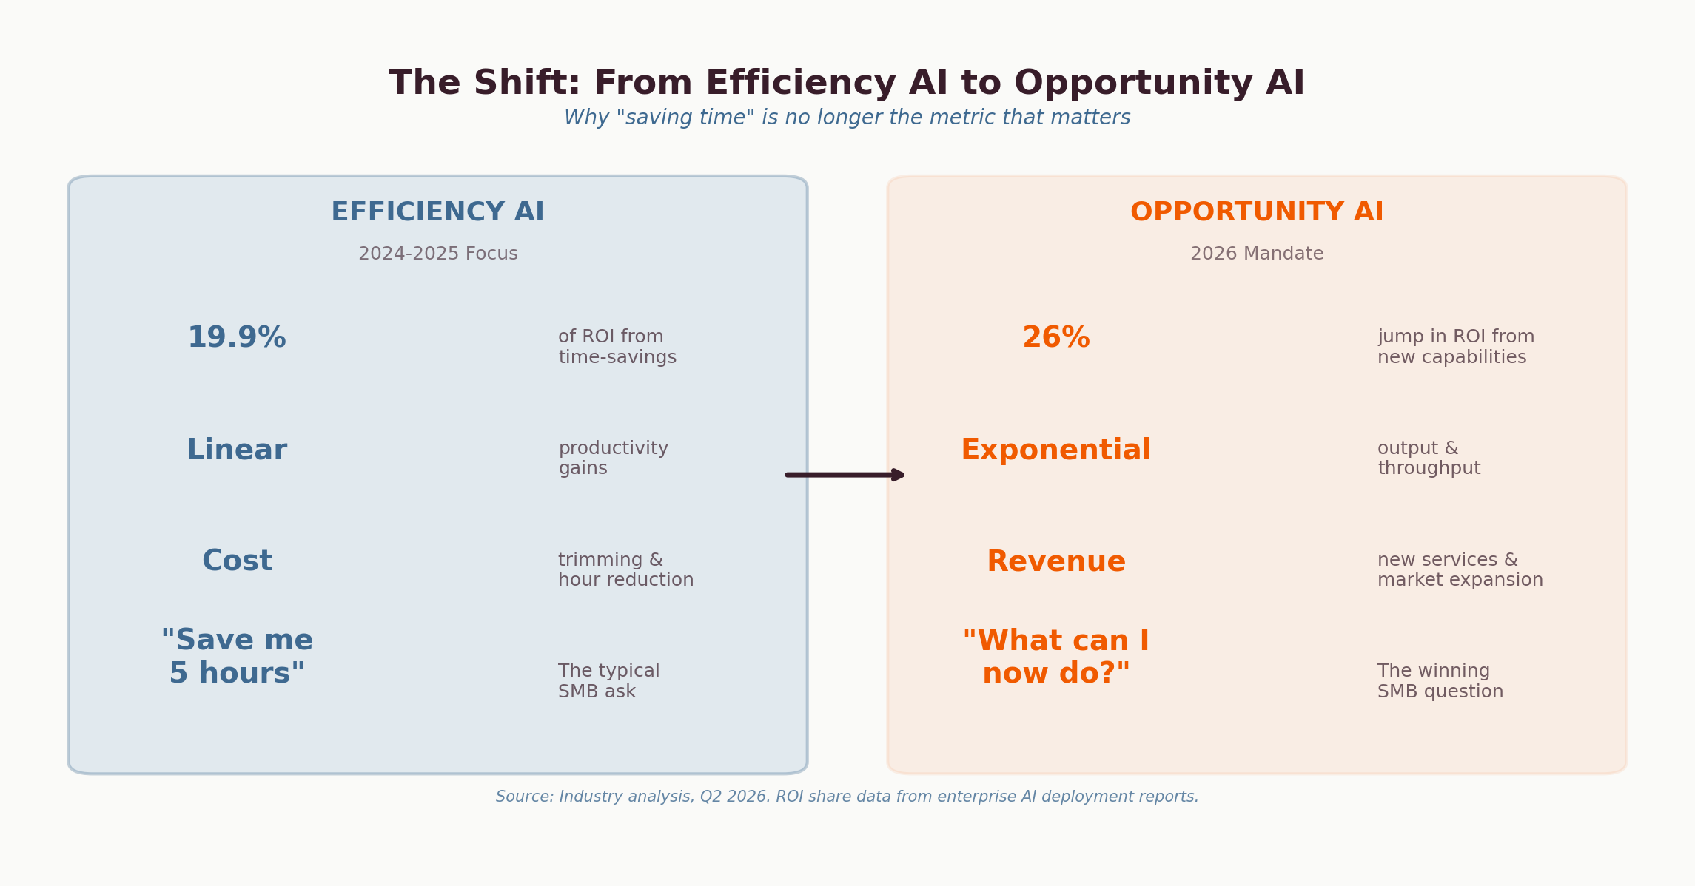
Figure 15: The shift from Efficiency AI to Opportunity AI. Source: Enterprise AI deployment reports, Q2 2026.
For a 10-person business, this reframe changes everything. The old question was 'How much time does AI save me?' The new question is 'What can I now do that I couldn't before?' A physiotherapy clinic that uses AI to automate booking saves 10 hours a week — that's efficiency. The same clinic using AI to generate personalised treatment plans, produce video content for patient education, and run a self-service client portal — that's opportunity. The revenue impact is an order of magnitude larger.

The Velocity of This Shift
The market data is unambiguous. Anthropic's annualized revenue hit $19 billion in March 2026 — growing over 10x year-on-year for three consecutive years. Claude Code alone reached $2.5 billion in annualized revenue, more than doubling since January 2026. These aren't speculative projections; they're reported financials. The infrastructure for AI-native business is being built at unprecedented speed.

$19 Billion
Anthropic's annualized revenue as of March 2026 — growing 10x annually for three consecutive years. Claude Code alone: $2.5B. The AI infrastructure market is no longer emerging. It's here.

Two Paths to Agent-Ready Business
The infrastructure for AI agents has matured into two complementary approaches. Understanding which path — or combination — suits your business is critical to closing the capability overhang.
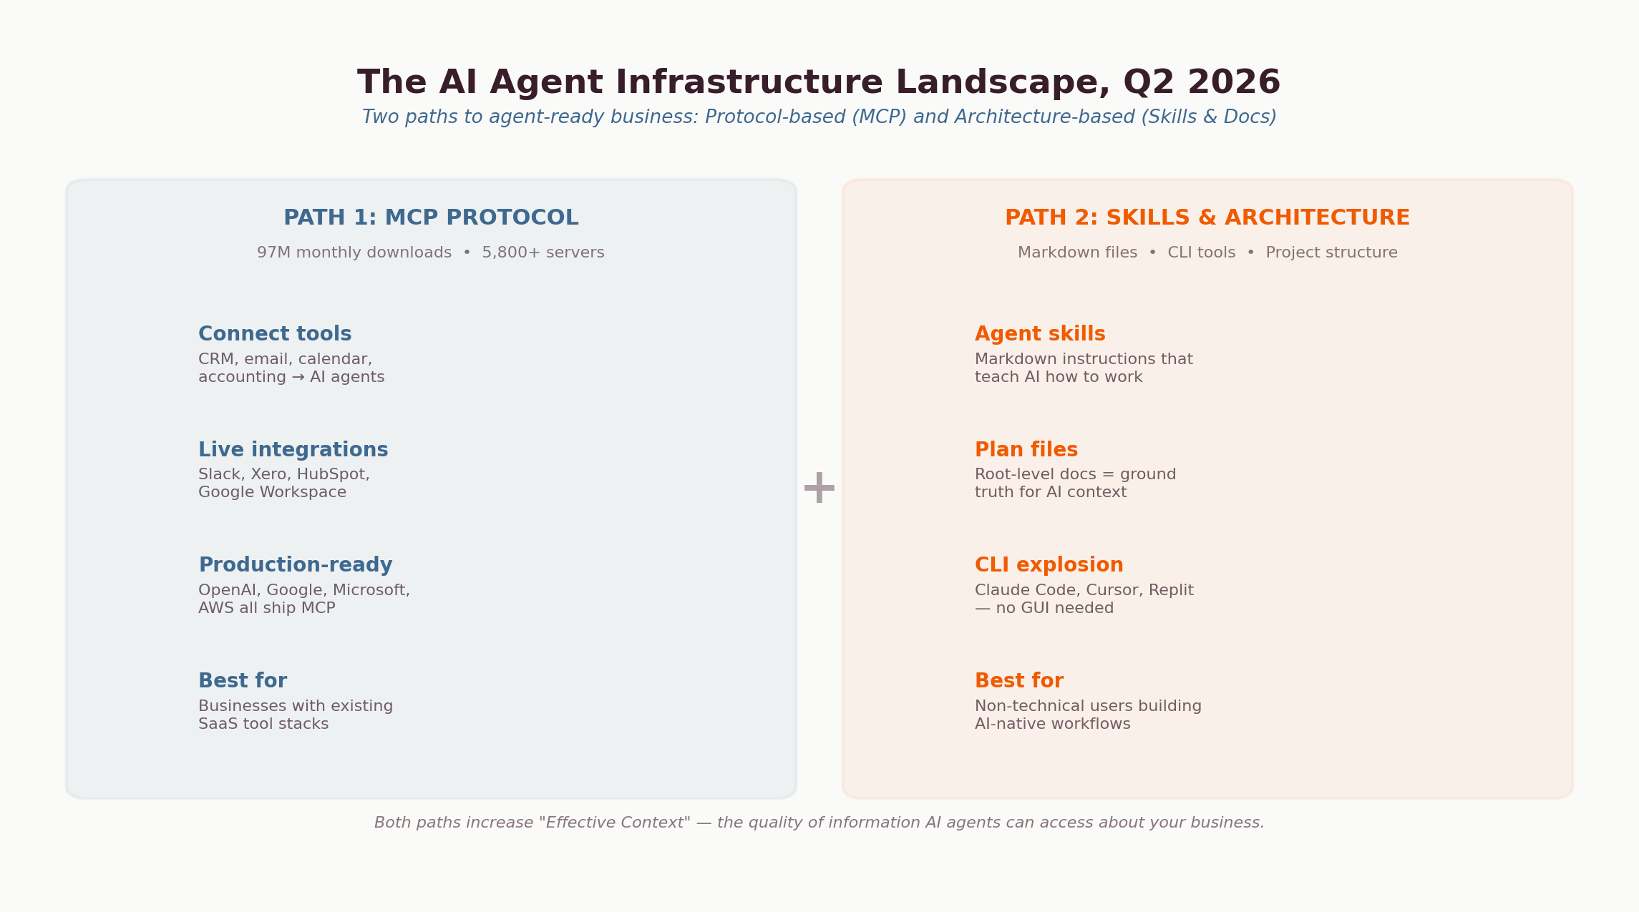
Figure 16: Two paths to agent-ready business: Protocol-based (MCP) and Architecture-based (Skills & Documentation).
Path 1: MCP Protocol
The Model Context Protocol connects your existing tools to AI agents through a standardised integration layer. If your business runs on Xero, HubSpot, Gmail, and Slack, MCP servers already exist for these tools. The plumbing is built. This path works best for businesses with established SaaS tool stacks that need to make their existing infrastructure AI-accessible.

Path 2: Skills & Project Architecture
The explosion of CLI-based AI tools — Claude Code, Cursor, Replit — has created a second path that doesn't require traditional integrations at all. Instead, it relies on structured documentation: markdown files that teach AI agents how your business works, 'plan files' at the root of your project structure, and skill definitions that encode your processes. This path is increasingly accessible to non-technical users and is especially powerful for businesses building workflows from scratch.
At Tech Horizon Labs, we deploy both approaches depending on the client's context. A business with 15 existing SaaS tools needs MCP to connect them. A solo consultant building an AI-native practice from the ground up might start with skills and project architecture. Most businesses end up using both — MCP for tool integration, skills for business logic and context.

The Jevons Paradox: Why AI Means More Work, Not Less
In 1865, economist William Stanley Jevons observed that making coal more efficient to use didn't reduce demand — it increased it dramatically. The same paradox applies to AI in 2026. As AI makes software and content 100x easier to produce, demand doesn't decrease — it increases by orders of magnitude. Businesses that build AI capability don't find themselves with less to do. They find entirely new categories of work that were previously uneconomical: personalised client communications at scale, real-time market analysis, custom internal tools, automated compliance monitoring.
"The goal is not headcount reduction. It is the total empowerment of your people to solve the hardest, most valuable problems of the 2026 economy. The AI-native business is not an automated one — it is a hyper-augmented one."
— Adapted from the AI-Native Engineering Blueprint, Q2 2026

9. The Training Gap — Why Most AI Education Fails to Deliver
Every report on AI adoption — including this one — recommends staff training. It appears in the top three recommendations from Deloitte, Gartner, and every industry body that publishes on this topic. But there is a problem hiding inside that recommendation: the quality of available AI training is, for most Australian SMBs, remarkably poor.

Two Broken Archetypes
The current AI training market is dominated by two archetypes, neither of which serves small businesses well.
The first is the business coach or digital strategist who has added 'AI' to their offering. They can speak to mindset, productivity, and business frameworks — but they lack the technical depth to evaluate which model is best for which task, how to structure prompts for complex workflows, or how to connect AI tools to existing business systems. Their training tends to stay at the surface: 'here's how to use ChatGPT for brainstorming.'
The second is the technical specialist locked into a single platform. They know one tool deeply — often Microsoft Copilot or ChatGPT — but have limited experience across the rapidly evolving landscape. They cannot advise on when Claude outperforms GPT-4o for document analysis, when Gemini's multimodal capabilities are the better choice, or how to orchestrate multiple models for different tasks within the same workflow.
Neither archetype delivers what businesses actually need: someone who operates across the frontier of multiple platforms, builds real systems with these tools, and can translate that into language a non-technical team can act on.
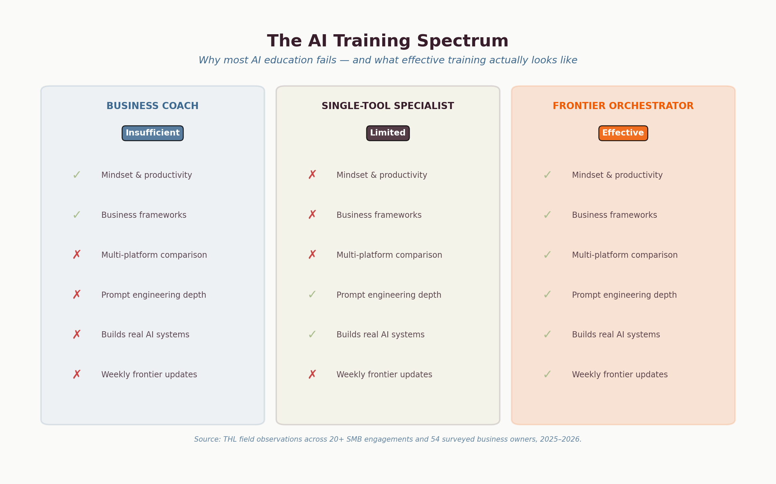

The Copilot Problem
Microsoft Copilot deserves special attention because it is the AI tool most Australian businesses encounter first — often not by choice. It arrives bundled with Microsoft 365 subscriptions, and in many organisations it is the only AI tool employees are permitted to use.
2.7 Million
Australian Microsoft 365 users affected by what the ACCC alleges was 'deliberately hidden' pricing — forcing customers onto Copilot-bundled plans without clear alternatives. (ACCC, 2026)
The Australian Competition and Consumer Commission is currently suing Microsoft for allegedly misleading 2.7 million Australian consumers by hiding cheaper Microsoft 365 plans that did not include Copilot. This is not just a pricing issue — it reflects a broader dynamic where vendor lock-in, not capability, is driving AI adoption decisions.
The Australian Government's own whole-of-government Copilot evaluation (digital.gov.au, 2025) found significant limitations: poor integration with non-Microsoft products, data security risks from Copilot accessing sensitive information inappropriately, and user frustration with output quality. The report noted challenges that 'limit its potential benefits to agencies that use non-Microsoft products.'
Enterprise users on Reddit forums paint an even starker picture. One evaluator tasked with assessing Copilot for 450 employees reported: 'We are all surprised by how utterly incompetent and useless it is. It failed to find and delete duplicate rows in a 500-row table. It failed to locate emails related to a project.' Multiple threads — with titles like 'Can we all agree Copilot is crap?' — document systematic frustration, particularly from users who have experience with Claude, ChatGPT, or Gemini and can see the quality gap firsthand.
The deeper issue is that government employees and enterprise workers are being trained on Copilot by Microsoft-certified specialists who may not know which underlying model they are using, what its limitations are, or how it compares to alternatives. In Australian government tenancies, Copilot often runs older model versions with slower rollout cycles — meaning users are getting inferior results and attributing the failure to 'AI' broadly, rather than to a specific tool choice.

The Frontier Knowledge Gap
AI capabilities are evolving on a weekly cycle. New models, new tools, and new integration patterns emerge constantly. Most training providers operate on a quarterly or annual update cycle — which means their curriculum is perpetually months behind the frontier.
Consider the landscape in early 2026 alone: Anthropic shipped Claude Opus 4.6 with breakthrough reasoning capabilities. Claude Code reached $2.5 billion in annualised revenue. Anthropic's Cowork mode brought agentic desktop automation to non-technical users. MCP hit 97 million monthly SDK downloads. Agent Opus launched multi-model AI video. Claude's document and presentation generation capabilities surpassed alternatives for many business use cases.
A trainer who last updated their materials in Q4 2025 has already missed several paradigm shifts. A trainer who only knows one platform cannot advise on which tool is best for which job. And a trainer who hasn't personally built applications, automated workflows, or deployed AI systems in production cannot teach others to do so credibly.

What Effective AI Training Actually Looks Like
The data from our own workshops and engagements — across 15+ industries and 54 surveyed business owners — reveals consistent patterns in what actually works:
Multi-Platform Literacy
Effective training compares platforms honestly. Claude for document analysis and long-form generation. ChatGPT for conversational exploration. Gemini for multimodal tasks within Google Workspace. Copilot for specific Microsoft integrations where it genuinely excels. Each model has strengths — the skill is knowing which to deploy for which task and how to orchestrate them together.
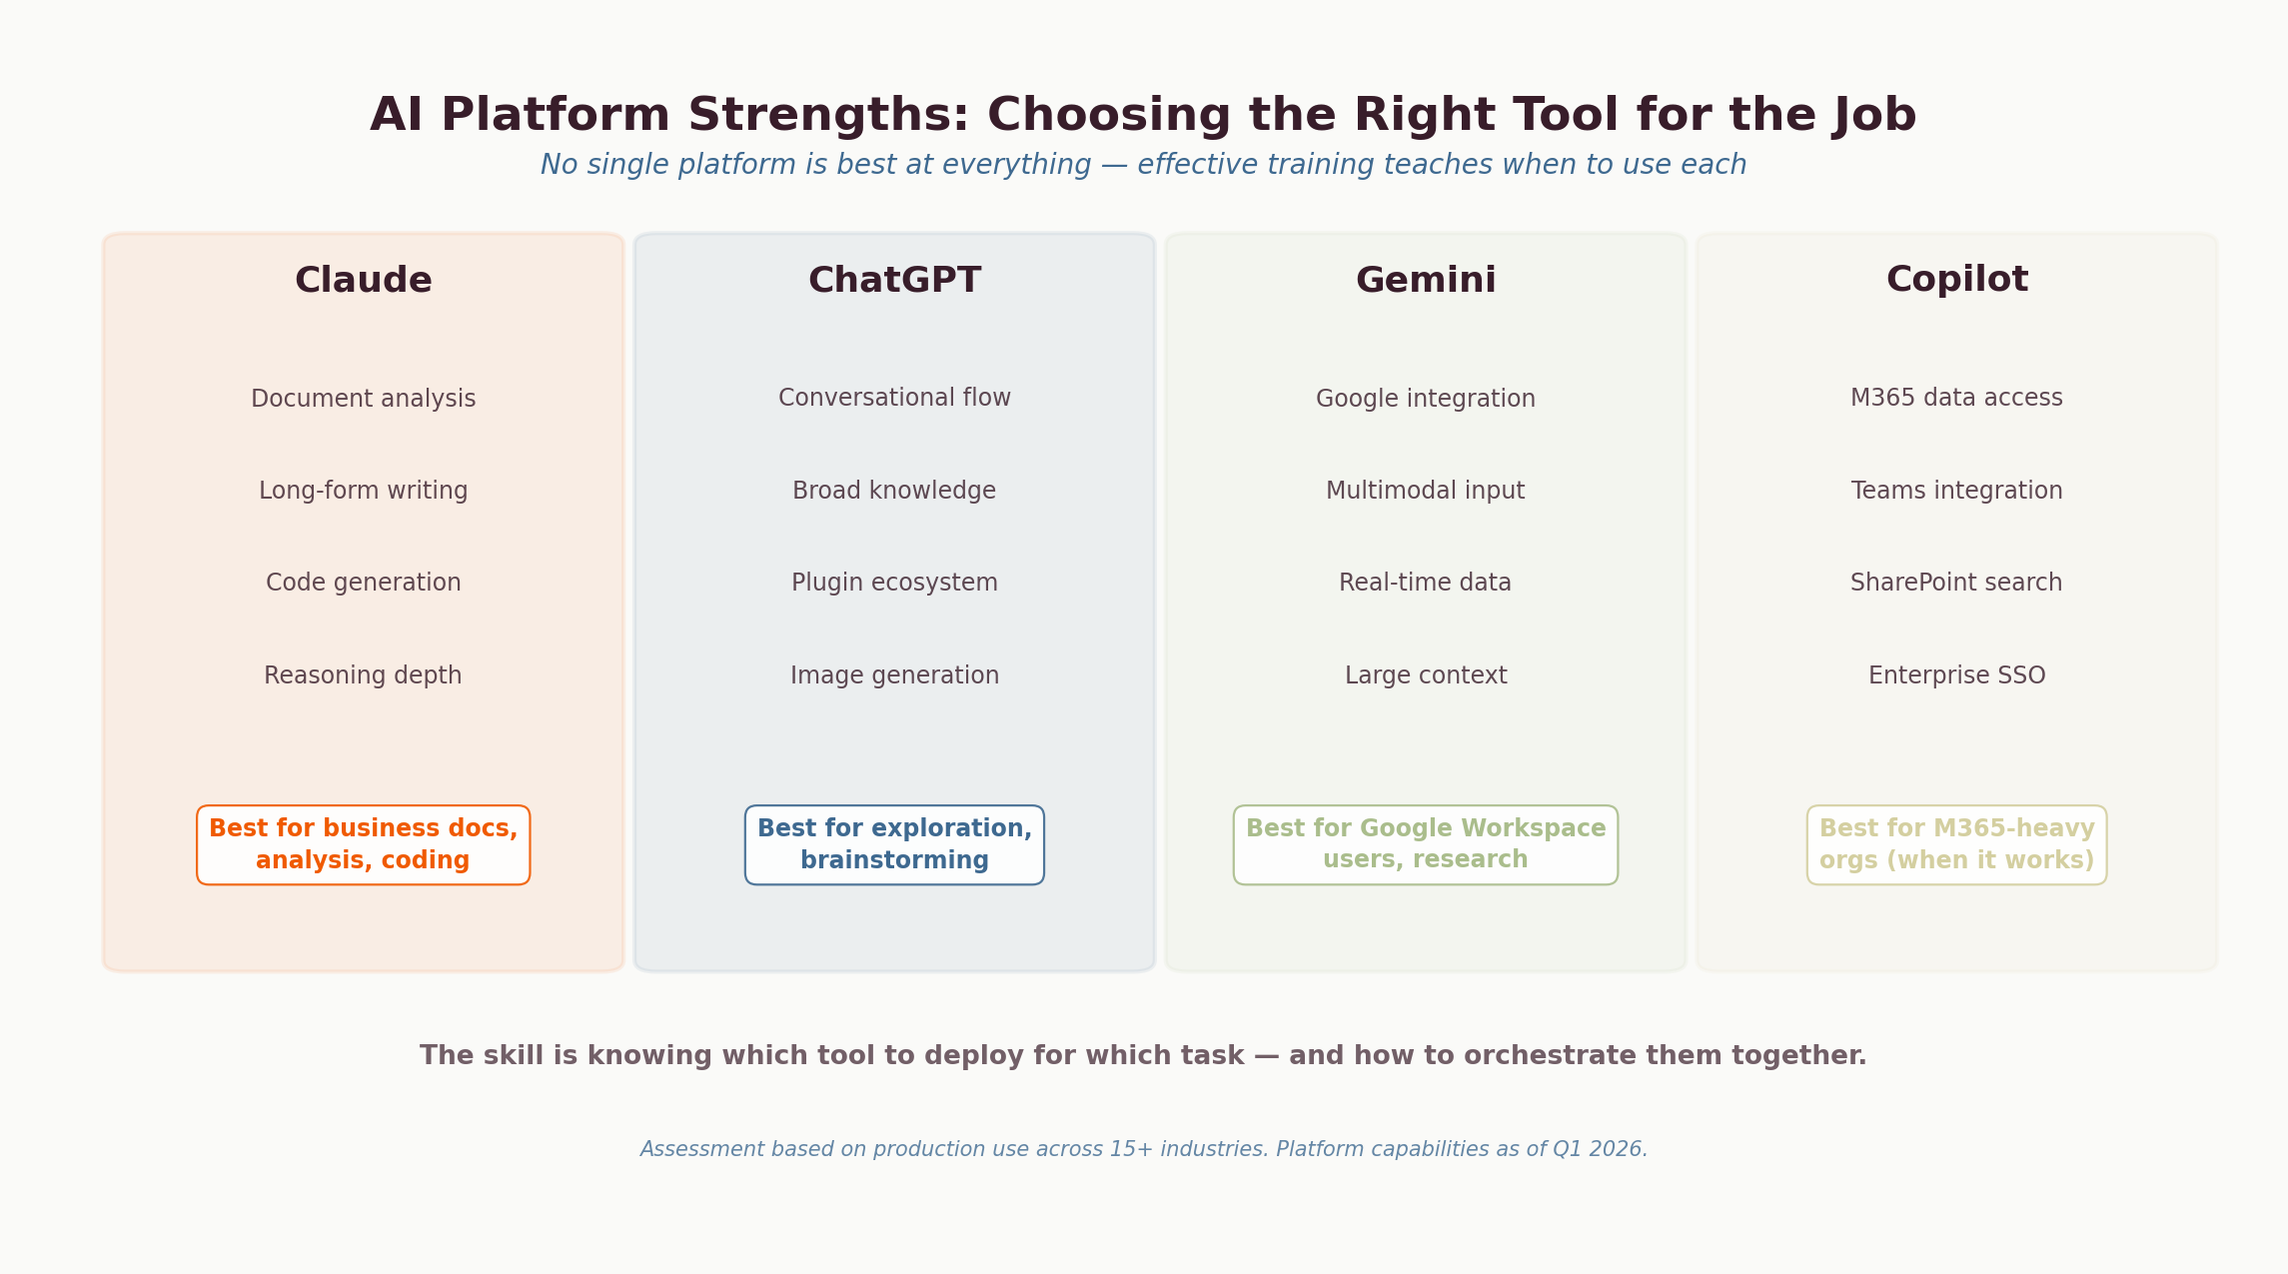
Prompt Engineering Depth
Surface-level prompt training ('be specific, give context') is table stakes. Effective training covers system prompts, chain-of-thought reasoning, structured output formats, persona framing, and iterative refinement. It teaches people to prompt engineer models into producing professional-quality documents, code, and analysis — not just 'good enough' drafts.
Building Real Things
The gap between theory and practice is where most training fails. Effective AI education includes building actual systems: connecting AI to business data, automating real workflows, creating content engines that produce consistent branded output. When participants see a functional application built in hours that would have taken weeks or months conventionally, the shift in mindset is immediate and permanent.

Continuous Currency
A course recorded six months ago is already outdated. Effective AI training operates as a living system — updated weekly as tools evolve, with ongoing access to someone who is actively working on the frontier and can advise when a new model drop or feature release changes the recommendation.
"'I like how you just talk about lots of different things... you're not just showing one avenue. You're combining them all — different platforms for different things.' What effective AI training feels like is orchestration across tools and models, not a tutorial for a single product."
— Workshop participant feedback, Tech Horizon Academy, 2026

10. What Smart Businesses Are Doing Differently
Based on 20+ Australian SMB engagements and patterns from both our data and the Anthropic Economic Index:
1. They Start With Operations, Not Marketing
The businesses seeing the highest ROI start with operations: automating client communications, standardising reporting, connecting existing tools. An engineering consultancy shifted from AI-drafted marketing emails to AI proposal generation — saving 8-10 hours per week on revenue-generating work.
2. They Build the Brain Before Deploying the Agent
AI tools don't work without context. Businesses that invest in structuring their information — SOPs, brand guidelines, client data — before deploying AI see dramatically better results. A talent management client using the Brain Architecture moved from ad hoc ChatGPT to a system handling candidate screening, compliance, and reporting with consistent quality.
3. They Use AI Collaboratively
Australia's low autonomy score (3.38/5) correlates with more sophisticated prompting and higher success rates. Businesses that train teams to work with AI outperform those that attempt full delegation.
4. They Choose Depth Over Breadth
Rather than experimenting with 10 tools, successful adopters master one or two deeply. They build knowledge systems and develop team fluency before expanding. GDPval data confirms: increased scaffolding consistently improves performance.
5. They Have a Guide
The single strongest predictor of successful adoption is whether the business had access to structured implementation support. Our 7-9% workshop-to-engagement conversion rate reflects genuine willingness to invest — when the path forward is clear.

11. Implications and Recommendations

For Australian Small Business Owners
- Audit your current AI usage honestly. If you're using ChatGPT for ad hoc tasks but haven't connected it to your business processes, you're in Stage 2. That's normal — but it's not where the value is.
- Start with your biggest time sink, not your most interesting problem. Our data is clear: manual repetitive tasks are the number one pain point. Solve that first.
- Structure your business knowledge before deploying AI. Brand guidelines, SOPs, client FAQ, product catalogues — this is the Brain Architecture that makes AI useful in context.
- Understand the new tech stack. The Stack Collapse means your software landscape is changing whether you act or not. Build your agent architecture deliberately rather than having it happen to you.
- Invest in team training, not just tools. The Anthropic data shows collaborative AI use outperforms delegation. Your team needs to know how to work with AI, not just access it.
- Get structured implementation support. The transition from Stage 2 to Stage 3 is where most businesses stall. A clear roadmap with accountability makes the difference.

For Policy Makers and Industry Bodies
- The $44 billion opportunity is real. Deloitte's modelling shows that modest improvements in SMB AI maturity would add 1.3% to GDP. Programs targeting implementation support — not just awareness — deliver the highest return.
- Queensland's AI adoption gap needs closing. Below 1.0 AUI despite being third for total usage. Regional centres like the Sunshine Coast have particular room to grow.
- SMBs need implementation partners, not more information. The barrier is the gap between knowing AI exists and knowing how to make it work. Fund implementation programs, not just digital literacy.

Your Next Step
Find out where you sit.
Take the free AI Readiness Assessment to identify your stage, where the quick wins are, and your specific next step.
techhorizon.academy/readiness
Or book a free 30-minute discovery call: techhorizonlabs.com/discovery

Methodology and Data Sources

First-Party Survey Data
Data collected via Tally forms across workshops, the Noosa Council Business Boost program, and AI readiness assessments. 54 respondents across 7 forms, July 2025 – March 2026.

Anthropic Economic Index
Two publications: The Economic Primitives report (January 15, 2026) using 1 million sampled conversations, and How Australia Uses Claude (March 31, 2026) using February 2026 data.

GDPval Benchmark
Patwardhan et al. (October 2025). 1,320 tasks, 44 occupations, 9 sectors. Tested Claude Opus 4.1; current production version is Claude Opus 4.6.

Deloitte Access Economics
November 2025 survey of 1,000+ Australian SMBs on AI adoption patterns, maturity stages, and profitability correlations. The $44 billion GDP opportunity figure is from Deloitte's economic modelling based on this data.

Bain & Company
Technology Report 2025, defining the three-layer agentic AI stack: systems of record, agent operating systems, and outcome interfaces.

Field Observations
Anonymised client insights from 12 months of AI implementation engagements, discovery calls, and advisory relationships across the Sunshine Coast and South East Queensland.

Supplementary Sources
- Arcade (2026): State of AI Agents — adoption barriers and deployment patterns
- HeyGen (2026): AI video adoption metrics for small businesses
- Gartner (2026): AI agent deployment forecast for SMBs
- Fortune Business Insights (2025): AI video generator market sizing
- IDC (2025): Software vendor pricing model predictions
- IDC (2025): The Agentic Evolution of Enterprise Applications, doc#US53194625, February 2025
- MCP adoption data (2026): npm registry SDK download statistics, Anthropic ecosystem reporting
- Enterprise AI deployment reports (2026): ROI composition analysis — efficiency vs. new capability returns
- Anthropic financial reporting (2026): ARR and product revenue data via Yahoo Finance and SaaStr
- OpenAI capability analysis (2026): Frontier model benchmarks and competitive landscape
- AI-native engineering blueprint, Q2 2026: Capability overhang analysis and agent infrastructure mapping
- ACCC v Microsoft (2026): Legal proceedings re misleading Copilot bundling for 2.7M Australian M365 users
- Australian Government Copilot Evaluation (2025): Whole-of-government Microsoft 365 Copilot trial report, digital.gov.au
- Reddit community data (2025–2026): Enterprise user experience threads on r/ArtificialIntelligence and r/CopilotPro

About Tech Horizon Labs
Tech Horizon Labs is an AI implementation consultancy and education platform based on the Sunshine Coast, Queensland. We help Australian SMBs move from AI-curious to AI-enabled through structured implementation, team training, and ongoing partnership.
Our methodology — Discover, Architect, Activate — has been validated across engagements spanning talent management, manufacturing, insurance, finance, tourism, health, and non-profit sectors.
Get your free AI Readiness Assessment: techhorizon.academy
Contact: hello@techhorizonlabs.com

This report may be shared freely with attribution to Tech Horizon Labs.
For enquiries about licensing, speaking, or partnership: huxley@thzn.world

