July 17, 2017

Where Lean Accounting Came From – and Why.

Brian H. Maskell, President: BMA Inc., Cherry Hill, New Jersey

My personal Lean Accounting journey began in 1989 when I emigrated with my family from the United Kingdom to the United States. I took up a job in Cherry Hill, NJ with a division of the Xerox Corporation called Praxa Inc. Praxa was a pioneer in the development of management software, and I moved up in the company to run the product design, development, and operations.

At this time, American manufacturers were beginning to learn about Japanese **lean** production methods – (in those days we called it **just-in-time**). At Praxa, the team put our heads together and developed software to support these more advanced customers. As with much innovation, it became difficult because we needed new thinking to support lean management. Manufacturing software was previously focused on the details of individual production and inventory levels. But **lean** manufacturing focuses on low inventories and the entire flow from customer orders, pulling raw materials, making and shipping products, and then collecting the cash. Traditional manufacturing manages vertically at each work center. Lean manufacturing controls horizontally from the incoming requirements right through to shipping the products.

**Lean Accounting** was developed in the mid-1990’s to support lean manufacturing and lean management. It began as a method to understand the financial benefits of lean manufacturing. But over a few years, Lean Accounting became a simpler and more useful replacement for traditional cost and management accounting. It took time for Lean Accounting to be accepted, but it is now widely used by companies employing effective lean management[1].

Our software team worked hard to design and develop the “just-in-time modules” of the Praxa systems, and we began to slowly build up customers for these new production methods. Shortly after this, Praxa was acquired by a larger management software company, and I decided to set up my own consulting firm, BMA Inc. in 1995.

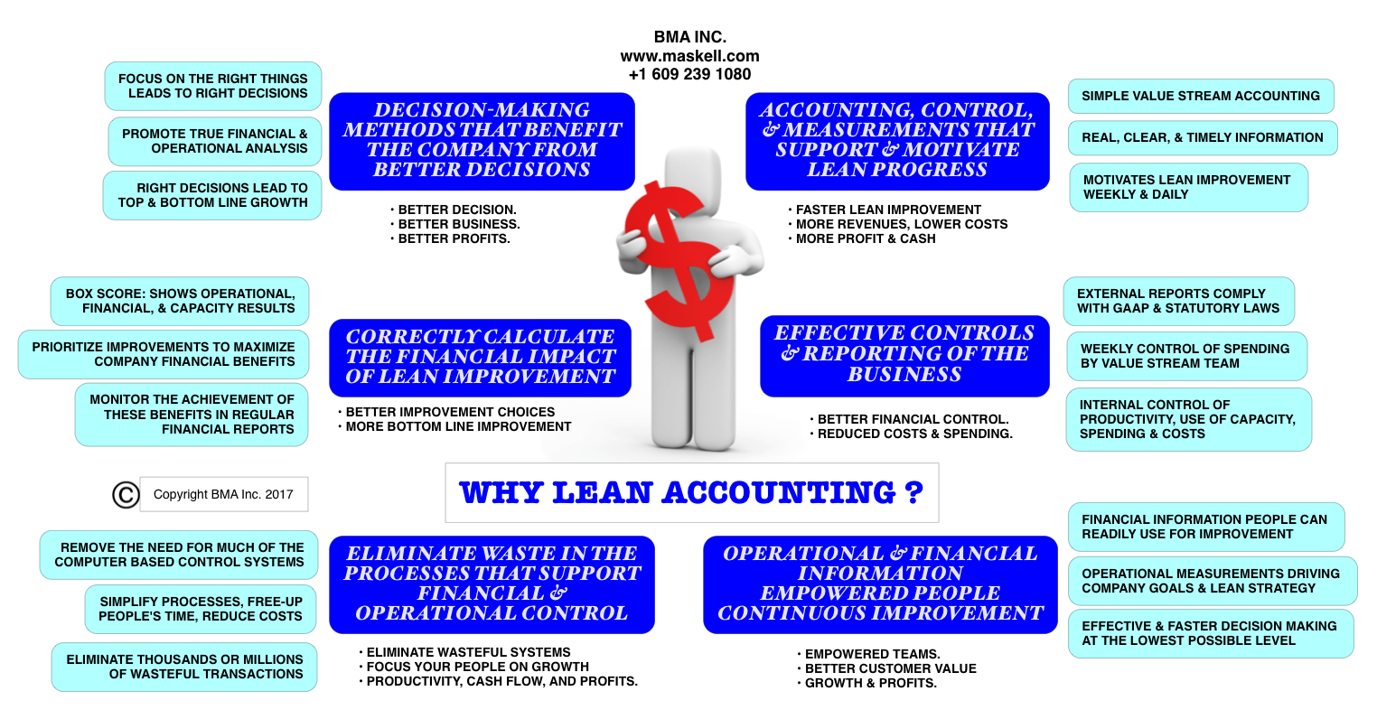

**Food on the Table, Writing Books, and a Damascus Road Experience**

Whilst working at Praxa I wrote my first book, “Just In Time; Implementing the New Strategy” (1994). The book sold quite well within the narrow community of companies pursuing just-in-time, and it went to a Second Edition in 2009. But it was my second book, “Making the Numbers Count”, that began my focus on Lean Accounting.

In the early days of just-in-time manufacturing, the accounting aspects of lean management did not gain much attention. Most people thought that lean was just for the factory shop floor. As time went by, however, it became clear that lean thinking applies to every part of the company, including the accounting office. My odd mix of education helped me a lot. I was an engineering graduate from the new, radical, and trendy University of Sussex[2] in Brighton, England. I later studied accounting with the (not so trendy) Institute of Management Accountants[3], UK while also having a full time job. The second degree was hard work and a stress for my family; but it certainly paid-off. I needed both engineering and accounting skills for the development of what became Lean Accounting.

“Making the Numbers Count” (1996), was published by Productivity Press that was (and still is) an important organization in the lean world. With the help of Norman Bodek, Maura May, and others from Productivity, my second book gained a good deal of traction and opened up many professional opportunities. BMA Inc. gradually increased from a “one man band” to a small group of professional consultants focused on lean management and accounting. Our growing number of clients not only expanded our company, but also enabled us to develop a great deal of knowledge and experience in the new practice of Lean Accounting. At that time there were no competitors in the field. There were plenty of accounting firms, but they did not have the production and engineering skills. There were many new firms providing consulting in lean manufacturing. But BMA Inc. pioneered the focused niche of Lean Accounting.

My first partner was Bruce Baggaley, whose deep knowledge and experience with accounting added a great deal to our early success. I learned a lot from Bruce over the years we worked together as colleagues and buddy’s. Susan Lilly, who worked so hard for BMA Inc., was an absolute godsend. Susan was officially the company’s administrator, but she did a lot more than that. Susan’s practical skills, warm personality, high-level intellect, and her patience with our ups and downs, kept the whole company afloat.

In the spring of 1998 we won an assignment with Hewlett Packard in Maryland. This was the first BMA Inc. project with a large multi-national corporation. We brought in a team of four consultants and worked for several months with the HP accounting and continuous improvement teams. We assisted them to make some major changes to their operations towards small batches and just-in-time production. We demonstrated to HP how to introduce and use Activity Based Costing[4] (ABC) within their production plant. The work went well, we learned a lot; and HP became a good reference for seeking work with other companies.

But …. as Bruce, Susan, and I were driving back together from Bethesda, MD, we had an important conversation about the project and the future of our consulting firm. We agreed that the HP assignment had gone well and that the leaders in HP were happy with our contribution, but we also recognized that ABC was NOT the right solution to their problem. This recognition changed everything for us; and for the better.

ABC was fashionable amongst accountants at that time, and was advocated by well-known academics[5]. But it is complicated, obscure, and meaningful only to accounting specialists. It has no relevance for the operational and sales people looking to serve the customer and profit the business. The most important result of our conversation was that we realizing we needed to develop a fundamentally different approach. An accounting, control, and management system that is simple to use, understandable to everybody, timely, practical for both financial control and decision-making, and …… does not require a lot of work.

By the end of our journey back to New Jersey, we agreed that we needed to develop accounting, control, measurement, and management methods that are:

* flexible
* timely
* clearly understood by everyone in the company
* provides a clear basis for action and improvement[6]
* drives increasing customer value
* provides excellent information for decision-making
* fully complies with GAAP[7]
* has rigorous financial and operational controls,
* and frees-up time for financial controllers, CFOs, and other leaders.

**Cost Accounting Needs to Change**

Modern cost accounting was developed in the 1920’s to support companies using “economies of scale”, including long production batches, relatively few products, and large finished goods inventories. Their approach to customer service was summed up by Henry Ford’s apocryphal comment; “***Any customer can have a car painted any color so long as it is black*”.**

Lean manufacturing is the opposite of mass production and focuses on:

* small quantities to meet the customers’ immediate needs.
* wide range of products that are often custom-designed.
* Short lead times and low levels of inventory.

It was very clear that new kinds of management accounting was needed to support the companies pioneering lean management in their business. I would like to tell you that we carefully, soberly, and thoroughly developed a series of Lean Accounting methods. If fact it took us a good deal of time to really think through our vision. It is difficult and time-consuming to make things simple!! But we soldiered on.

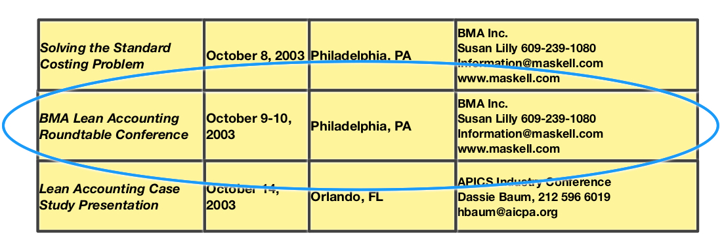

It was an exciting time for our team that now included the very talented and detailed accountant Nick Katko, and other associates. An opportunity to be genuinely creative does not come very often in industry - outside of new product development. True creativity comes by a team working together and coming up with many different approaches Over time our team created the beginnings of what has now been dubbed “Lean Accounting”.

We did of course think that we were unique in our field!! It was only later we met up with other people who were taking a similar journey. Jean Cunningham, Jerry Solomon, Jim Huntzinger, and others were coming to similar conclusions with regard to lean management in their companies. The large, well-known consulting firms did not have Lean Accounting on their radar at all. We were able to move around as a small fish in the large sea of lean manufacturing.

To focus on Lean Accounting, we developed a “Lean Accounting Vision”. We developed our vision by specifying almost the opposite of the attributes of traditional cost and management accounting.

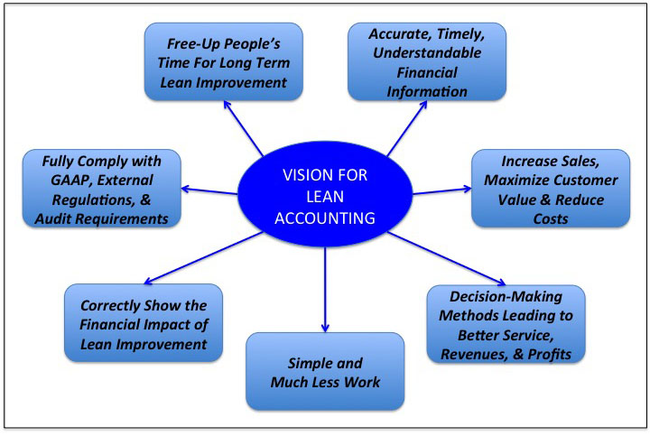

**The Box Score For Reporting and Decision-Making**

To fulfill the vision, we needed to devise of simple, single page report that everybody in a company can immediately understand and use. We purloined the term “Box Score” from baseball and basketball. The purpose of the lean management Box Score is to report the company’s operational and financial performance in a way that everybody can immediately understand and use. Box Scores are reported for each of the company’s value streams, and can be rolled up to higher levels.

The value stream leaders are responsible for their operational and financial results. The Box Score information is also used for routine decision-making in sales, operations, process improvement, procurement, forecasting resources, identifying problems, analysis leading to improved performance, longer term strategic decisions, and other issues.

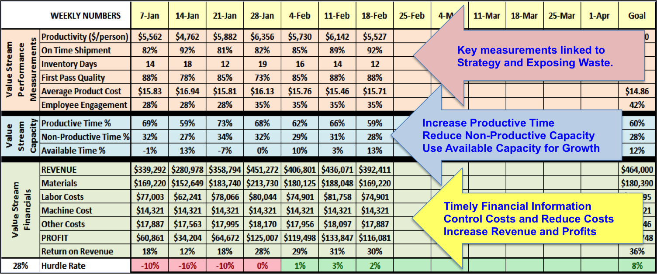

The Box Score shows the operational and financial effectiveness of an entire organization or location, but box scores are better used to measure, control, and improve the **Value Streams** within the organization.

Value streams can be defined in many ways, but a typical production plant, distribution process, product development team, etc. will use value streams that serve their customers with particular families of products or services. Ideally each value stream provides every aspect of the process for customer service - from order taking, purchasing materials, and through to completing and delivering the product (or service) to the customer. The production plant may have – for example – three major product families. Each product family’s value stream will have it’s own box score and the value stream manager is fully responsible for it’s performance.

The box scores are usually updated each week and the people in the value stream update their box score themselves; typically every Monday morning. The team will then use the up-to-date box scores at their weekly “huddle” to review the value stream’s performance, solve problems, make improvements, and set up the plan for the week ….. and beyond.

The **top section** of the box score contains 5-7 measurements that show together the operational performance of the value stream. This data is balanced between measurements relating customer services, measurements relating to process efficiency, employee engagement, and costs.

The **center section** of the box score shows the efficiency of the work being done in the value stream. The Productive Time % show the amount of time used producing the value stream’s “product”. The product may be a physical product in a factory or other kinds of services. An example is a value stream controlling the sales and marketing processes, another the new product engineering value stream, and so on.

The **bottom section** of the box score shows the financial outcome of the value stream each week. These revenues and costs show the actual money coming in and out of the value stream. We do NOT allocate any external overheads into the value streams; just the actual income and payments. The value stream manager is responsible for the costs and profitability of their value streams.

Value streams are not “departments” performing certain tasks. They are (as much as possible) the entire flow of the process from the customer’s order right through to delivering the product or service. A product development value stream, for example, usually begins with a customer need that must be fulfilled by a new product and/or service. These value streams provide the entire flow for the specification, design, development, costing and pricing, marketing, and launching the product.

The “Productive” and “Non-Productive” percentage for the value stream shows the amount of work that is required to serve the customers, and support the value stream.

* The “Productive %” is making and selling the product (or service) and delivering the product to the customer. The productive work creates customer value and cash coming into the company.
* The “Non-Productive %” shows the amount of work done in the value stream that supports the productive processes. They are important things like paying the people, managing the process, continuous improvement, investigating errors, rework, quality issues, returned products, etc.. This non-productive work supports the business process, but does not directly create financial value and cash.
* The “Available Time” or “Available Capacity” is the time that is not included in the Productive and Non-Productive capacity. A value stream can not be run at 100% every week. There will always be a need for additional capacity to take care of the inevitable variability of the process.

**The Vision for Lean Accounting**

Another important aspect of our work in the early days was to recognize that accounting is NOT for the accountants. It is for almost EVERYBODY in the company. We must make the accounting, control, and measurements systems “user friendly” - so that all the people designing, planning, making, selling, and distributing their company’s products and services have effective and useable information. In addition, senior leaders needed to abandon the 50 page monthly financial reports in favor of simple, timely, and usable lean accounting.

Here are the seven aspects of the vision we developed in 1999 for Lean Accounting:

1. *Accurate, Timely, and Understandable Information*

The Box Score is usually reported every week, or more often. It is can also be available on demand. The box score is designed so it is immediately understood by anybody in the company. This is achieved by using “plain English” in the reporting instead of using complicated jargon and calculations. Keep it simple.

1. *Increase Sales and Maximize Customer Value*

Sales prices are determined by the value created for the customers. The starting point of pricing is to understand customer value. The prices must match the customer value. Some times the value is not with the product itself but your services and/or reputation.

1. *Decision-Making Leading to Service, Revenue, and Profits*

Decisions for pricing, product range, inventory levels, and many others are not made by calculating product costs. They are made based on the value to the customers and their impact on the value stream as a whole. We do not spend time calculating product costs, because they are largely driven by misleading cost allocations. If we know the material costs and we know the capacity of the value stream, decisions are made using the true financial and operation impact on the value stream as a whole. Ideally we want to create product mix and volumes that maximize the profitability of the value stream.

1. *Free-Up People’s Time for Long Term Lean Improvement*

Lean Accounting eliminates wasteful work, in-process inventory, and streamlines the process from customer order through to payment. When this is done well, a great deal of time is saved for the people working in the company. The freed up time can then be used to make more improvement, and grow the business. This is the essence of continuous improvement; eliminate waste, free up people’s time, use this time for more continuous improvement.

1. *Correctly Show the Financial Impact of Lean Improvement*

Traditional companies calculate the financial benefits of improvement by the reduction of the so-called product costs. This is always misleading. Lean companies focus on eliminating waste from the value stream processes within the company. When improvements are made, the team calculates the financial impact of the improvement. This will be the actual change in the value stream costs and the product profitability. Make changes and improvements, free-up capacity, design-make-sell more products, work out the bottom line financial impact.

1. *Fully Comply with GAAP and Other External Regulations*

Lean accounting fully complies with GAAP (generally accepted accounting processes) requirements. The simplicity of lean accounting eliminates the need for the complex GAAP reporting. GAAP is a set of requirements established by the “Financial Accounting Standards Board (FASB) to ensure correct reporting. Lean Accounting fully complies with all GAAP and all other accounting rules.

1. *Simple and Much Less Work*

Lean companies typically use box scores to show the operational, financial, and capacity use of the value stream. They also provide a weekly income statement based on lean accounting. The financial information is posted visually each week and is reviewed by the value stream team (not just the accountants) as part of their visual management. The same information is used for the monthly external reporting.

**Why is Lean Accounting Important?**

Lean management has come a long way in recent years. Everybody now recognizes that lean management is NOT about manufacturing. It is about creating a new management system focused on **value in the eye of the customers**, and **eliminating waste** in every process. Lean management applies to every aspect of the business and crosses a wide variety of industries, including manufacturing, distribution, healthcare, administration, professional services, and others.

Lean Accounting is important to organizations pursuing lean management for both positive and negative reasons. The negative reasons are that traditional cost and management accounting is actively anti-lean. This is NOT because traditional management is bad and wrong, but it is not appropriate for lean organizations. The principles and methods of lean management are quite different from the mass production era of the 1920’s and beyond. The traditional accounting, measurement, and control systems push back against lean methods. Lean management requires lean accounting, control, and measurements; not the traditional management accounting or activity-based costing.

Lean Accounting is the management control process for achieving superior customer value through the reporting, planning, measurement, and controls supporting the company’s value streams. Lean Accounting motivates lean behaviors and continuous improvement. The financial reports are simple and understandable to everyone. Value stream planning, controls, and execution achieve the company’s business goals. Lean Accounting hears to voice-of-the-customer through target costing, value-based pricing, and just-in-time flexibility.

Lean Accounting brings increased sales, reduced costs, timely and accurate information, simplified systems, eliminates wasteful transactions, motivates and empowers people, provides real data, drives long-term lean improvement, and shows the true financial benefits of lean.

1. According to recent surveys, approximately 10% of American manufacturers are using lean methods thoroughly. More than 50% try to apply lean thinking but together with their traditional ERP/MRP production push methods. Unfortunately, lean manufacturing does not work well when a company employs half-measures.
2. http://www.sussex.ac.uk/about/index
3. https://www.imanet.org/
4. http://www.cgma.org/resources/tools/essential-tools/activity-based-costing.html
5. # “Time-Driven Activity-Based Costing”; Harvard Business Review, Nov 2014

  
6. These days we would call this ***kaizen***
7. GAAP: Generally Accepted Accounting Principles