**SCOPE AND IMPACT**

About a week or so back, a few Northeastern dorms caught fire, and Northeastern has an emergency message notification service that basically sends alerts related to any emergencies near Northeastern University.

Taking inspiration from this idea, we came up with TwiNotify.

TwiNotify is a messaging service that broadcasts trending alerts.

To accomplish this, we performed the following steps:

1. Fetching Tweets
2. Classification of Tweets
3. Selection of Tweets
4. Broadcasting

**Fetching Tweets:**

In order to get tweets, we used the Twitter API, and also imported data from a publicly available dataset.

**Classification of Tweets:**

We classified tweets as Relevant and Not Relevant using Logistic Regression.

We merged tweets we got from the Twitter API and from an external dataset and got over 1.6 million tweets. To get data from the Twitter API, we queried the Twitter API based on a pre-defined set of words that flagged the tweet as relevant.

Later, in order to classify tweets, we divided the set into training and testing and trained the model using logistic regression.

**Why Logistic Regression:**

Logistic regression is the appropriate regression analysis to conduct when the dependent variable is dichotomous (binary). We are using it on our training data to figure out what consists the relevant tweets versus the irrelevant ones.

**Selection of Tweets:**

We select the tweets based on their relevance using a custom algorithm that is explained separately.

**Algorithm:**

We convert the list of words with arranged by their weights over all the tweets in the test data, into a dictionary. The key is the word itself, while the rank is the rank of the word in the input list. We then iterate over list of words in all the tweets and pick out the tweets with the greatest score. Score for each of the tweets is the sum of all the words found in the tweet.

**Broadcasting:**

We use Twilio’s SMS API to then broadcast messages that we have selected.

**Scope:**

The scope of the project is currently limited to disaster related information, but later can be broadened to other topics of interest.

**Impact:**

The concept used for the project can prove be significantly impactful in events where a person does not have access to stable or reliable internet connection. This leads to a person being cut-off from the latest news or events.

Another impact it has is, that the shortened and concise text can provide the more relevant information without the person spending many hours to look for it.

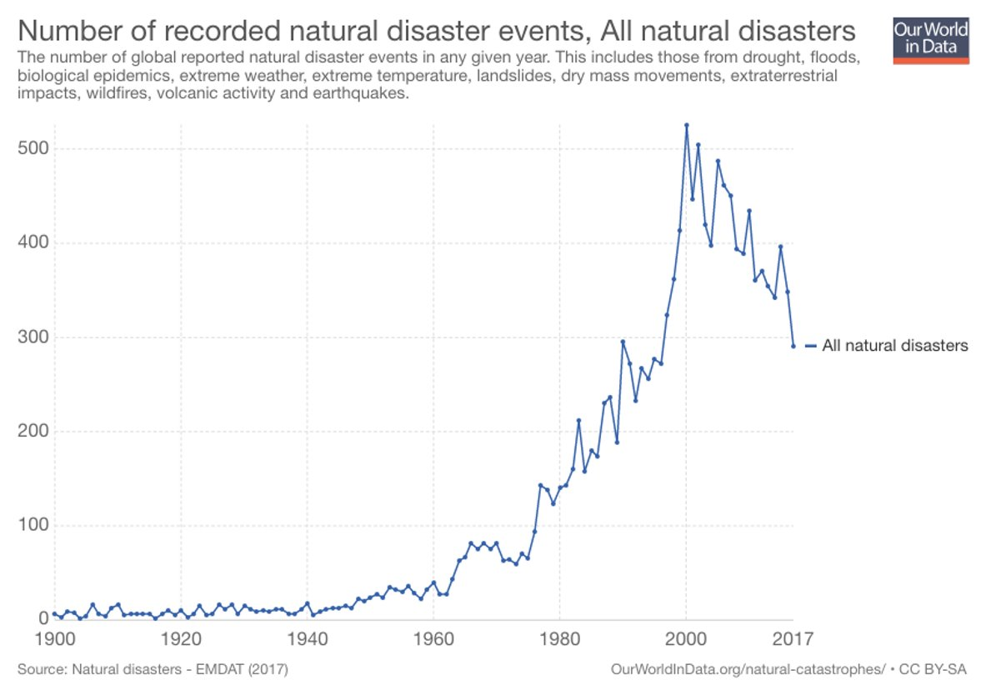

Looking at this graph, we realized that there is TwiNotify can alert a huge amount of people in the face of crisis, and thereby, have a big and meaningful impact on the society.

The concept used for the project can prove to be significantly impactful in events where a person does not have access to stable or reliable internet connection. This leads to a person being cut-off from the latest news or events.

Another impact it has is, that the shortened and concise text can provide the more relevant information without the person spending many hours to look for it.

**RESULT:**

1.6 million tweets trained using Logistic Regression, giving an accuracy of >80%

**FUTURE SCOPE:**

The future scope of the project is:

1) Customized subscription:

Users can set static set-points for starting and stopping the subscription

2) Subscription based on interests:

Users get messages pertaining to their interests

3) Geo location-based alerts:

Users receive alerts based on their location