A REPORT
ON
BUSINESS ANALYTICS & KPI DASHBOARD USING JAVA
By
Name of the Student | Registration No.
Guda Raghavendra Sujith | AP25110090016
Shaik Fayaz Ahmed | AP25110090032
Eluru Hrushikesh | AP25110090017
Sudabathula Nikitha | AP25110090026
Prepared in the partial fulfillment of the
Project Based Learning of Course CSE 213 – Advanced Java Programming

SRM UNIVERSITY, AP
NOVEMBER 2026

CERTIFICATE
This is to certify that the project entitled Business Analytics & KPI Dashboard using Java has been successfully completed by
1. Guda Raghavendra Sujith - AP25110090016
2. Shaik Fayaz Ahmed - AP25110090032
3. Eluru Hrushikesh - AP25110090017
4. Sudabathula Nikitha - AP25110090026
as a required academic component of the course [Course Code]: [Course Title] during Semester 3 of Academic Year 2026–27 in the Department of Computer Science and Engineering at SRM University, AP. This work was executed under the guidance of the undersigned and is deemed to have successfully met all course requirements as of November 2026.
(Signature of the Course Instructor)
Ajay Kumar Sahu,
Assistant Professor,
Department of Computer Science and Engineering
SRM University, AP
ACKNOWLEDGEMENTS
We would like to express our sincere gratitude to Ajay Kumar Sahu, Assistant Professor, Department of Computer Science and Engineering, SRM University, AP, our course instructor, under whose guidance this project was carried out. The clear explanations of Java in class, the feedback and the encouragement at every stage helped us turn an idea into a working program.
We are also thankful to SRM University, AP and the Department of Computer Science and Engineering for giving us the opportunity to undertake this project as part of the Project Based Learning component of CSE 213.
The Project Team
Guda Raghavendra Sujith
Shaik Fayaz Ahmed
Eluru Hrushikesh
Sudabathula Nikitha
ABSTRACT
Reviewing raw sales records in a spreadsheet by hand is slow and error-prone, and business intelligence tools depend on back-end code that first reads, checks and totals the data. This project, Business Analytics & KPI Dashboard using Java, is a desktop application developed by Guda Raghavendra Sujith, Shaik Fayaz Ahmed, Eluru Hrushikesh and Sudabathula Nikitha under the supervision of Ajay Kumar Sahu for the course [Course Code] – [Course Title]. The program reads a CSV file in which every row records an order ID, a customer name, a product, a category, a quantity, a unit selling price, a unit cost price and an order date. It is organised into five classes: Order, DataLoader, KPIEngine, DashboardUI and Main. Broken rows are reported and skipped so that the program never stops on bad input. The engine adds up revenue and cost, groups revenue by category, product and customer with HashMaps, and calculates net profit, profit margin and average order value. The results are shown in a Java Swing window with four colored KPI cards, a summary of the top drivers and a banner that turns green when the margin is 20 percent or higher and coral red when it is lower. On the sample data of 18 orders, the gross revenue was ₹325,300.00, the net profit was ₹71,830.00 and the margin was 22.08 percent, so the banner showed OPTIMAL.
TABLE OF CONTENTS
Page no.
1. Introduction 1
1.1 Background 1
1.2 Problem Statement 1
1.3 Objectives 1
1.4 Scope and Limitations 2
2. System Design and Implementation 3
2.1 Overview 3
2.2 Input Data Format 3
2.3 Class Design 3
2.4 Handling Corrupted Records 5
2.5 Program Flow 6
2.6 Dashboard Layout 7
2.7 KPI Formulas and Health Rule 8
2.8 Assumptions 9
3. Results and Outputs 10
3.1 Test Run on the Sample Data 10
3.2 Principal Outcomes 11
3.3 Discussion 11
4. Conclusions and Recommendations 12
4.1 Conclusions 12
4.2 Work Still to Do 12
4.3 Recommendations 12
Appendix A: Project Files and Build Instructions 13
Appendix B: Abbreviations 14
References 15

1. Introduction

1.1 Background
Every sale made in a shop or an online store is stored as a transaction record. A record notes the order number, the customer, the product, the quantity sold, the price and the date. A busy business creates hundreds of such records every day, and reading them row by row in a spreadsheet is slow and easily leads to mistakes. Business intelligence tools such as Power BI and Tableau present this kind of data as charts and summary tiles, but they depend on back-end code that first reads the raw data, checks it and calculates the financial figures [4].
Three figures matter most to the owner of a business. Revenue is the total value of the goods sold, and net profit is what remains after the cost of buying those goods is subtracted. The profit margin expresses net profit as a percentage of revenue and shows how much of every rupee earned is kept; a margin that keeps shrinking is an early sign that costs are growing faster than sales. The average order value shows how much a customer spends in one purchase. A dashboard places such key performance indicators (KPIs) on one screen so that they can be read at a glance [4].

1.2 Problem Statement
Given a CSV file of sales transactions, the program must calculate the key business metrics, find the strongest product category, product and customer, and present the results in a single desktop window that also shows whether the profit margin is healthy. Real data files often contain incomplete or garbled lines, so the program must also cope with damaged records without stopping.

1.3 Objectives
The objectives of the project are to:
- read a CSV file of sales transactions line by line;
- detect corrupted rows and skip them with a warning instead of crashing;
- store every valid row as an Order object in an ArrayList;
- calculate gross revenue, net profit, profit margin and average order value;
- find the top category, the top product and the top customer by revenue using HashMap objects;
- display the results in a Java Swing window with four KPI cards, a driver summary and a financial health banner; and
- apply the Java concepts of the course, namely classes and objects, encapsulation, collections, file handling, exception handling and a graphical user interface (GUI) [1], [2].

1.4 Scope and Limitations
The program analyses a file after it has been recorded; it does not connect to a database or to a live sales system. Its output is a single window that shows totals only, without charts, filters or an export option. The health threshold of 20 percent is a fixed value in this version. Every row is split at the commas, so a name that itself contains a comma is not supported and the row is skipped as damaged. Charts, a date filter and an export option are planned but not yet built (Section 4.2).

2. System Design and Implementation

2.1 Overview
Business Analytics & KPI Dashboard is a desktop application written in Java that uses only classes from the standard library [3]. It takes the CSV file orders.csv as input, builds an in-memory list of orders from it, calculates the business metrics and shows them in a window. Following the object-oriented programming (OOP) approach taught in [Course Code], each kind of thing in the problem is represented by a class, the data of an order is kept private inside its class, and errors are handled with try-catch blocks [1], [2]. The program needs Java 8 or later.

2.2 Input Data Format
The input is a CSV file whose first line is a header. Every following line describes one completed sale. Table 1 lists the eight fields in the order in which they appear. The sample file supplied with the project is orders.csv, which the program reads from the folder in which it is run. Empty lines are ignored.
Table 1: Fields of one order record
Field | Description
Order ID | Identifies the order (read as text)
Customer Name | Name of the customer who placed the order
Product Name | Name of the product sold
Category | Product category, for example Electronics
Quantity Sold | Number of units sold, as a whole number
Unit Selling Price | Price at which one unit was sold, in rupees
Unit Cost Price | Price the business paid for one unit, in rupees
Order Date | Date of the sale (read, but not used by the calculations)

2.3 Class Design
The program uses five classes. Figure 1 shows how they are related, and Table 2 summarises the role of each one.
Order is the model class. It stores the eight fields of one row as private variables and offers public getter methods, so no other class can change an order by accident; this is encapsulation. It also holds the three formulas of the problem: getGrossRevenue() returns the selling price multiplied by the quantity, getProductCost() returns the cost price multiplied by the quantity, and getNetProfit() returns the difference between the two [1].
DataLoader handles the file. Its static method loadOrders() opens the CSV file with a FileReader wrapped in a BufferedReader, skips the header, splits every line at the commas, converts the text to numbers with Integer.parseInt() and Double.parseDouble(), and stores each valid row as a new Order in an ArrayList.
KPIEngine is the calculation class. It goes through the list once, adds up the total revenue and the total cost, and keeps the revenue of every category, product and customer in three HashMap objects. From these it works out net profit, profit margin and average order value, and it finds the top category, product and customer by locating the largest value in each map.
DashboardUI is derived from JFrame, the window class of Java Swing, so it inherits everything a window needs and adds its own layout. It receives a KPIEngine object and builds the header, the four rounded KPI cards, the driver summary and the health banner from JPanel containers with BorderLayout and GridLayout. The cards are JPanel objects whose paintComponent() method is overridden to draw rounded corners, which is an example of runtime polymorphism [3]. Main contains the main() method; it calls the other classes in order and starts the window on the Swing event thread.
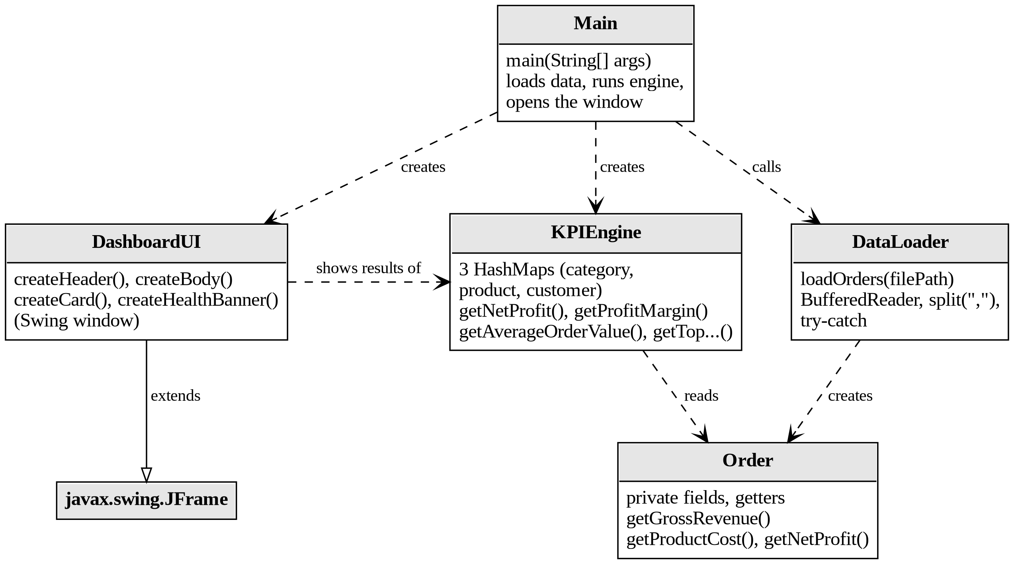
Figure 1: Relationships between the classes

Table 2: Classes and their responsibilities
Class | Responsibility
Order | Model class. Holds the eight fields of one sale as private variables and calculates gross revenue, product cost and net profit.
DataLoader | Reads orders.csv with BufferedReader, skips bad rows with a warning and returns an ArrayList of Order objects.
KPIEngine | Calculation engine. Adds up the totals, fills three HashMap objects and finds the KPIs and the top category, product and customer.
DashboardUI | Extends JFrame. Builds the header, the four KPI cards, the driver summary and the health banner.
Main | Entry point. Calls DataLoader, KPIEngine and DashboardUI in turn.

2.4 Handling Corrupted Records
Data files are rarely perfect. A line may be cut short, a field may be empty or a value may not be a number. Every data row is therefore checked in three ways: it must have exactly eight columns, the quantity must be a whole number and the two prices must be decimal numbers, and the quantity must be above zero while the prices must not be negative. If a check fails, the row is not turned into an Order; instead loadOrders() prints a message such as “expected 8 fields”, “invalid numbers” or “number format error” together with the line number.
The conversion of text to numbers is placed inside a try-catch block that catches NumberFormatException. The catch block prints the warning and the loop moves on to the next line, so one bad row never ends the run, and every good row is still analysed. A second try-catch, around the whole file operation, catches IOException, which is thrown when the file is missing or cannot be read; in that case loadOrders() prints the reason and returns an empty list. main() then finds that the list is empty, shows an error dialog and ends without opening the dashboard. The file is opened in a try-with-resources statement, so it is closed automatically in every case.

2.5 Program Flow
The program runs in seven steps, which are drawn as a flowchart in Figure 2.
- Read the file line by line. The first line is a header and is skipped.
- Skip bad lines and print a warning with the line number and the reason for each one.
- Store the data. Each valid row becomes an Order object in the ArrayList. If there is no valid order at all, an error dialog is shown and the program ends.
- Calculate the totals. KPIEngine adds up revenue and cost and groups the revenue by category, product and customer in three HashMap objects.
- Calculate the KPIs. Net profit, profit margin and average order value are computed, and the top category, product and customer are found.
- Choose the banner. If the margin is 20 percent or higher, the banner is green and reads OPTIMAL; otherwise it is coral red and reads WARNING.
- Display the dashboard. DashboardUI builds the window from the calculated values and makes it visible.
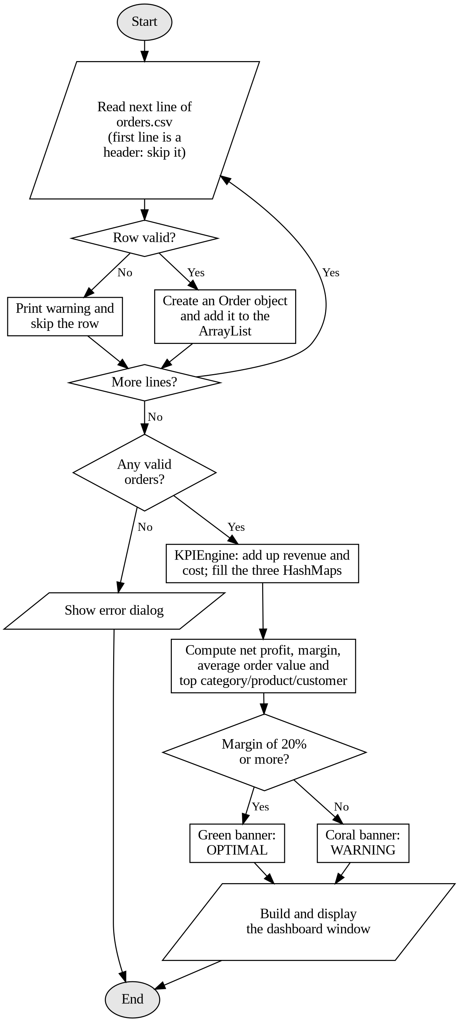
Figure 2: Flowchart of the dashboard program

2.6 Dashboard Layout
The window is titled “Executive Business & KPI Analytics Dashboard” and is divided into four zones, which are described in Table 3.
Table 3: Zones of the dashboard window
Zone | Content | Appearance
Header bar | Dashboard title, project name and a note with the number of orders loaded | Dark navy banner across the top
KPI cards | Gross Revenue, Net Profit, Profit Margin and Average Order Value | Four rounded cards side by side: royal blue, emerald green, teal and purple, with white text
Driver summary | Top category, top product, top customer and number of valid orders | Light-gray framed panel on the left, below the cards
Health banner | OPTIMAL or WARNING message | Forest green if the margin is 20% or higher, coral red if it is lower; at the bottom

All text and numbers are generated from the calculated values, so the window changes automatically when orders.csv changes. Currency values are shown with the rupee sign and two decimal places, for example ₹325,300.00.

2.7 KPI Formulas and Health Rule
Table 4 states the formulas and the health rule precisely.
Table 4: KPI formulas and health rule
Metric | Formula | Shown as
Gross Revenue | Sum of (selling price × quantity) over all orders | Blue card
Net Profit | Gross revenue − total product cost | Green card
Profit Margin | Net profit ÷ gross revenue × 100 | Teal card
Average Order Value | Gross revenue ÷ number of valid orders | Purple card
Health rule | Profit margin of 20% or more | Green OPTIMAL banner; otherwise coral WARNING banner

The total product cost is the sum of the cost price multiplied by the quantity for every order. If the revenue or the number of orders is zero, the engine returns zero instead of dividing by zero. The top category, product and customer are chosen by revenue, not by profit or quantity: the program keeps a running total for each name in a HashMap and then picks the name with the largest total.
Each row of the file is read once, and each lookup or update in a HashMap takes constant time on average, so the running time grows in proportion to the number of records. Finding the top item of a map takes one pass through its keys.

2.8 Assumptions
- The file is analysed after it has been recorded, not while sales are taking place.
- The first line of the file is a header, and the file has eight comma-separated columns in the order of Table 1.
- Each name identifies one category, one product or one customer, so two customers with the same name are treated as one.
- All prices are in rupees, and “top” means the highest total revenue.
- The 20 percent health threshold is fixed in the program.

3. Results and Outputs

3.1 Test Run on the Sample Data
The program was run on the sample file orders.csv, which holds 18 orders placed by seven customers for nine products in four categories. All 18 rows were valid, so none was skipped. The window that opened is shown in Figure 3, and the values it displays are listed in Table 5.
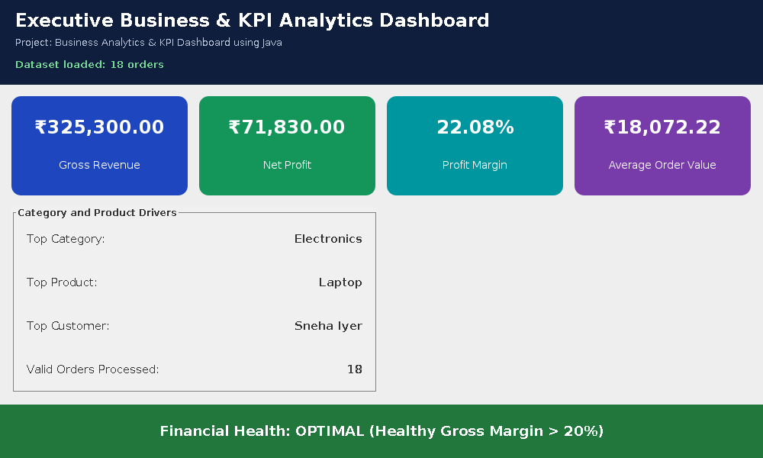
Figure 3: Dashboard window for the sample data

Table 5: Values shown for the sample data
Metric | Value | Basis
Gross Revenue | ₹325,300.00 | Sum of selling price × quantity over 18 orders
Net Profit | ₹71,830.00 | ₹325,300.00 − ₹253,470.00 total product cost
Profit Margin | 22.08% | 71,830 ÷ 325,300 × 100
Average Order Value | ₹18,072.22 | 325,300 ÷ 18 orders
Top Category | Electronics | Revenue of ₹249,000.00
Top Product | Laptop | Revenue of ₹165,000.00
Top Customer | Sneha Iyer | Revenue of ₹89,500.00
Financial Health | OPTIMAL | Margin is above the 20% limit

The gross revenue of ₹325,300.00 less the product cost of ₹253,470.00 gives a net profit of ₹71,830.00, which is 22.08 percent of the revenue. This is 2.08 percentage points above the 20 percent limit, so the banner is green and reads OPTIMAL. Electronics earned the most revenue, mainly through three Laptop and three Smartphone units, and Sneha Iyer was the highest-spending customer.

3.2 Principal Outcomes
- Damaged rows are reported with a warning and skipped, so a bad line never interrupts the run.
- Gross revenue, net profit, profit margin and average order value are calculated from the orders and shown on four colored cards. On the sample data they were ₹325,300.00, ₹71,830.00, 22.08% and ₹18,072.22.
- The top category (Electronics), the top product (Laptop) and the top customer (Sneha Iyer) are found with HashMap objects.
- The health banner reacts to the margin: with 22.08 percent it was green and read OPTIMAL, and when the cost prices were raised in a test file so that the margin fell below 20 percent, it turned coral red and read WARNING.

3.3 Discussion
On the sample data the calculations and the banner behave as designed. Because the health check uses a fixed 20 percent limit, a business with a margin of 20.1 percent is shown as healthy even though it is close to the limit, and because the dashboard shows only totals, it cannot tell whether a profit came from a few large orders or from many small ones. If two names have exactly the same revenue, the program reports the one that its HashMap happens to reach first.

4. Conclusions and Recommendations

4.1 Conclusions
The project shows how a few well-chosen classes can turn a raw sales file into an executive dashboard. Keeping the data in Order, the file handling in DataLoader, the calculations in KPIEngine and the display in DashboardUI means that each part can be understood, tested and changed on its own. Handling bad rows with try-catch blocks makes the program dependable on imperfect data. On the sample file the dashboard showed a gross revenue of ₹325,300.00, a net profit of ₹71,830.00 and a margin of 22.08 percent, named Electronics, Laptop and Sneha Iyer as the top drivers, and displayed the green OPTIMAL banner.

4.2 Work Still to Do
Three features are planned for the next version:
- Charts. Add bar charts of revenue by category and by month, so that trends can be seen as well as totals.
- Date filter. Use the order date, which is read but not yet used, to show the KPIs for a chosen period.
- Export. Save the dashboard figures to a file so that they can be kept and shared.

4.3 Recommendations
When the banner shows a warning, the cost prices of the best-selling items should be reviewed first, because the margin falls when supplier costs rise faster than selling prices. Before the program is used on real business data, the file should be checked for names that contain commas, since such rows would look damaged and be skipped, and the 20 percent threshold should be set to a value that suits the business.

Appendix A: Project Files and Build Instructions
Table 6: Project files
File | Description
Main.java | Entry point that connects the other classes
Order.java | Model class for one sale
DataLoader.java | Reads and validates the CSV file
KPIEngine.java | Calculates the KPIs and the top drivers
DashboardUI.java | Builds the Swing dashboard window
orders.csv | Sample transaction data used for testing

The program is built and started with the following commands:
javac -encoding UTF-8 *.java
java Main
The option -encoding UTF-8 makes the compiler read the rupee sign correctly, and *.java compiles all five source files together. The program must be started from the folder that contains orders.csv; if the file is missing, an error dialog appears instead of the dashboard. A Java Development Kit (JDK) of version 8 or later is required.

Appendix B: Abbreviations
Table 7: Abbreviations used in this report
Abbreviation | Meaning
CSV | Comma-Separated Values
GUI | Graphical User Interface
JDK | Java Development Kit
KPI | Key Performance Indicator
OOP | Object-Oriented Programming

References
[1] Schildt, H., Java: The Complete Reference, 11th edition, McGraw-Hill Education (2018).
[2] Bloch, J., Effective Java, 3rd edition, Addison-Wesley (2018).
[3] Oracle Corporation, The Java Tutorials: Creating a GUI With Swing, https://docs.oracle.com/javase/tutorial/uiswing/.
[4] Few, S., Information Dashboard Design: The Effective Visual Communication of Data, 2nd edition, Analytics Press (2013).

