**Genetic Characterization of Biological Nitrogen Fixation in Landraces of *Zea mays***

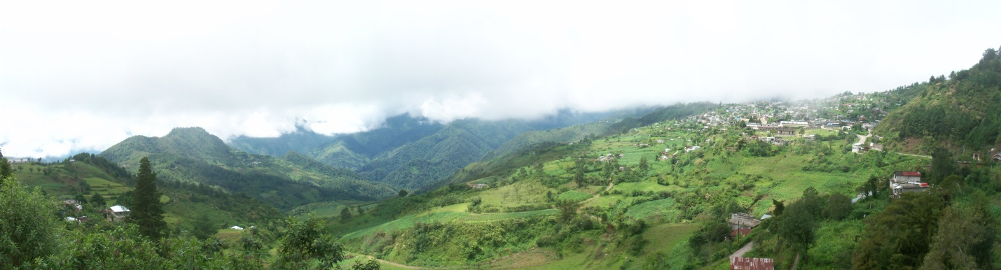

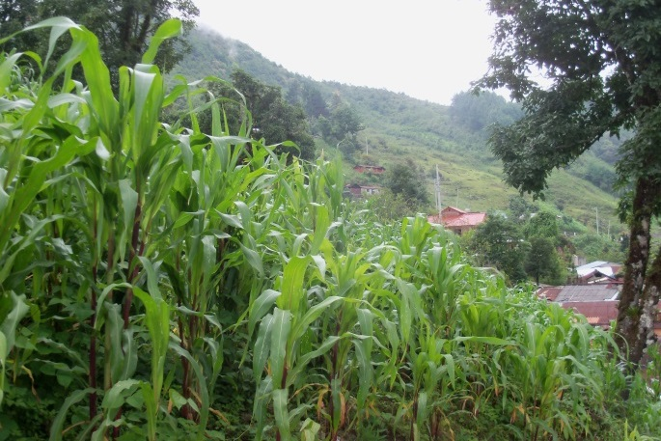 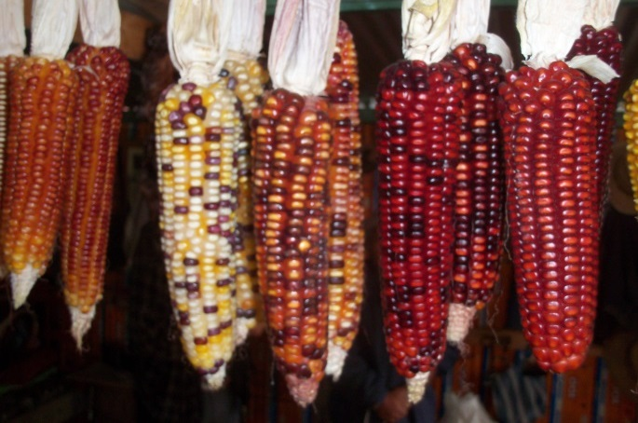

**David O’Donnell**

**<daodonnell@ucdavis.edu>**

**P.I. – Dr. Alan Bennett**

**GGG Qualifying Examination**

**November 22, 2013**

**Plant Reproductive Biology 1111, 9:00AM – 12:00PM**

***Chair:* Abhaya Dandekar, <amdandekar@ucdavis.edu>**

***Transmission Genetics:* Michael Syvanen, <msyvanen@ucdavis.edu>**

***Population Genetics:* Marie Jasieniuk, <mjasien@ucdavis.edu>**

***Molecular Genetics:* Thomas Tai, <thtai@ucdavis.edu>**

***Genomics:* Alan Rose, <abrose@ucdavis.edu>**

**[Images: Personal; Totontepec Villa de Morelos, Oaxaca, Mexico]**

**I. SPECIFIC AIMS**

Totontepec Villa de Morelos (hereafter Totontepec) is a small municipality in the state of Oaxaca, in the far south of Mexico. At ~1840 m elevation, the mild climate (~15.4 + 4⁰C) exhibits substantial rainfall (2163 mm annually), with the wettest months occurring between June and October [1]. Maize fields in the indigenous community of Totontepec have been reported to be farmed using traditional cultivation practices without fertilizers or pesticides [2], and several fields have exhibited low NO3- levels. Interestingly, the landrace maize of this village (*Zea mays* L. *spp. Mays*, hereafter maize) performs well under such conditions, and reaches heights greater than 5 m at maturity. This landrace is characterized by the presence of thick, abundant aerial roots that secrete significant quantities of root exudate (*a.k.a.* mucilage). Our research collaborative has conducted numerous studies and field trials to indicate a vital role for mucilage in attracting diazotrophic microbes with an abundance of polysaccharides, thereby facilitating nitrogen fixation within this landrace. This forms the rationale for this proposal. I aim to genetically characterize loci governing nitrogen fixation and aerial root development in *Zea mays*, and also to infer correlations between these traits. Genetic elucidation of nitrogen fixation in maize would have profound impacts on global maize production, with the potential to drastically reduce both production costs and harmful effects on the environment.

***Overall Hypothesis:*** *Nitrogen fixation is a quantitative trait governed by a moderate number of small-effect loci, indicative of a mild domestication bottleneck and adaptive introgression from an extant wild relative (Zea mays spp. Mexicana). Identified loci will be enriched for regulatory factors governing aerial root development and root exudate abundance, traits which may facilitate symbiotic diazotrophic association via chemoattraction.*

**Aim 1: Investigate indicators of nitrogen fixation: Linkage mapping to genetically characterize differential nitrogen isotope assimilation and aerial root abundance.**

*Hypothesis: A moderate number of small-effect loci will contribute to the capacity for nitrogen fixation, due to presence of this trait prior to domestication. Aerial root development will show correlations to this process.*

I will generate a mapping population derived from two parental genotypes – Totontepec maize and B73. At each generation, and culminating with phenotypic assessment of F4 individuals, I will identify significant marker associations relative to 15N values and aerial root abundance. I hypothesize that aerial roots and mucilage production are directly linked to nitrogen fixation via diazotrophic chemo-attraction, and the presence of aerial roots in ancestral teosinte populations suggests a trait architecture governed by multiple QTL.

**Aim 2: Investigate the prevalence of nitrogen fixation in populations of *Zea mays* from varying regions and elevations.**

*Hypothesis: There will be greater evidence of nitrogen fixation in highland maize varieties, compared to lowland maize, indicative of adaptive introgression from spp. Mexicana. Improved lines will show minimal evidence of nitrogen fixation due to selective pressures for high performance in fertilizer-rich conditions.*

I will investigate patterns of 15N abundance and aerial root development in *Zea mays* at three levels – pre-domestication, post-domestication, and post-improvement. At the level of pre-domestication, I anticipate greatest nitrogen fixation in *Zea mays spp. Mexicana* (compared to *spp. Parviglumis*) due to the presence of large aerial roots that provide abundant supplies of mucilage to attract diazotrophic microbes. At the level of post-domestication, I anticipate greatest fixation in highland maize varieties due to geographic overlap and interfertility with *spp. Mexicana*. Finally, I expect minimal evidence of fixation in post-improvement lines due to recent selective pressures for high performance in fertilizer-rich conditions.

**Aim 3: Comparative genome analysis within *Zea mays* populations segregating for indicators of nitrogen fixation.**

*Hypothesis: I anticipate significant admixture between highland maize varieties and spp. Mexicana, as well as selective sweeps unique to such highland varieties. I expect alternate alleles to be found at such loci in improved varieties, indicative of selection against diazotrophic association during modern maize improvement.*

I will perform a comparative genome analysis of all *Zea* varieties specified in *Table 1*, with the goal to identify patterns of kinship, admixture, and evidence of selection in varieties exhibiting biological nitrogen fixation.

**II. BACKGROUND and SIGNIFICANCE**

Maize, with a global output exceeding 844 million tons in 2010, is the most vital crop in the world [3]. Aside from traditional use for human consumption, maize has important use as livestock feed, cooking oil, and biofuel [4]. The projected global human population of 9 billion in the year 2050 is expected to require 70% more food than is presently produced, a major portion of which must come from maize [4]. With the advent of the Green Revolution, reported increases in yield have been due to intense application of synthetic nitrogen fertilizers. 60% of such fertilizers are used for cereal production [5], which entirely doubled between 1966 and 2000 [4, 6]. Yet fertilizer-use by cereals is inefficient, at a rate of less than 50% [7]. This inefficiency results in nitrate leaching into soil and groundwater supplies, thereby generating profound environmental concerns and health risks [8]. Furthermore, present rates of fertilizer over-application cannot be sustained [9], leaving an ever-growing need to develop alternative solutions for increased crop yield. This has led to recent efforts and accumulating evidence to indicate nitrogen fixation in cereal grains of agronomic importance [5, 8, 10, 11, 12]. As stated previously, our research collaborative has accrued evidence for biological nitrogen fixation in Totontepec maize (highlighted in *Preliminary Results)*. With this foundation, I will work to genetically characterize nitrogen fixation and aerial root development in *Zea mays*.

In recent years, genetic mapping in maize has been greatly enhanced by development of the maize Nested Association Mapping panel [13]. With a joint-linkage association approach, this population has allowed for the genetic characterization of complex traits. Traits that were not intensely selected during maize domestication and improvement have trait architectures governed by numerous loci of small effect. Flowering time and leaf architecture, for instance, each are controlled by more than 30 QTL [14, 15]. This is in stark contrast to the genetic architectures for known domestication and improvement traits. *Teosinte branched1* (*tb1*, governing apical dominance) and *teosinte glume architecture1* (*tga1*, governing seed coat lignification) are two loci of extreme effect that govern radical differences between teosinte and modern maize domesticates [16, 17]. In addition, kernel carotenoid content, brought under intense selection within the past century due to its beneficial health effects for humans and livestock, is governed by only three loci of large effect [3, 18, 19, 20]. This forms the rationale for aim 1. Based upon the hypothesis that nitrogen fixation in maize is governed by aerial root development and mucilage production [to act as a chemo-attractant for diazotrophic microbes], this trait would have been present in ancestral teosinte populations – namely, *Zea mays spp. Mexicana* (hereafter *Mexicana*) which develops an abundance of aerial roots (Figure 4A). Following the model of trait architecture for pre-domestication traits, and including mild selection pressures by humans, I anticipate a moderate number of loci of small effect contributing to nitrogen fixation in maize.

Modern maize has a complex evolutionary history. Due to its tremendous phenotypic diversity [21, 22], maize originally was thought to be the product of multiple domestication events [23]. It now has been proven that all maize falls within a monophyletic clade derived from the wild teosinte *Z. mays spp. Parviglumis* (hereafter *Parviglumis*) [23], domesticated more than 8,700 years CBP in the Balsas River Valley [24]. Sequence analysis originally identified highland maize as genetically most similar to *Parviglumis*, which resides in lowland regions below ~1,800 m elevation [23]. Recent work has elucidated this paradox. Relative kinship between highland maize and *Parviglumis* has been affected by significant admixture between highland maize and the related *Mexicana* (Figure 4B) [25, 26, 27], which resides in highlands above ~1,700 m elevation [23] and diverged from *Parviglumis* ~61,000 years ago [28]. This forms the rationale for aims 2 and 3. Due to the presence of abundant aerial roots in *Mexicana*, and lack thereof within *Parviglumis* (Figure 4A), I hypothesize that aerial root formation, and thus nitrogen fixation in maize, were the products of adaptive introgression from *Mexicana*. I anticipate greater presence of nitrogen fixation and aerial root abundance in highland maize varieties, with selective sweeps indicative of selection for prominent aerial root development. Furthermore, I expect nitrogen fixation to be largely absent in improved lines, due to drastically reduced need for this process and selection for reallocation of energy to other physiological processes.

**III. PRELIMINARY STUDIES**

During months of intense rainfall, Totontepec maize aerial roots produce large amounts of complex oligosaccharide mucilage, rich in arabinose, fucose and galactose (Figure 1). The complex sugars in mucilage may be catabolized to provide free sugars capable of supporting bacterial growth and nitrogen fixation. Mucilage was tested for nitrogenase activity using the acetylene reduction assay (ARA) [29]. ARA was used to assay seedlings, underground roots, isolated aerial roots (without mucilage), and mucilage collected from Totontepec maize plants grown both in Totontepec and in Madison, WI, USA. No ARA activity was detected in underground roots or intact 3-week old seedlings before aerial root formation and mucilage production (data not shown). In contrast, significant ARA activity was detected in mucilage collected both in Totontepec and in Madison (Figure 2A), indicating nitrogen fixation. The ARA for mucilage from Totontepec maize grown in Madison suggests heritable factors involved in recruitment of diazotrophic microbes.

As with Totontepec maize, *Mexicana* also produces extensive aerial roots (Figure 4A). ARA was performed on *Mexicana* mucilage to measure endogenous nitrogenase activity, and acetylene reduction was readily observed (Figure 2A). This suggests that diazotrophic association [via mucilage production] is an ancient trait in *Zea mays* that has been amplified in the Totontepec landrace. To assess the mucilage characteristics that support nitrogen fixation, two phylogenetically distinct nitrogen-fixing bacteria [*Herbaspirillum seropedicae* and *Azospirillum brasilense*] were embedded in Totontepec maize mucilage; both bacteria showed readily detectable ARA activity (Figure 2B). Bacterial nitrogenase requires a low oxygen environment (<5% O2 concentration) as well as an abundant carbon source to derive energy for this process [8, 30]. With regard to these requirements, free-oxygen concentration was measured in mucilage of Totontepec maize and *Mexicana*. Oxygen concentration was <5%, indicating that the mucilage serves as a barrier to O2 diffusion and provides a microaerobic environment compatible with nitrogen fixation [31] (Figure 2C).

In 2010, 2011, and 2012, % Nitrogen derived from atmosphere (%Ndfa) was assessed in Totontepec field trials using previously described methods of 15N natural abundance [32, 33, 34]. Non-nitrogen-fixing plants were used as references, and atmospheric nitrogen fixation was evaluated in Totontepec maize and a conventional variety, Maiz Blanco Conasupo (Figure 3A). δ15N values for Totontepec maize were significantly lower than those of the reference plant species and the conventional maize variety, indicating nitrogen fixation in Totontepec maize. δ15N values of Totontepec maize grown in field trials in Totontepec were determined at a single developmental time-point in 2010, and at five developmental time-points in 2011 and 2012 (Figure 3B). At all time-points, δ15N values of Totontepec maize were significantly lower than those of reference plants. In addition, Totontepec maize was grown in a field trial in Davis, CA, USA, alongside five conventional maize varieties and a number of reference plant species (Figure 3C). Collective results indicate that nitrogen fixation is occurring within this maize landrace, and that this characteristic is heritable and expressed outside of the native Totontepec environment. Conventional maize lines do not show significant atmospheric N2 fixation or the ability to thrive in N-depleted soil, lending support that diazotrophic association was selected against during maize improvement.

**IV. EXPERIMENTAL DESIGN**

**Aim 1: Investigate indicators of nitrogen fixation: Linkage mapping to genetically characterize differential nitrogen isotope assimilation and aerial root abundance.**

*Hypothesis: A moderate number of small-effect loci will contribute to the capacity for nitrogen fixation, due to presence of this trait prior to domestication. Aerial root development will show correlations to this process.*

The starting material for this aim will be an F1 hybrid population (B73 x Totontepec maize parental lines), to be advanced to the F4 generation. Each generation will consist of 1,500 individuals, to give high likelihood to detect QTL of small-effect (>1% of total phenotypic variability) [4]. All generations will be grown and maintained in a greenhouse in Davis, CA. Molecular markers will be designed via genotyping-by-sequencing, as previously described [35]. With each generation, I will genotype, phenotype via 15N natural abundance measurements of leaf tissue from the third-youngest leaf [32, 33, 34], and simultaneously phenotype all plants for aerial root development. Aerial root development will be assessed by monitoring the total number of nodes with aerial roots and recording total aerial root abundance.

To create each subsequent generation, I will utilize Bulked Segregant Analysis (BSA) [36], selecting highest and lowest performers on the basis of 15N content and aerial root development. I will perform QTL analysis using QTL cartographer [37], attempting to obtain finer resolution with each generation. I will identify QTLs via Multiple Interval Mapping (MIM), using a threshold LOD score > 2.5 to indicate significant QTL. I will estimate total heritability via single-factor ANOVA, and subsequently estimate dominance and additive effects of QTL [37]. I will test for significant epistatic interactions using 2-way ANOVA, and most importantly, I will determine whether correlations exist between δ15N values and aerial root development using Pearson’s correlation. Finally, I will compare identified loci to QTL identified in previous mapping studies focusing on aerial root formation and 15N abundance [11, 38, 39], with common overlap serving to strengthen any QTL in question.

**Aim 2: Investigate the prevalence of nitrogen fixation in populations of *Zea mays* from varying regions and elevations.**

*Hypothesis: There will be greater evidence of nitrogen fixation in highland maize varieties, compared to lowland maize, indicative of adaptive introgression from spp. Mexicana. Improved lines will show minimal evidence of nitrogen fixation due to selective pressures for high performance in fertilizer-rich conditions.*

This aim will investigate patterns of aerial root development and 15N abundance in varieties of *Zea mays* at levels of pre-domestication, post-domestication (highland and lowland varieties), and improvement. All varieties are specified in *Table 1*. Varieties will be grown in random block design in replicate field trials in Davis, CA, and Madison, WI. 28 plants per genotype will be monitored over a 16 week period. I will use 15N abundance of leaf tissue to assess nitrogen fixation at 8 and 12 weeks post-transplantation [32, 33, 34]. I will monitor aerial root development over this time course by counting the total number of nodes with aerial roots. At the end of the measuring period, I will record the total number of aerial roots per plant, per genotype, and I will record thickness of 60 aerial roots of the second node for each genotype. Aerial root thickness will be assessed by measuring the diameter of the aerial root cross-section, cut from the base of the root.

To assess nitrogenase activity, I will sample 5 replicates of each variety for root exudates, rhizosphere, stem, leaf, aerial root and underground root. Although preliminary studies indicate only mucilage as the primary location of diazotrophic association, ARA tests on multiple tissue types of multiple plant genotypes will serve to strengthen this initial finding. With the aforementioned samples, I will perform ARA to assess nitrogenase activity [29]. Ultimately, this aim will serve to identify patterns [with regard to nitrogen fixation, aerial root development, and nitrogenase activity in mucilage] among *Zea* genotypes from various regions and elevations, at levels of pre-domestication, post-domestication, and post-improvement.

**Aim 3: Comparative genome analysis within *Zea mays* populations segregating for indicators of nitrogen fixation.**

*Hypothesis: I anticipate significant admixture between highland maize varieties and spp. Mexicana, as well as selective sweeps unique to such highland varieties. I expect alternate alleles to be found at such loci in improved varieties, indicative of selection against diazotrophic association during modern maize improvement.*

The purpose of this aim will be to identify key genome differences connected to indicators of nitrogen fixation, again at the levels of pre-domestication, post-domestication, and improvement. I will utilize genotyping-by-sequencing (GBS) of low-copy regions of the maize genome at 5x coverage to obtain sequence data for each variety of *Zea* specified in *Table 1* [35], sequencing 13 individuals of each variety. By inferring ancestral allele frequencies of modern maize based on averages across maize domesticates [27], I will search for loci with decreases in nucleotide diversity compared to wild progenitors, increases in LD, and alteration in nucleotide/allele frequencies between populations (*a.k.a.* selective sweeps and further evidence for selection) using the cross population composite likelihood ratio (XP-CLR) [26]. The majority of phenotypic variation in maize has been shown to be the result of altered gene transcription, as opposed to change in protein-coding sequences [3, 40]. With this in mind, I expect identified loci to be enriched for transcription factors and other regulatory elements affecting gene expression. I will test this hypothesis using *ab initio* methods to identify regulatory elements. Targeted enrichment of low-copy regions through GBS will allow for identification of any regulatory elements pertinent to altered gene expression.

**V. REFERENCES**

1. Schwarz, Tobias. "Climate-Data.org." Climate: Totontepec Villa De Morelos. N.p., n.d. Web. 21 Oct. 2013. <http://en.climate-data.org/location/334810/>
2. Estrada, P. *et al.* (2002). A N2-Fixing Endophytic *Burkholderia Sp.* Associated with Maize Plants Cultivated in Mexico. *Canadian Journal of Microbiology* **48**, 285–294.
3. Wallace, J.G. *et al.* (2013). Entering the Second Century of Maize Quantitative Genetics. *Heredity*  **00**, 1-9.
4. Yan, J. *et al.* (2011). Association Mapping for Enhancing Maize ( L.) Genetic Improvement.  *Crop Science* **51**, 433-449.
5. Montañez, A. *et al.* (2012). Effects of Inoculation on Growth Promotion and Biological Nitrogen Fixation in Maize (*Zea mays* L.) under Greenhouse and Field Conditions. *Bas. Res. Journal of Ag. Sci. and Rev.* **2**, 102-110.
6. Khush, G.S. (2001). Green revolution: The way forward. *Nat. Rev. Genet.* **2**: 815–822.
7. Halvorson, A.D. *et al.* (2002). Tillage system and crop rotation effects on dry land crop yields and soil carbon in the Central Great Plains. *Agron. J.* **94**: 1429-1436.
8. Santi, C *et al.* (2013). Biological Nitrogen Fixation in Non-Legume Plants. *Annals of Botany* **111**, 743–767.
9. Robertson, G.P. *et al*. (2009). Nitrogen in agriculture: Balancing the cost of an essential resource.  *Annu. Rev. Environ. Resour.* **34**, 97–125.
10. Montañez, A. *et al.* (2008). Biological Nitrogen Fixation in Maize (*Zea mays* L.) by 15N Isotope- Dilution and Identification of Associated Culturable Diazotrophs. *Biology and Fertility of Soils*  **45**, 253–263.
11. Coque, M. *et al.* (2006). Genetic Variation and QTLs for 15N Natural Abundance in a Set of Maize Recombinant Inbred Lines. *Field Crops Research* **97**, 310–321.
12. Christiansen-Weniger, C. (1998). Endophytic Establishment of Diazotrophic Bacteria in Auxin- Induced Tumors of Cereal Crops. *Critical Reviews in Plant Sciences* **17**, 55–76.
13. McMullen, M. D. *et al.* (2009). Genetic Properties of the Maize Nested Association Mapping Population.” *Science* **325**, 737–740.
14. Buckler, E. S. *et al.* (2009). The Genetic Architecture of Maize Flowering Time.” *Science* **325**, 714– 718.
15. Tian, *et al.* (2011). Genome-Wide Association Study of Leaf Architecture in the Maize Nested Association Mapping Population. *Nature Genetics* **43**, 159–162.
16. Doebley, J. *et al.* (1997). The evolution of apical dominance in maize. *Nature* **386**, 485–488.
17. Wang, H. *et al.* (2005). The Origin of the Naked Grains of Maize. *Nature* **436**, 714–719.
18. Buckner, B. *et al.* (1990). Cloning of the *yl* locus of maize, a gene involved in the biosynthesis of carotenoids. *Plant Cell* **2**: 897–876.
19. Harjes, C.E. *et al.* (2008). Natural genetic variation in lycopene epsilon cyclase tapped for maize biofortification. *Science* **319**, 330–333.
20. Yan, J. *et al.* (2010). Rare genetic variation at *Zea mays* crtRB1 increases beta-carotene in maize grain. *Nat Genet* **42**, 322–327.
21. Prasanna, B.M. (2012). Diversity in Global Maize Germplasm: Characterization and Utilization.  *Journal of Biosciences* **37**, 843–855.
22. Mackay, T.F.C. (2009). A-Maize-Ing Diversity. *Science* **325**, 688–689.
23. Matsuoka, Y. *et al.* (2002). A Single Domestication for Maize Shown by Multilocus Microsatellite Genotyping. *Proceedings of the National Academy of Sciences* **99**, 6080– 6084.
24. Piperno, D.R. *et al.* (2009). Starch Grain and Phytolith Evidence for Early Ninth Millennium BP Maize from the Central Balsas River Valley, Mexico. *Proceedings of the National Academy of Sciences* **106**, 5019–5024.
25. Hufford, M.B. *et al.* (2013). The Genomic Signature of Crop-Wild Introgression in Maize. *PLoS Genetics* **9**, e1003477.
26. Hufford, M.B. *et al.* (2012). Comparative Population Genomics of Maize Domestication and Improvement. *Nature Genetics* **44**, 808–811.
27. van Heerwaarden, J. *et al.* (2010). Genetic signals of origin, spread, and introgression in a large sample of maize landraces. *PNAS* **108**, 1088–1092.
28. Ross-Ibarra, J. *et al.* (2009). Historical Divergence and Gene Flow in the Genus Zea. *Genetics* **181**, 1399–1413.
29. Dilworth, M.J. (1966). Acetylene reduction by nitrogen fixing preparations from *Clostridium pasteurianum*. *Biochim. biophys. Acta* **127**, 285-94.
30. Hunt, S. and Layzell, D.B. (1993). Gas exchange of legume nodules and the regulation of nitrogenase activity. *Ann. Rev. Pl. Phys. Pl. Mol. Bio.* **44**, 483-511.
31. Marchal, K. and Vanderleyden, J. (2000). The‘ Oxygen Paradox’ of Dinitrogen-Fixing Bacteria.  *Biology and Fertility of Soils* **30**, 363–373.
32. Boddey, R.M. (1987). Methods for quantification of nitrogen fixation associated with gramineae.  *CRC Crit. Rev. Plant Sci.* **6**, 209-266.
33. Boddey, R.M. *et al.* (2001). Use of the 15N natural abundance technique for the quantification of the contribution of N2 fixation to sugar cane and other grasses. *Aust. J. Plant. Physiol.* **28**, 889-895.
34. Bremer, E., and Van Kessel, C. (1990). Appraisal of the Nitrogen-15 Natural-Abundance Method for Quantifying Dinitrogen Fixation. *Soil Science Society of America Journal* **54**, 404–411.
35. Elshire, R.J. *et al.* (2011). A Robust, Simple Genotyping-by-Sequencing (GBS) Approach for High Diversity Species. *PLoS ONE* **6**, e19379.
36. Michelmore, R.W. *et al.* (1991). Identification of markers linked to disease-resistance genes by bulked segregant analysis: a rapid method to detect markers in specific genomic regions by using segregating populations. *Proc. Natl. Acad. Sci.* **88**, 9828-9832.
37. Wang, S., C. J. Basten, and Z.-B. Zeng (2012). Windows QTL Cartographer 2.5. Department of Statistics, North Carolina State University, Raleigh, NC. (http://statgen.ncsu.edu/qtlcart/WQTLCart.htm)
38. Mano, Y. *et al.* (2005). QTL Mapping of Adventitious Root Formation under Flooding Conditions in Tropical Maize (*Zea mays.* L.) Seedlings. *Breeding Sciences* **55**, 343–347.
39. Mano, Y. *et al.* (2009). QTL Mapping of above-Ground Adventitious Roots during Flooding in Maize x Teosinte ‘*Zea nicaraguensis*’ Backcross Population. *Plant Root* **3**, 3–9.
40. Doebley, J. *et al.* (2006). The molecular genetics of crop domestication. *Cell* **127**, 1309-1321.
41. "México." Localidades De. N.p., n.d. Web. 18 Oct. 2013. <mexico.pueblosamerica.com>

**VI. FIGURES**

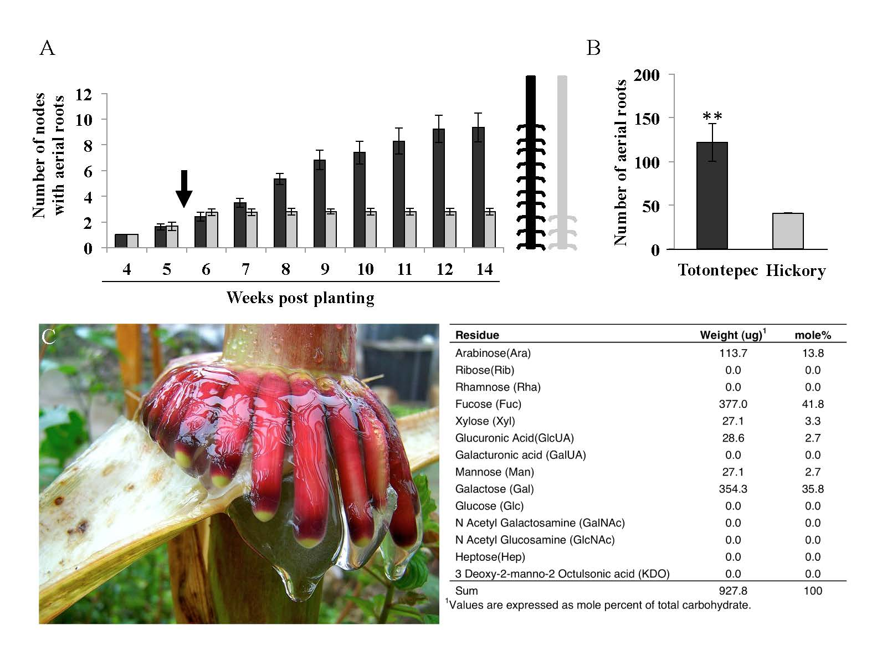

**Figure 1. Aerial Roots and Mucilage of Totontepec maize.** The aerial roots of Totontepec maize (left) secrete large quantities of mucilage between 3 and 6 months after planting. The mucilage is carbohydrate-rich, with the composition dominated by arabinose, fucose and galactose.

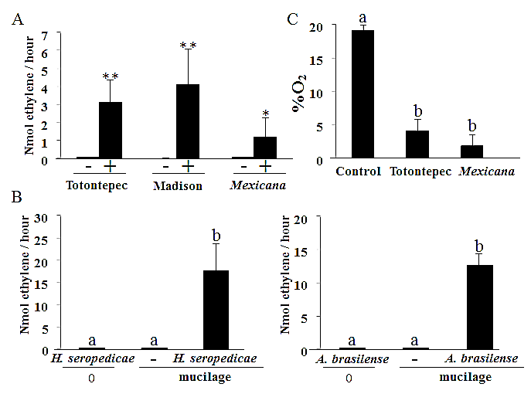

**Figure 2: The mucilage produced by Totontepec maize supports nitrogen fixation.** A) Mucilage of Totontepec maize [collected in Totontepec or in Madison, WI] and of *Mexicana* display strong acetylene reduction activity. (-, no acetylene; +, 10% acetylene). Asterisks indicate significant differences (\**P* < 0.05; \*\**P* < 0.01, Mann-Whitney test). B) *Herbaspirillum seropedicae* and *Azospirillum brasilense* display acetylene reduction activity when added to non-fixing mucilage, whereas the same mucilage supplemented with sterile medium (-) or the same bacteria without mucilage (0) do not. C) Oxygen concentration at 7 mm inside of the mucilage. Means and s.e.m. are shown. Different letters indicate statistically supported groups (Kruskal-Wallis test).

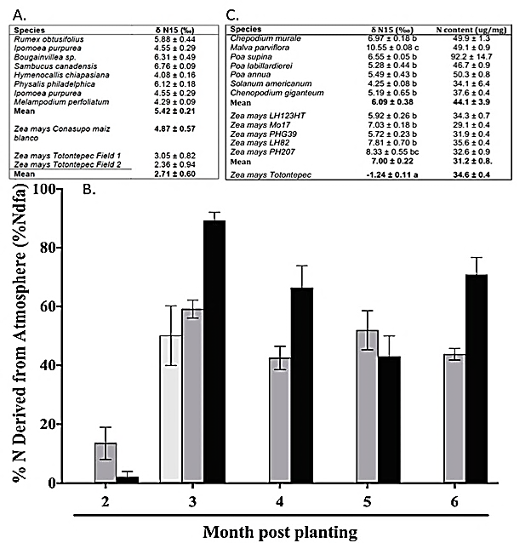

**Figure 3: Natural abundance 15N determinations.** A) δ15N values from Totontepec maize, a conventional maize variety (Maiz Blanco Conasupo) and reference plants grown in Totontepec, 3 months after planting. Values are given as mean and s.e.m. Different letters indicate statistically supported groups (one-way ANOVA test, *P* < 0.05).B) Totontepec maize plants grown in Totontepec during 2010 (light grey bars), 2011 (dark grey bars) and 2012 (black bars) were evaluated for proportion of N derived from biological N2 fixation (%Ndfa). Percentages were calculated using δ15N of reference plants. Values are plotted as mean and s.e.m. C) δ15N and total N values from Totontepec maize, conventional maize lines and reference plants from 3 months post-planting grown in Davis, CA. Values are given as mean and s.e.m. Different letters indicate statistically supported groups (one-way ANOVA, *P* < 0.05).

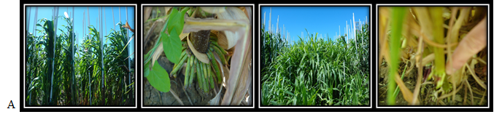

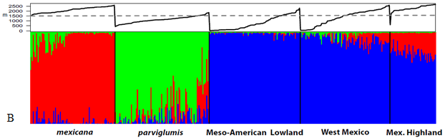

**Figure 4: Model of Adaptive introgression.** (A). Whole plant and aerial root morphology of *Mexicana* (two at left) and *Parviglumis* (two at right). (B) Admixture analysis between *Zea mays* subspecies (borrowed from [27]). (Lower) Bar plot of assignment values for samples of Mexican accessions: Mexicana (red), parviglumis (green), and mays (blue). (Upper) Solid black line indicates the altitude for each sample. The dotted line marks the minimum altitude at which mexicana occurs.

|  |  |  |
| --- | --- | --- |
| ***Zea* Variety** | **Evolutionary Status** | **Origin Elevation** |
| *Z. diploperrenis* | Pre-domestication | 1,400 – 2,400 m |
| *Z. mays spp. Parviglumis* | Pre-domestication | < 1,800 m |
| *Z. mays spp. Mexicana* | Pre-domestication | > 1,700 m |
| Tipikal, YC | Post-domestication | 19 m |
| Jaltepec de Candayoc, OA | Post-domestication | 90 m |
| San Juan Comaltepec, OA | Post-domestication | 650 m |
| Santiago Choapam, OA | Post-domestication | 900 m |
| Jala, NA | Post-domestication | 1,080 m |
| Santa Maria Temaxcalapa, OA | Post-domestication | 1,100 m |
| San Jose Chinantequilla, OA | Post-domestication | 1,160 m |
| San Ildefonso Villa Alta, OA | Post-domestication | 1,230 m |
| San Cristobal Lachirioag, OA | Post-domestication | 1,280 m |
| Santiago Tepitongo, OA | Post-domestication | 1,530 m |
| San Marcos Moctum, OA | Post-domestication | 1,560 m |
| Totontepec – field Carmita, OA | Post-domestication | 1,840 m |
| Totontepec – field Vicente, OA | Post-domestication | 1,840 m |
| Totontepec – field Vidal, OA | Post-domestication | 1,840 m |
| Venustiano Carranza, DG | Post-domestication | 1,970 m |
| Santa Maria Tiltepec, OA | Post-domestication | 1,990 m |
| San Miguel Metepec, OA | Post-domestication | 2,600 m |
| B73 inbred line | Post-improvement | N/A |
| Mo17 inbred line | Post-improvement | N/A |
| Hickory King | Post-improvement | N/A |
| B73 x Mo17 hybrid | Post-improvement | N/A |

**Table 1: Varieties of *Zea* utilized in Aims 2 and 3.** All *Zea* varieties listed with evolutionary status [pre-domesticate (light red), post-domesticate (blue), or post-improvement (purple)], as well as natural elevation. Inbred line elevation not applicable due to recent development within the past century. All elevation information was obtained from <mexico.pueblosamerica.com> [41].