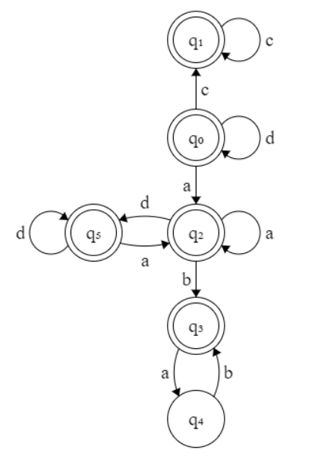

$${\left(d | a\right)}^{*}{\left(ab\right)}^{*}|c^{*}$$

|  |  |  |  |  |
| --- | --- | --- | --- | --- |
|  | a | b | c | d |
| 0 | $$q_{2}$$ |  | $$q_{1}$$ | $$q_{0}$$ |
| 1 |  |  | $$q_{1}$$ |  |
| 2 | $$q_{2}$$ | $$q_{3}$$ |  | $$q_{5}$$ |
| 3 | $$q_{4}$$ |  |  |  |
| 4 |  | $$q_{3}$$ |  |  |
| 5 | $$q_{2}$$ |  |  | $$q_{5}$$ |

$$\left\{q_{0}, q_{1},q_{2},q_{3},q_{4},q_{5}\right\}$$

$$a: \left\{q_{0}\right\},\left\{q_{1}\right\},\left\{q_{3}\right\},\left\{q_{2},q_{4},q_{5}\right\}$$

$$b: \left\{q_{0}\right\},\left\{q_{1}\right\},\left\{q_{3}\right\},\left\{q_{5}\right\},\left\{q_{2},q_{4}\right\}$$

$$d: \left\{q_{0}\right\},\left\{q_{1}\right\},\left\{q_{3}\right\},\left\{q_{5}\right\},\left\{q_{2}\right\},\{q_{4}\}$$