Full Stack Development with MERN
Project Documentation

1. Introduction
• Project Title: Flightfinder: Navigating your air travel options
Team Members:
Team Size: 4
Team Leader:
- Kalepu Meghana– Full Stack Development (Backend APIs, Database Integration, Project Integration) & Frontend Support & Testing Team Members:
- Lammatha Chandini– Documentation & Presentation Support
- Katna Lavanya– Frontend Development (UI Components & Design)
- Chinthapalli Lallitha-Project Deployment

2. Project Overview
• Purpose:
The purpose of this project is to develop a full-stack web application where users can search flights, book tickets, and view their bookings.
The system also provides an Admin Panel to manage flights and monitor all bookings.
This project demonstrates real-world MERN stack development skills.
- Features:
👤 User Features:
- User Registration & Login
- View Available Flights
- Book Flight Tickets
- Select Journey Date
- View My Bookings
- Cancel Booking

👨💼 Admin Features:
- Admin Login
- Add New Flight
- Edit Flight Details
- Delete Flights
- View All Flights
- View All Bookings

3. Architecture
Frontend (Client – React)
- Built using React.js
- Component-based architecture
- React Router for navigation
- Axios for API calls
- CSS for styling
- Runs on: http://localhost:3000
Frontend communicates with backend using REST APIs.
Backend (Server – Node.js + Express)
- Built using Node.js and Express.js
- REST API architecture
- Password hashing using bcrypt
- CORS enabled
- JSON request handling
- Runs on: http://localhost:6001
Database (MongoDB)
MongoDB used as NoSQL database.
Collections:
    - Users
    - Flights
    - Bookings
Schemas created using Mongoose.

4. Setup Instructions
• Prerequisites:
- Node.js (v16 or above)
- MongoDB (Local or Atlas)
- Postman
- VS Code
Installation:
Step 1: Clone Project
git clone <your-repo-link>
Step 2: Backend Setup
cd server
npm install
npm start
Backend runs on:
http://localhost:6001
Step 3: Frontend Setup
cd client
npm install
npm start
Frontend runs on:
http://localhost:3000

5. Folder Structure
- Client: client/
│
├── src/
│ ├── components/
│ ├── pages/
│ ├── styles/
│ ├── App.js/
│ └── index.js

- Server:
server/
│
├──schemas.js
├── index.js
├──package.json
6. Running the Application
- Start MongoDB
- Start Backend:
npm start
- Start Frontend:
npm start
Open:
- Frontend → http://localhost:3000
- Backend → http://localhost:6001

7. API Documentation
- Authentication:
Method Endpoint Description
POST /register Register user
POST /login Login user

- Flights:

Method Endpoint
GET /fetch-flights
POST /add-flight
PUT /update-flight/:id
DELETE /delete-flight/:id

- Bookings:
Method Endpoint
POST /book-flight
GET /fetch-bookings/:userId
GET /all-bookings
DELETE /cancel-booking/:id

8. Authentication
- Passwords encrypted using bcrypt
- User login validation
- Admin access for flight management
- Session stored in frontend (localStorage)

9. User Interface
• The UI includes:

- Home Page

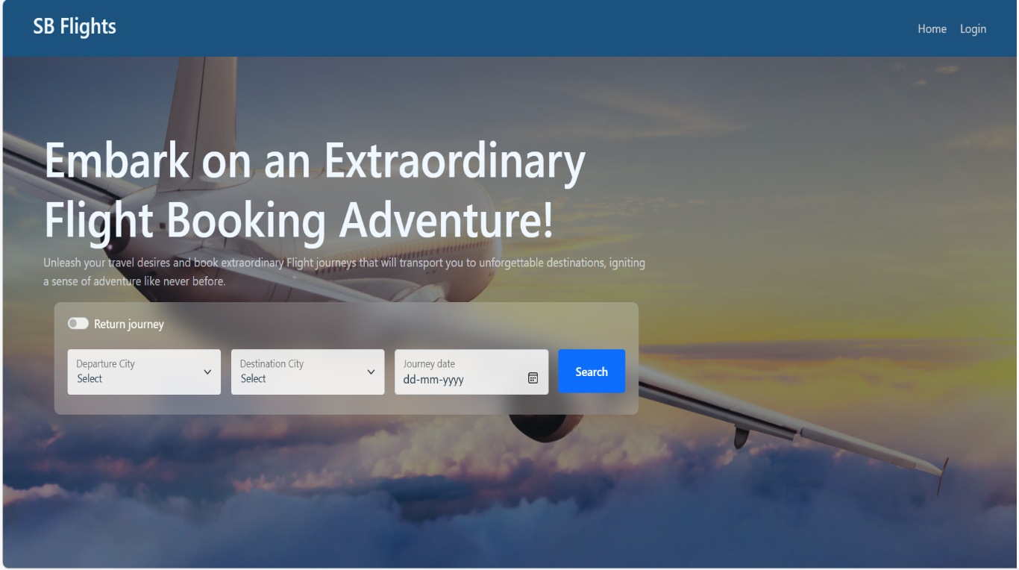

- Login Page

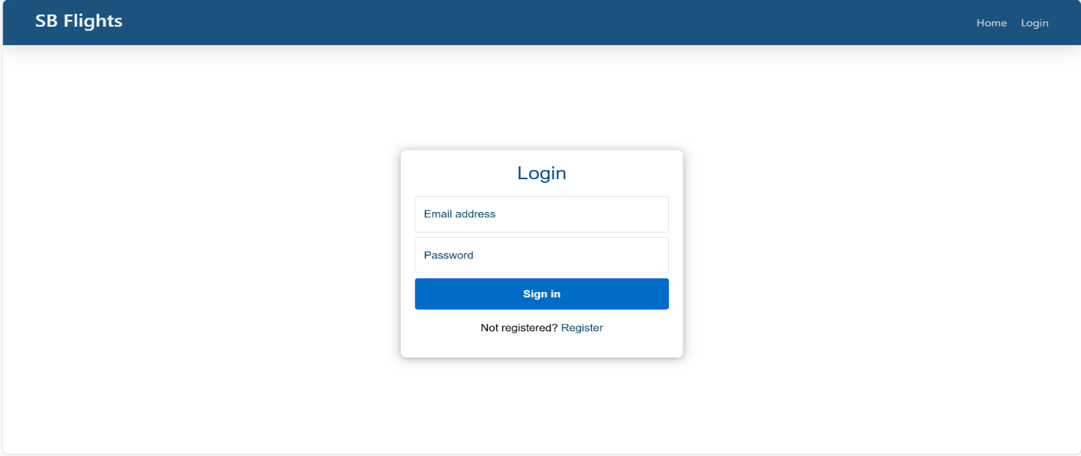

- Registration Page 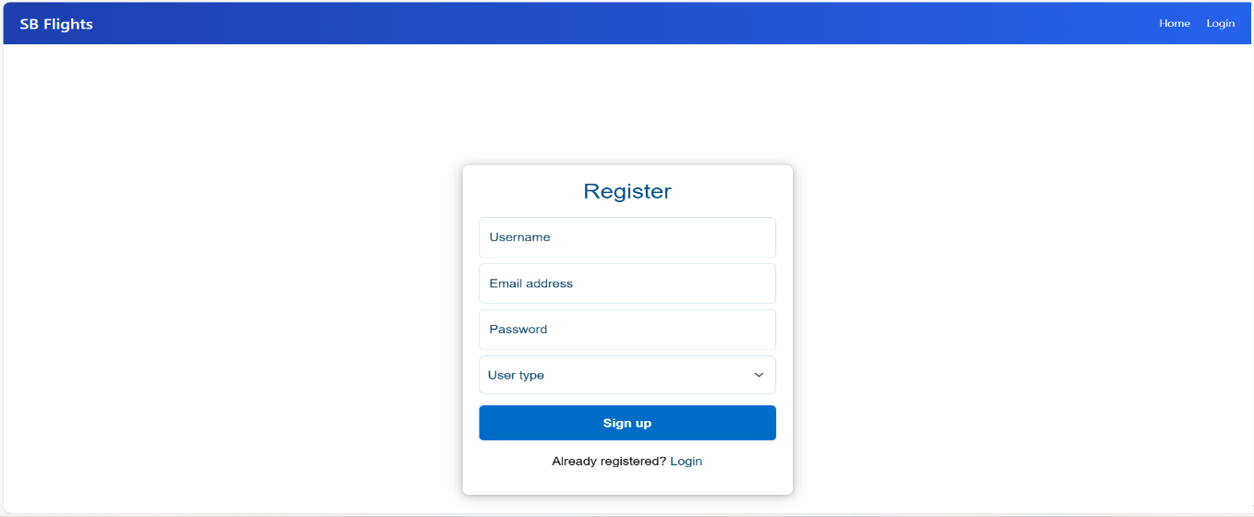

- Flights Page
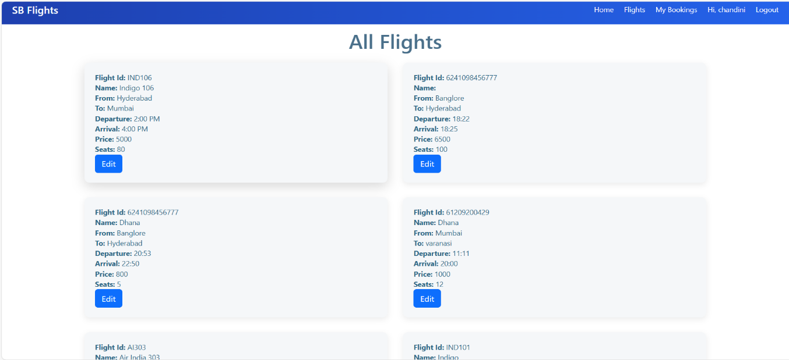
- My Bookings page
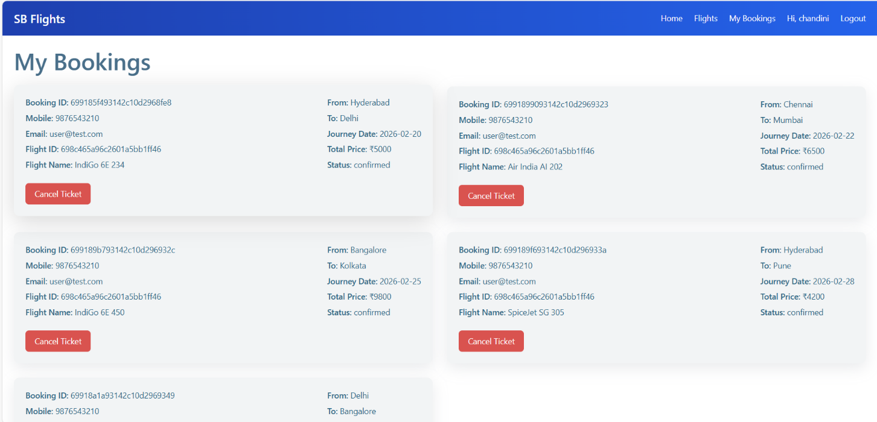
- Admin Dashboard
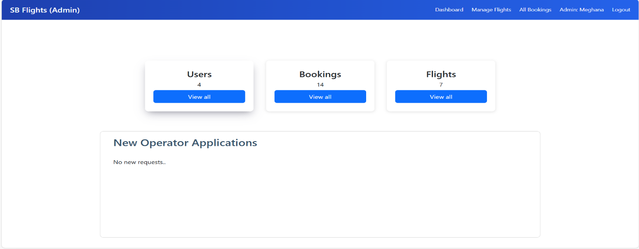
- Flight Management Page
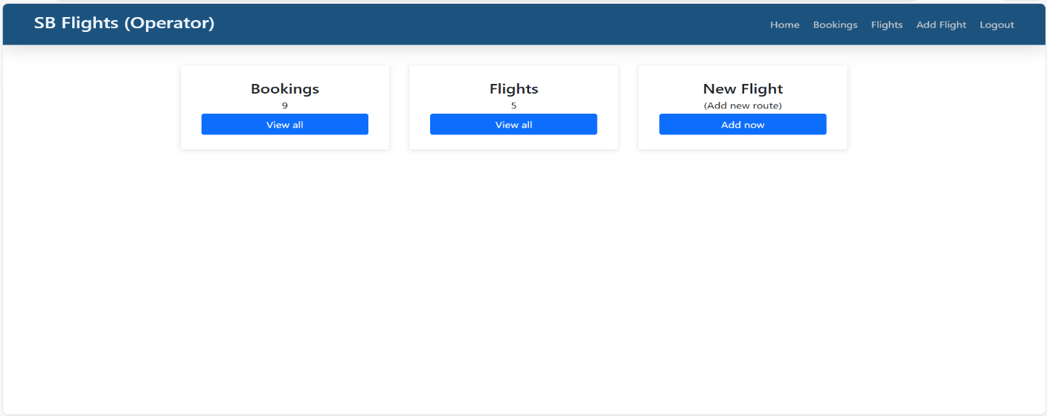
- All Bookings Page
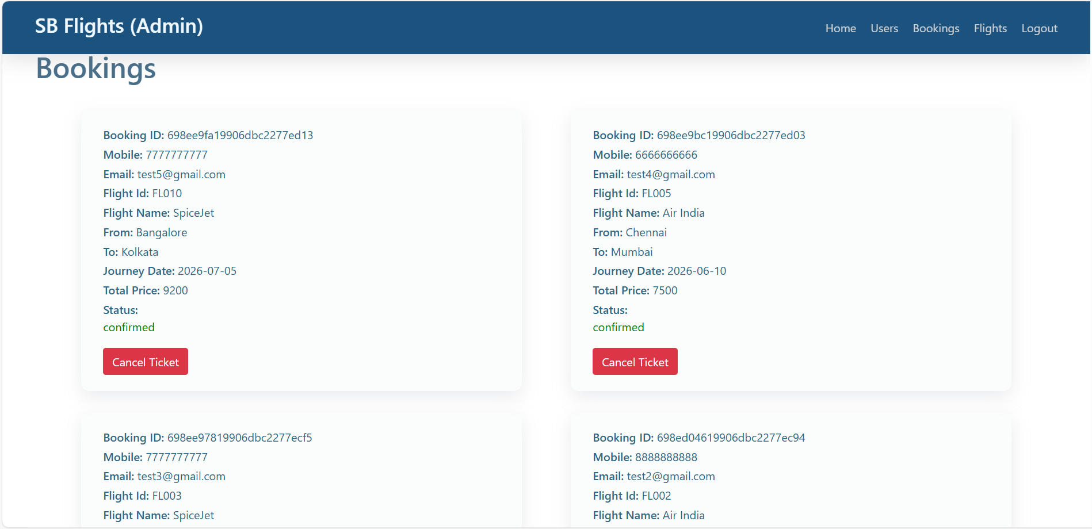

10. Testing
• Manual testing performed for all APIs
Verified:
- Registration
- Login
- Add Flight
- View Bookings
- Admin Operations
Tested using:
Browser
Postman

11. Screenshots or Demo
• Demo Video Link:
https://drive.google.com/file/d/1th_KxS7WttrEmU9li1qHkCqACSJDd_4J/view?usp=drive_link
Screenshots included in documentation.

12. Known Issues
- No payment integration
- No email notifications
- Basic admin authentication
- UI responsiveness can be improved
13. Future Enhancements
- Payment Gateway (Razorpay/Stripe)
- Email Ticket Confirmation
- Flight Search Filters
- Seat Selection
- Role-based Authentication (JWT)
- Deployment on Render / AWS

