**Introduction:**

According to the World Health Organisation, skin cancer accounts for 33.33% of all cancer cases and is a growing worldwide health problem [1]. In countries such as the United States, Australia, and Canada, the incidence rate has risen considerably during the previous decade. Over 15,000 people die from skin cancer each year [2]. In the United States, just one kind of skin cancer claimed 7180 lives in 2021, and 7650 deaths from melanoma cancer are anticipated in 2022 [3]. In 2019, it is anticipated that 192,310 new melanoma cases would have been detected in only the United States, taking 7,230 fatalities. Although it is rather uncommon among the different. This kind of skin cancer is by far the most deadly. When recognised Melanoma has a 98% 5-year survival rate if detected early. However, as the illness spreads to organs and lymph nodes,5-year survival rates drastically decline, reaching 64% and 23%, respectively. Early detection is crucial [4]. Patients with stage I cancer, for instance, have an estimated 94% to 98% likelihood of overall survival after 10 years, whereas patients with stage IV disease have an estimated 10-year overall survival of just 10% to 15%. Some populations have a higher prevalence of melanoma than others. These high-risk situations can be avoided by being aware of these groups [5]. A dermoscopy, a specialised microscope that can alter lighting, distance, resolution, angle, and other aspects of image capture, is frequently used by doctors and dermatologists to make melanoma diagnoses. The ability to see the tiny structures of the epidermis and outer dermis is provided by dermoscopy pictures [6]. Machine learning is commonly employed in contemporary computer-based technology. It is a vast and quickly developing area of artificial intelligence that enables computers to autonomously learn and grow without needing to be explicitly programmed. [7]

Baldrick et al. contrasted professional judgement with artificial neural networks when categorising lesions. Dermatologists found equal sensitivity and specificity scores of 95% and 90%, respectively, whereas the computer programme claimed a sensitivity of 95% and a specificity of 88% [8]. These findings suggest that automated methods might be used in the fields of cancer detection

A largely supervised learning technique is used to predict cancer using classification algorithms based on conditional judgements or probabilities. Decision trees [9], convolutional neural networks (CNN), support vector machines (SVM), and k-nearest neighbours (KNN) are among the most widely used techniques or approaches.

The use of these three algorithms in the search for skin cancer will be examined in this paper.

In contrast to traditional machine learning techniques, CNN is a deep learning approach that uses image processing algorithms and conclusions [10]. CNN models are effective at resolving complicated issues and produce output with great precision. They may be used with many mathematical learning techniques [11].

Regression and classification tasks are handled by support vector machines (SVMs) [12]. This method [6] use decision planes to establish decision boundaries. It utilises a labelled dataset for training as it is a supervised learning algorithm [13].

One of the simplest picture classification techniques is the k-nearest neighbour classifier. The main use of KNN is pattern recognition. This technique classifies unlabeled data points by locating the clusters with the most similarity among the k-closest examples.

This systematic review's objective was to assess the reliability and security of AI/ML technologies that could aid in the early diagnosis of skin cancer in primary and community care settings. The application of diagnostic algorithms to primary and community care (hence referred to as primary care), where the frequency of skin cancer is lower than in specialist clinics, is the topic of this Review, which was chosen on purpose. The first evaluation of the majority of worrisome skin lesions occurs in this context, hence this may be the area where AI/ML technologies can be most helpful. We looked at the quality of the available evidence, the stage of development the AI/ML technologies had reached, the gaps in the available evidence, and the potential for application in primary care.

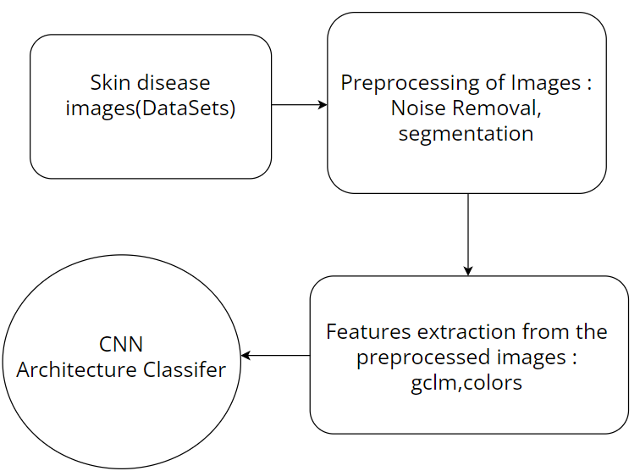

**Fig 1.1 –** Data flow diagram

**References:**

[1] S. A. AlSalman, T. M. Alkaff, T. Alzaid, and Y. Binamer, ‘‘Nonmelanoma skin cancer in Saudi Arabia: Single center experience,’’ Ann. Saudi Med., vol. 38, no. 1, pp. 42–45, Jan. 2018

[2] K. S. Nehal and C. K. Bichakjian, ‘‘Update on keratinocyte carcinomas,’’ New England J. Med., vol. 379, no. 4, pp. 363–374, Jul. 2018.   
 [3] Key Statistics for Melanoma Skin Cancer, American Cancer Society, Atlanta, GA, USA, 2022.   
 [4] Skin Cancer Foundation. (2016). Melanoma Overview. [Online]. Available: <http://www.skincancer.org>

[5] O’Neill CH, Scoggins CR. Melanoma. J Surg Oncol 2019;120(5):873–81. doi:10.1002/jso.25604.  
[6] A. Herschorn, ‘‘Dermoscopy for melanoma detection in family practice,’’ Can. Family Phys., vol. 58, no. 7, pp. 740–745, 2012.

[7] Shailaja K, Seetharamulu B, Jabbar MA. Machine Learning in Healthcare: A Review. Proceedings of the 2nd international conference on electronics, communication and aerospace technology. ICECA; 2018. doi:10.1109/ICECA.2018.8474918.

[8] Leiter U, Eigentler T, Garbe C. Epidemiology of skin cancer. Adv Exp Med Biol 2014;810:120–40. doi:10.1007/978-1-4939-0437-2_7

[9] Kharya S, Dubey D, Soni S. Predictive machine learning techniques for breast cancer detection. Available from: [www.ijcsit.com](http://www.ijcsit.com).

[10] Bhagyasri M, Bhavanishree PN, Madan KS, et al. Study on machine learning and deep learning methods for cancer detection. J Image Process AI 2018;

[11] Khan MQ, Hussain A, Rehman SU, et al. Classification of melanoma and nevus in digital images for diagnosis of skin cancer. IEEE Access 2019;7:90132–44. doi:10.1109/ACCESS.2019.2926837